Ques1 : Write the following a functional interface and implement it using lambda:
  - (1) First number is greater than second number or not Parameter (int ,int ) Return boolean
  - (2) Increment the number by 1 and return incremented value Parameter (int) Return int
  - (3) Concatination of 2 string Parameter (String , String ) Return (String)
  - (4) Convert a string to uppercase and return Parameter (String) Return (String)

Code:
package myjava8pack;
@FunctionalInterface
interface MyGreater
{
boolean checkGreater(int a,int b);
}
@FunctionalInterface
interface MyIncrement
{
int increNum(int a);
}
@FunctionalInterface
interface MyConcat
{
String concatString(String a,String b);
}
@FunctionalInterface
interface MyConvert
{
String convertUpper(String a);
}
public class Ques1 {
public static void main(String[] args) {
//(1) First number is greater than second number or not Parameter (int ,int ) Return boolean
System.out.println("Greater");
MyGreater mg=(a,b)-> a>b;
System.out.println(mg.checkGreater(2,4));
System.out.println("------------------------------");
//(2) Increment the number by 1 and return incremented value Parameter (int) Return int
System.out.println("Increment by 1");
MyIncrement mi=(a)->++a;
System.out.println(mi.increNum(3));
System.out.println("------------------------------");
//(3) Concatination of 2 string Parameter (String , String ) Return (String)
System.out.println("Concatenation");
MyConcat mc=(a,b)->a+b;
System.out.println(mc.concatString("him","anshu"));
System.out.println("------------------------------");
//(4) Convert a string to uppercase and return .
System.out.println("Convert to Uppercase");
MyConvert mct=(a)->a.toUpperCase();
System.out.println(mct.convertUpper("himanshU"));
System.out.println("------------------------------");
}
}

Output
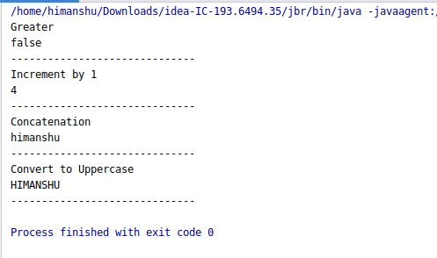

Ques2 : Create a functional interface whose method takes 2 integers and return one integer.
Code:
package myjava8pack;
@FunctionalInterface
interface Operate
{
int myReturnOne(int a,int b);
}
public class Ques2 {
public static void main(String[] args) {
Operate op=(a,b)->a+b;
System.out.println("The return output in 1 integer: "+op.myReturnOne(4,5));
}
}
Output
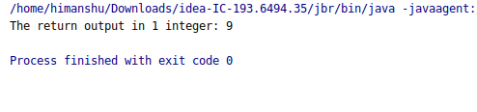

Ques3 : Using (instance) Method reference create and apply add and subtract method and using (Static) Method reference create and apply multiplication method for the functional interface created.
Code:
package myjava8pack;
@FunctionalInterface
interface Myoperate
{
int myGenericOperate(int a,int b);
}
public class Ques3 {
//Instance method
int myAdd(int a,int b)
{
return a+b;
}
int mySub(int a,int b)
{
return a-b;
}
//static method
static int myMultiply(int a,int b)
{
return a*b;
}
public static void main(String[] args) {
//using instance method
//Adding
System.out.println("Instance method");
Myoperate myoperate=new Ques3()::myAdd;
System.out.println("Sum is: "+myoperate.myGenericOperate(2,3));
//Subtract
myoperate=new Ques3()::mySub;
System.out.println("Subtract is: "+myoperate.myGenericOperate(3,1));
System.out.println("---------------------------------------");
System.out.println("Static method");
myoperate=Ques3::myMultiply;
System.out.println("Multiplication: "+myoperate.myGenericOperate(3,4));
}
}
Output
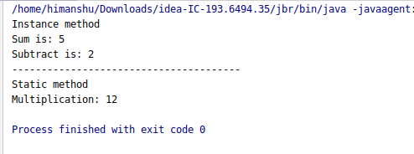

Ques4 : Create an Employee Class with instance variables (String) name, (Integer)age, (String)city and get the instance of the Class using constructor reference
Code:
package myjava8pack;
class Employee
{
String name,city;
int age;
public Employee(String name, String city, int age) {
this.name = name;
this.city = city;
this.age = age;
}
public Employee getObject()
{
return this;
}
@Override
public String toString() {
return "Employee{" +
"name='" + name + '\'' +
", city='" + city + '\'' +
", age=" + age +
'}';
}
}
@FunctionalInterface
interface Myinterface
{
Employee getEmpInstance();
}
public class Ques4 {
public static void main(String[] args) {
Myinterface mi=new Employee("kamal","delhi",23)::getObject;
System.out.println(mi.getEmpInstance());
}
}

Output

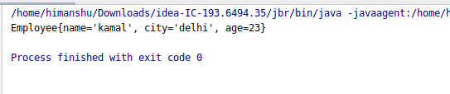

Ques5 : Implement following functional interfaces from java.util.function using lambdas:
  - (1) Consumer
  - (2) Supplier
  - (3) Predicate
  - (4) Function
Code:
package myjava8pack;
import java.util.function.Consumer;
import java.util.function.Function;
import java.util.function.Predicate;
import java.util.function.Supplier;
public class Ques5 {
public static void main(String[] args) {
//Consumer
System.out.println("---------- Consumer ----------------");
Consumer c=(a)->{
System.out.println("I want square of number and print it :"+(int)a*(int)a);
};
c.accept(2);
System.out.println("---------- Supplier ----------------");
//Supplier
Supplier s=()->{
return "Hi i am supplier";
};
System.out.println(s.get());
System.out.println("---------- Predicate ----------------");
Predicate<Integer> predicate=(a)->a%2==0;
System.out.println("Test :"+predicate.test(4));
System.out.println("---------- Function ----------------");
Function<Integer,Integer> f=(a)->a*2;
System.out.println("Square of number :"+f.apply(3));
}
}

Output

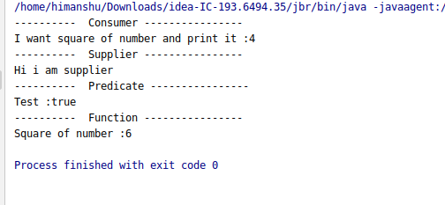

Ques6 : Create and access default and static method of an interface.
Code:
package myjava8pack;
interface Mydefault
{
//default
default void inDeafult()
{
System.out.println("Yes i am in default method (non abstract)....");
}
//static
static void inStatic()
{
System.out.println("Yes i am in static method..");
}
}
public class Ques6 implements Mydefault {
public static void main(String[] args) {
Ques6 q=new Ques6();
q.inDeafult();
System.out.println("------------------------");
Mydefault.inStatic();
}
}

Output
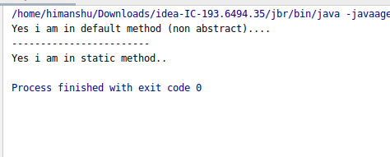

Ques7 : Override the default method of the interface.
Code:
package myjava8pack;
interface Mydefault1
{
//default
default void inDefault1()
{
System.out.println("Yes i am in default method (non abstract)....");
}
}
public class Ques7 implements Mydefault1 {
@Override
public void inDefault1()
{
System.out.println("Yes i am overridding this default method");
}
public static void main(String[] args) {
Ques7 q1=new Ques7();
q1.inDefault1();
}
}

Output

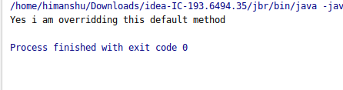

Ques8 : Implement multiple inheritance with default method inside interface.
Code:
package myjava8pack;
interface X
{
default void display(){
System.out.println("X display() is called..");
}
}
interface Y
{
default void display()
{
System.out.println("Y display() is called..");
}
}
public class Ques8 implements X,Y{
@Override
public void display() {
//If we want to call X interface method
X.super.display();
//If we want to call Y interface method
Y.super.display();
}
public static void main(String[] args) {
Ques8 ques8=new Ques8();
ques8.display();
}
}
Output

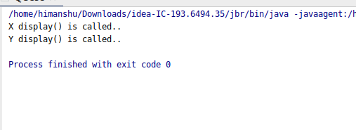

Ques9 : Collect all the even numbers from an integer list.
Code:
package myjava8pack;
import java.util.Arrays;
import java.util.List;
import java.util.stream.Collectors;
public class Ques9 {
public static void main(String[] args) {
//Collect all the even numbers from an integer list.
List<Integer> li= Arrays.asList(1,2,3,4,6,7,8);
System.out.println(
li.stream()
.filter(a->a%2==0)
.collect(Collectors.toList()));
}
}
Output

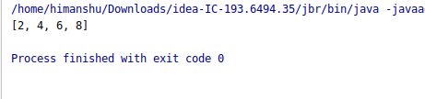

Ques10 : Sum all the numbers greater than 5 in the integer list.
Code:
package myjava8pack;
import java.util.Arrays;
import java.util.List;
import java.util.stream.Collectors;
public class Ques10 {
public static void main(String[] args) {
//Sum all the numbers greater than 5 in the integer list.
List<Integer> li= Arrays.asList(1,2,3,4,6,7,8);
System.out.println("Sum is : "+
li.stream()
.filter(a->a>5)
.mapToInt(Integer::intValue)
.sum());
}
}

Output

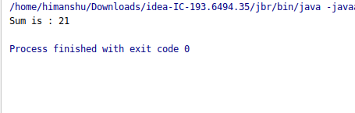

Ques11 : Find average of the number inside integer list after doubling it.
Code:
package myjava8pack;
import java.util.Arrays;
import java.util.List;
import java.util.stream.Collectors;
public class Ques11 {
public static void main(String[] args) {
//Find average of the number inside integer list after doubling it.
List<Integer> li= Arrays.asList(1,2,3,4);
System.out.println("Average average of the number inside integer list after doubling it : "+
li.stream()
.collect(Collectors.averagingInt(a->a*2)));
}
}

Output

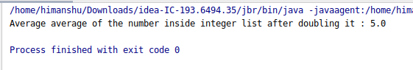

Ques12 : Find the first even number in the integer list which is greater than 3.
Code:
package myjava8pack;
import java.util.Arrays;
import java.util.List;
import java.util.stream.Collectors;
public class Ques12 {
public static void main(String[] args) {
//Using stream
//first even number in the integer list which is greater than 3.
List<Integer> li=Arrays.asList(1,2,3,4,5,6,7,8);
System.out.println(li.stream()
.filter(a->a%2==0)
.filter(a->a>4)
.findFirst()
);
}
}

Output

