1. Name of method in Thread class to pause execution?

Code:

package mypack1;
public class Ques1pause extends Thread {
public static void main(String[] args) throws InterruptedException {
//Thread.sleep() method can be used to pause the execution of current thread for specified time in milliseconds.
System.out.println("I am pausing the thread for 10000 ms");
Thread.sleep(10000);
System.out.println("I am Back");
}
}
Output
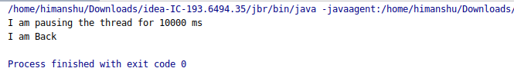
--------------------------------------------------------------------------------
2. Role of "volatile" keyword.

Code:

package mypack1;
import java.util.Scanner;
class Mytask extends Thread
{
private volatile boolean rstatus=true;
public void run()
{
while(rstatus)
{
System.out.println("I am running");
try {
Thread.sleep(1000);
} catch (InterruptedException e) {
e.printStackTrace();
}
}
}
public void updateStatus()
{
rstatus=false;
}
}
public class Ques2volatile {
//volatile keyword allows to multiple thread to modify value from the main memory instead of dedicated cache memory.
public static void main(String[] args) {
//Here I am starting the thread
Mytask mt=new Mytask();
mt.start();
//and the main thread is also in execution phase and now two threads concurrenty runnung
Scanner sc=new Scanner(System.in);
sc.nextLine();
mt.updateStatus();
System.out.println("Stop");
}
}

Output

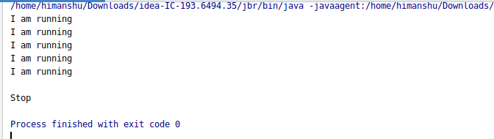

3. Write a program to create a thread using Thread class and Runnable interface each.

Code:

By using Thread Class

package mypack1;
class Myodd extends Thread
{
@Override
public void run() {
for (int i=1;i<=10;i+=2)
{
System.out.println(i);
try {
Thread.sleep(1000);
} catch (InterruptedException e) {
e.printStackTrace();
}
}
}
}
class Myeven extends Thread
{
@Override
public void run() {
for(int i=2;i<=10;i+=2)
{
System.out.println(i);
try {
Thread.sleep(1000);
} catch (InterruptedException e) {
e.printStackTrace();
}
}
}
}
public class Ques3Thread {
public static void main(String[] args) throws InterruptedException {
Myodd md=new Myodd();
md.start();
Thread.sleep(1000);
Myeven me=new Myeven();
me.start();
}
}

Output

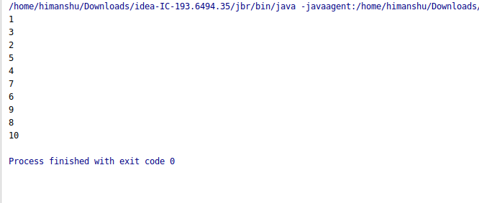

By using Runnable Interface

package mypack1;
class Myodd1 implements Runnable
{
@Override
public void run() {
for (int i=1;i<=10;i+=2)
{
System.out.println(i);
try {
Thread.sleep(1000);
} catch (InterruptedException e) {
e.printStackTrace();
}
}
}
}
class Myeven1 implements Runnable
{
@Override
public void run() {
for(int i=2;i<=10;i+=2)
{
System.out.println(i);
try {
Thread.sleep(1000);
} catch (InterruptedException e) {
e.printStackTrace();
}
}
}
}
public class Ques3Runnable {
public static void main(String[] args) throws InterruptedException {
Myeven1 ev=new Myeven1();
Myodd1 od=new Myodd1();
Thread t1=new Thread(ev);
t1.start();
Thread t2=new Thread(od);
Thread.sleep(1000);
t2.start();
}
}
Output

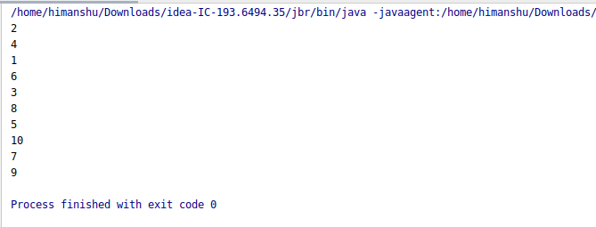

5. Write a program using synchronization method

Code:

package mypack1;
class MyThread1 {
int x,y;
synchronized void add(int a,int b){
System.out.println("Hi");
System.out.println("Bye");
int s=a+b;
try {
Thread.sleep(400);
} catch (InterruptedException e) {
e.printStackTrace();
}
System.out.println("Addition="+s);
}
}
class Thread1 extends Thread{
MyThread1 q;
Thread1(MyThread1 o){
q=o;
}
public void run(){
q.add(4,5);
}
}
class Thread2 extends Thread {
MyThread1 q;
Thread2(MyThread1 o) {
q = o;
}
public void run() {
q.add(8, 6);
}
}
public class Ques5synmethod {
public static void main(String[] args) {
MyThread1 ob=new MyThread1();
Thread1 t1=new Thread1(ob);
Thread2 t2=new Thread2(ob);
t1.start();
t2.start();
}
}

Output

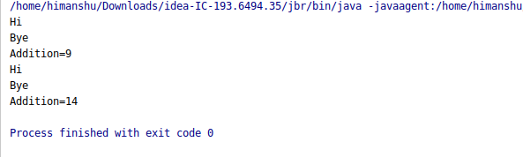

6. Write a program to create a Thread pool of 2 threads where one Thread will print even numbers
and other will print odd numbers.

Code:

package mypack1;
import java.util.concurrent.ExecutorService;
import java.util.concurrent.Executors;
import java.util.concurrent.TimeUnit;
class Odd implements Runnable
{
@Override
public void run() {
for (int i=1;i<=20;i+=2)
{
System.out.println(i);
try {
Thread.sleep(1000);
} catch (InterruptedException e) {
e.printStackTrace();
}
}
}
}
class Even implements Runnable
{
@Override
public void run() {
for(int i=2;i<=20;i+=2)
{
System.out.println(i);
try {
Thread.sleep(1000);
} catch (InterruptedException e) {
e.printStackTrace();
}
}
}
}
public class Ques6Threadpool {
public static void main(String[] args) {
ExecutorService executor=Executors.newFixedThreadPool(2);
executor.submit(new Odd());
executor.submit(new Even());
executor.shutdown();
try {
executor.awaitTermination(1, TimeUnit.DAYS);
}catch (InterruptedException e)
{
e.printStackTrace();
}
System.out.println("End");
}
}

Output

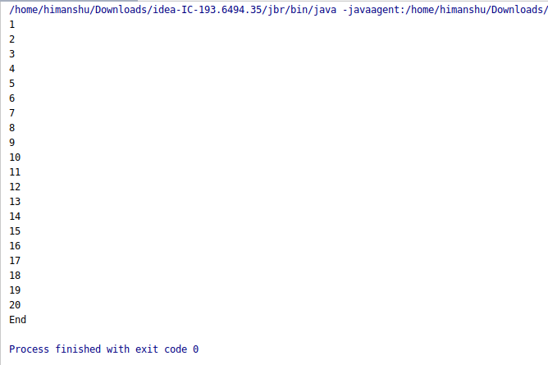

4,7. Write a program using synchronization block.
Write a program to demonstrate wait and notify methods.

Code:

package mypack1;
//With wait() and notify() i want that thread completes its task first and then other will completes its task.
//Here there are two threads First(thread) will print the odd numbers.
class First
{
public void myProducer() throws InterruptedException {
synchronized (this)
{
System.out.println("By Producer->>>>Produced");
wait();
System.out.println("The item is consumed and resumed");
}
}
public void myConsumer() throws InterruptedException {
synchronized (this)
{
Thread.sleep(3000);
System.out.println("By Consumer ->>> Consumed");
notify();
}
}
}
public class Q7q4waitnotify {
public static void main(String[] args) {
First f1=new First();
Thread t1=new Thread(new Runnable() {
@Override
public void run() {
try {
f1.myProducer();
} catch (InterruptedException e) {
e.printStackTrace();
}
}
});
Thread t2=new Thread(new Runnable() {
@Override
public void run() {
try {
f1.myConsumer();
} catch (InterruptedException e) {
e.printStackTrace();
}
}
});
t1.start();
t2.start();
}
}

Output

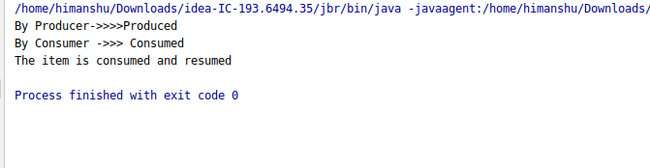

8. Write a program to demonstrate sleep and join methods.

Code:

package mypack1;
class MyThread extends Thread
{
@Override
public void run() {
System.out.println("hey i am executing..."+Thread.currentThread().getName());
try {
Thread.sleep(3000);
} catch (InterruptedException e) {
e.printStackTrace();
}
System.out.println("Finished");
}
}
public class Ques8Join {
public static void main(String[] args) {
MyThread t1= new MyThread();
MyThread t2=new MyThread();
t1.start();
//starts second thread when thread t1 has died
try{
t1.join();
} catch (InterruptedException e) {
e.printStackTrace();
}
t2.start();
}
}

Output

