*Internationalization
- Add support for Internationalization in your application allowing messages to be shown in English, German and Swedish, keeping English as default.
Solution:
IN Demo Project
File Includes
DemoApplication
messages.properties (For English language)
messages_de.properties (For German language)
messages_sv.properties (For Swedish language)
BookController

- Create a GET request which takes "username" as param and shows a localized message "Hello Username". (Use parameters in message properties)
Solution:
IN Demo Project
File Includes
DemoApplication
messages.properties (For English language)
BookController

*Content Negotiation
3. Create POST Method to create user details which can accept XML for user creation.
4. Create GET Method to fetch the list of users in XML format.

Solution:
IN Demo Project
We have to include the ‘com.fasterxml.jacksin.dateformat’ dependencies for XML format
dependencies
{
compile group: 'com.fasterxml.jackson.dataformat', name: 'jackson-dataformat-xml', version: '2.10.3'
}
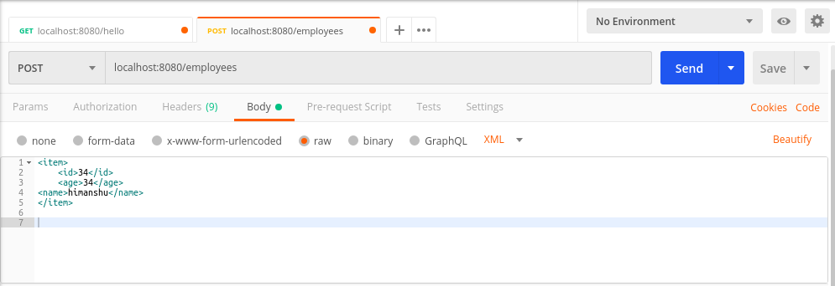
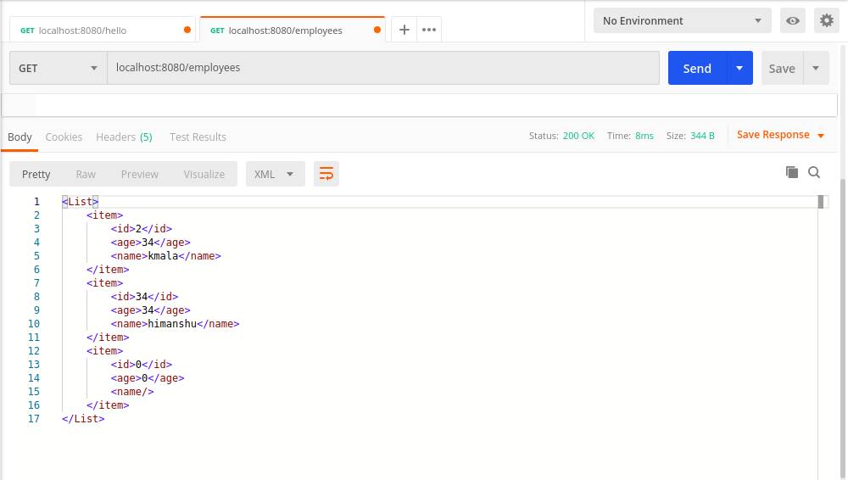
*Swagger
5. Configure swagger plugin and create document of following methods:
Get details of User using GET request.
Save details of the user using POST request.
Delete a user using DELETE request.
Solution:
In SwaggerExample Project
package com.example.SwaggerExample;
import org.springframework.context.annotation.Bean;
import org.springframework.context.annotation.Configuration;
import springfox.documentation.spi.DocumentationType;
import springfox.documentation.spring.web.plugins.Docket;
import springfox.documentation.swagger2.annotations.EnableSwagger2;
@Configuration
@EnableSwagger2
public class SwaggerConfig {
@Bean
public Docket api()
{
return new Docket(DocumentationType.SWAGGER_2);
}
}

build.gradle
dependencies {
compile group: 'io.springfox', name: 'springfox-swagger2', version: '2.9.2'
compile group: 'io.springfox', name: 'springfox-swagger-ui', version: '2.9.2'
}

For see the document:
http://localhost:8080/v2/api-docs

7. In swagger documentation, add the description of each class and URI so that in swagger UI the purpose of class and URI is clear.

*Static and Dynamic filtering
8. Create API which saves details of User (along with the password) but on successfully saving returns only non-critical data. (Use static filtering)
Solution:
IN Demo Project
For static filtering include
@JsonIgnore before the required attribute.
9. Create another API that does the same by using Dynamic Filtering.
Solution:
IN Demo Project
For dynamic filtering include
@JsonFilter(“EmployeeBeanFilter”)

In code I applied static and dynamic filter on password attribute.

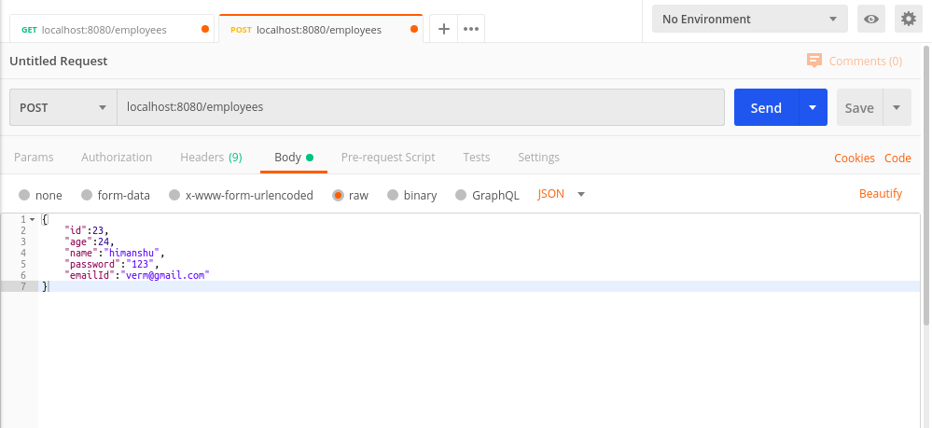
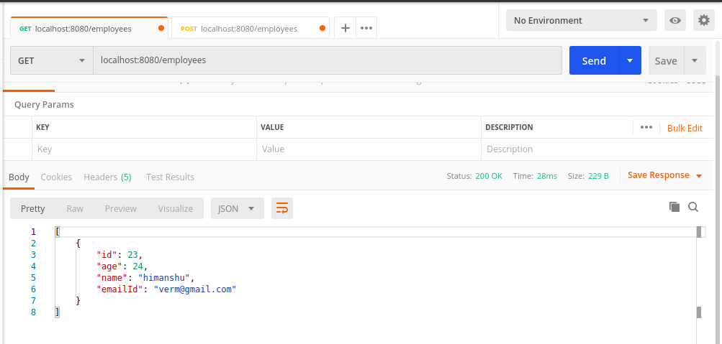

*Versioning Restful APIs
10. Create 2 API for showing user details. The first api should return only basic details of the user and the other API should return more/enhanced details of the user,
Now apply versioning using the following methods:
- MimeType Versioning
- Request Parameter versioning
- URI versioning
- Custom Header Versioning

Solution
In the HateoasQues project the Versioning is covered.
FileIncludes
Person1.java
Person2.java
FullName.java
UserController.java
Code:
package com.example.HateoasQues.controller;
import com.example.HateoasQues.entitiy.FullName;
import com.example.HateoasQues.entitiy.Person1;
import com.example.HateoasQues.entitiy.Person2;
import org.springframework.web.bind.annotation.GetMapping;
import org.springframework.web.bind.annotation.RestController;
@RestController
public class UserController {
//URI versioning----------------------------------------------------------------------------
//For Person 1
@GetMapping("/getdetails")
public Person1 getRecordFromPerson1()
{
Person1 person1=new Person1(12,"Neel");
return person1;
}
//For Person2
@GetMapping("/get-enhanced-details")
public Person2 getRecordFromPerson2()
{
FullName fullName =new FullName("Neel","niten","mukesh");
Person2 person2=new Person2(23, fullName);
return person2;
}
//-----------------------------------------------------------------------------------------------
//Request Parameter
@GetMapping(value = "/getdetails/param",params = "nameVersion1")
public Person1 getRecordFromPerson1UsingParam()
{
Person1 person1=new Person1(12,"Neel");
return person1;
}
//For Person2
@GetMapping(value = "/getdetails/param",name = "nameVersion2")
public Person2 getRecordFromPerson2UsingParam()
{
FullName fullName =new FullName("Neel","niten","mukesh");
Person2 person2=new Person2(23, fullName);
return person2;
}
//-----------------------------------------------------------------------------------------------
//Custom Header Versioning
//Request Parameter
@GetMapping(value = "/getdetails/header",headers = "nameVersion=1")
public Person1 getRecordFromPerson1UsingHeader()
{
Person1 person1=new Person1(12,"Neel");
return person1;
}
//For Person2
@GetMapping(value = "/getdetails/header",headers = "nameVersion=2")
public Person2 getRecordFromPerson2UsingHeader()
{
FullName fullName =new FullName("Neel","niten","mukesh");
Person2 person2=new Person2(23, fullName);
return person2;
}
//-----------------------------------------------------------------------------------------------
// MimeType Versioning
//Request Parameter
@GetMapping(value = "/getdetails/produces",produces = "application/vnd.company.app-v1+json")
public Person1 getRecordFromPerson1UsingMime()
{
Person1 person1=new Person1(12,"Neel");
return person1;
}
//For Person2
@GetMapping(value = "/getdetails/produces",produces = "application/vnd.company.app-v2+json")
public Person2 getRecordFromPerson2UsingMime()
{
FullName fullName =new FullName("Neel","niten","mukesh");
Person2 person2=new Person2(23, fullName);
return person2;
}
//-----------------------------------------------------------------------------------------------
}

*HATEOAS
11.Configure hateoas with your springboot application. Create an api which returns User Details along with url to show all topics.
Solution

In the HateoasQues project the Versioning is covered.
For Hateoas we have to include the dependencies
dependencies {
compile group: 'org.springframework.boot', name: 'spring-boot-starter-hateoas', version: '2.2.5.RELEASE'
}

Code:
// Implement GET http request using path variable top get one employee
@GetMapping("/employees/{id}")
public EntityModel<Employee> retrieveEmployee(@PathVariable int id)
{
Employee emp= empDao.getEmployeeById(id);
if(emp==null)
{
throw new EmployeeNotFoundException("Sorry !! The record related to this ID : "+id +" is not Exist.." );
}

//HATEOAS LOGIC
EntityModel<Employee> model=new EntityModel<>(emp);
WebMvcLinkBuilder link= WebMvcLinkBuilder.linkTo(WebMvcLinkBuilder.methodOn(this.getClass()).retrieveEmpRecord());
model.add(link.withRel("All-Employees"));

return model;
}

