**Index:**

**System requirements:**

**Preparing the system:**

**Getting the Token ID:**

**Downloading Data from Canvas:**

**Without sync.csv file**

**With sync.csv file**

**File Upload:**

**Canvas_FileUpload (Manual Script):**

**Canvas_FileUpload (Automate):**

**System requirements:**

A suitable version of **Windows PowerShell** is available for these operating systems:

* Windows 10
* Windows 8.1 Pro
* Windows 8.1 Enterprise
* Windows 7 SP1
* Windows Server 2019
* Windows Server 2016
* Windows Server 2012 R2
* Windows Server 2008 R2 SP1

**Preparing the system:**

Go to start button right click on the *windows PowerShell* Run as *Administrator*

Check the ExecutionPolicy by running below command in console

Get-ExecutionPolicy

Set the ExecutionPolicy to Unrestricted

Set-ExecutionPolicy -ExecutionPolicy Unrestricted

**Getting the Token ID:**

Generate the new access token using below process.

login into the Canvas website uri (Ex:https://jlg.instructure.com)

Go to Account-->settings-->Approved integrations-->New Access Token

**Downloading Data from Canvas:**

**Without sync.csv file**

1. How to run the script?
2. Run the script by double clicking “**CanvasApiMainScript.ps1**”
3. Script will ask for **Uri** - Pass login canvas Uri (Ex: <https://jlg.instructure.com>)
4. Script will ask fir **Token ID -** Provide created Token id (Ex:4626~OhR7Arue1IhsaJnplrLYYeqj********)
5. Where files will be created?

Files will be created in the same directory where the script file is located.

Once you run the script, it downloads the all available courses data from canvas and creates courses.csv and looks for sync.csv file ( If location not having sync.csv file Script will create sync.csv and ask you for the provide the details to move further.)

Script will ask user to “keep course id in sync.csv file and press Y to proceed”



Once user press “Y” then enter. Remaining script will run and create the below files for given input sync.csv course ids.

1. What files will be created?

School.csv

Section.csv

Teacher.csv

Student.csv

StudentEnrollment.csv

TeacherRoster.csv

**With sync.csv file**

1. How to run the script?

* Run the script by double clicking “**CanvasApiMainScript.ps1**”
* Script will ask for **Uri** - Pass login canvas Uri (Ex: <https://jlg.instructure.com>)
* Script will ask fir **Token ID -** Provide created Token id (Ex:4626~OhR7Arue1IhsaJnplrLYYeqj********)

1. Where files will be created?

Files will be created in the same directory where the script file is located.

Once you run the script, it downloads the all available courses data from canvas and creates courses.csv.

Script will check sync.csv file. If file is available runs the remaining script. If file is not available script asks you to re-run the script by keeping the sync.csv file in current location.

Script will creates below files taking the input from sync.csv.

School.csv

Section.csv

Teacher.csv

Student.csv

StudentEnrollment.csv

TeacherRoster.csv

**Canvas Files Upload to SDS:**

**Canvas_FileUpload (Manual Script):**

Uploading files to School Data Sync (Manual process):

* Click this link <https://sds.microsoft.com>
* Login using your Global Admin account
* Click on Add Profile
* Enter sync profile Name
* Choose Sync method 🡪Upload CSV files
* Choose Type for Csv files you are using 🡪 CSV files: SDS Format
* Click start
* Sync options : choose new users or Existing usersA screenshot of a cell phone

  Description automatically generated
* Upload files: Select created 6 csv files (School.csv, Section.csv, Teacher.csv, Student.csv, StudentEnrollment.csv, TeacherRoster.csv)

* Select “Replace unsupported special characters” option A screenshot of a cell phone

  Description automatically generated
* When should we stop syncing this profile?

* Choose Teacher Options



Select licenses for Teachers

* Choose Student Options



Select licenses for Students

* Review all data and select Create profile

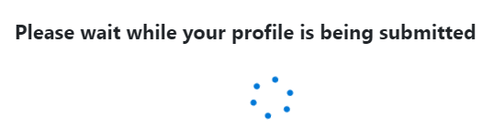

* Once Sync profile is submitted it will take some time to Create sync profile.

Once its created. It will show the status of sync



It will create new Teams in Teams Console

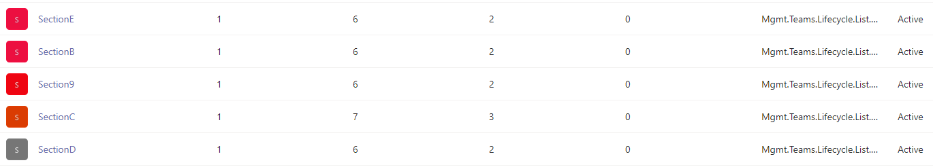

Once its done. It will create O365 groups as shown in below same will reflect in Teams

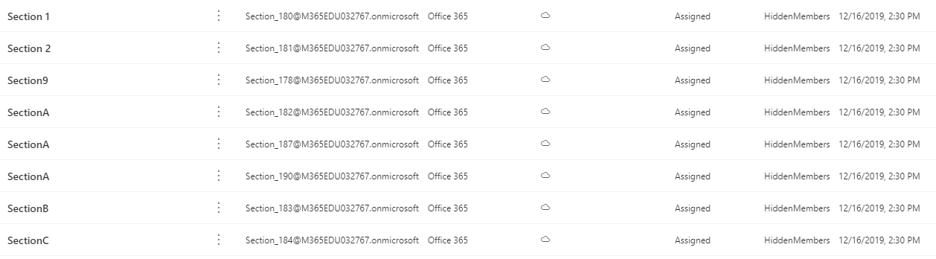

**Canvas File Upload to SDS (Automation):**

Keep the below files in current folder where you are running the script.

azcopy.exe

uploading .csv files(School.csv; section.csv; student.csv; studentEnrollment.csv; teacher.csv; teacherroster.csv)

navigate to current folder Run the script using runas admin rights

ex: if I want to run the script in d:

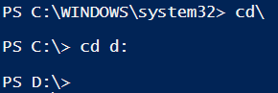

Script will run in current folder and create (conf.json)file and sastoken.cmd files.

provide the username, password and syncprofileName for the firsttime running the script.

second time onwards script will provide sync status.

**FAQs/Common Problems:**

Active directory sync error

If teachers or students are invited but they don’t enrolled as teacher or student. They wont be available as teacher or student in the created team.

If No Teachers – SDS wont create teams for that section (if it having the students also)

In tenant Teacher will be assigned teacher license and student will be student license.