Keep the Below details in info.jsonfile

"client_Id": "please paste your application id here",

"Client_Secret": "please paste your client secret here",

"Tenantid": "please paste your tenant id here"

Run the script it will open webpage for grant permissions.

Please login with your tenant *USER ID* and *PASSWORD*

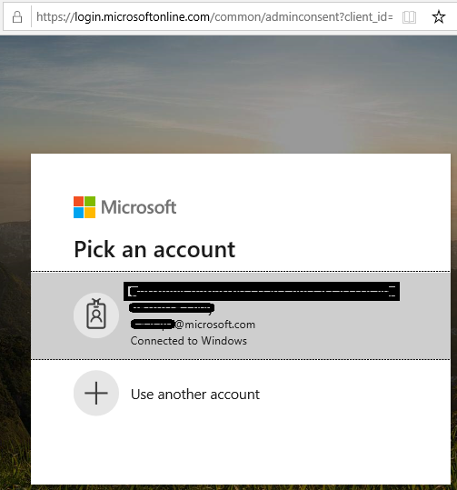

Once you are login it will shows the

Click accept

If you provided correct credentials it will through success status admin_consent = True



Now press **Y** to proceed further in script.

Script will create 3files.

Apps.csv is the final output file having Teams applications for each user.

Output file:

|  |  |  |  |
| --- | --- | --- | --- |
| ID | DisplayName | UserPrincipalName | InstalledApps |