Math 6019 Assignment 1.

Problem 1:

Implement Univariate scan method which would output an interval with the minimum bracketed.

The function is defined in the python file named *univariate.py.* This is the structure of function ‘univariatescan(f, x0, tol, alp, maxiter)’ where ‘f’ is any mathematical equation defined using ‘lambda function’ in python and doesn’t have a default equation, ‘x0’ is the initial guess the user has to input and doesn’t have a default value. ‘tol’ is the tolerance allowed in the error calculation and has a default value of 10-8, ‘alp’ is the step size and has a default value of 10-2, ‘maxiter’ is the maximum iterations defined for stopping criteria and has a default value of 103.

Once the function is called with above mentioned inputs, the function outputs, plots showing objective function defined by the user and the interval with the bracketed minimum. The function also returns lower interval point ‘a’, upper interval point ‘b’ and the total no. of iterations ‘k’ it took the function to find the interval.

The python code is appropriately commented defining the process.

Some of the compiled results:

1. F(x) = x3-3x2

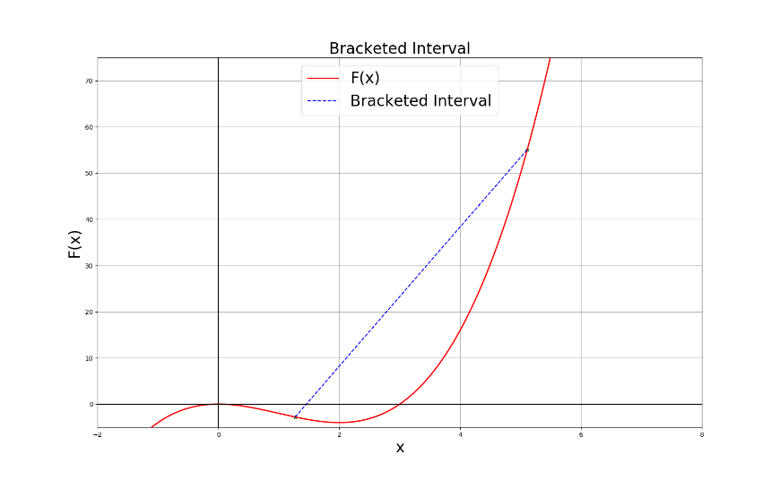

1. F(x) = x2- 6x + 10

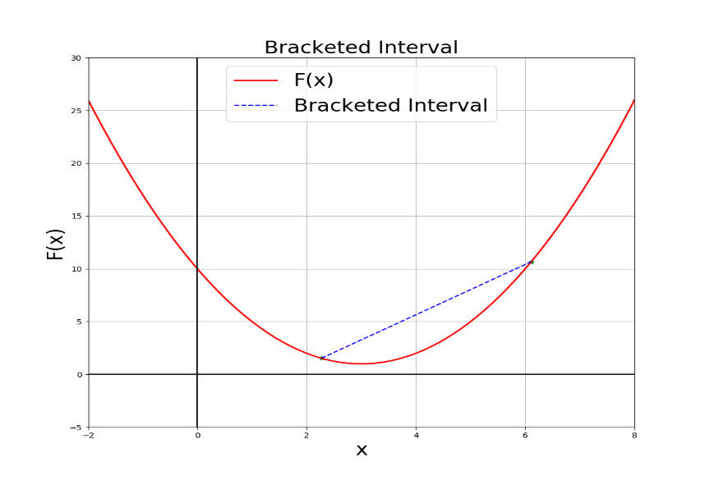

1. F(x) = x2 + 3x-10

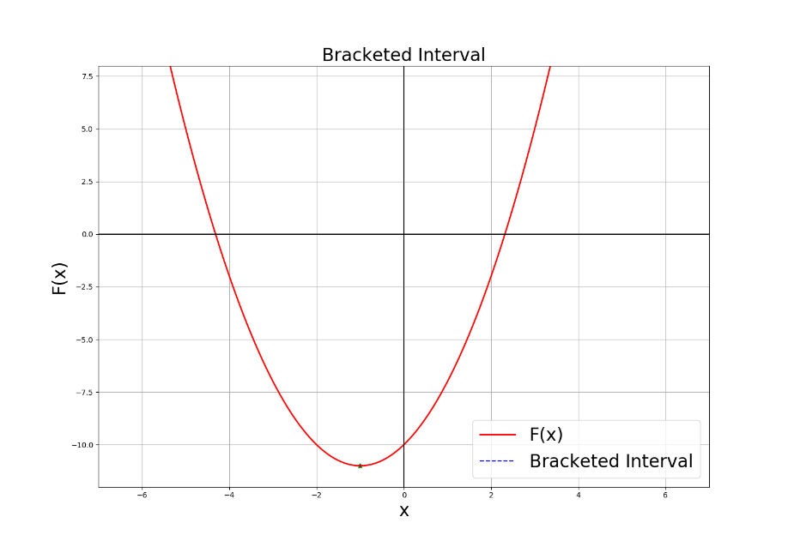

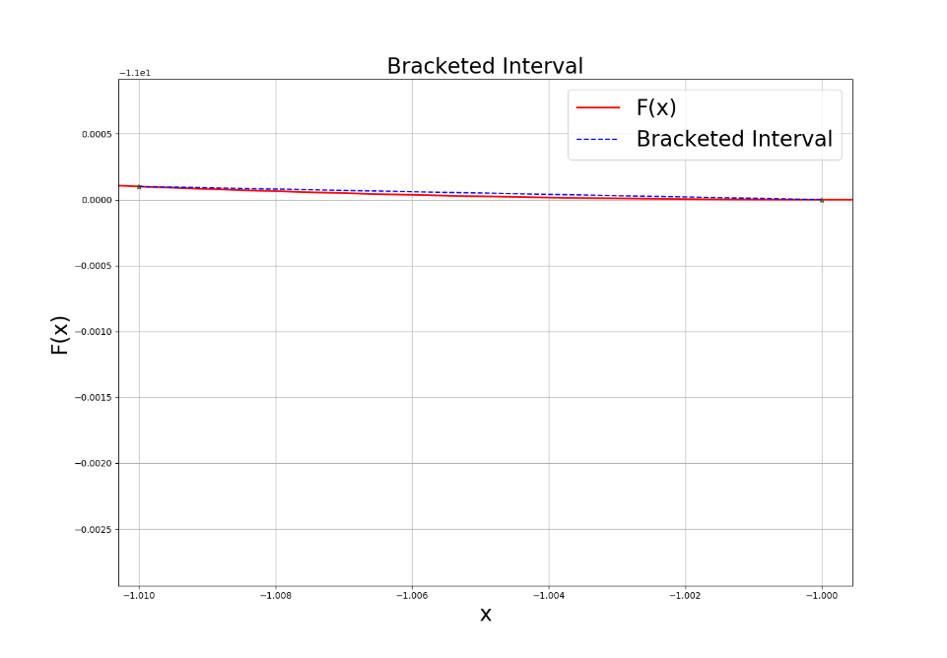

Problem 2:

Implement Bisection method which would output a minimum value of the objective function given two guesses that contain the minimum.

The function is defined in the python file named *bisection.py.* This is the structure of function ‘bisection(f, a, b, tol, maxiter)’ where ‘f’ is any mathematical equation defined using ‘lambda function’ in python and doesn’t have a default equation, ‘a’ is the lower interval guess point for the minimum and ‘b’ is the upper interval guess point for the minimum. ‘tol’ is the tolerance allowed in the error calculation and has a default value of 10-8, ‘maxiter’ is the maximum iterations defined for stopping criteria and has a default value of 103.

Once the function is called with above mentioned inputs, the function outputs, plots showing objective function defined by the user and the minimum. The function also returns minimum value of the objective function ‘c’ and the total no. of iterations ‘k’ it took the function to find the minimum.

The python code is appropriately commented defining the process.

Some of the compiled results:

1. F(x) = x3-3x2

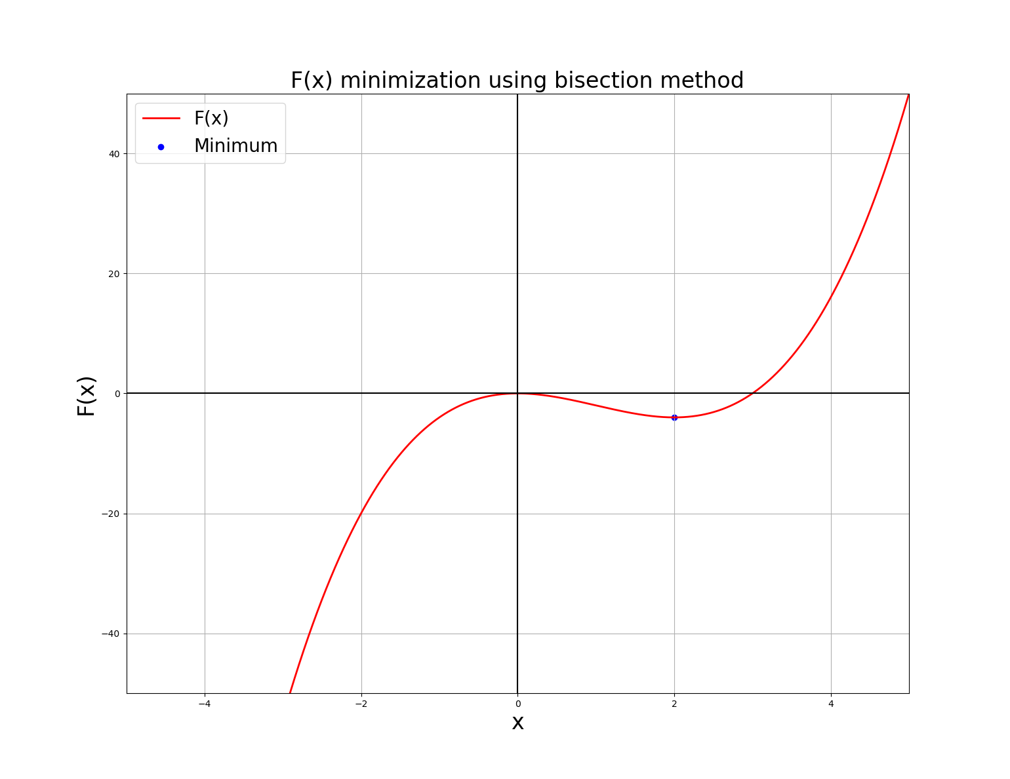

1. F(x) = x2- 6x + 10

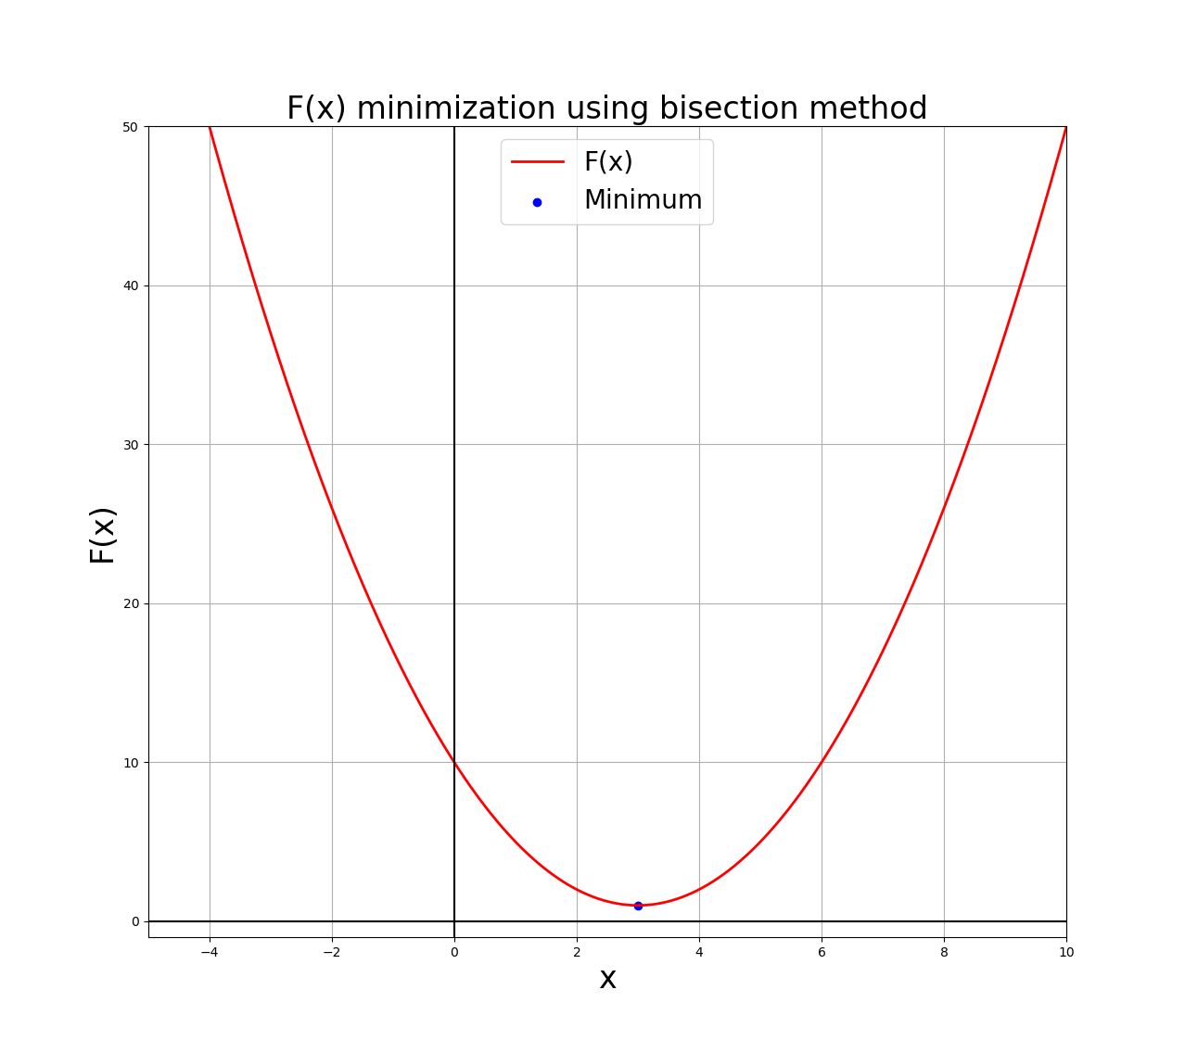

1. F(x) = x2 + 3x-10

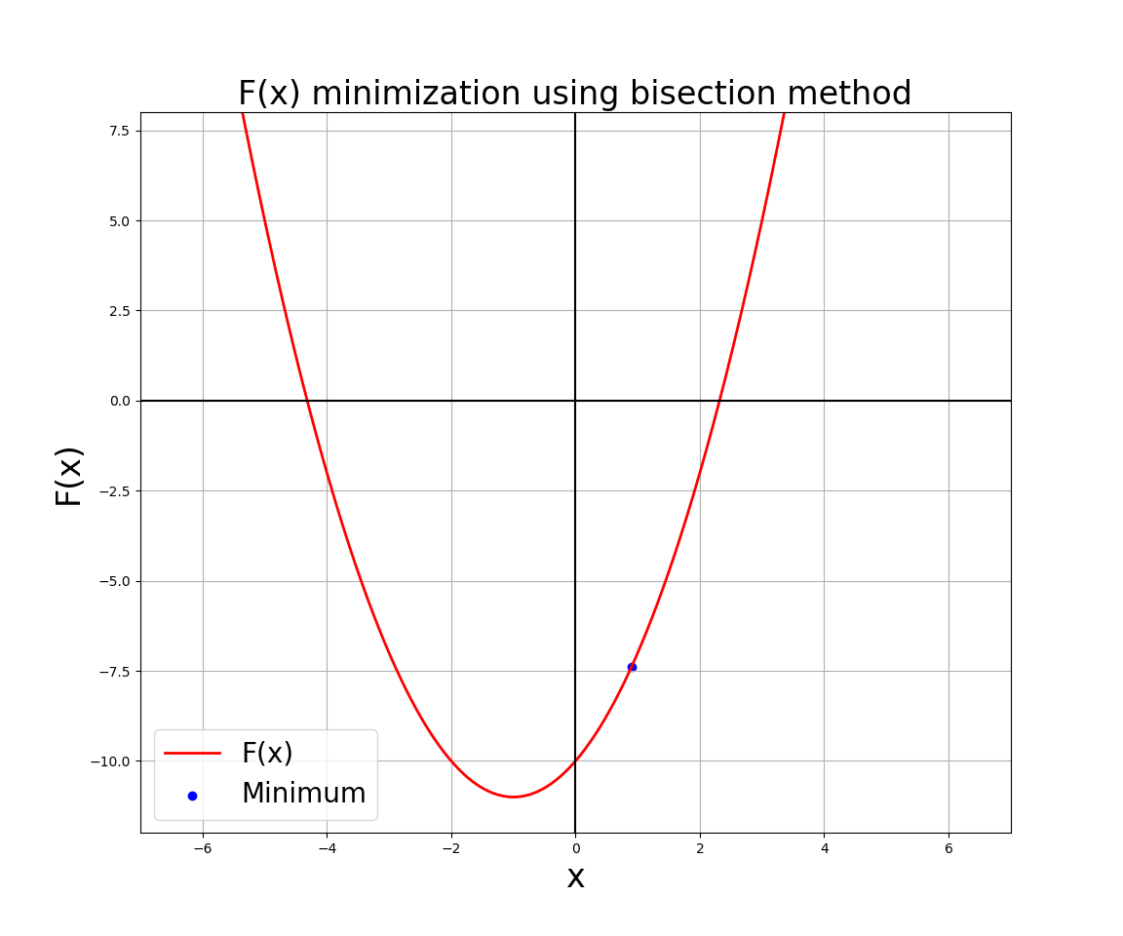

Problem 3:

Implement Newton – Raphson method which would output a minimum value of the objective function given an initial guess.

The function is defined in the python file named *Newton.py.* This is the structure of function ‘newton_raphson(f, x0, tol, alp, maxiter)’ where ‘f’ is any mathematical equation defined using ‘lambda function’ in python and doesn’t have a default equation, ‘x0’ is the initial guess the user has to input and doesn’t have a default value. ‘tol’ is the tolerance allowed in the error calculation and has a default value of 10-8, ‘alp’ is the step size and has a default value of 10-2, ‘maxiter’ is the maximum iterations defined for stopping criteria and has a default value of 103.

Once the function is called with above mentioned inputs, the function outputs, plots showing objective function defined by the user and the minimum. The function also returns minimum value of the objective function ‘c’ and the total no. of iterations ‘k’ it took the function to find the minimum.

The python code is appropriately commented defining the process.

Some of the compiled results:

1. F(x) = x3-3x2

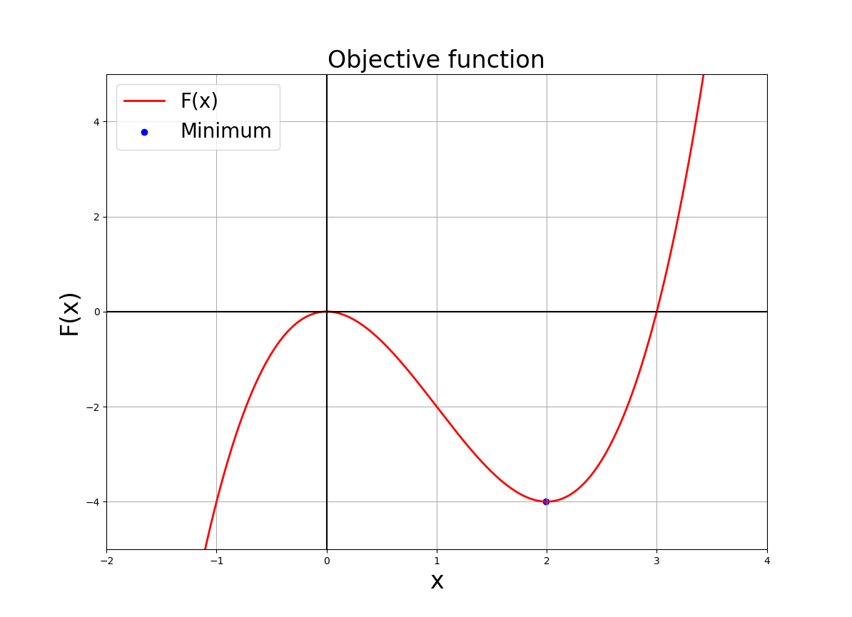

1. F(x) = x2- 6x + 10

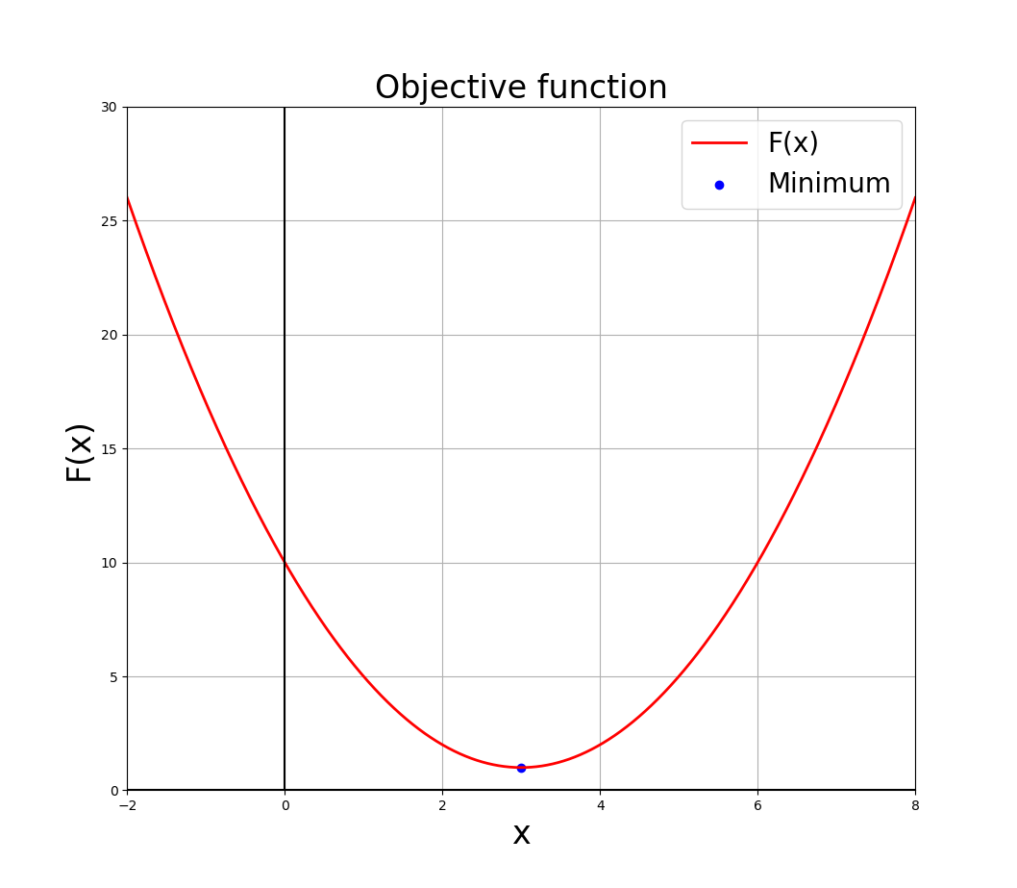

1. F(x) = x2 + 3x-10

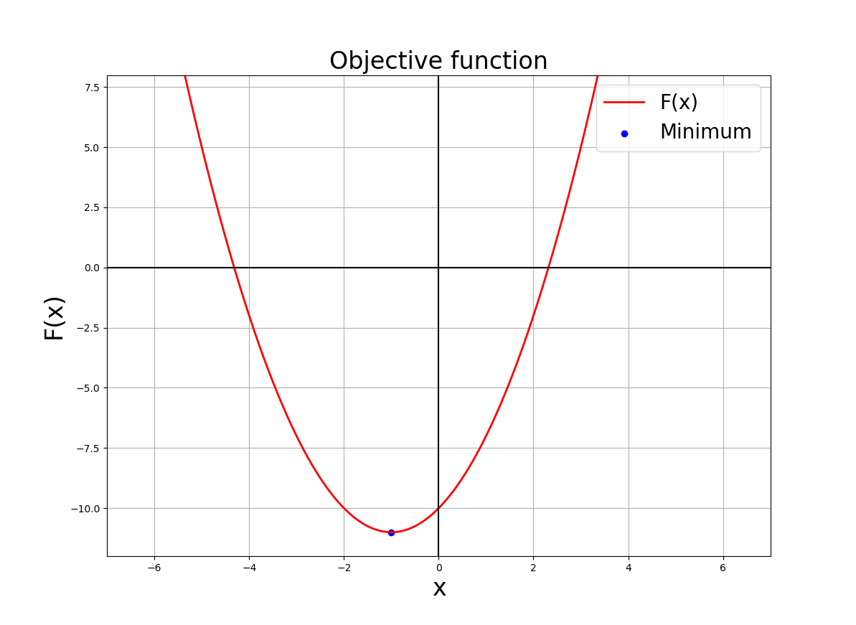

Problem 4:

The total_least_squares (x0=0.1, m=0.5, n=1000, d_range=(0,5), b=0.0, eps=1e-2) function takes the following inputs

INPUT:

x0 - It takes a float value, which acts as an initial guess to Newton-Raphson Method

m - It takes a float value and it represents the slope of the input line

n - It is the no. of points that are being mapped. It takes an integer value >0

d_range - It is the range defined for the graph

b - is the y-intercept and takes a float values

eps - represents the magnitude of the noise in the input data

OUTPUT:

Plots showing objective function with the minimum point and the best fit line along with original data

Also prints the values of minimum x, minimum F(x) to the console.

Here are the compiled results for the default values.

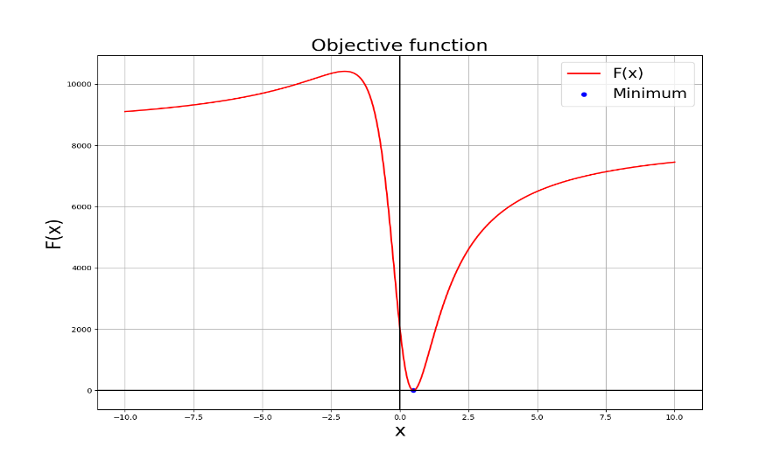

Best Line Fit plot:

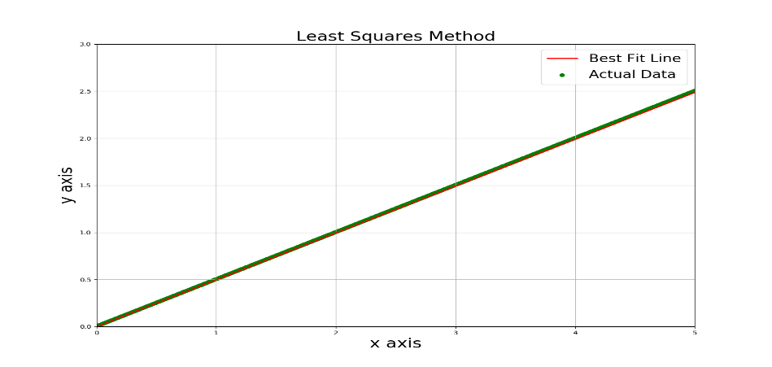

Problem 5:

The collective compiled results for a, b, c for all 3 cases are shown in following figures.

1. P = (5, 3), C = (2, 2), r = 1

Interval containing the minimum. For initial guess value x0 = 0.5

Output a = 0.81 , b = 1.77

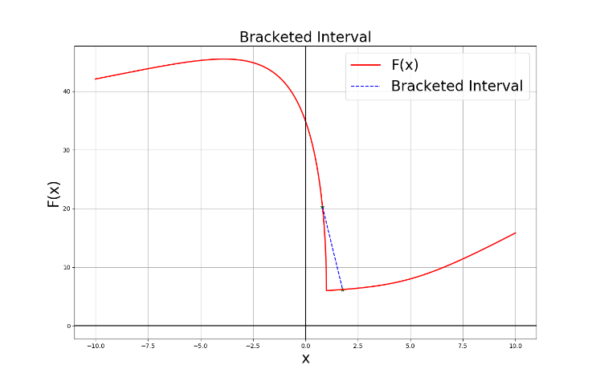

Objective function with minimum point.

Output minimum = 1.0 and F(xmin) = 6.0

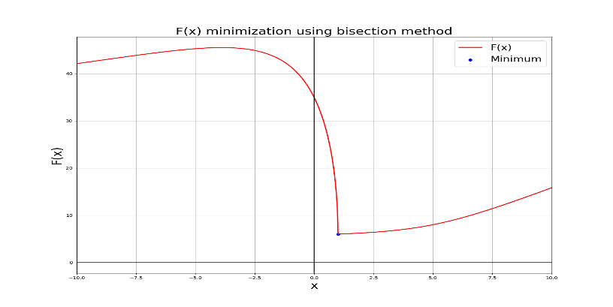

Optimal Path for Robot. The robot has to travel until x = 1.0 along x-axis to avoid the circle while reaching the point P.

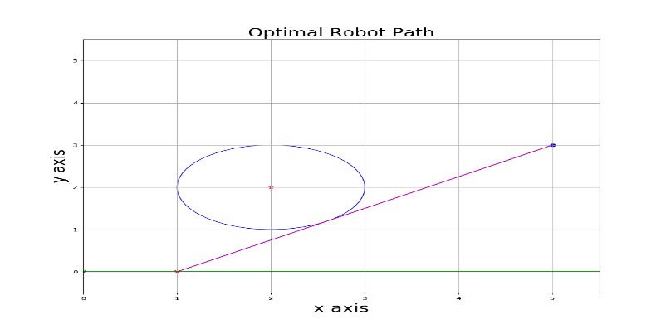

Interval containing the minimum. For initial guess value x0 = 3.0

Output a = 0.73 , b = 1.69

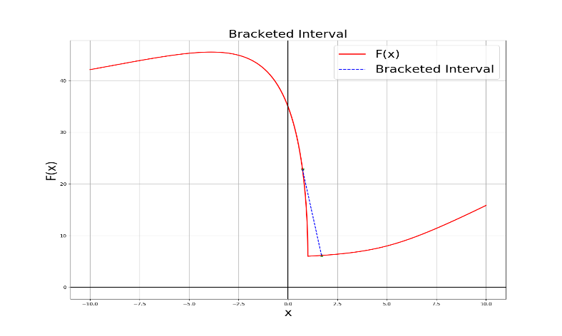

Objective function with minimum point.

Output minimum = 1.0 and F(xmin) = 6.0

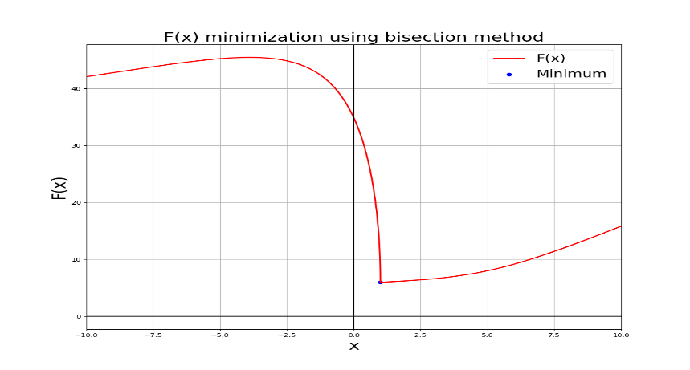

Optimal Path for Robot. The robot must travel until x = 1.0 along x-axis to avoid the circle while reaching the point P.

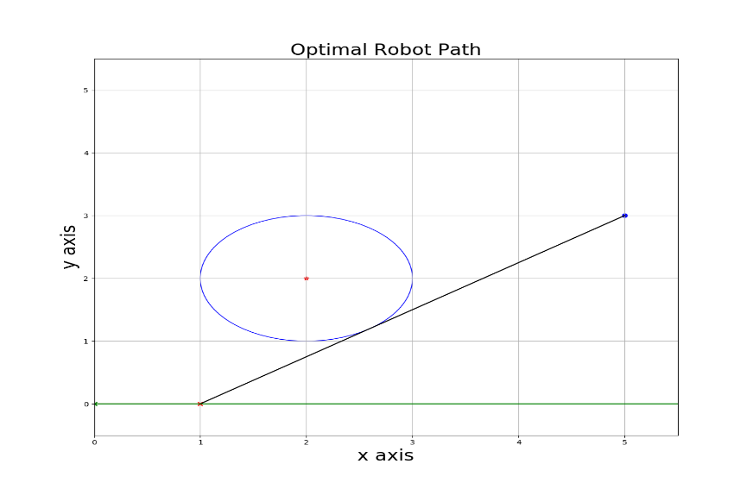

1. P = (2, 4), C = (2, 2), r = 1

Interval containing the minimum. For initial guess value x0 = 0.5

Output: a = 0.5, b = 5.0

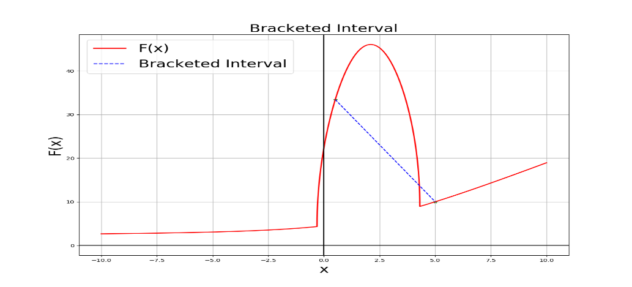

Objective function with minimum point.

Output: minimum = 4.3094 and F(xmin) = 8.9282

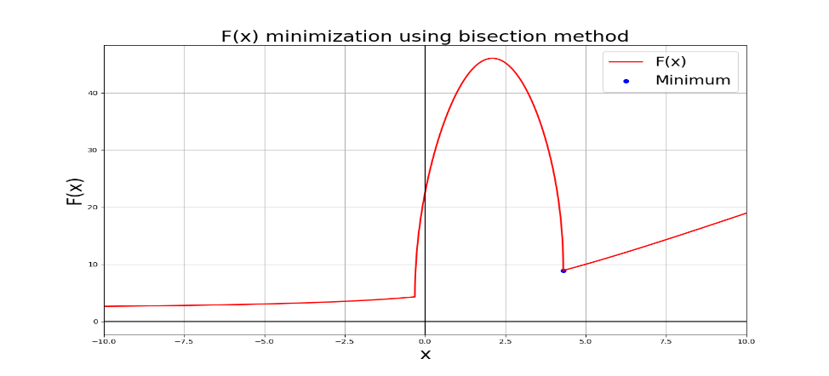

Optimal Path for Robot: The robot must travel until x = 4.3094 along x-axis to avoid the circle while reaching the point P.

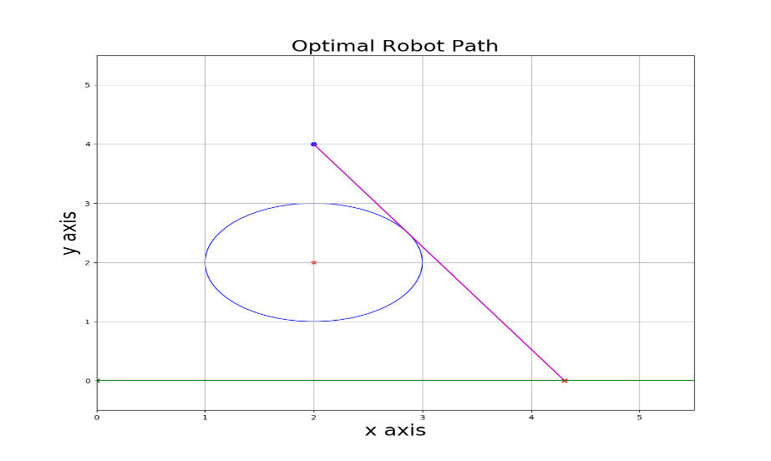

Interval containing the minimum. For initial guess value x0 = 3.0

Output: a = 4.27, b = 8.11

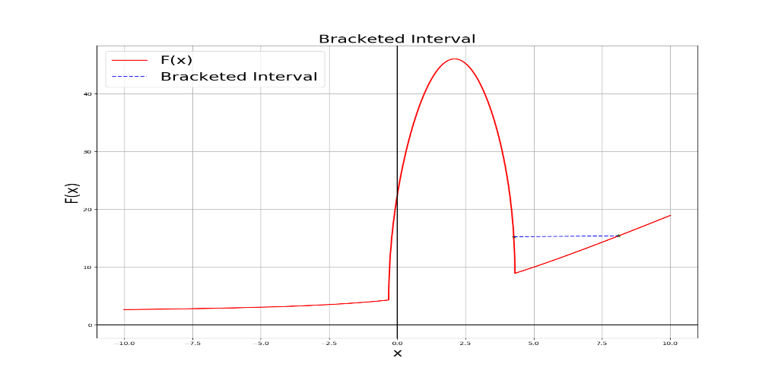

Objective function with minimum point.

Output: minimum = 4.3094 and F(xmin) = 8.9282

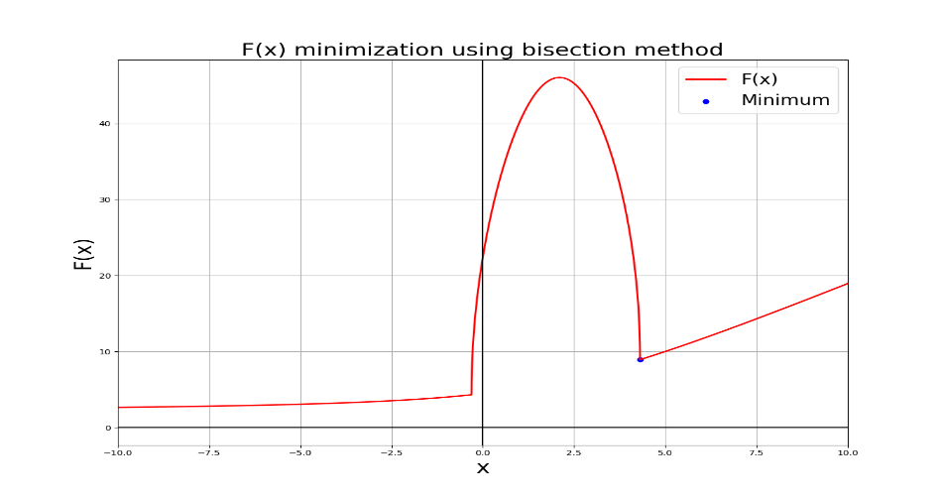

Optimal Path for Robot: The robot must travel until x = 4.3094 along x-axis to avoid the circle while reaching the point P.

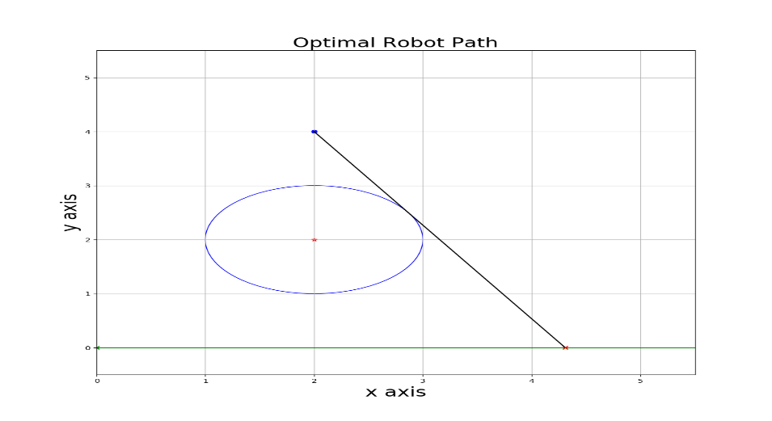

1. P = (2, 5), C = (2, 2), r = 1

Interval containing the minimum. For initial guess value x0 = 0.5

Output: a = 0.5, b = 5.0

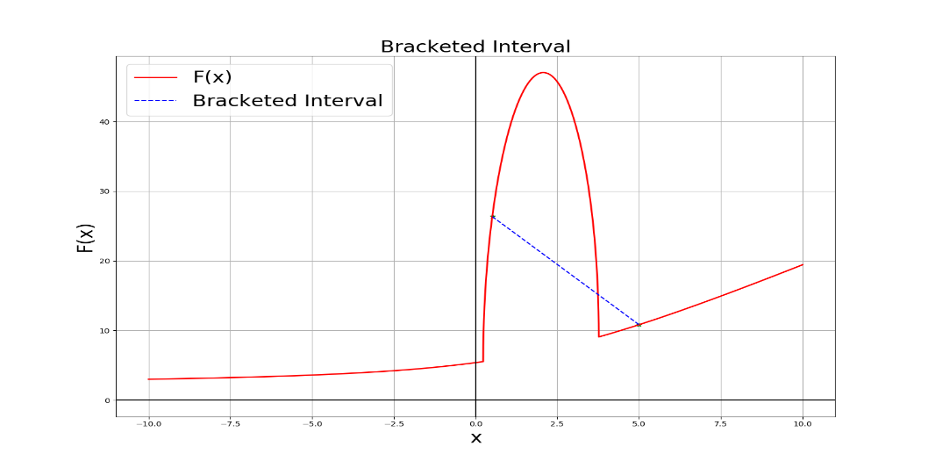

Objective function with minimum point.

Output: minimum = 3.7678 and F(xmin) = 9.0711

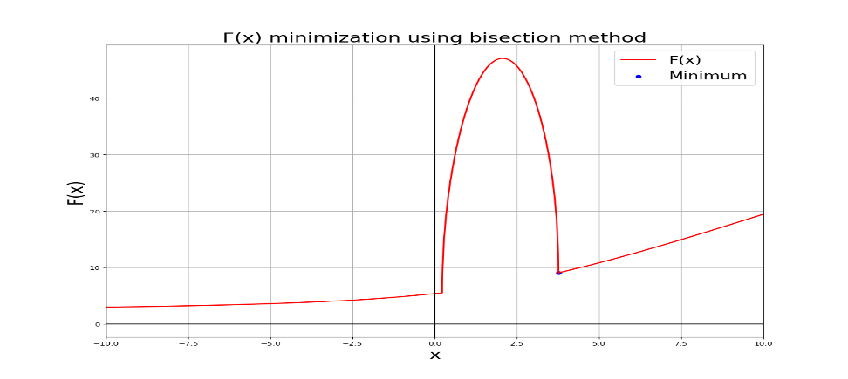

Optimal Path for Robot: The robot must travel until x = 3.7678 along x-axis to avoid the circle while reaching the point P.

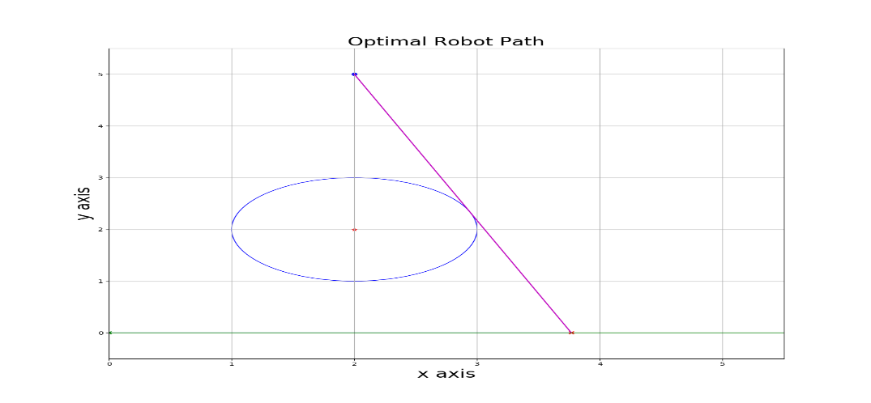

Interval containing the minimum. For initial guess value x0 = 3.0

Output: a = 3.63, b = 5.55

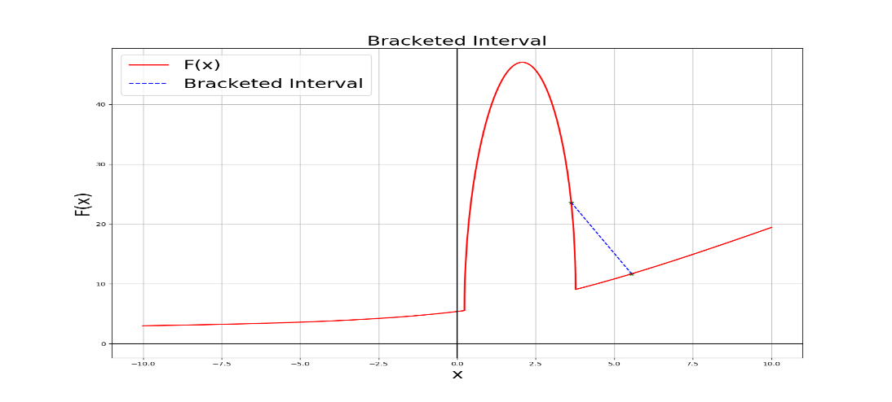

Objective function with minimum point.

Output: minimum = 3.7678 and F(xmin) = 9.0711

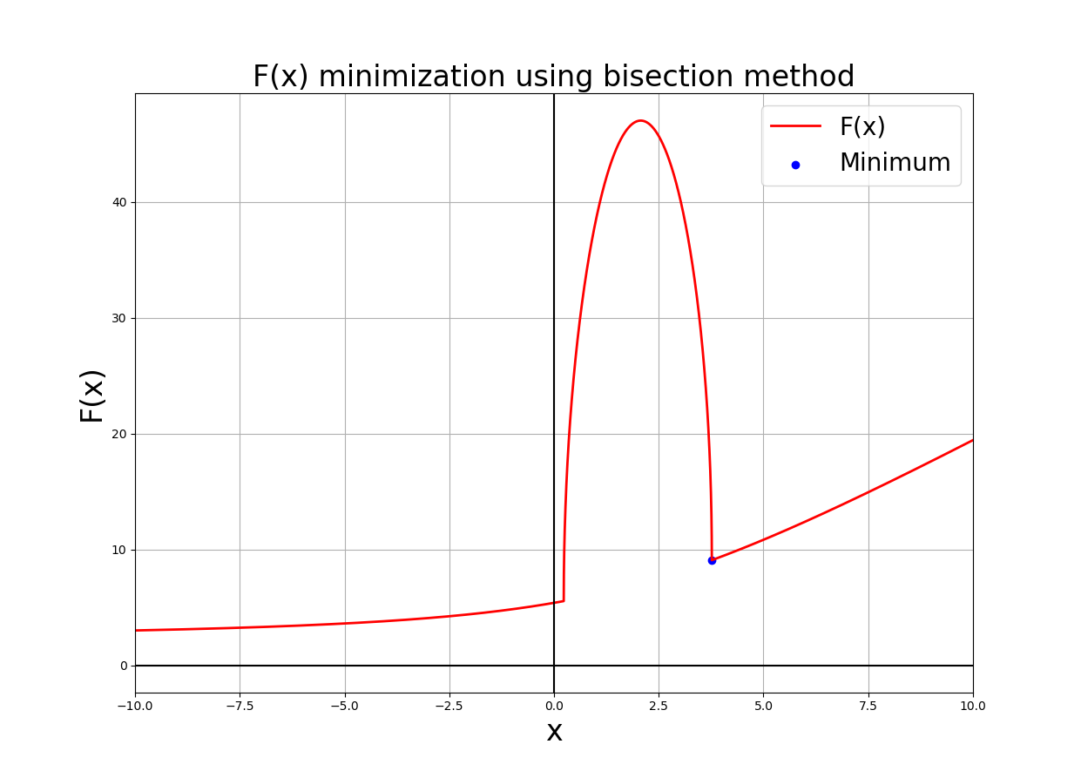

Optimal Path for Robot. The robot must travel until x = 3.7678 along x-axis to avoid the circle while reaching the point P.

