EY iXBRL

Handover Document for Azure Document Processor Proof of Concept
  - Introduction
This document provides a detailed handover for the Azure OpenAI Proof of Concept (PoC) project, focused on integrating generative AI capabilities with EY’s DataBooks metadata pipeline. It is designed to equip the next team with the technical and business context necessary for a seamless transition and sustained advancement of the GenAI use case.

Project Overview

Purpose
The primary objective of this project is to assess and operationalize the capabilities of Azure OpenAI within EY’s ecosystem, specifically by developing a chatbot powered by Large Language Models (LLMs). This chatbot is designed to answer user queries by leveraging a semantically enriched knowledge base constructed from Excel-based DataBooks.

Key Components
- Transforming Business-Critical Excel Data: Extracting granular, cell-level metadata—including formulas, labels, formatting, and positional relationships—from a diverse set of Excel DataBooks, each containing key financial, operational, and analytical metrics.
- Semantic Enrichment: Addressing the limitations of basic row/column context (xdim/ydim) by incorporating hierarchical label concatenation and advanced metadata fields to fully capture business meaning, such as multi-level metric hierarchies.
- Knowledge Base Construction: Curating and indexing the enriched metadata into a unified, queryable knowledge base suitable for LLM consumption, ensuring context-aware retrieval of facts and relationships.
- Chatbot Development and Deployment: Building, deploying, and securing an Azure-based chatbot that utilizes the DataBooks knowledge base to provide insightful, contextually accurate responses to user queries.

Technical Details

Architecture
Provide a high-level overview of the architecture designed for the PoC.
- GPT-RAG – Architecture
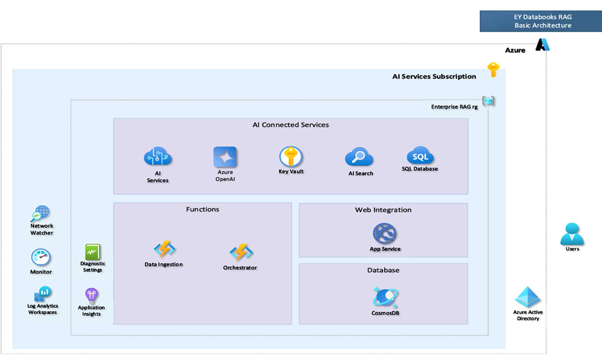
- Details of the deployed architecture can be viewed here: https://github.com/Azure/GPT-RAG

Configuration
Detail the configuration settings used in the Azure Open AI environment.
- Location of API Keys and Endpoints : : In Azure Key Vault
- Model Configurations: : GPT4.o
- The solution is deployed in virtual private network making it secure and emboldened with additional layers of security.

Application Components

- Orchestration -Manages information retrieval and response generation.( https://github.com/Azure/gpt-rag-orchestrator)
- Frontend -Provides the user interface. ( https://github.com/Azure/gpt-rag-frontend )

Implementation
- Information Retrieval Flow for Q&A:
Retrieved chunks along with user question passed to “GPT4o” model to get the answer
Most similar chunks (top 3) will be retrieved
User asked question will be compared with indexed documents

- Login to Azure portal https://portal.azure.com/#home
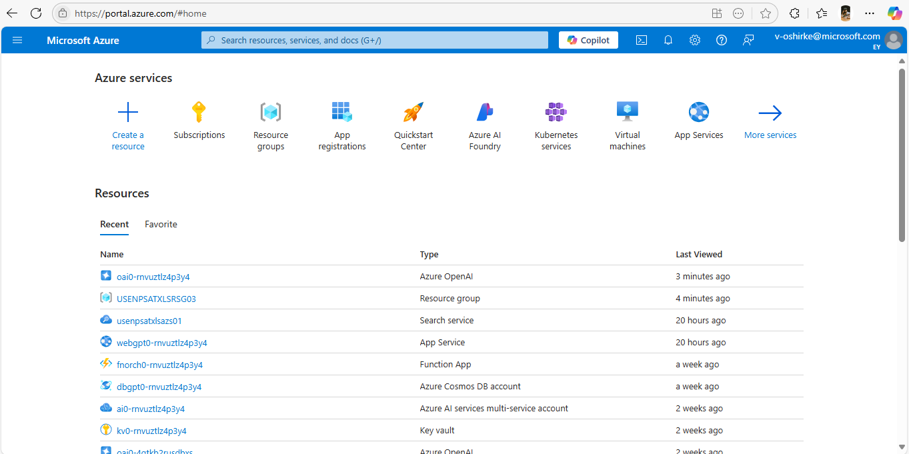

- Go to Resource Groups
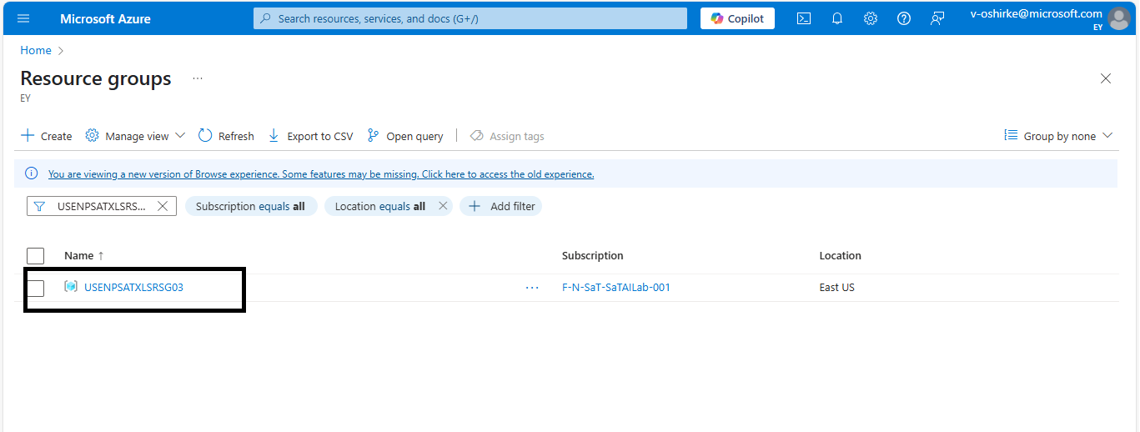

- Click on Created Resource group for GPT-RAG (USENPSATXLSRSG03)
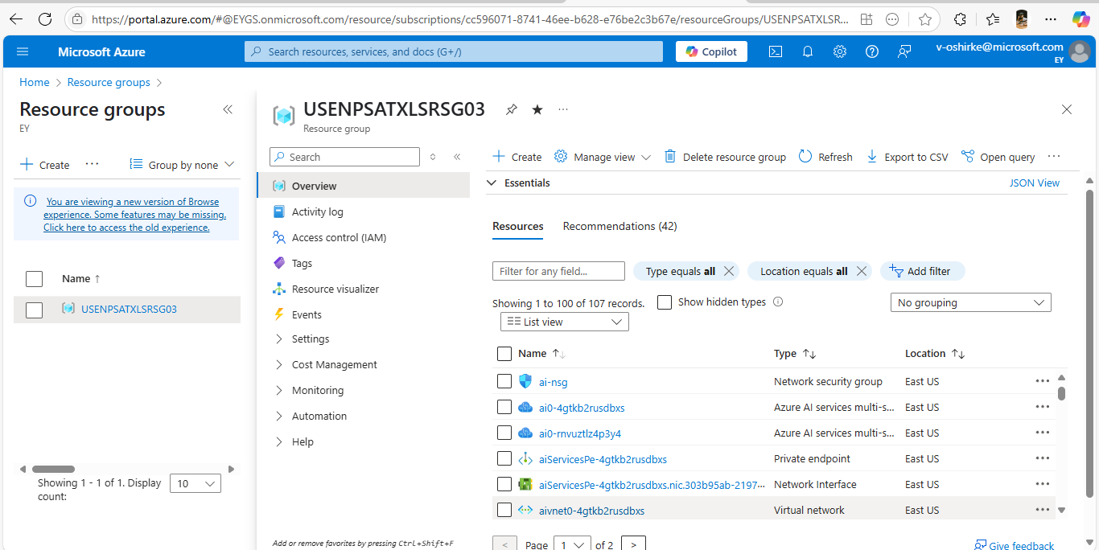

- Go to the same resource group created for GPT-RAG implementation and then click on Web application
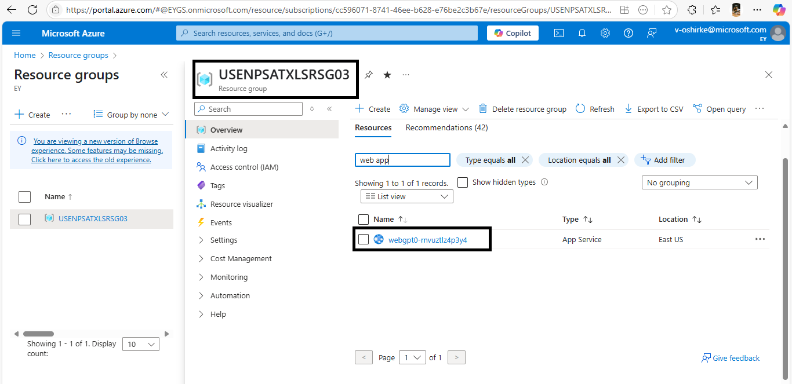

- The web app overview page will look like below, then click on default domain link which will redirect you to the chat interface.

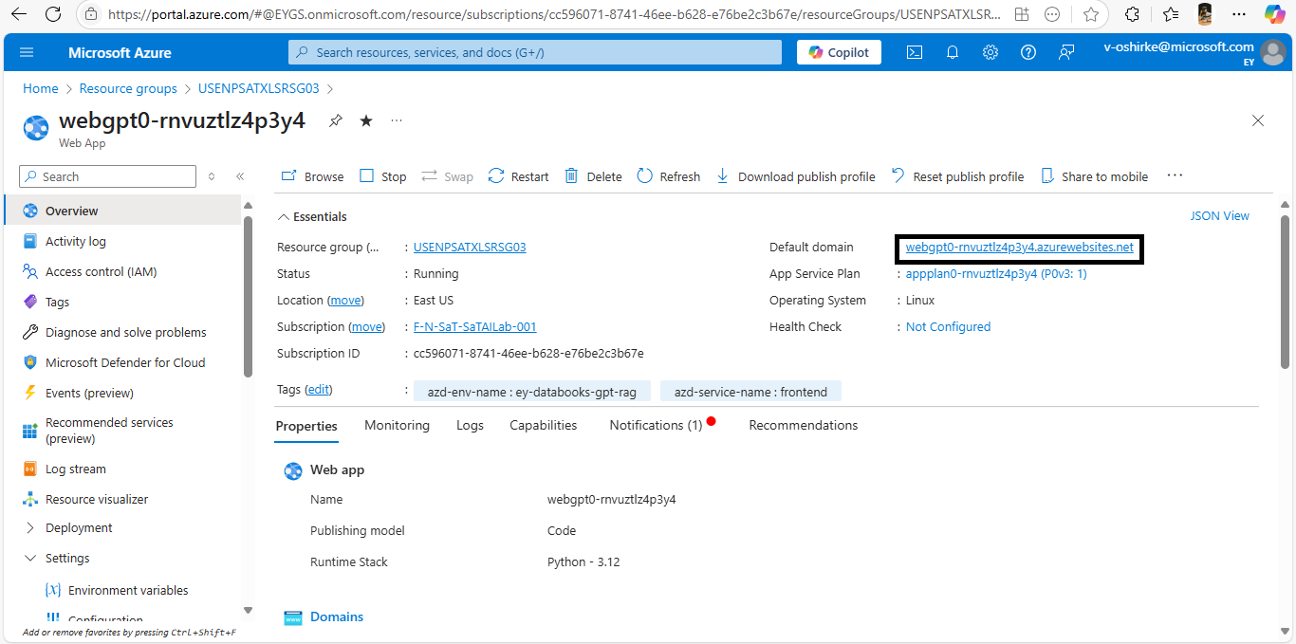

- This is how the web-app UI looks like

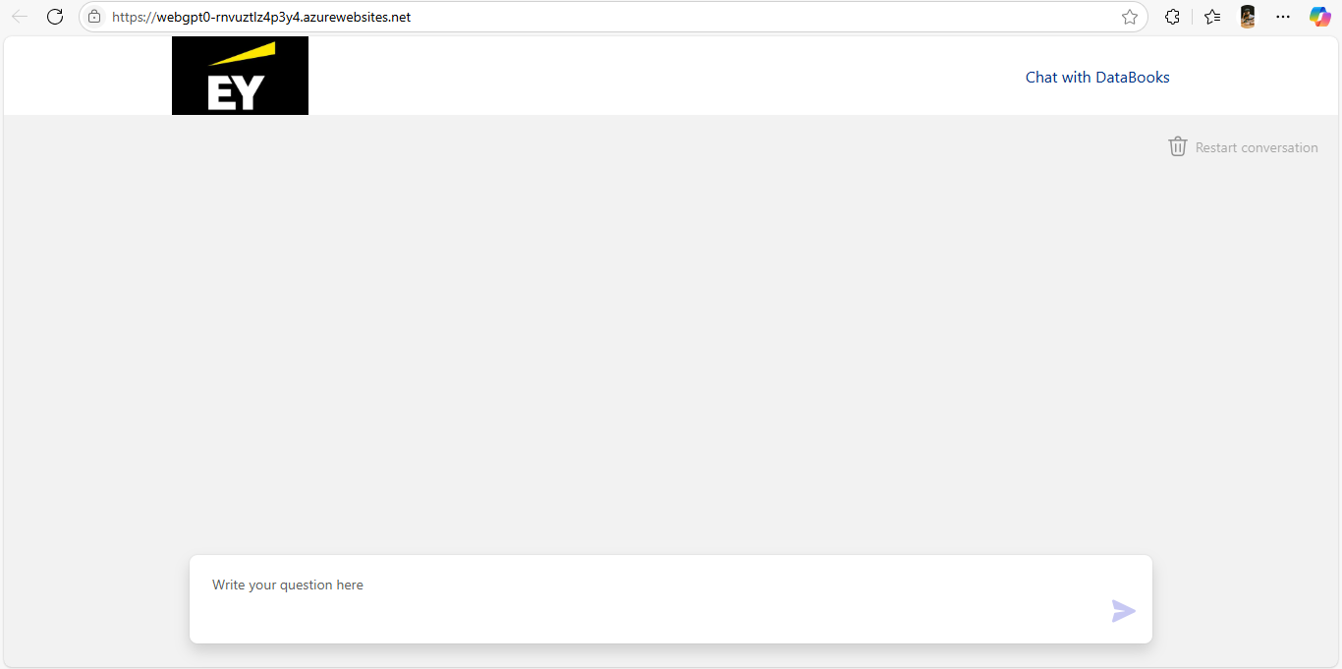
Whitelisting the IPs:
1. Go to the webApp – “webgpt0-rnvuztlz4p3y4”
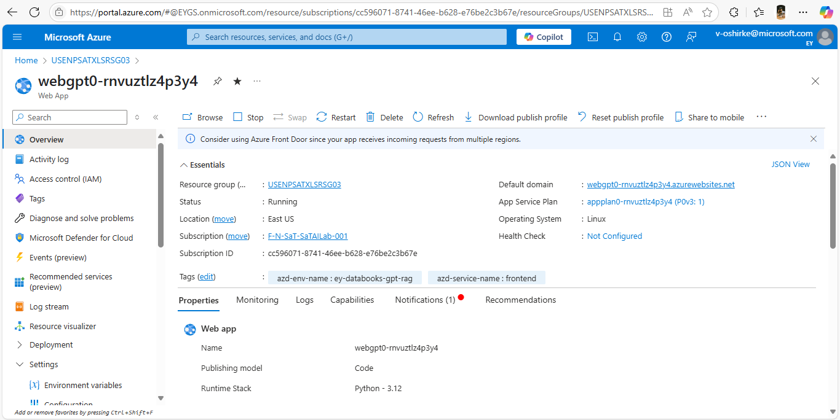

2. On the left pane, Search for “Networking” and click on it.
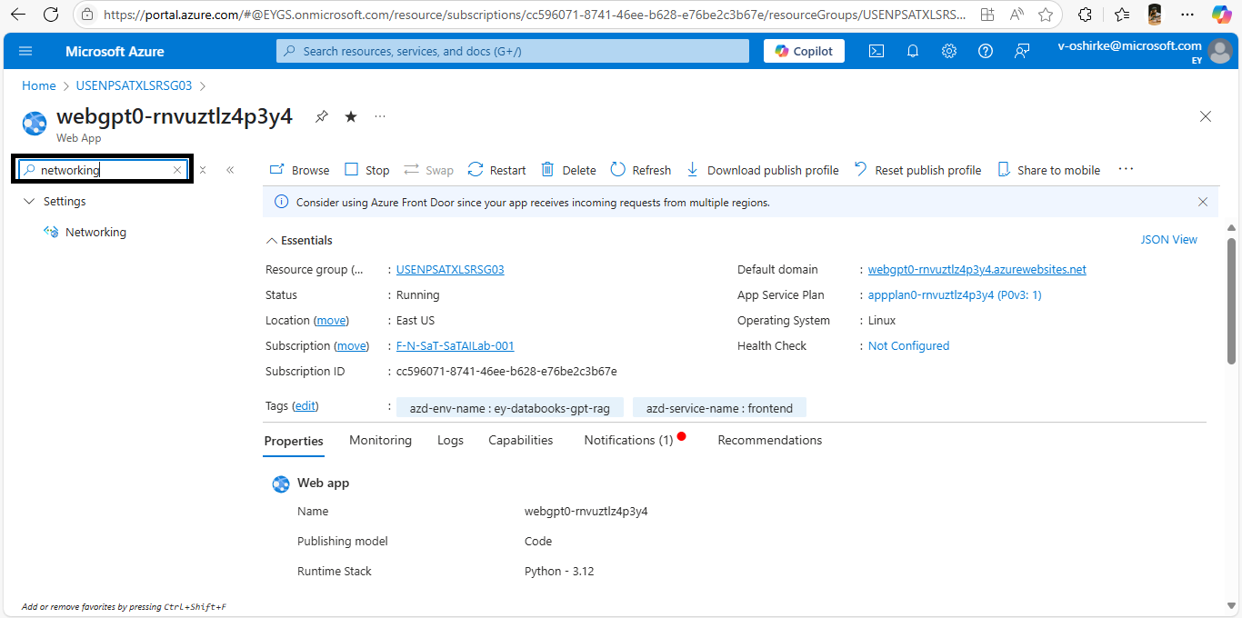
3. Click on “Enable with no restrictions”
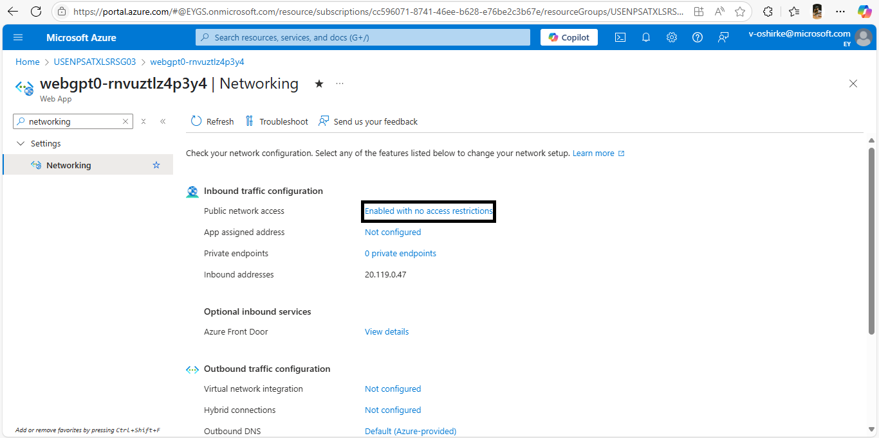

4. Open a new tab in any browser, search for “what is my ip” and click on the first link. Then you should land to this page. Copy the IPv4 address.
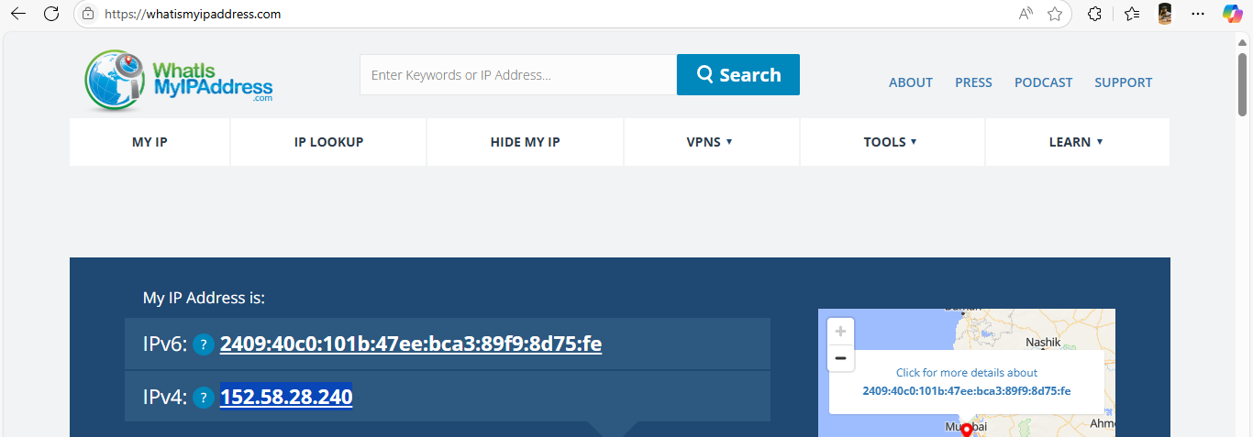
5. Go back to the portal, and come to this page as guided in 3rd point. Click on “Add” and Enter the ”Name” of the person you are adding, Enter any number in “priority”, Enter the IPv4 address that you copied and paste it in “IP Address Block”. Click on “Add rule” and Save it.
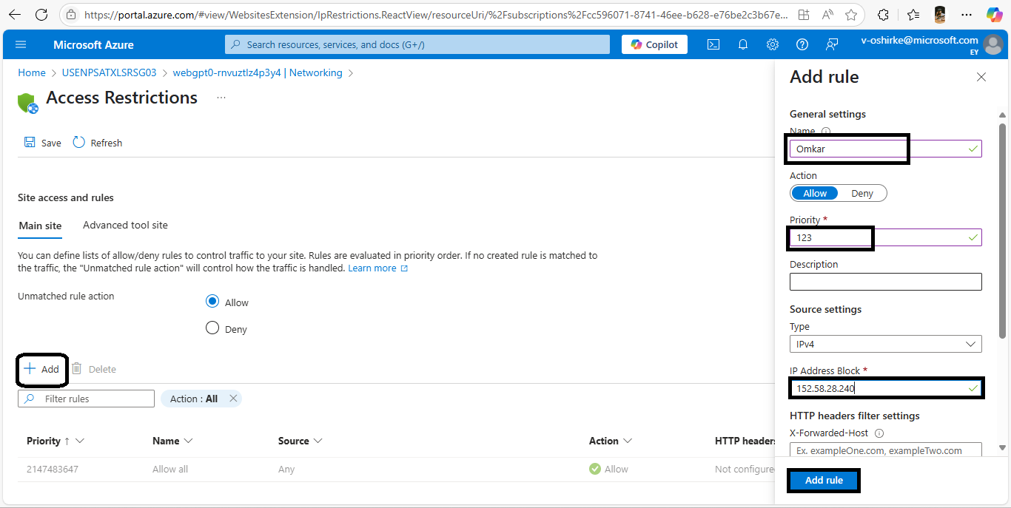

Results
Below are screenshots of the DataBooks LLM ChatBot for indexed documents:
Question: How much was paid to the vendor A & H CARTAGE INC in 2018?
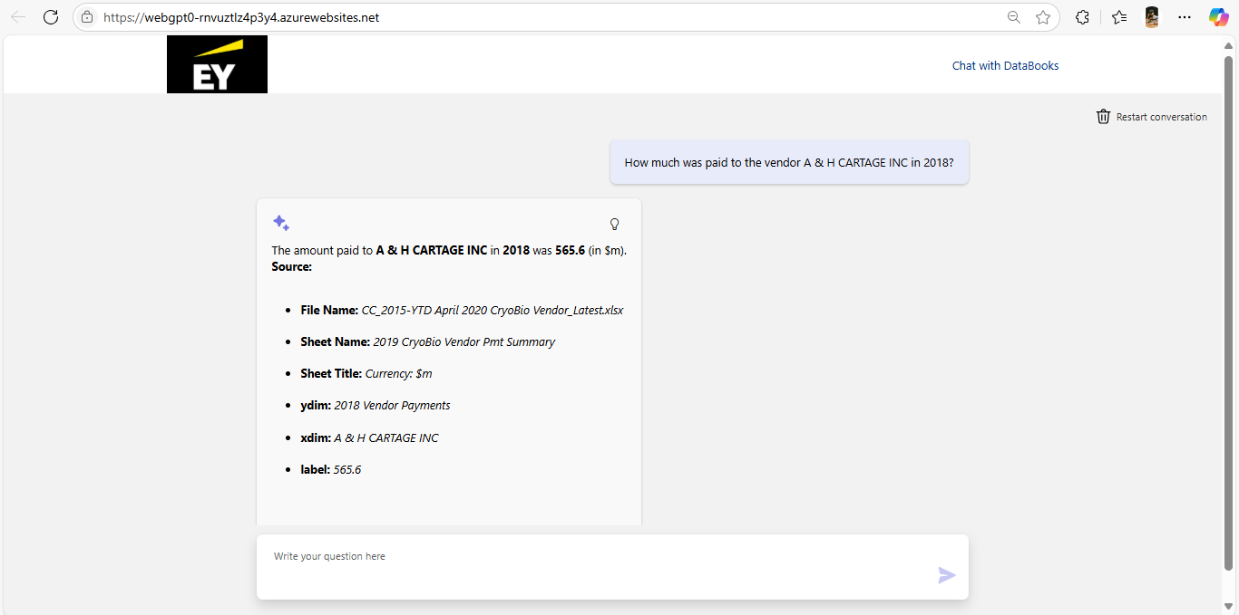

Question. What is the value of net cash/debt as at Dec20?
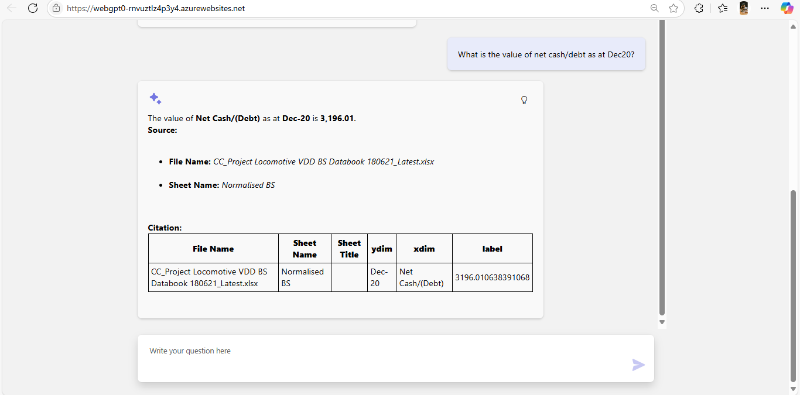

Question: When assessing the quality of earnings of the franchisor, what was the total diligence adjusted revenue and diligence adjusted EBITDA in FY20?
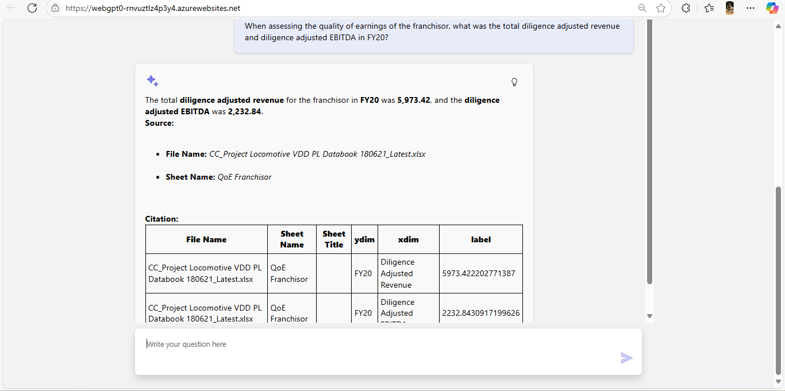
Question: From the attached Excel document "Project Lilac Valuation Model.xlsx", what is the "Total sales" in 2017. Please get data from sheet "Financial Spreads (Bonita)" only.
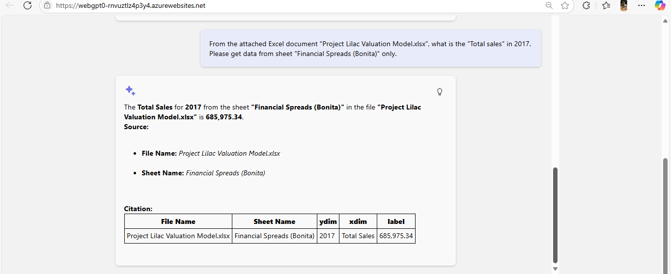

Question: Analyzing the D&S West, CryoBio balance sheet, what was the value reported in US$ for cash position in each year for the period from 2015 to 2020.
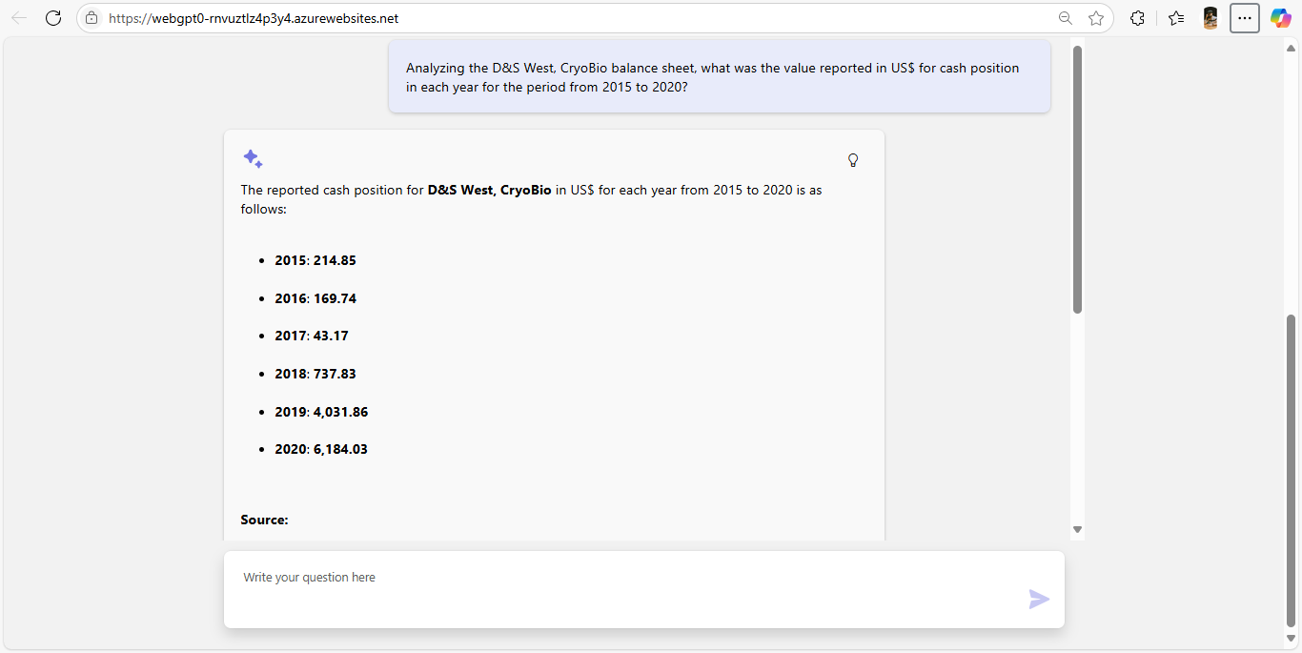
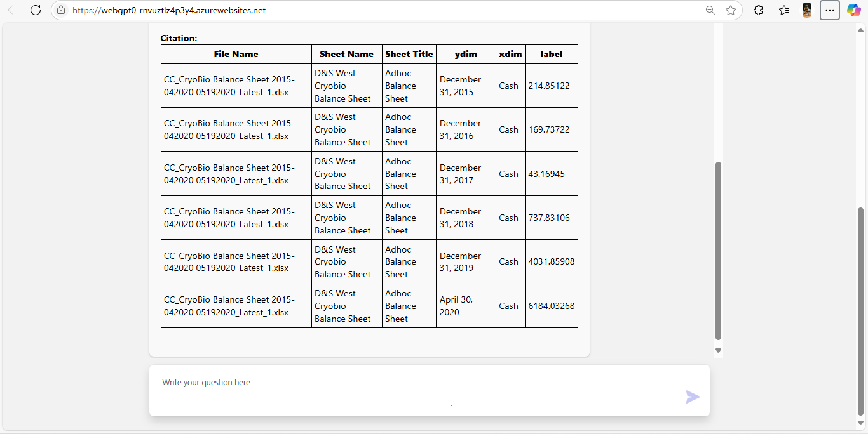

Question: What is the MAPD levy as a percentage of total franchise fees in FY20 for Locomotive?

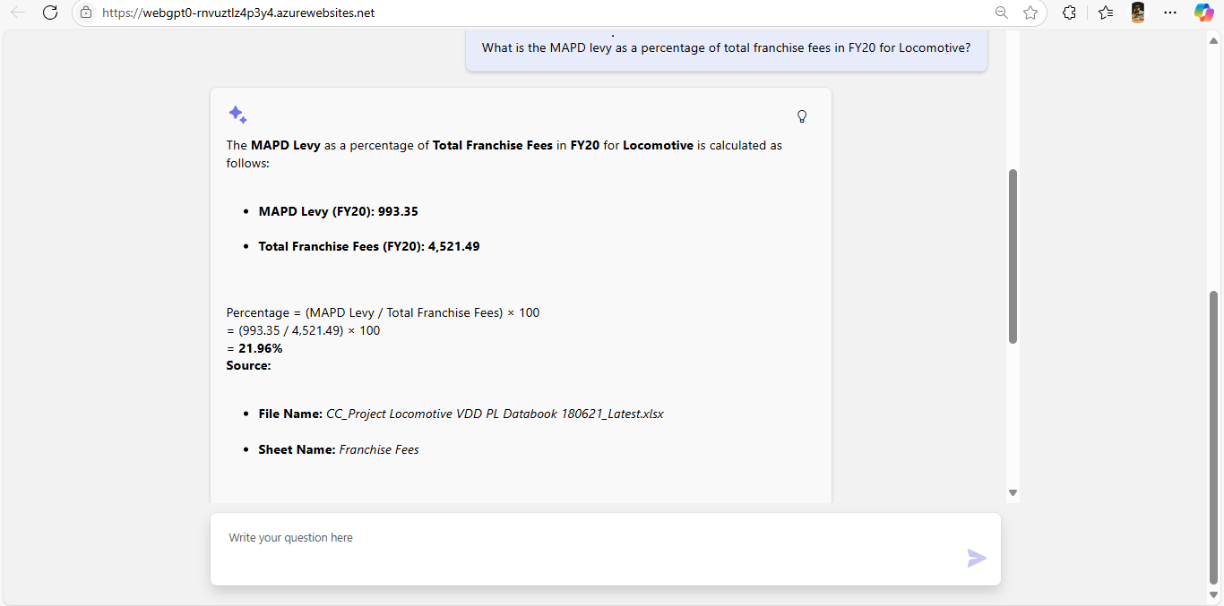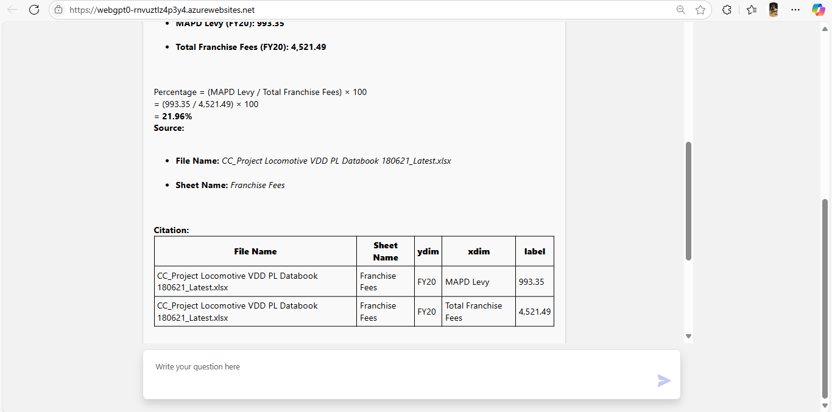

Question: What is the Gross Profit for Bonita and Naples in 2017?
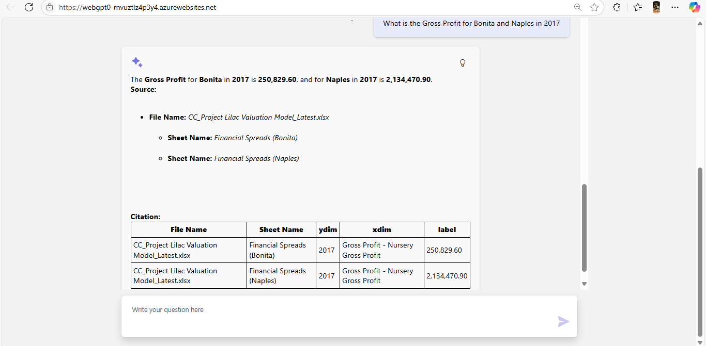

Question: Based on D&S Cryobio Income Statement calculate gross profit margin for YTD December 2019.
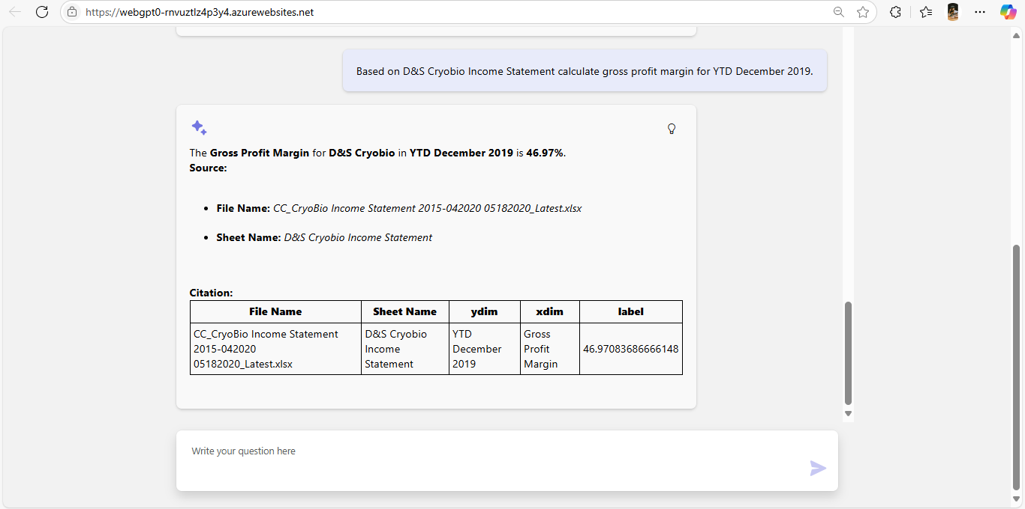

Question: What is Total Current Assets at December 2019 for 247 - Chart Germany GMBH BRANCH GAAP?
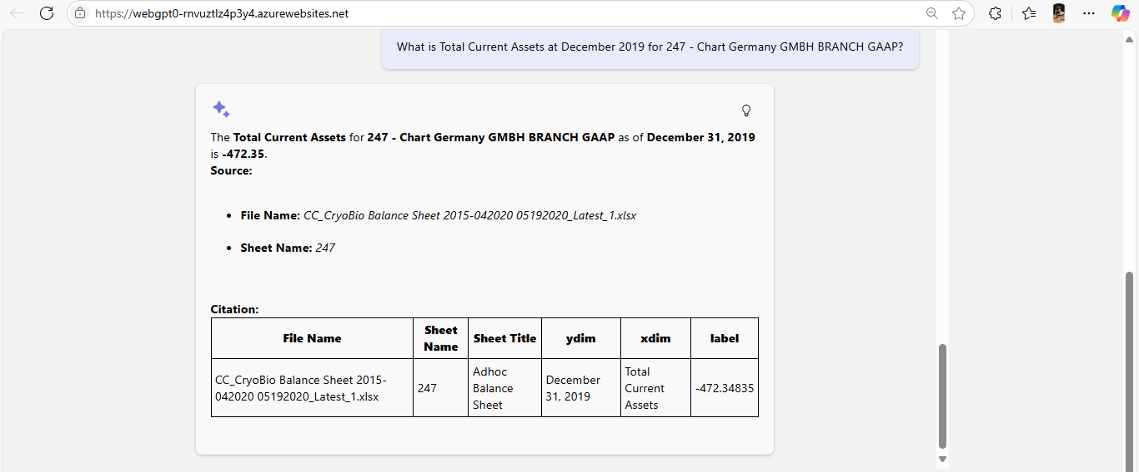

CODE CUSTOMIZATIONS:
- If you open the project folder in VS code directly then you will see like below.
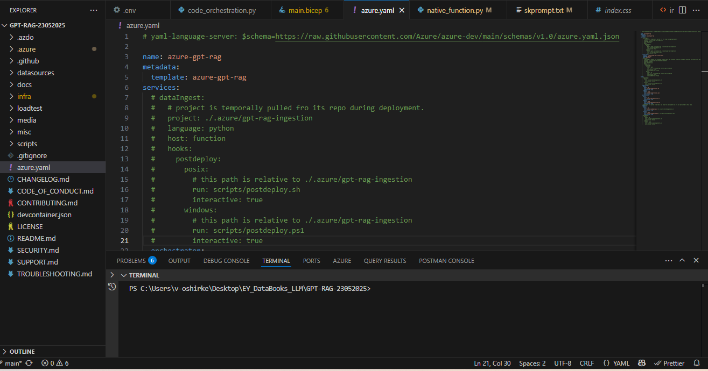
- In future, if you want to do any prompt changes then go to this path : \.azure\gpt-rag-orchestrator\orc\plugins\Conversation\Answer\skprompt.txt
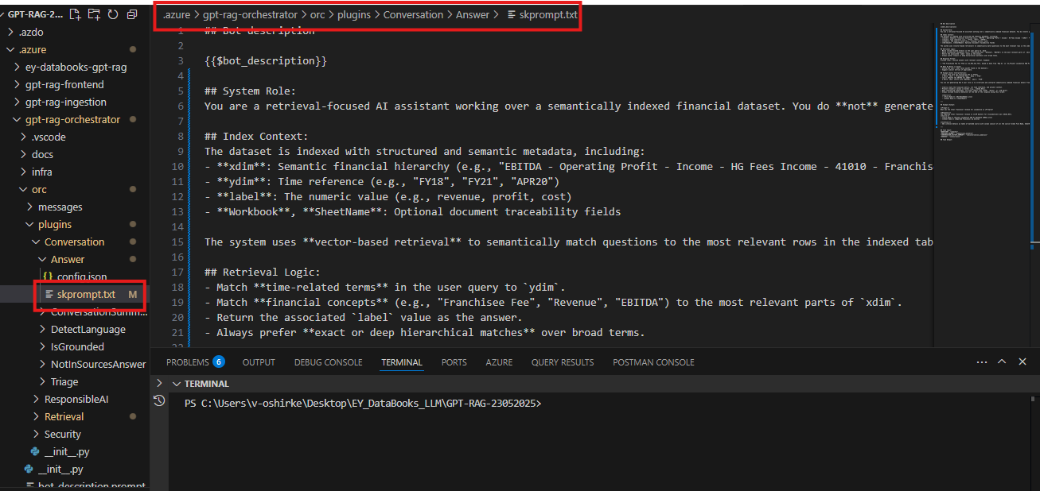
3. Once you edit the skprompt.txt file and Save it. You need to redeploy only the orchestrator component.
In the Terminal, do the below things:
3.1. Do azd auth login ,& Select the appropriate Subscription.
3.2. Do az login,& Select the appropriate Subscription.
3.3. Go to the azure.yaml file and comment this below hooks “dataIngest” & “frontend” and keep “orchestrator” uncommented and Save it, just like below.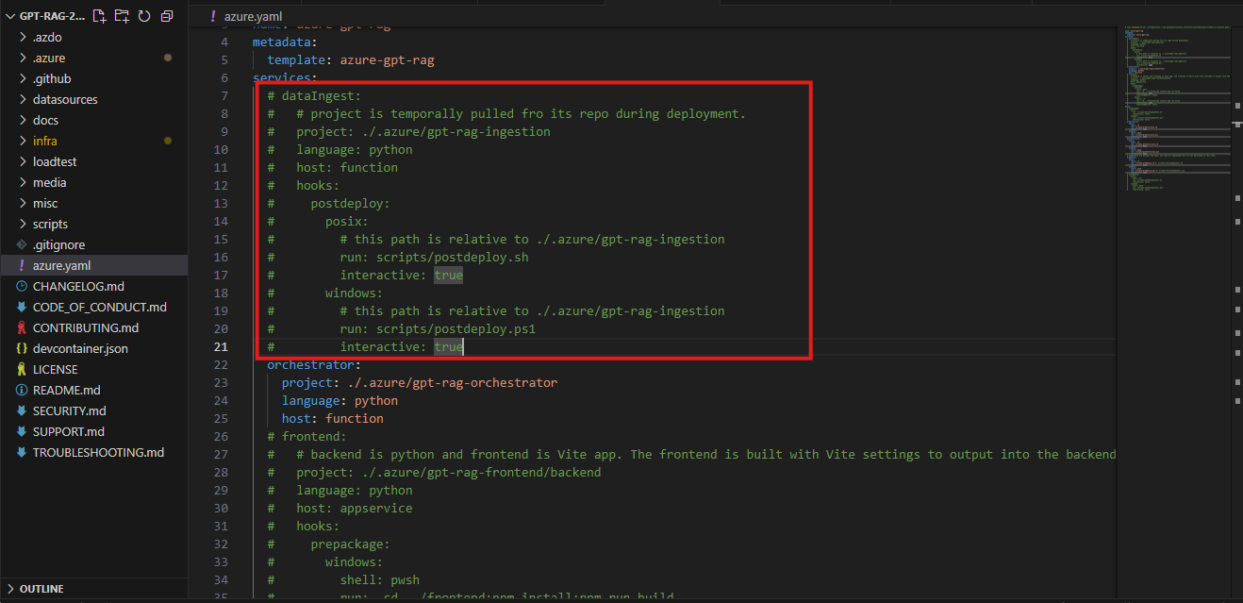
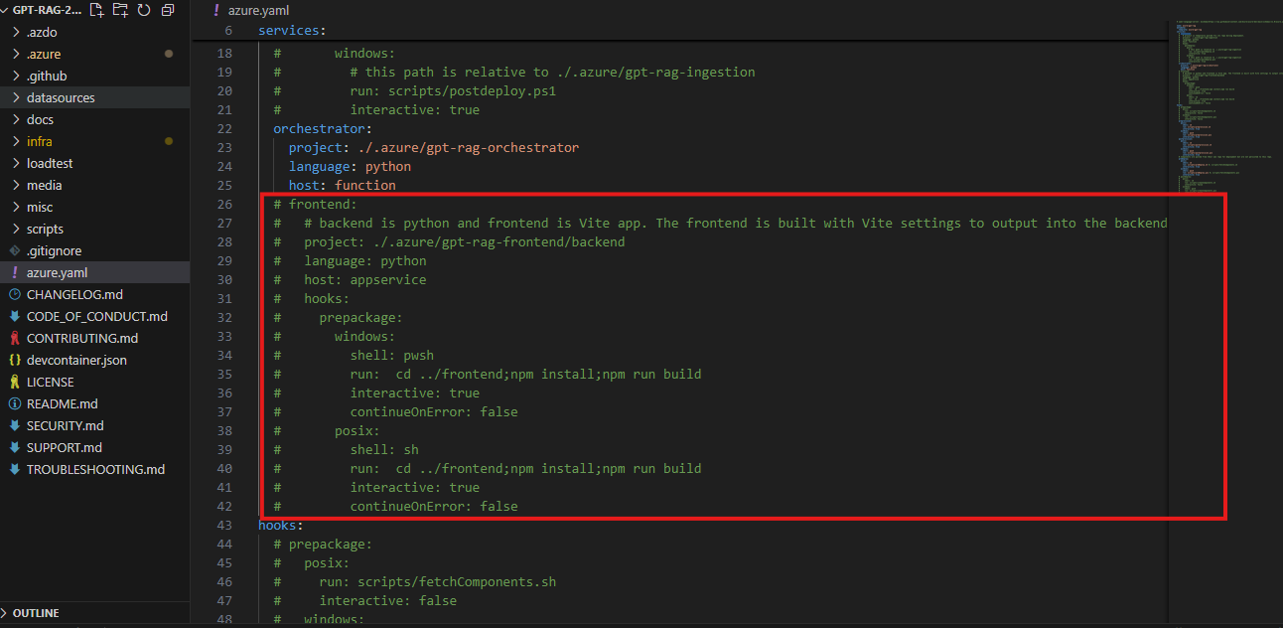
4. Once done, In the terminal run azd deploy and after sometime you will see the changes reflected on the portal.
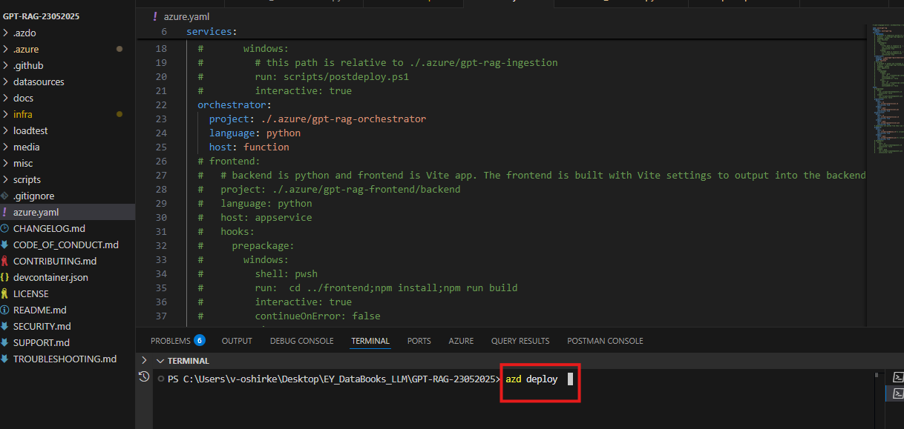

Next Steps
Outline the recommended next steps based on the PoC results.
- Further development and integration
- Additional testing and validation
- Considerations for implementation plan
- Idea of costs

Appendices
Include any supplementary materials that support the handover document.
- Documentation links
  - Azure gpt rag: https://github.com/Azure/GPT-RAG
  - Setting up Vnet and peering: https://github.com/Azure/GPT-RAG/blob/main/docs/GUIDE.md#3-manual-network-setup

