**Title - 5-202382930592_Fail to log in MSC CRM:023809224**

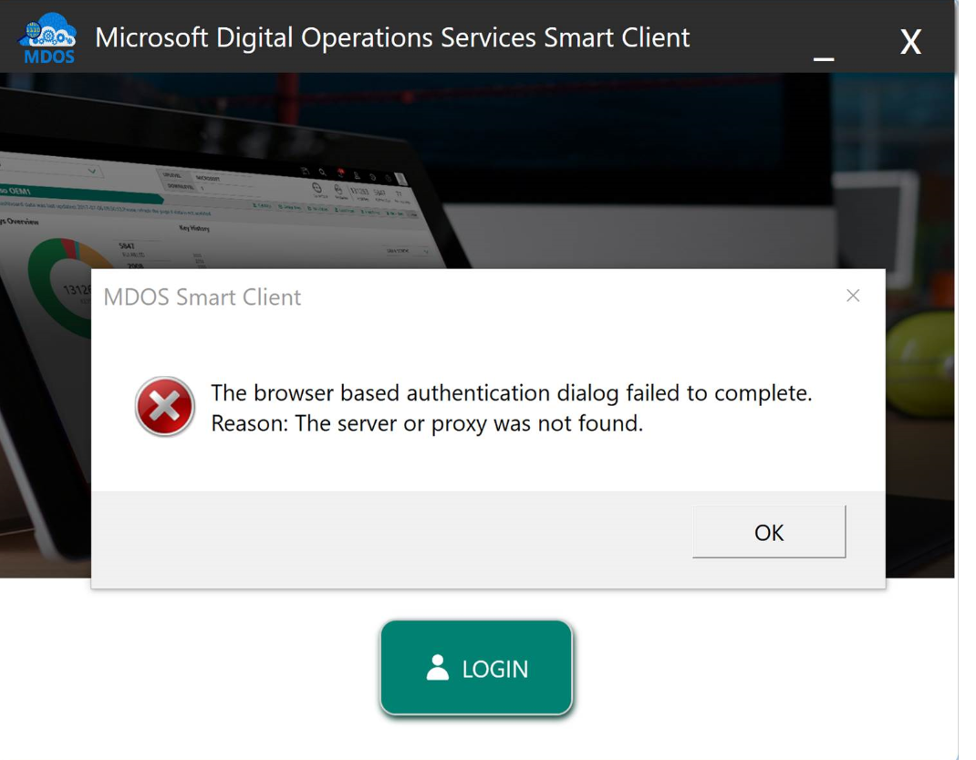

**Description**: MSX Login Issue

**Solution**:

1. Took the call with partner , to check the issue.
2. Asked to connect with their IT/CIS team to configure IE browser settings to login using MSD account.
3. Also asked to reboot the device .

Resolved.

**Scenario 2:**

**Issue**: User is unbale to login to MSX.

**Description**: After entering the MSX account login id the screen freezes

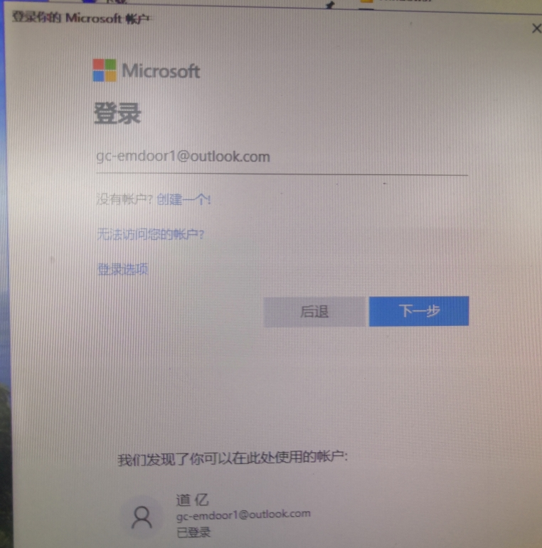

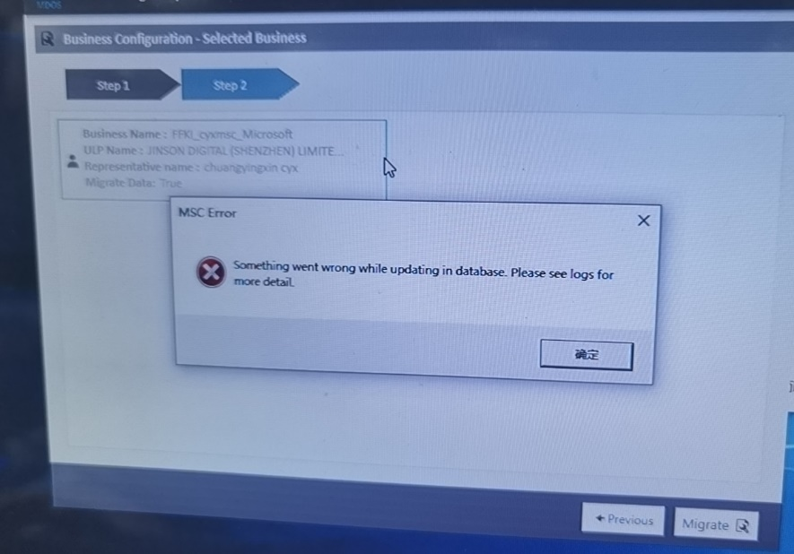

**Solution**:

* Checked logs and found ‘User canceled authentication’ error
* Had a screenshare with the user and checked MDF LDF files, they are present.
* Checked for services, working fine
* Checked the version of MSC, partner is using old version. Requested to install the latest version
* Partner installed the latest version 2.1.1.2 still the issue is persisting.
* Send to Customer mastering team to check further. Below is the reply from them and the issue is resolved

‘We are facing some issue in prod AAD, on further investigation we found that, AAD is throwing some validation exception while partner trying to configure new business in MSC and hence business configuration is failing. We have raise an AAD support ticket’

**Route Cause:**

AAD team has added a validation which says while creating AAD application, we cannot use Microsoft.com domain. They had pushed these changes on 15th Sep to AAD Production which broke MSC business setup process.

During MSC business setup process, MSC APIs connects to MDOS Cloud and registers new AAD application in our custom active directory for the selected business, since the application registration was failing MSC users was not able to complete setup. **AAD team had done these changes without prior any intimation**.

AAD changes and deployment are out of our scope, hence we cannot assure you that this will not occur in future. Also to prevent this we need some code changes and we have a huge impact on entire system, especially on MSC factory floors, hence we cannot directly provide assurance of fix right away, but on the other note we can say since AAD team has whitelisted our active directories we are good to go. We need to do further analysis to come up with the solution to prevent this issue in future.

**Reference Numbers:** ICM 12339342094, ICM 2329489