**Title: 5-34236635_RE: MDOS Ordering Issue CRM:47675674**

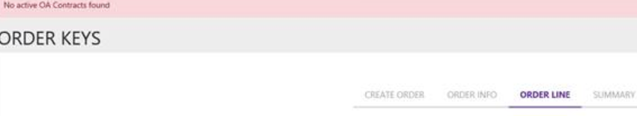

**Description:**   
Partner is unable to order the SKU & fulfill the order in MDOS, hence, they ordered through DOC but still can't fulfill in MDOS.  
  
**Solution:**

1) Partner is getting “No active OA contracts found” while placing key order from MDOS. Please refer the attached screenshot for reference.

By looking into the error message, it seems the exception is coming from OA.