REPORT AND DATA AUDIT
- Problem Formulation and Modelling Technique
Public fear that AI will replace workers has led governments and businesses to use occupation-level “AI exposure” scores to predict job losses. However, previous research used employment and wage data, which may miss people losing their jobs, and these scores have rarely been compared to what actually happens to workers. According to Frank, Ahn and Moro [1], this is because unemployment statistics by occupation, location, and time were not available. They fixed this by collecting monthly counts of Unemployment Insurance (UI) claimants by two-digit Standard Occupational Classification (SOC) group from every US state’s UI office from 2010 to 2020. They first created a measure of unemployment risk for each occupation and then showed that standard figures such as state unemployment rates are poor alternatives for it. Their main goal is to check which existing AI exposure scores, either alone or combined, predict the likelihood of unemployment, job separation and skill changes, and whether the best predicting scores change between states and industries.
The unemployment risk is the target variable, and it is calculated as the number of claimants divided by the sum of claimants and employed workers, for each occupation, state and month. The model predicts the base-10 logarithm of unemployment risk. Employment data is obtained from Bureau of Labor Statistics OEWS estimates. Twelve published, standardised AI exposure scores are used as inputs, and LASSO regression reduces the weight of less useful scores towards zero. The authors compared three models: the baseline with O*NET skills, education and year, month, and state effects (R² = 57.4%), the exposure scores alone (R² = 29.8%, as opposed to 10.7% for the best single score), and the baseline plus exposure scores (R² = 75.5%). The study is not causal but rather predictive, and ten iterations of 10-fold cross-validation are used to check the performance.
- Hands-on Data Audit and Preliminary EDA
Both data files were downloaded from the authors’ GitHub repo [2] and audited in Python using Google Colab. The unemployment file has 140,274 rows covering 50 states, 22 occupational groups and every month from 2010 to 2020. This matches the number of observations reported in the paper [1]. Although the paper claims that most of its research only uses 2010-2019 to exclude the COVID-19 recession, this total includes 2020. The period 2010-2019 has 127,452 rows, so it is unclear which sample is used.
There are no blank values or zero counts in the files, which is unlikely for small occupations in small states and suggests that empty rows were removed instead of being recorded as zero. 4,926 of the 145,200 rows expected in a complete dataset are missing and they are concentrated in a few states (Fig. 1). Connecticut drops from 144 rows in 2010 to 48 in 2019, California only has five of the 22 occupation groups, and Rhode Island has no data for 2014. The unemployment risk in 26 rows is greater than 1, which is not feasible for a probability. All of them are farming occupations in Alaska and Rhode Island.
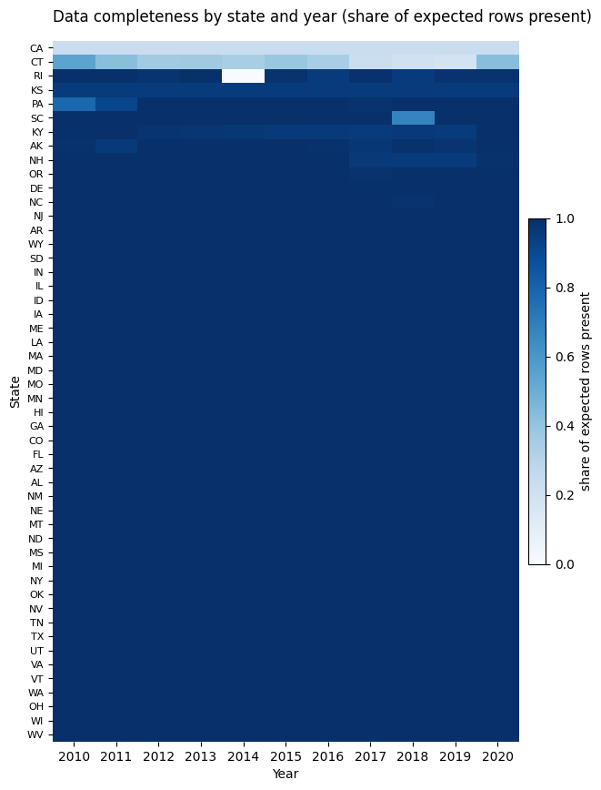
Figure 1: Share of Expected state x month x occupation rows present per state and year.
Working backwards from the paper’s formula implies about 34.3 million employed workers in Alabama in January 2015, which is 15.8 times the state’s actual labour force [3]. The authors also outline an alternative Bayesian approach that may explain this, but the main target variable cannot be recreated from the released data as no employment data or code is supplied.
The exposure file only includes 11 of the paper’s 12 scores, with Eloundou et al.’s [4] score missing. Connecticut and California scores look unreliable. The COVID-19 jump in 2020 is significantly more than any previous change (Fig. 2). LASSO’s decision may be unstable because some exposure scores are almost identical (Fig. 3).
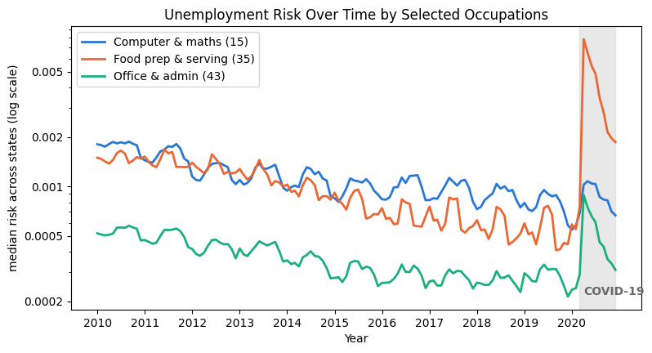
Figure 2: Median unemployment risk across states for three occupation groups
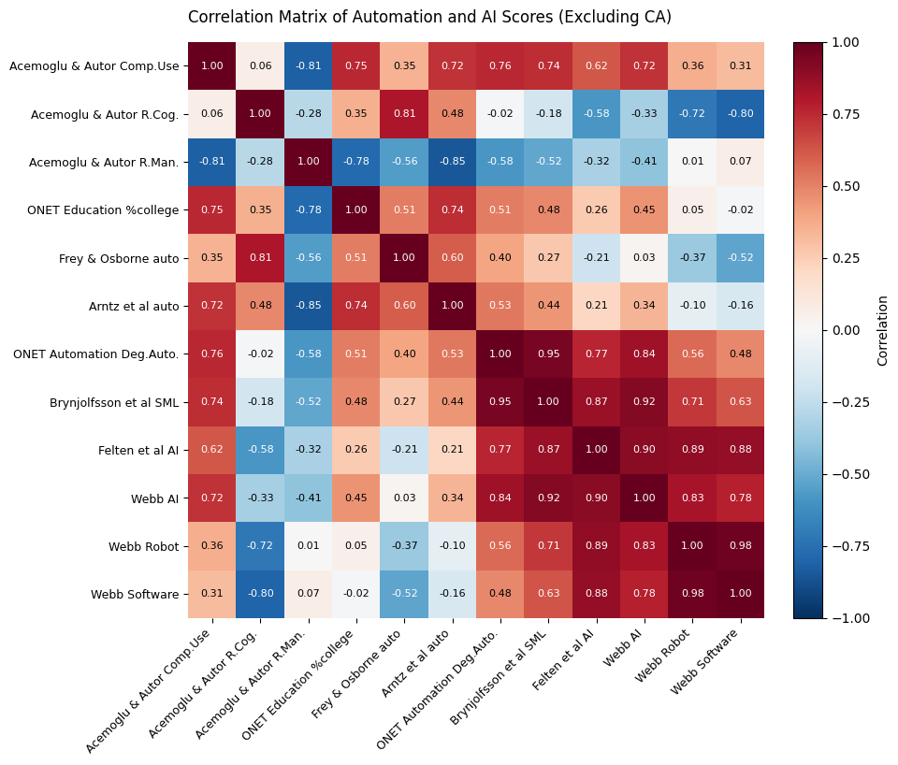
Figure 3: Correlation between state-level exposure scores (excluding California).
- Critical Analysis and Reflections
The use of wide occupation groupings and lack of causality are already noted in the paper [1], but there are several flaws across the data science lifecycle. At the data collection stage, UI claims only include the people who are eligible and choose to apply. Self-employed and gig workers, people who quit and non-claimants are invisible, and because the eligibility requirements vary by state, unemployment risk partly measures access to benefits rather than job loss. The audit notes that missing rows are concentrated in a few states, so the state comparisons are based on incomplete data. Although most of the exposure scores describe earlier automation and Eloundou et al.’s LLM score describes tools that were non-existent for most of that time, the exposure scores are applied backwards to 2010-2019 at the modelling stage. This is a type of temporal drift: rather than looking at how present AI impacts employment, the study tests whether old measures of exposure match past unemployment. The 18-point improvement from the ensemble may be due to general differences amongst occupations rather than AI specifically because several scores are almost identical. The abstract also concludes that the findings suggest “automation shapes US unemployment”, which goes beyond what the predictive analysis supports and reads as causative. These claims are difficult to independently verify because the target variable cannot be recreated from the released data.
The study’s main contribution is the new dataset combining monthly UI claims by occupation from every state. Instead of creating another score, using it to test existing exposure scores against real outcomes is also a useful contribution. Showing an ensemble performing better than any single score is practically useful.
Although there is low risk to an individual’s privacy because the data is aggregated, some cells include a single claimant, which might make people in small states and occupations traceable if paired with other data. The data was collected for benefit systems, not for research. How these results are used carries a greater risk. Exposure scores may be used by governments to decide where to allocate funds for retraining, so unreliable scores could send funds to the wrong places and labelling occupations or locations “at risk” may negatively impact workers. These risks would increase if the results were read as causal.
References
[1] M. R. Frank, Y.-Y. Ahn, and E. Moro, “AI exposure predicts unemployment risk: A new approach to technology-driven job loss,” PNAS Nexus, vol. 4, no. 4, Art. no. pgaf107, Apr. 2025, doi: 10.1093/pnasnexus/pgaf107.
[2] M. R. Frank, “unemploymentRisk,” GitHub repository. [Online]. Available: https://github.com/mrfrank8176/unemploymentRisk (accessed Oct. 25, 2026).
[3] U.S. Bureau of Labor Statistics, “Civilian Labor Force in Alabama [LAUST010000000000006A],” retrieved from FRED, Federal Reserve Bank of St. Louis. [Online]. Available: https://fred.stlouisfed.org/data/LAUST010000000000006A (accessed Oct. 23, 2026).
[4] T. Eloundou, S. Manning, P. Mishkin, and D. Rock, “GPTs are GPTs: Labor market impact potential of LLMs,” Science, vol. 384, no. 6702, pp. 1306–1308, Jun. 2024, doi: 10.1126/science.adj0998.

