CSCU9M6 REPORT

INTRODUCTION
For the community of people with hearing impairments, sign language is the main form of communication. However, the communication gap between the sign language users and non-signers continues to be a major obstacle in daily life. The automated sign language system aims to close this gap by using machine learning to read hand gestures in real time and enables more inclusive human-computer interaction.
The sign language MNIST dataset is used which includes 27,455 training images and 7,172 test images of American Sign Language (ASL) hand gestures representing 24 letters of the alphabet (A-Y excluding J and Z which require motion). Each grey scale image is 28 by 28 pixels.
The main goal of this assignment is to design, implement and assess the two Convolutional Neural Network (CNN) models for the classifications of the ASL hand gestures. After building and training a baseline CNN, an improved VGG-style architecture is built. The impact of the architectural decisions on model performance is then examined by comparing the accuracy, loss, number of parameters and the training times of both the models.

Data Preprocessing
The dataset was provided in the CSV format, and each row represents a single image. The first column contains the class label and the 28x28 image’s pixel was represented in the remaining 784 columns. Pandas was used to load the CSV file and separate the label column from the pixel values.
The pixel values were then divided by 255 to normalise them from their initial range of 0-255 to a range of 0-1. This preprocessing step is crucial because large input values might result in unstable gradients during training making it more difficult to train the model successfully.
The single greyscale channel is represented by the final dimensions of the 28x28x1 tensors which are created by reshaping the flat pixel arrays from the 784 values. This format is required by the Conv2D layers in Keras.
To ensure that every class was equally represented, 20% of the training data was reserved as a validation set using train_test_split with stratify = y. 21,964 images remained for training, 5,491 for validation and 7,172 for testing. to_categorical was used to one-hot encode the labels, transforming each integer label into a vector of 25 values.

CNN Architectures
Two CNN architectures are designed and tested for this assignment: a baseline CNN and an enhanced VGG-style CNN.
The baseline CNN consists of two convolutional blocks and a classifier head. MaxPooling2D comes after a Conv2D layer with 32 filters and a 3x3 kernel in the first block. Another MaxPooling2D layer comes after a Conv2D layer with 64 filters and a 3x3 kernel in the second block. The filter count doubles between the layers because the earlier layers identify simple edges while the deeper layers identify more complicated features. A Flatten layer, a Dense layer with 128 neurons and ReLU activation, a Dropout layer with a rate of 0.5, and a final Dense layer with 25 neurons with softmax activation for classification follows the convolutional blocks. There are a total of 423,577 trainable parameters in the baseline model.
The enhanced model is inspired by VGGNet (Simonyan and Zisserman, 2014). The representational power at each spatial scale is increased by two convolutional layers instead of one before each pooling operation. Three blocks, each having a filter size of 32, 64 and 128, make up the model. After every convolutional layer, BatchNormalisation is applied to stabilise training and allow for quicker convergence. To reduce overfitting, a dropout rate of 0.25 is applied after each block. Flatten is replaced with GlobalAveragePooling2D, which reduces the number of parameters and therefore the risk of overfitting. The enhanced model has a total of 327,673parameters out of which 326,777 are trainable and the rest 896 are non-trainable.
Both the models use softmax for the output layer and ReLU activation for all the hidden layers. The Adam optimiser with a learning rate of 0.001 is used because it is more stable than a fixed learning rate as it automatically adjusts the learning rate per weight. Categorical cross entropy was used as a loss function as it is the standard choice for multi-class classification problems.

Training and results
The Adam Optimiser was used to train both the models with a batch size of 64 and a learning rate of 0.001. Maximum number of epochs was set to 30 but EarlyStopping was also used to stop training when validation accuracy did not improve for 10 consecutive epochs. In order to help the model fine-tune without diverging, ReduceLROnPlateau was also used to cut the learning rate in half when the validation loss stopped improving for 5 epochs. Dropout was used in both the models as a regularisation approach; 0.5 in the baseline model and 0.25 in the enhanced model. BatchNormalisation was also used in the enhanced model after each convolutional layer to stabilise training.

Training Curves: 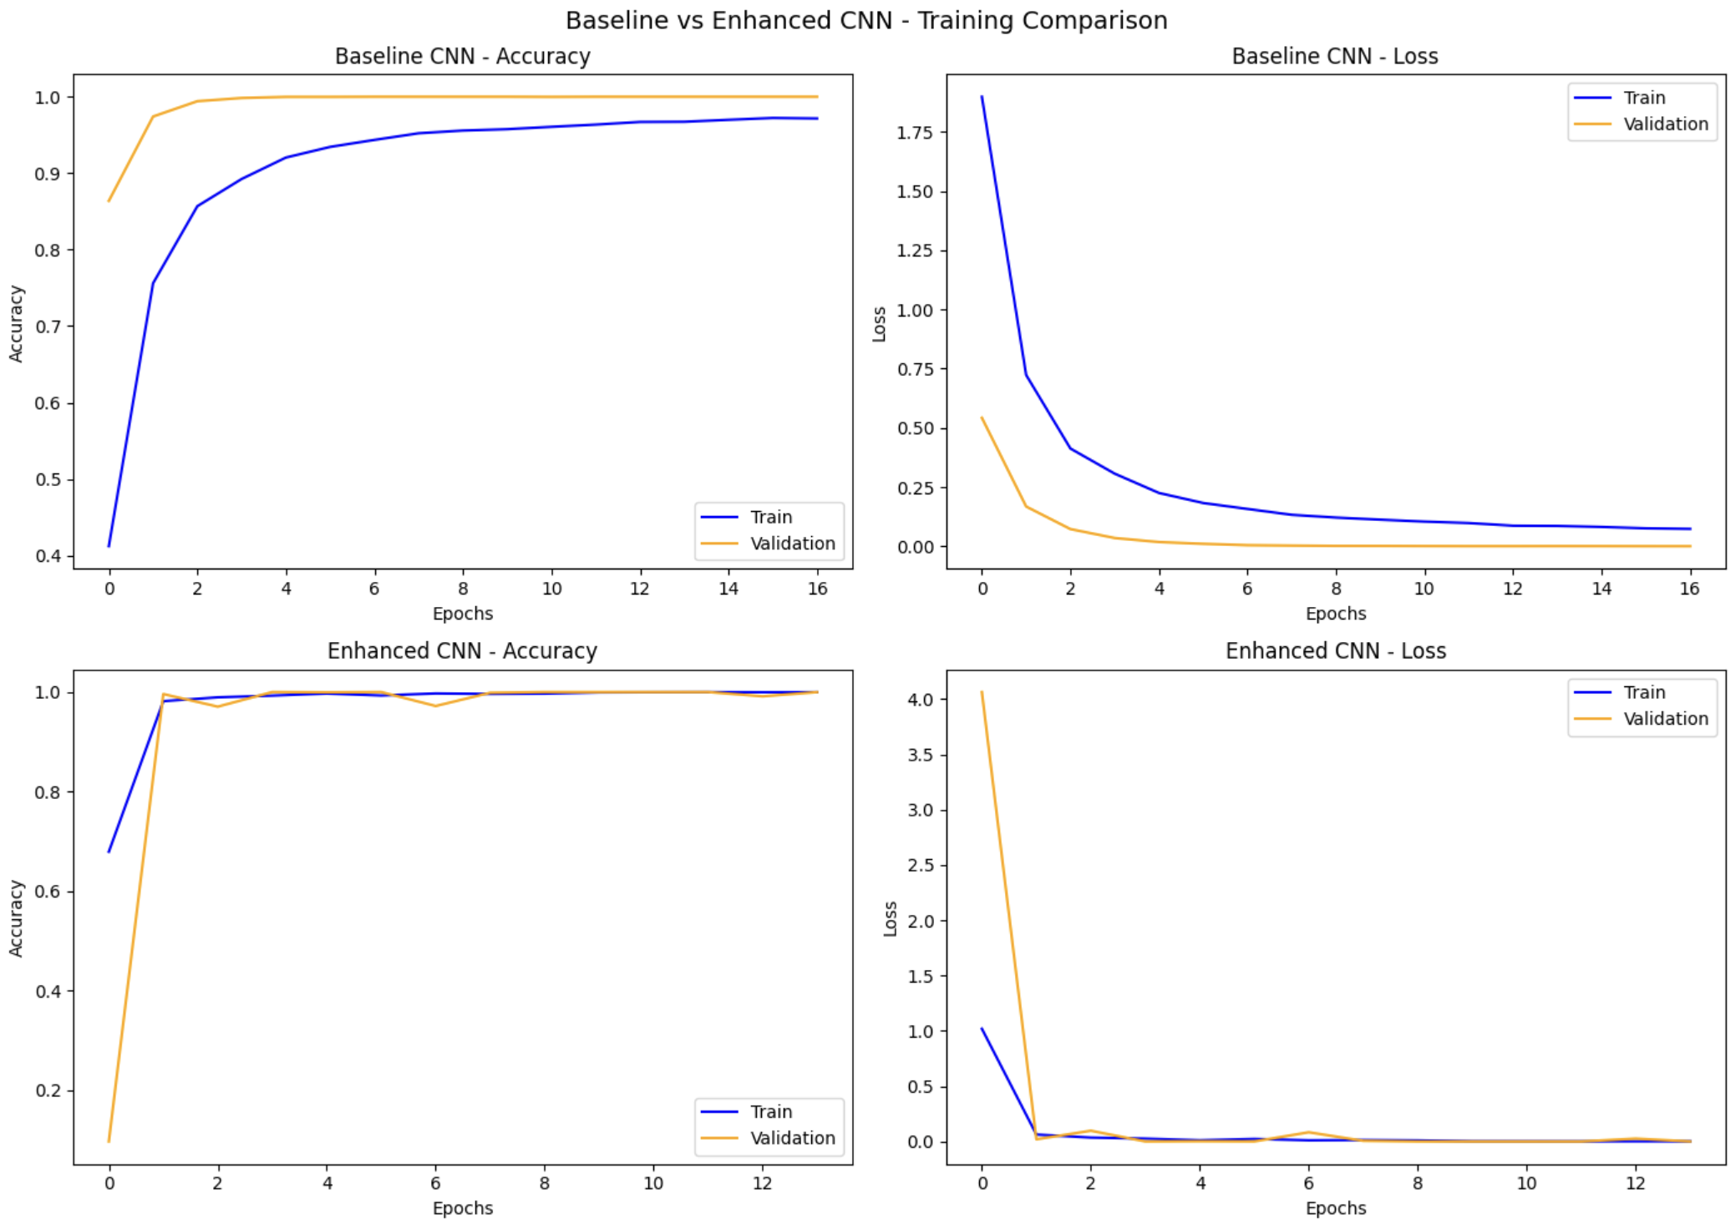

The baseline CNN had a test accuracy of 92.48% after training for 17 epochs. Throughout training the validation accuracy was constantly higher than the training accuracy which shows that the dropout layer was effectively preventing overfitting
The convergence of the enhanced CNN was much higher, achieving 99.62% test accuracy in 14 epochs and a near perfect validation by epoch 2. As the BatchNormalisation layers were warming up over the first few epochs, the model’s validation loss was unstable, but it was soon stabilised. The small spike around the 6th epoch shows that the ReduceLROnPlateau callback adjusting the learning rate.

Model Comparison:
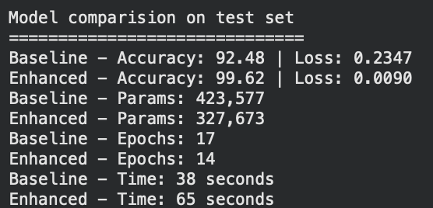
The performance of both the models on the test set is summarised here. The enhanced model performed better than the baseline model in every metric with an accuracy of 99.62% compared to 92.48% for the baseline model. The enhanced model had fewer parameters than the baseline model and also reduced the loss from 0.2347 in baseline to 0.0090 in enhanced model. The enhanced model trained for 14 epochs in 65 seconds whereas the baseline model trained for 17 epochs in 38 seconds. Random weight initialisation caused the training times to change across runs, but the enhanced model consistently achieved more accuracy than the baseline model.

Confusion matrix analysis:
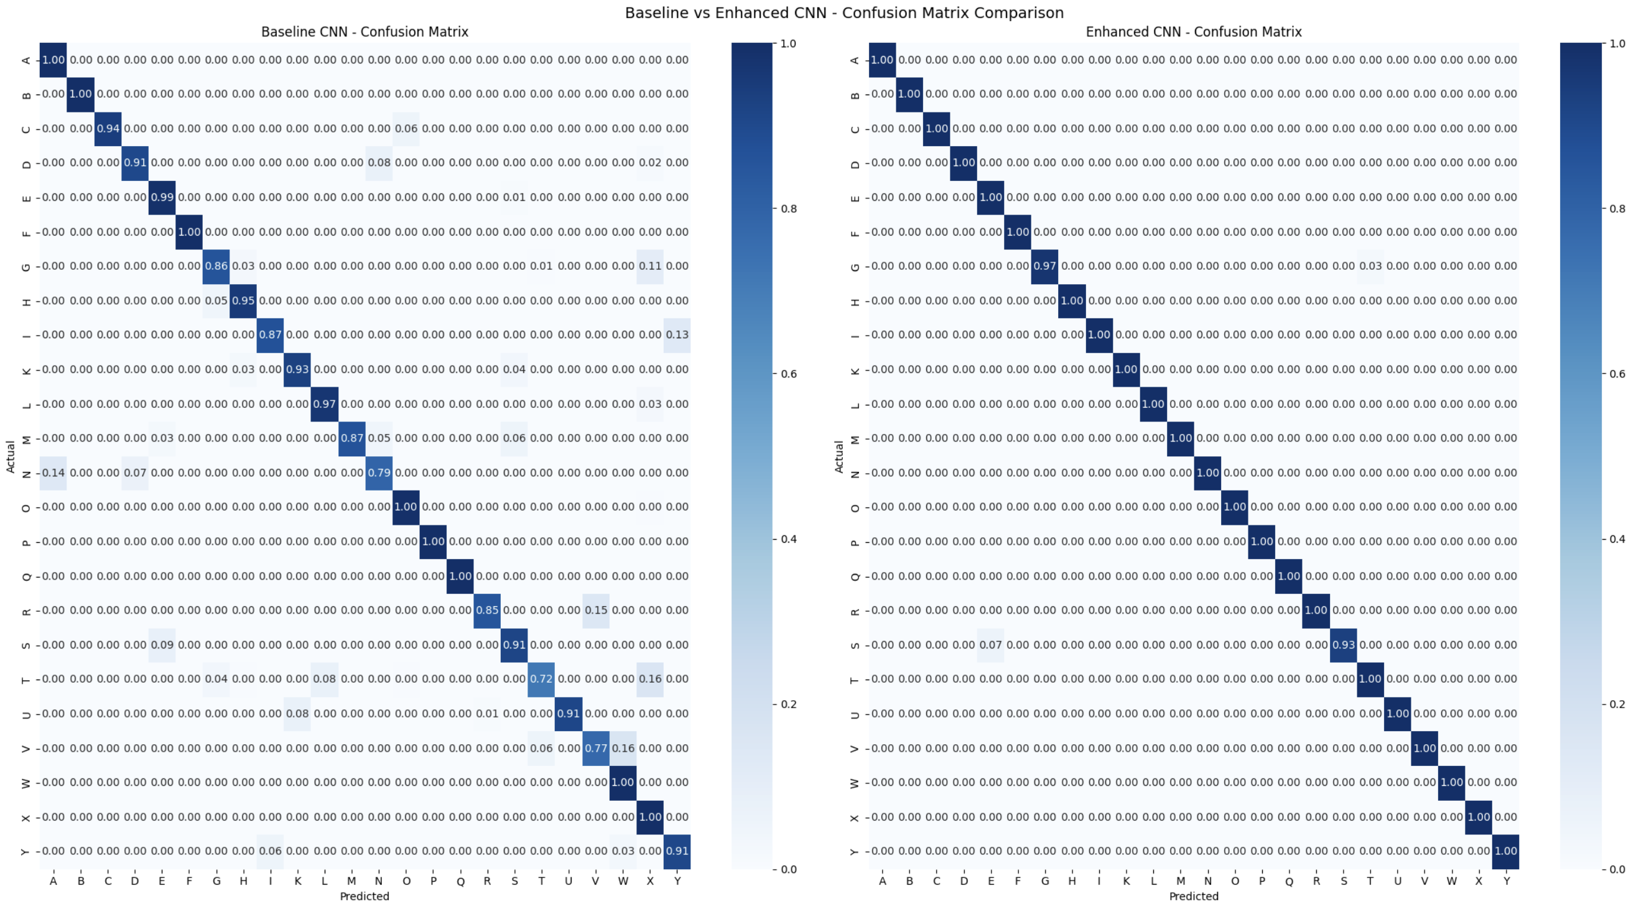

There are many misclassifications in the baseline model’s confusion matrix, especially between visually similar letters. The most mistaken letter was T, which had an accuracy rate of 72% and was often mistaken for Xand L. N also had an accuracy rate of 79% and was mostly misclassified as A. V had an accuracy of 77% often misclassified as W. Nearly all these errors were reduced in the enhanced model, except S with a 93% accuracy rate, which was confused with E. The confusion matrix of the enhanced model shows a near perfect diagonal with almost no misclassifications.

Classification report:
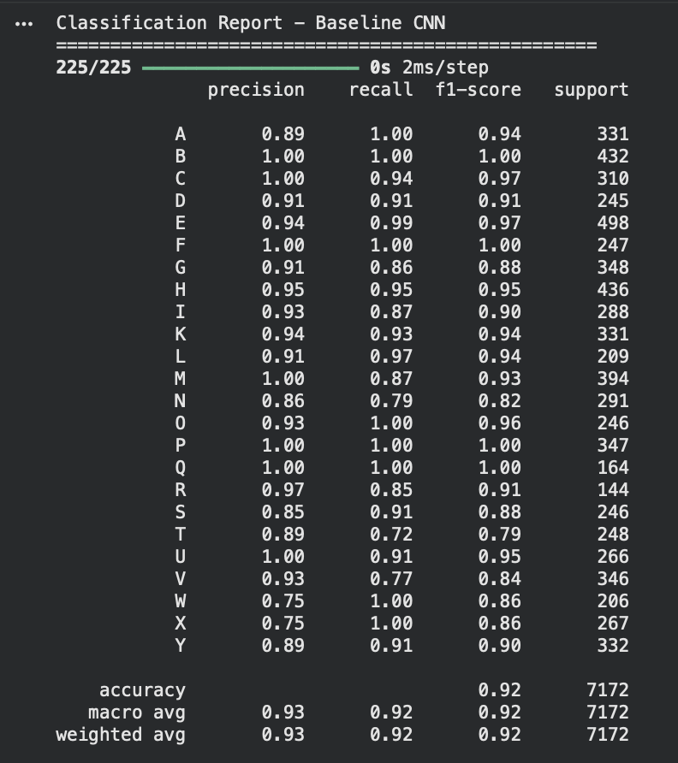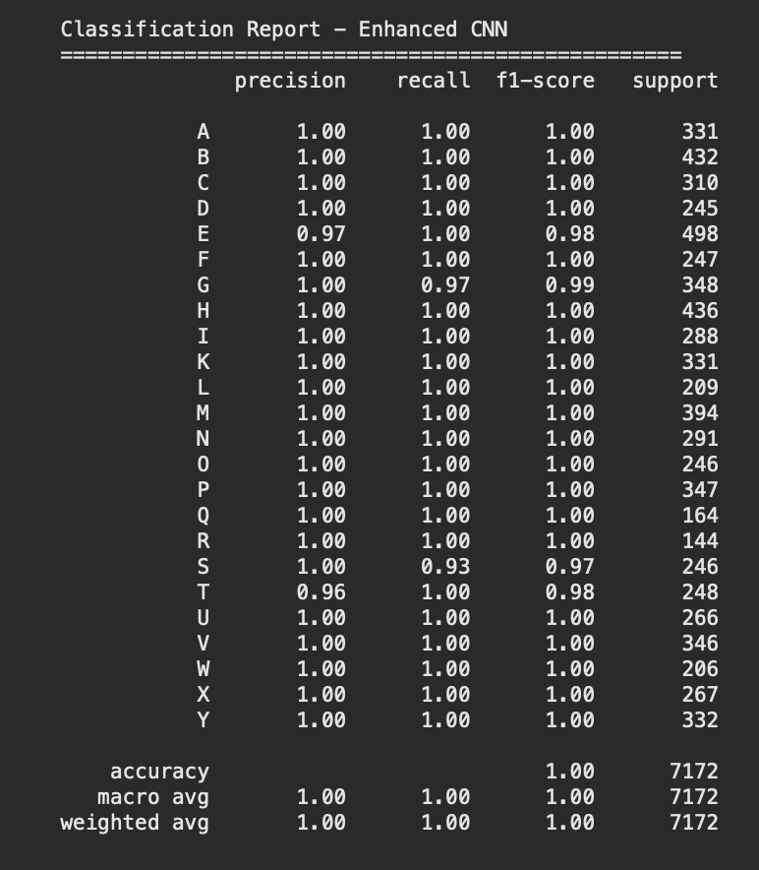

The classification report for the baseline model showed an overall accuracy of 92% with macro average precision, recall and F1 of 0.93, 0.92 and 0.92 respectively. The classification table agrees with the confusion matrix that T, N and V were the worst classes with their F1 scores being 0.79, 0.82 and 0.84 respectively. Letters like B, F, P and Q did well with F1 scores of 1.00.
The enhanced model achieved an overall accuracy of 99% with macro average precision, recall and F1 all at 0.99. Almost all the classes achieved a perfect score except E (F1 = 0.98), S (F1 = 0.97) and T (F1 = 0.98). This shows that T remains to be one of the harder letters even for the enhanced model. The increase in the F1 score across all the classes shows that the enhanced model generalises better and makes fewer errors on difficult classes.

Reflection
The results of this assignment, on paper, look impressive, but there are a few limitations that should be discussed.
There are some restrictions on the sign language MNIST data. The photos were taken in a controlled environment with uniform background and lighting, so they don’t really represent the real-world situations. Additionally, the model has not been tested on unseen data as the test images come from the same photos as the training images. This might be the reason why the enhanced model has achieved near perfect test accuracy. Testing on images by many people with different lighting, background and hand sizes would be necessary for a deeper evaluation.
The dataset also only includes static gestures. The letters J and Z were completely excluded because their gestures require motion. In order to include dynamic motions, a real-world sign language recognition system would need to include video input and an architecture other than a CNN, most likely using recurrent Neural Network (RNNs) or Long Short-Term Memory network (LSTMs).
The enhanced model’s near perfect accuracy also raised concerns on overfitting. The model appears to be memorising the dataset rather than generalising it. Although the validation accuracy seemed perfect during training, this can be misleading since the validation and training data come from the same distribution.
Increasing the resolution to capture finer hand characteristics, testing on a more varied data set to increase the diversity and data augmentation to intentionally change all the training images could be done to improve this work. Transfer learning using a pretrained model like ResNet could also improve generalisation on a real-world data.
The gap between benchmark performance and real-world deployment was highlighted by Koller et al. (2016), who showed in their work on continuous sign language recognition that real world systems require much more complicated architecture than static image classifiers.

References
Koller, O., Ney, H. and Bowden, R. (2016) ‘Deep Hand: How to Train a CNN on 1 Million Hand Images When Your Data Is Continuous and Weakly Labelled’, Proceedings of the IEEE Conference on Computer Vision and Pattern Recognition (CVPR), pp. 3793-3802.

Simonyan, K. and Zisserman, A. (2014) ‘Very Deep Convolutional Network for Large-Scale Image Recognition’, arXiv preprint arXiv: 1409.1556. Available at: https://arxiv.org/abs/1409.1556

