CSCU9E5 INDIVIDUAL MODELLING ASSIGNMENT

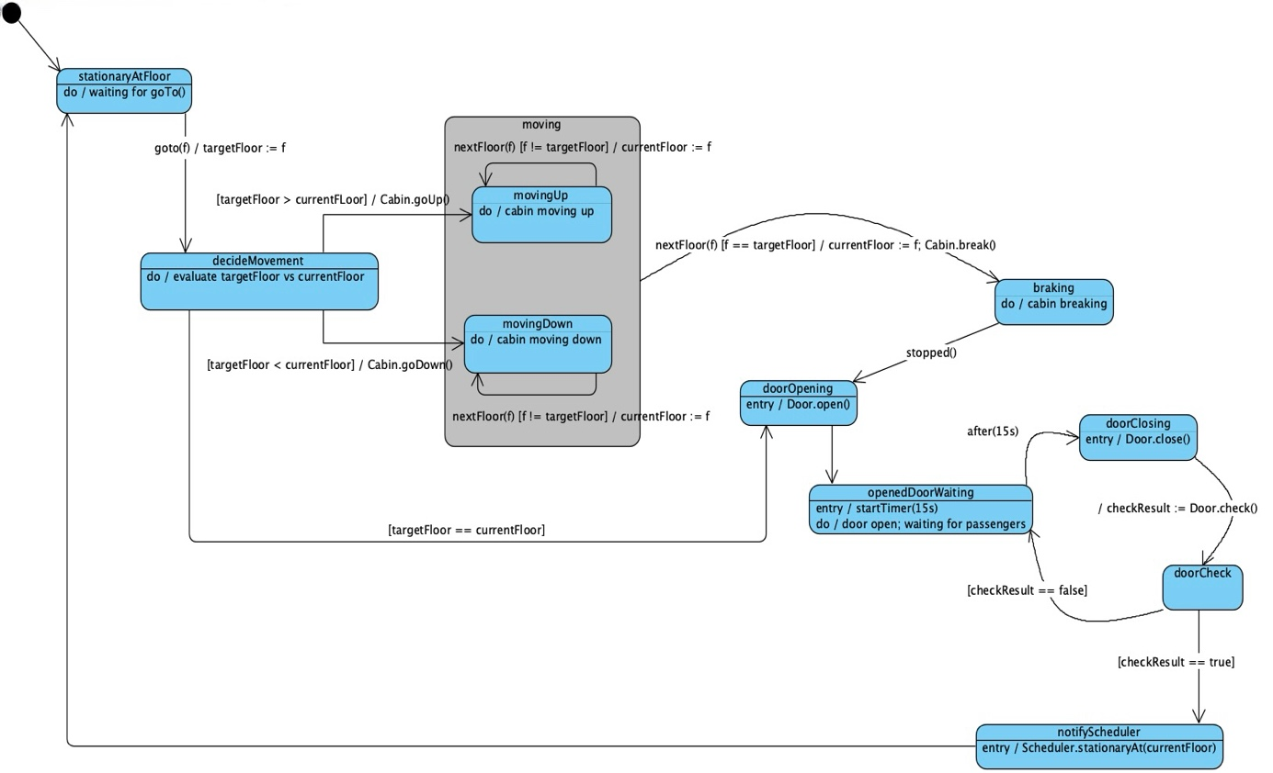

Initially, the system is in the stationaryAtFloor state. It remains in that state until it receives a new floor request (goto()). When the new floor request comes in it then moves on to the decideMovement state where it evaluates the target floor and current floor and decides whether to go up, down or to stay in the same floor depending on the scheduler’s request. If the target floor is the current floor, it directly transitions to the doorOpening state. If the target floor is higher than the current floor, the system sends the cabin to movingUp state using the goUp() command and if the target floor is lower than the current floor, the system sends the cabin to movingDown using the goDown() command. Both these states are in the moving super state. While in these states the, the system checks the next floor using nextFloor(f) and updates the current floor as it passed the floor until the target floor is reached. When the target floor is reached, it exits the superstate and enters the breaking state. In this state the cabin applies breaks until its fully stopped. After it is fully stopped it enters the doorOpening state where the cabin opens the door using Door.open(). Once the door is opened it enters the openedDoorWaiting state where upon entering the state it starts the timer of 15 seconds and leaves the door open until the timer ends for the passengers to enter the cabin. Once the timer ends it enters the doorClosing state where it closes the door using doorClose(). While the door is closing it goes to the doorCheck state to check if the door is closing safely. If the door fails to close properly (checkResult == false), then it loops back to the openedDoorWaiting state and waits for 15 seconds to try again. If the door is successfully closed (checkResult == true), then it enters the notifyScheduler state when it notifys the scheduler the current floor the cabin’s on. It then loops back to the stationaryAtFloor state waiting for the next request.

Added attributes:

currentFloor : int | Shows the floor that the cabin in currently in and it updates whenever nextFloor() command is called
targetFloor : int | This shows the requested floor by the scheduler using the goto(f) command and is used to decide whether the cabin should go up, down or stay in the same floor
checkResult : Boolean | Stores a Boolean value to show whether the door has been closed successfully or not

