**Part 1: Prerequisites For Running This Project:**

1. First of all to run this application user must have Java installed on system.

2. Internet access is mandatory.

3. User should have amazon s3 account

4. User should have drop-box account.

**Part 2: Instructions (Setup):**

**1.** Copy aws folder from the Application Settings folder to

(~/.aws/credentials for linux users ) or (C:\Users\USER_NAME\.aws\credentials for Windows users) and rename the folder .aws

**2.** Create/Import new project into eclipse. Project folder name is “*Secure Data Distribution Application*” it contains source code.

**3.** Place the “*settings.properties”* file into the same project folder from application settings folder if not exists.

**4.** Add external java library to the build path add all SDK's from the Application Settings/lib folder.

**5.** Main file is placed into the main package for running the application run this file. File name is “*MainApplication.java*”.

**6.** After running the project from eclipse select the file and upload it into the clouds and try downloading files from the cloud services. Please refer working instruction given below.

**Part 3: Instructions Working:**

Once all these basic things are done user can start the application.

This application has three sections

**1.** Configure Section

**2.** Upload Section

**3.** Download Section

When user starts the application, application starts in upload section. As shown below:

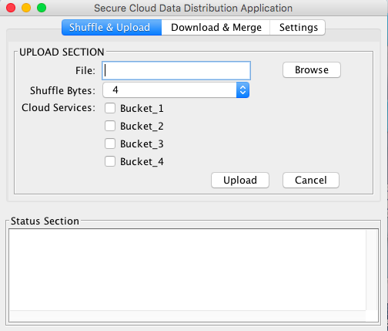

Application has three sections (tabs) to go onto specific section to perform specific function according to users need. Though application starts in upload section it check for the user’s cloud service provider and bucket configurations in order to upload and download and if that specification is missing it prompts user to save that in configuration section. User must save it to proceed further.

1. **Configure Section:**

As mentioned above it is must to save the cloud buckets and service provider to use the application.

* When user go to the configure section he should fill all the details about bucket and cloud service providers along with the drop-box access token (key) to perform upload and download operations.
* These details will be saved to the file *“settings.properties”* in same directory the application is placed.
* Refer below picture for the reference.

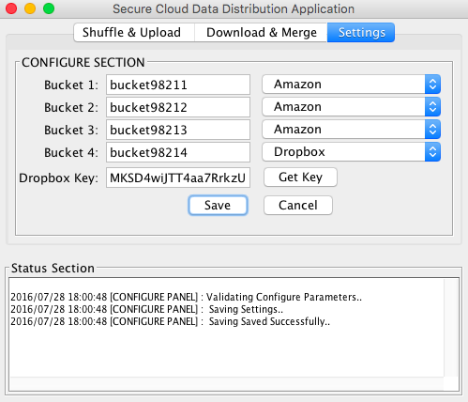

1. **Upload Section:**

Once the configurations are mode the user can start the uploading the file to the buckets he configured.

In order to upload the file user should follow the steps as below…

* Select the file from browse.
* Select number of bytes to shuffle (*Important!!*)

***Note:*** *user must remember this number in order to retain the original file when downloading without this number its hard to get the original file back from scrambled data file.*

* Select the buckets (this application currently restricted to even number of buckets only so make sure user selects only even number of cloud buckets for storing data). Usually all four bucket.
* Press Upload.

\**After the upload button press application will check the validity of drop-box access token if it is valid then it will upload if not then application will prompt user to enter new drop-box key and redirect user to drop-box site to get token. After the new valid token files will be uploaded to buckets.*

***Note:*** *the drop-box key which user will get will be valid for few minutes in order to use application multiple times without entering new key user should get developer key.*

* Refer picture below:

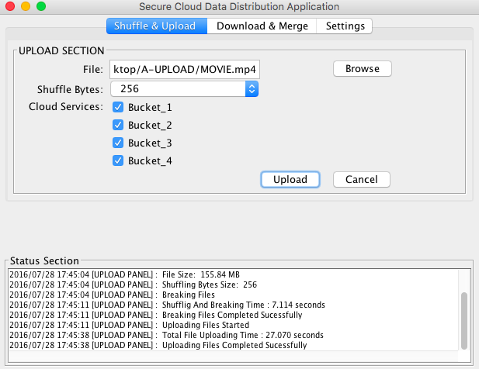

1. **Download Section:**

* In order to download the original file user should have files in the buckets.
* User must select the file, which he wants to download from the buckets.
* Then user should select the shuffling bytes, which he used for uploading and shuffling data in the buckets. This is important in order to get the original file back from sub files.
* If user want to download file to a specific directory then he can select that directory else file will be downloaded to current folder where application is placed.

***Note:*** *If the drop-box key provided will be not valid then application will prompt user to enter the new key and then it will proceed for downloading the file.*

* Refer Picture Below:

