**TASK 1**

Sreevidya V

# Concepts of Git explaining various terms

Git is an open source distributed version control system, which is designed to handle minor and major projects with high speed and efficiency. It allows us to track and work together with our team members on a project, on the same workspace. Some of the basic terminologies used in Git are:

## Repository

A Git repository is a directory that contains a Git working directory. The Git repository is the place where the files are stored.

## Working Directory

A Git working directory is a directory containing all the files that Git tracks. Git tracks all the files in the directory and updates it if changes are committed.

## Branch

A branch is an independent line of development that adds certain features and fix bugs without interfering with the main project. Thus we can develop new features in parallel, and when the development is completed, we can add them back to the main project.

## Commit

Git tracks the changes in a project and saves a certain state known as commit. A commit is a snapshot of the file’s current version. When we use the Git commit command, the changes are saved in our local system, along with a short message related to the commit is also stored, which is provided by the user along with the command.

## Clone

The clone is a Git command-line utility. It is used to make a copy of the target repository or clone it.

## Index

The Git index is a staging area between the working directory and repository. It is used as the index to build up a set of changes that you want to commit together.

## Merge

The Git merge command facilitates you to take the data created by Git branch and integrate them into a single branch.

## Pull/Pull Request

The term Pull is used to receive data from GitHub. It fetches and merges changes on the remote server to your working directory. The Git pull command is used to make a Git pull.

## Push

The push term refers to uploading local repository content to a remote repository. It is an act of transferring commits from your local repository to a remote repository. Pushing is capable of overwriting changes.

# Basic commands of Git

## Git config command

The Git config command is the first and necessary command used on the Git command line, which sets the user name and email address to be used with your commits.

## Git Init command

Init command is used to create a new repository. It will initialize an empty repository.

## Git clone command

This command is used to make a copy of a repository from an existing URL.

## Git add command

It is used to add one or more files to staging area.

## Git commit command

Git commit command is mainly in two scenarios.

### Git commit -m

This command changes the head. It records or snapshots the file permanently in the version history with a message.

### Git commit -a

This command commits any files added in the repository with Git add and also commits any files you have changed since then.

## Git push Command

Pushing is an act of transfer commits from your local repository to a remote repository. Pushing is capable of overwriting changes, and caution should be taken when pushing.

## Git pull command

Pull command is used to receive data from GitHub. It fetches and merges changes on the remote server to your working directory.

## Git Branch Command

This command lists all the branches available in the repository.

## Git Merge Command

This command is used to merge the specified branch’s history into the current branch.

## Git remote Command

The Git remote command is used to manage remote repositories. This command allows you to create, view, and delete connections to other repositories.

## Git log Command

This command is used to check the commit history.

## Git status command

The status command is used to display the state of the working directory and the staging area. It allows you to see which changes have been staged, which haven’t, and which files are not being tracked by Git.

# GitHub

GitHub is an online platform, launched in April 2008, which allows developers to create, store, and manage their code. It uses Git software and is commonly used to host open source software development projects. Projects on GitHub can be accessed and managed using the standard Git command-line interface.

# GitLab

GitLab is a service that provides remote access to Git repositories. In addition to hosting your code, the services provide additional features designed to help manage the software development phase. These additional features include managing the sharing of code between different people, bug tracking, wiki space and other tools for coding.

# BitBucket

BitBucket is a Git based code hosting and collaboration tool, built for teams. It helps developers store and manage their code, as well as track and control the changes to their code. BitBucket allows the user to authenticate and add social media via GitHub.

# Industrial practices of Git

One of the biggest advantages of Git is its branching capabilities, which are cheap and easy to merge. Feature branches provide an isolated environment for every change to your codebase. When a developer wants to start working on something, they create a new branch. This ensures that the main branch always contains best quality code.

Git is a distributed version control system where each developer gets their own local repository, complete with a full history of commits. Having a full local history makes Git fast, since it means you don’t need a network connection to create commits, inspect previous versions of a file, or perform diffs between commits.

Git’s distributed version control system allows multiple developers to work on a project simultaneously. This makes it easy for developers to share their work, provide feedback, and merge changes from other developers, improving collaboration and productivity.

# Cloning a repository to local

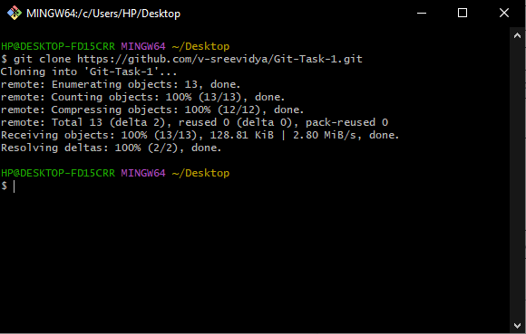

# References

* <https://www.javatpoint.com/git-commands>
* <https://www.simplilearn.com/tutorials/git-tutorial/what-is-git#commands_in_git>
* <https://en.wikipedia.org/wiki/GitHub>
* <https://www.tutorialspoint.com/gitlab/index.htm>
* <https://www.geeksforgeeks.org/introduction-to-bitbucket/>
* <https://www.atlassian.com/git/tutorials/why-git>
* <https://www.copia.io/blog/three-surprising-benefits-when-using-git-for-industrial-automation>
* <https://docs.github.com/en/repositories/creating-and-managing-repositories/cloning-a-repository>

Figure 1: Cloning a repository to local machine