Project Report
Predicting Potential Spammers on Fiverr
Model Development Document (MDD): Supervised Machine Learning, Binary Classification

1. Title of the Project
Predicting Potential Spammers on Fiverr from New-User Behaviour: A Supervised Machine Learning Approach.

2. Brief on the Project
Project type: Supervised learning, binary classification on a highly imbalanced tabular dataset.
Problem: Fiverr is an online marketplace. Spammers who join the platform harm genuine buyers and sellers and add moderation cost. Using the steps a new user takes after joining, the task is to predict which users will turn out to be spammers (label = 1) so that they can be reviewed or blocked early.
Motivation: Only about 2.7% of users are spammers, so manual review of everyone is impractical. A model that ranks users by spam risk lets moderators focus on a small, high-risk group, and is a realistic example of fraud and abuse detection, where class imbalance and the cost of false alarms drive every design decision.
Approach (tentative, then executed): clean the data, explore it, fix skewed distributions, treat outliers and scale features, split into train, validation and test sets, train all the major supervised algorithms, diagnose and treat overfitting, tune the best models and evaluate the winner once on an untouched test set. Because accuracy is misleading at a 2.7% positive rate, models are compared mainly on PR-AUC, along with ROC-AUC, precision, recall and F1.
Previous work: gradient-boosted trees (XGBoost, LightGBM) are the standard strong baseline for tabular fraud and abuse data; precision-recall analysis is the recommended evaluation for imbalanced problems (see References).

3. Deliverables of the Project
High-level approach and the evidence gathered:
- A cleaned dataset and a documented list of every cleaning decision, with the evidence behind it.
- Exploratory analysis with visualisations that show which behaviours separate spammers from genuine users.
- Skewness, outlier and scaling analysis with before/after evidence.
- A comparison of 11 supervised algorithms (Logistic Regression, Naive Bayes, KNN, Linear and RBF SVM, Decision Tree, Random Forest, Extra Trees, Histogram Gradient Boosting, XGBoost, LightGBM), 16 model configurations in total including tuned and early-stopped versions, against a dummy baseline.
- An overfitting study (train versus validation gaps, learning curves) with the treatment applied.
- A final tuned model, evaluated once on a held-out test set, with a threshold trade-off table, feature importance and a saved model file.
Evaluation plan: a stratified 70/15/15 train/validation/test split. All model selection uses the validation set (and cross-validation inside the training set); the test set is used once for the final number.

4. Questions the Model and Analysis Are Designed to Answer
- Which behaviours and user segments are most associated with spamming?
- How well can spammers be identified at all, given that they are only 2.7% of users?
- Which algorithm family works best on this data, and why do linear models fall behind tree-based ones?
- How much does overfitting affect each model, and which treatments fix it?
- What precision/recall trade-off is available, so that a platform can choose between a wide review queue and automatic blocking?

5. Details of the Model, Important Findings and Outcome
Headline result: a tuned LightGBM model reaches a test PR-AUC of 0.782 (random baseline 0.027, about 29 times better), a test ROC-AUC of 0.970, and for the spammer class a precision of 0.813, recall of 0.691 and F1 of 0.747 on 68,820 unseen users.

5.1 Data description
Why: Before cleaning or modelling we must know the size, types and target balance of the data.
How: Loaded the Excel file with pandas, inspected shape, dtypes, head/tail, summary statistics and the target distribution.
Finding: 458,798 users and 53 columns: label, user_id and 51 anonymised behaviour columns X1 to X51 (all numeric). Spammers are 2.6855% of users (about 12,321), so the data is heavily imbalanced and accuracy is not a useful metric: predicting 'nobody is a spammer' would already score 97.3%.
df.shape : (458798, 53)
dtypes : int64 x 52, float64 x 1 (X13, only because of 6 missing values)
columns : label, user_id, X1 ... X51

label user_id X1 X2 X3 X4 X5 X6 X7 X8 ... X49 X50 X51
0 0 1 20972 14 13 3 11 1 2 15 ... 0 1 0
1 0 2 7362 213 71 3 11 1 2 15 ... 0 0 0
2 0 3 21216 215 71 3 11 1 2 15 ... 0 0 0
3 0 4 2261 212 71 2 8 1 2 15 ... 1 0 0
4 0 5 4543 213 71 2 8 1 2 15 ... 0 0 0
(abridged output of df.head())

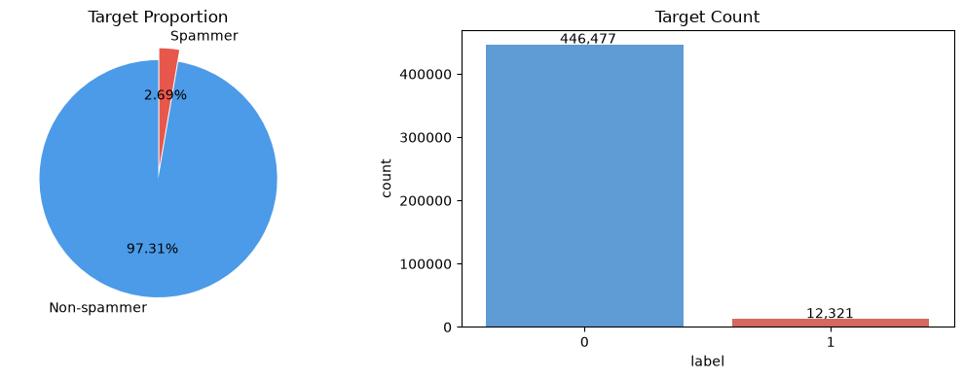
Figure 1: Target distribution: 2.69% of users are spammers

5.2 Data cleaning
Why: Duplicates cause leakage between train and test; constant columns carry no information; missing values break many models.
How: Checked duplicate users, duplicate rows, missing values, constant and near-constant columns, invalid values and conflicting labels.
Finding: Every decision was backed by a check, not by a blanket rule (table below).
Check | Result | Decision
Duplicate user_id / fully duplicate rows | 0 / 0 | No rows removed (drop_duplicates kept as an integrity safeguard)
Identical features, different user_id | 5,349 rows in 2,357 groups | Kept: different users with identical behaviour
Identical-feature groups with mixed labels | 91 groups, 726 users (about 0.16%) | Kept; documented as a limit on achievable accuracy
Missing values | Only X13, 6 rows | Imputed with the training median inside the pipeline
Constant columns | X27, X29, X30, X33, X46, X47, X48 | Dropped (single value, no information)
X51 (near-constant) | 33 non-zero rows, 2 spammers (6.1%) | Dropped: within chance, risk of memorisation
X37 (near-constant) | 189 non-zero rows, 0 spammers | Kept: 0 of 189 is unlikely by chance (expected about 5)
Negative or infinite values | None | No action
X35 versus X34 | Correlation 0.97, equal in 98.5% of rows | X35 dropped (near-duplicate)

Fully duplicate rows : 0
Duplicate user_id values : 0
Duplicate rows ignoring user_id : 5349 (2,357 identical groups)
Groups with mixed labels (0 / 1) : 91 (726 users)
Missing values : X13 = 6 rows (0.0013%)
Constant columns : X30, X27, X29, X33, X47, X48, X46
Near-constant (>99.9%) : X27, X29, X30, X33, X37, X46-X48, X51
Negative / infinite values : none
X37 : non-zero rows = 189, spammer rate = 0.0000%
X51 : non-zero rows = 33, spammer rate = 6.0606%
Shape after dropping 8 columns : (458798, 45)

Seven columns (X27, X29, X30, X33, X46, X47, X48) contain a single value for all 458,798 users (standard deviation = 0). Such columns carry no information for separating spammers from genuine users, cannot be used by tree models (no valid split exists), cause division by zero in standardization, and only add computation. They were therefore dropped, which does not change any model's predictions. After cleaning, 42 original feature columns remain (51 minus 8 constant/near-constant columns minus X35), and one engineered flag is added later.

5.3 Exploratory data analysis and visualizations
Why: EDA shows which features separate spammers from genuine users and exposes problems (skew, outliers, redundancy) to fix before modelling.
How: Plotted the spammer rate for every value of each binary and low-cardinality column against the overall 2.69% line, correlations with the label, rate tables with row counts, decile plots for the wide columns, and a correlation matrix for redundancy.
Finding: Several features carry strong, mostly non-linear signal.
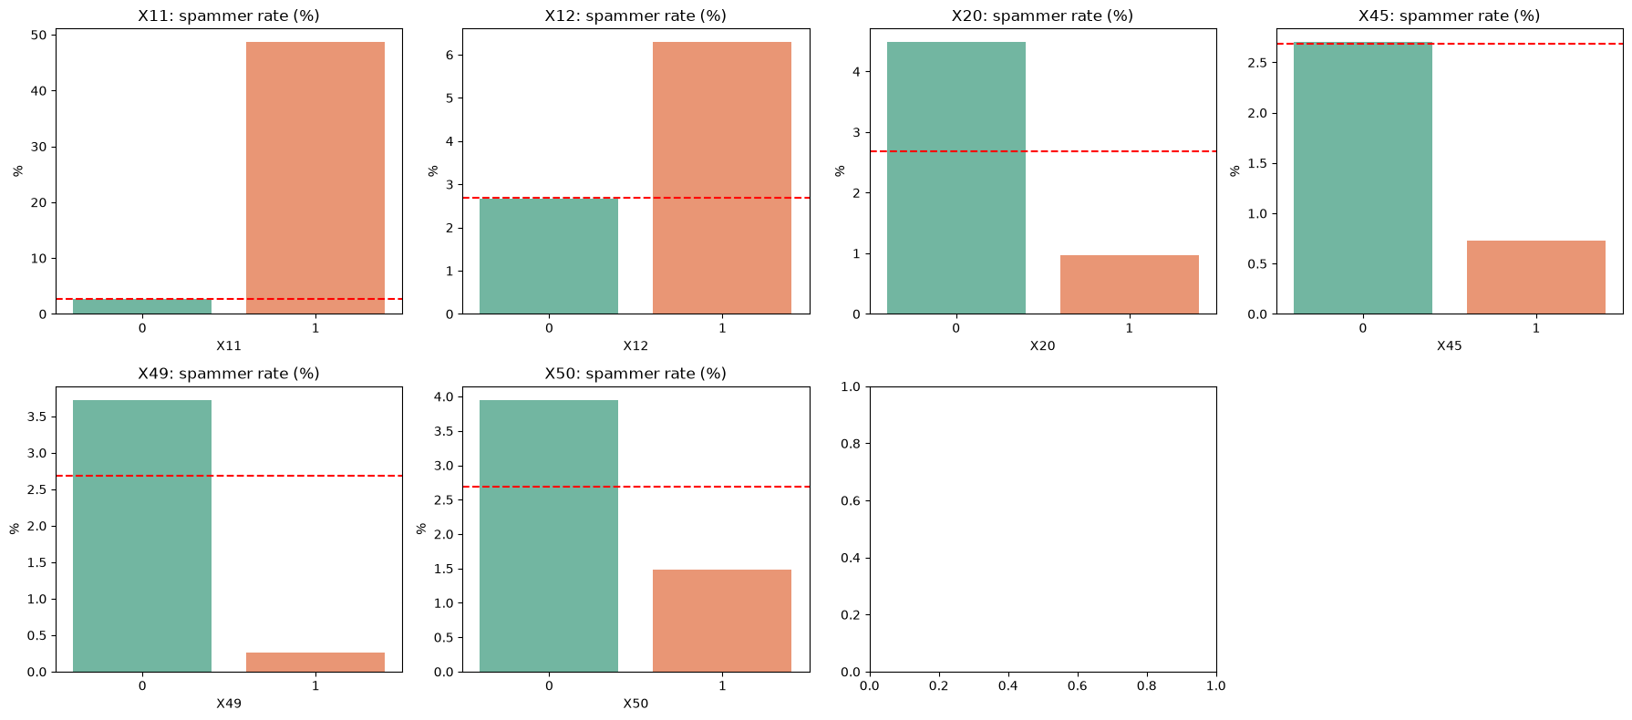
Figure 2: Spammer rate by value for the binary columns (red line = overall 2.69%)
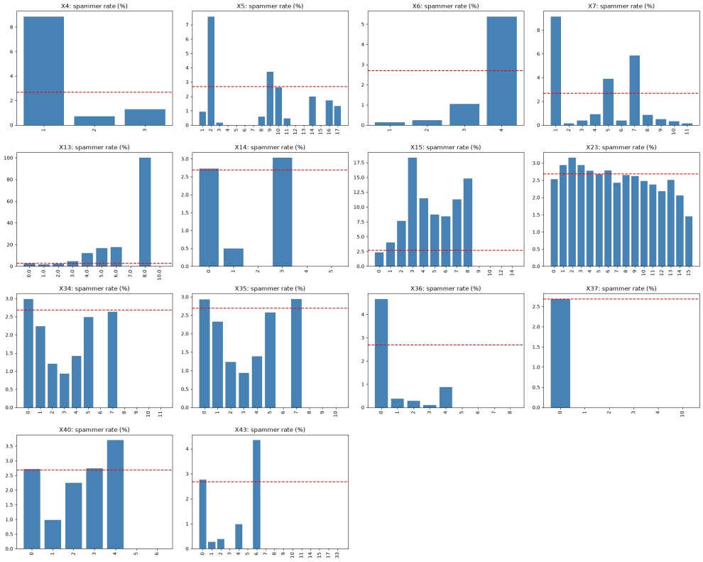
Figure 3: Spammer rate by value for the low-cardinality columns
Key observations:
- X11 = 1: about 48% of these users are spammers (base rate 2.7%), a rare but very strong flag.
- Protective flags: X49 = 1 (about 0.25% spam rate), X20 = 1 (about 1%), X50 = 1 (about 1.5%), X45 = 1 (about 0.7%).
- Counts X13 and X15: the spam rate rises with the count (X15: 2.3% at 0 up to 18.3% at 3). Counts above 8 have 1 to 7 users and are noise, which is why row counts were plotted next to the rates (X13 = 8 shows 100% but rests on 2 users).
- Category-like codes X2 to X8: spam rate jumps irregularly across values, so they are labels, not quantities. The risky codes are X4 = 1 (8.9%), X7 = 1 (9.1%), X8 = 21 (12.4%), X5 = 2 (7.6%), X3 = 37 (13.1%) and X2 = 147 (22.7%).
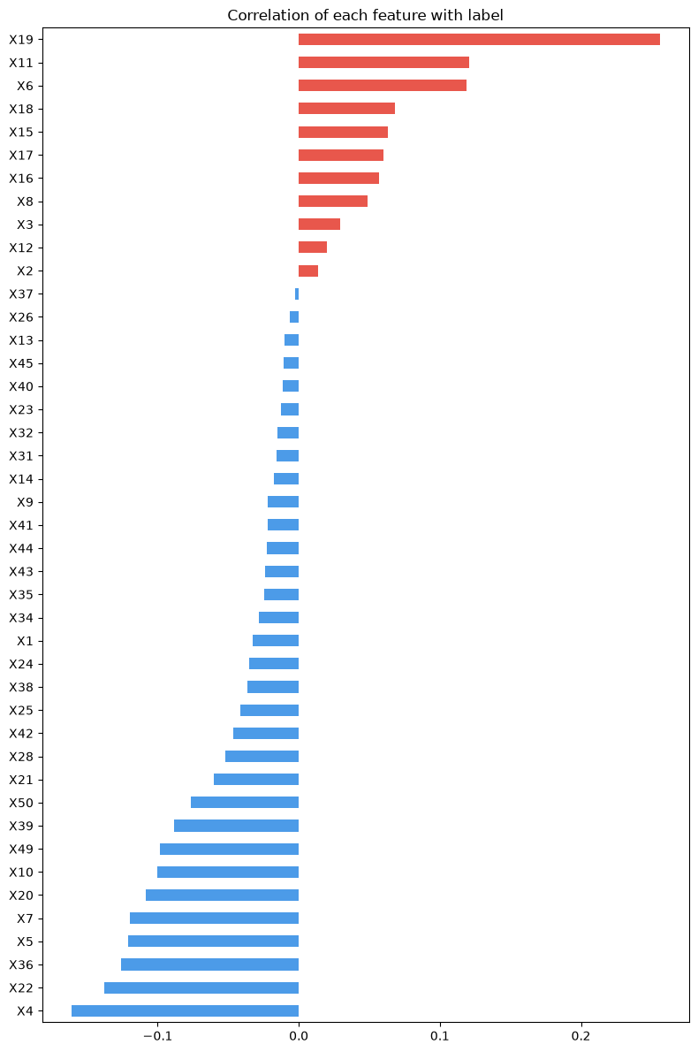  Figure 4: Correlation of each feature with the label | Linear correlations with the label are weak (the largest is X19 at +0.26, then X11 at +0.12 and X6 at +0.12; the most negative is X4 at -0.16), yet the plots above show strong non-linear patterns. This is the first evidence that tree-based models should outperform linear ones.
  Top positive Top negative
  X19 0.2558 X4 -0.1610
  X11 0.1206 X22 -0.1378
  X6 0.1188 X36 -0.1257
  X18 0.0683 X5 -0.1209
  X15 0.0630 X7 -0.1198
  X17 0.0599 X20 -0.1085
  X16 0.0571 X10 -0.1000
  X8 0.0486 X49 -0.0983
The X19 'dose-response' relationship. The spam rate climbs steadily with X19, from about 1% at zero to 83% at 26 to 50. Only 6.4% of users have X19 above zero, but they contain about 59% of all spammers.
X19 value | Users | Spammers | Spam rate
0 | 429,573 | 5,054 | 1.18%
1 | 17,604 | 1,499 | 8.52%
2 | 3,606 | 953 | 26.43%
3 to 5 | 3,338 | 1,596 | 47.81%
6 to 10 | 1,890 | 1,194 | 63.17%
11 to 25 | 1,757 | 1,326 | 75.47%
26 to 50 | 623 | 519 | 83.31%
51 and above | 407 | 180 | 44.23%

Segment analysis. The risky codes X4 = 1, X7 = 1, X8 = 21, X3 = 37 and X5 = 2 are strongly correlated with each other (X4/X7 correlation 0.94), i.e. they describe largely the same user segment. Users with all five flags number 34,056 and have a 17.6% spam rate (6.5 times the base rate). X2 = 147 is a separate group (correlation about 0.1 with the rest) with a 22.7% rate.
Share of users per flag : X4=1 19.9% | X7=1 18.4% | X8=21 12.6% | X5=2 19.9%
X3=37 10.9% | X2=147 3.1%
Flag correlations : X4/X7 0.94 | X7/X8 0.80 | X4/X8 0.76 | X3/X5 0.70
X2=147 with the others 0.09 to 0.13
Users with all 5 flags : 34,056 | spammer rate 17.58%

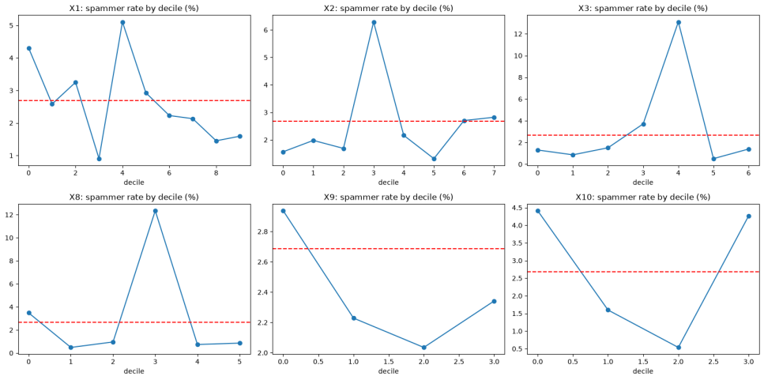
Figure 5: Spam rate by decile for X1, X2, X3, X8, X9, X10 (jumpy patterns indicate codes, not quantities)
Redundancy. Highly correlated pairs: X34/X35 (0.97), X41/X44 (0.93), X10/X20 (0.86), X16/X18 (0.84). Only X35 was removed; the others each carry label signal and tree models are insensitive to redundancy.

5.4 Distributions, skewness and transformation
Why: Strongly skewed variables distort linear models, SVM and KNN, and let a few extreme values dominate.
How: Computed skewness, kurtosis and zero share for the 29 numeric (count) columns, plotted histograms on a log axis, and applied log1p (log of 1 + x, which is safe at zero) to skewed columns. X37 and X26 (over 99% zeros) were left unchanged.
Finding: 23 of 29 columns had |skew| above 1, almost all of them zero-heavy counts.
Column | Skew before | Skew after log1p | Zeros
X25 | 91.24 | 1.81 | 69.6%
X32 | 42.16 | 1.63 | 67.8%
X31 | 29.42 | 1.25 | 65.9%
X21 | 4.69 | 0.60 | 0%
X9 | 1.38 | 0.55 | 0%
X19 | 30.41 | 6.69 | 93.6%
X44 | 24.14 | 5.16 | 94.7%

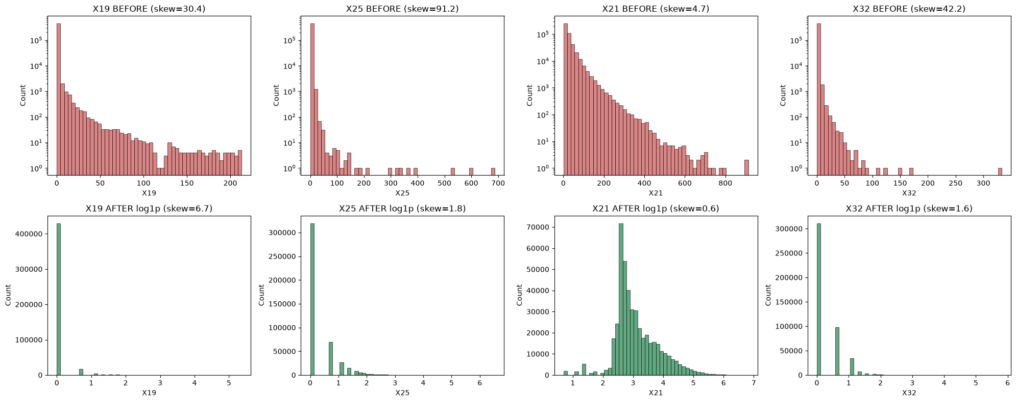
Figure 6: Before (red) and after (green) log1p for X19, X25, X21 and X32
Columns with 60 to 80% zeros were fixed (skew near 1 to 2 or lower); X21 became an almost perfect bell shape. Columns with over 90% zeros (X19, X44, X41, X43) improved a lot but stay skewed because a spike at zero cannot be removed by any transformation; they behave like 'has this behaviour or not' flags. Tree models split on thresholds and are unaffected by log1p, so two versions of the data are kept: raw values for trees and transformed values for the other models. log1p has no learned parameters, so it causes no leakage.

5.5 Outliers and feature scaling
Why: Extreme values can distort distance- and weight-based models. However, in spam detection an extreme value is often exactly what a spammer looks like.
How: Because 70 to 99% of many columns are zero, the IQR rule would flag every non-zero value, so outliers were detected by percentile (above the 99th). For each column the spam rate among those extreme values was checked before deciding what to do.
Finding: The extremes are mostly signal. Above p99, X19 has a 70% spam rate, X15 14% and X10 10%, whereas for X21, X22, X25, X24 the extreme values are about 0.2 to 0.5% (genuine users).
Column | p99 | p99.9 | Max | Rows above p99 | Spam rate above p99
X19 | 6 | 46 | 213 | 4,133 | 70.12%
X15 | 2 | 4 | 14 | 1,665 | 14.17%
X10 | 49,593 | 49,623 | 49,637 | 3,864 | 10.02%
X18 | 15 | 17 | 25 | 1,995 | 6.22%
X9 | 36 | 37 | 38 | 852 | 5.52%
X16 | 22 | 28 | 48 | 4,202 | 5.19%
X21 | 170 | 330 | 913 | 4,504 | 0.49%
X25 | 9 | 18.2 | 688 | 3,958 | 0.28%
X22 | 35 | 42 | 55 | 3,921 | 0.23%

Overall spammer rate for comparison: 2.69%. Selected rows shown; the full table covers all 27 count columns.
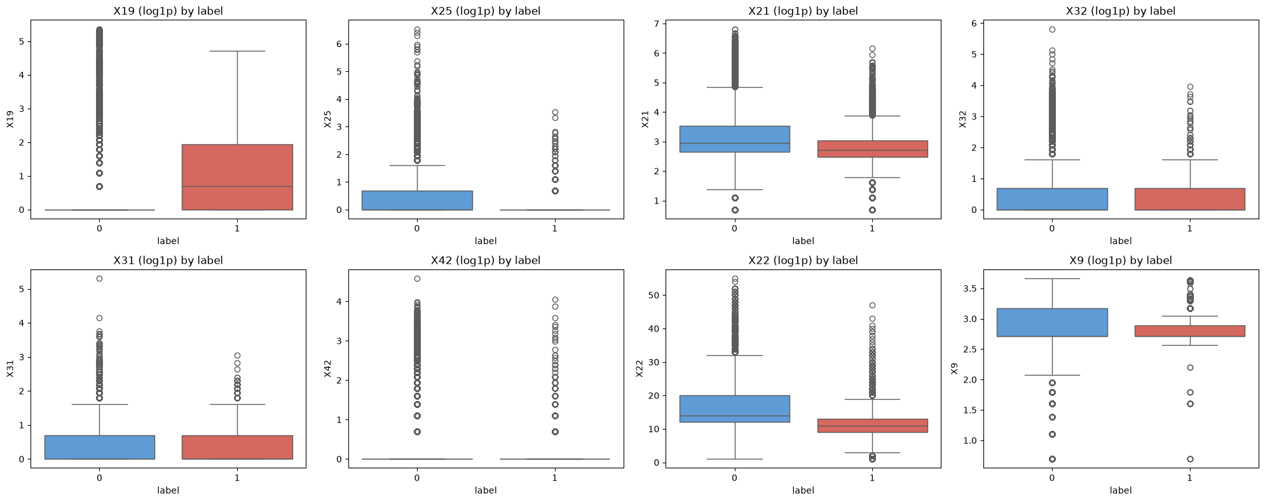
Figure 7: Boxplots of log1p-transformed columns by label (red = spammers)
Decision: no rows were deleted (there are only about 12,300 spammers and many sit in the tails). Tree models receive raw values. For Logistic Regression, SVM and KNN, columns are winsorised (capped) at the 99.9th percentile computed on the training split only, then log1p-transformed and standardised with StandardScaler fitted on the training split. Capping at p99.9 (X19 = 46) rather than p99 (X19 = 6) preserves the 6 to 46 range where the spam signal is strongest.
Model family | Scaling needed? | Reason
Decision Tree, Random Forest, XGBoost, LightGBM | No | Splits depend on order, not scale
Logistic Regression, SVM, KNN, Naive Bayes | Yes | Distances and weighted sums are dominated by large-range columns such as X10 (up to 49,637)

5.6 Encoding, feature engineering and data split
Why: Code columns (X2 to X8) are labels, not quantities, and wide codes (X2 has 222 values) are too many for one-hot encoding. Anything that learns from the data must be fitted on the training split only, to prevent leakage.
How: A stratified 70/15/15 train/validation/test split was made first. Code columns were target-encoded (each code replaced by a smoothed spam rate, smoothing strength 50, with 5-fold out-of-fold values for training rows so no row sees its own label). A flag X10_is_1 was added because users with X10 = 1 (47.5% of all users) have a 4.5% spam rate against 1.0% for the rest.
Finding: All three splits keep the same class balance, which makes their scores comparable.
Split | Rows | Spammers | Spam rate
Train | 321,158 | 8,625 | 2.686%
Validation | 68,820 | 1,848 | 2.685%
Test | 68,820 | 1,848 | 2.685%

Two datasets were built, each with 43 columns: Dataset A (raw values plus X10_is_1) for tree and boosting models, and Dataset B (capped, log1p, target-encoded, standardised) for Logistic Regression, SVM, KNN and Naive Bayes.

5.7 Model building and comparison
Why: A fair comparison across algorithm families shows which kind of model suits the data and justifies the final choice.
How: All models were trained on the training split and scored on the validation set. The main metric is PR-AUC (average precision), which suits imbalanced data (a random model scores about 0.027). Precision, recall and F1 are reported at the threshold that maximizes F1 on validation. Class imbalance was handled with class weights (class_weight='balanced' or scale_pos_weight). KNN and the SVMs were trained on stratified sub samples (60,000 and 40,000 rows) because they do not scale to 321,000 rows. Two Extra Trees variants (200 trees at default depth, and 100 trees limited to depth 20) and an early-stopped XGBoost are included.
Finding: Boosting models are clearly best; Random Forest and Extra Trees come next; linear models under fit; the unconstrained Decision Tree over fits badly.
Model | Val PR-AUC | Val ROC-AUC | Precision | Recall | F1 | Train-val gap
LightGBM (tuned) | 0.7715 | 0.9663 | 0.814 | 0.676 | 0.739 | 0.086
XGBoost (tuned) | 0.7663 | 0.9641 | 0.793 | 0.694 | 0.740 | 0.158
XGBoost (early stopping) | 0.7570 | 0.9644 | 0.815 | 0.663 | 0.731 | 0.104
XGBoost (default) | 0.7457 | 0.9627 | 0.785 | 0.672 | 0.724 | 0.082
LightGBM (default) | 0.7437 | 0.9637 | 0.789 | 0.656 | 0.717 | 0.075
Random Forest (tuned) | 0.7300 | 0.9521 | 0.831 | 0.619 | 0.710 | 0.253
Gradient Boosting (Hist) | 0.7211 | 0.9618 | 0.778 | 0.628 | 0.695 | 0.029
Random Forest (default) | 0.7093 | 0.9545 | 0.803 | 0.597 | 0.685 | 0.191
KNN (k = 25) | 0.6413 | 0.9003 | 0.690 | 0.594 | 0.638 | 0.359*
Extra Trees (200 trees) | 0.6356 | 0.9430 | 0.663 | 0.588 | 0.623 | 0.189
Extra Trees (100 trees, depth 20) | 0.5887 | 0.9376 | 0.611 | 0.527 | 0.566 | 0.077
Linear SVM | 0.5790 | 0.9325 | 0.637 | 0.540 | 0.585 | 0.008
Logistic Regression | 0.5771 | 0.9355 | 0.665 | 0.529 | 0.589 | -0.009
SVM (RBF) | 0.5116 | 0.9302 | 0.543 | 0.584 | 0.563 | 0.119
Gaussian Naive Bayes | 0.3422 | 0.8873 | 0.476 | 0.589 | 0.526 | 0.002
Decision Tree (unconstrained) | 0.3257 | 0.7748 | 0.558 | 0.559 | 0.559 | 0.674
Dummy (prior) | 0.0269 | 0.5000 | 0.027 | 1.000 | 0.052 | 0.000

* With distance weighting every training point is its own nearest neighbour, so the KNN training score is trivially 1.0; its validation PR-AUC (0.641) is the real figure. Fit times for tuned models include the whole hyperparameter search.
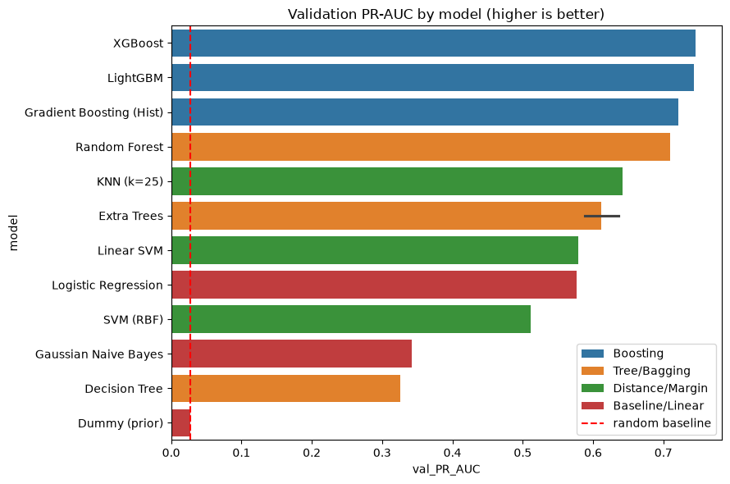
Figure 8: Validation PR-AUC by model before tuning (dashed line = random baseline; the two Extra Trees bars are the 200-tree and the depth-20 variants)
Interpretation: boosting leads because the data has non-linear and non-monotonic patterns (for example X19 rises then falls at the top end, and code columns have irregular effects) that trees capture and linear models cannot. Linear models show no train/validation gap but low scores, which is underfitting, not overfitting.

5.8 Over-fitting analysis and treatment
Why: A model that scores far better on training data than on new data is memorising. We measure the gap and then reduce model complexity.
How: Compared train and validation PR-AUC (Step 7), swept Decision Tree depth with a minimum leaf size, plotted the XGBoost learning curve with early stopping and regularization, and varied k for KNN.
Finding: Over-fitting was found in the Decision Tree, KNN with small k, and mildly in boosting; each was treated.
max_depth | Train PR-AUC | Val PR-AUC | Gap
4 | 0.357 | 0.357 | 0.001
8 | 0.539 | 0.532 | 0.007
12 | 0.634 | 0.593 | 0.041
15 | 0.713 | 0.634 | 0.079
20 | 0.773 | 0.640 | 0.133
None | 0.808 | 0.643 | 0.165

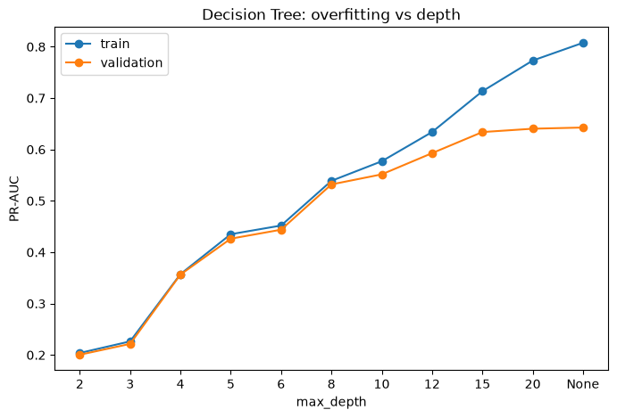 | 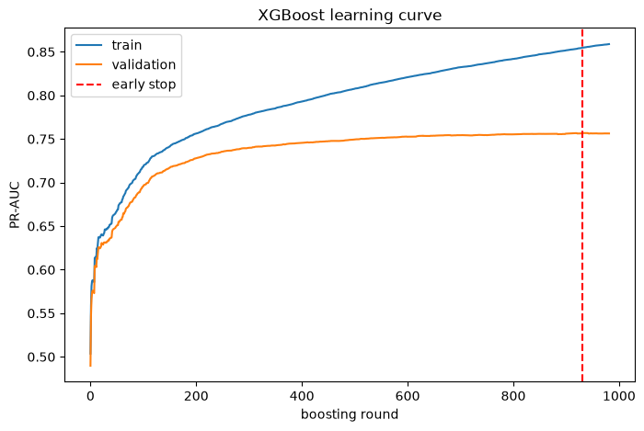
Figure 9: Left: Decision Tree train vs validation PR-AUC by depth. Right: XGBoost learning curve with early stopping
Model | Problem | Treatment | Result
Decision Tree | Memorised training data (train 1.00, val 0.33) | min_samples_leaf = 20, max_depth about 15 | Val PR-AUC 0.33 to 0.63, gap 0.67 to about 0.08
XGBoost | Mild over-fit (train 0.855, val 0.757) | Early stopping (best round 931), sub-sampling, reg_lambda, min_child_weight | Val PR-AUC 0.746 to 0.757
KNN | k = 1 gives 0.315 on validation | Larger k (about 50) | Val PR-AUC 0.315 to 0.623
Logistic Regression, Linear SVM | Underfit (no gap, score about 0.58) | Limited by linear form; not an overfitting issue | Unchanged

k (neighbours) | 1 | 5 | 15 | 25 | 50 | 100
Validation PR-AUC | 0.3149 | 0.5586 | 0.6089 | 0.6194 | 0.6229 | 0.6172

The biggest single fix is the minimum leaf size: a leaf with 1 to 5 users learns noise, so requiring 20 users per leaf roughly doubled the Decision Tree's validation PR-AUC. Note that early stopping uses the validation set, so its score is slightly optimistic, which is why the test set stays untouched until the end.

5.9 Hyperparameter tuning and final model selection
Why: Default settings are rarely optimal. Tuning with cross-validation inside the training set keeps the validation set an independent check.
How: RandomizedSearchCV with 3-fold stratified cross-validation, scored by average precision (PR-AUC): 15 candidates each for XGBoost and LightGBM and 8 for Random Forest (the Random Forest search alone took about 42 minutes).
Finding: LightGBM (tuned) was chosen: PR-AUC 0.7715 against 0.7663 for XGBoost, a much smaller train-validation gap (0.086 against 0.158) and faster training.
Model | Best parameters | CV PR-AUC
LightGBM | num_leaves 63, learning_rate 0.03, n_estimators 700, subsample 0.8, colsample_bytree 0.8, min_child_samples 50, reg_lambda 10, scale_pos_weight 1 | 0.7623
XGBoost | max_depth 8, learning_rate 0.05, n_estimators 700, subsample 0.7, colsample_bytree 0.8, min_child_weight 5, reg_lambda 1, gamma 0, scale_pos_weight 5 | 0.7579
Random Forest | n_estimators 300, max_depth None, min_samples_leaf 2, max_features 0.3, class_weight None | 0.7258

Two points worth noting: LightGBM's best scale_pos_weight was 1 and XGBoost's was 5 (not the full ratio of about 36), because ranking quality matters more than probability scale for PR-AUC; the class imbalance is handled instead through a tuned decision threshold. Both boosters chose slow learning rates, many trees and regularisation, consistent with the overfitting analysis.

5.10 Final evaluation on the test set
Why: The test set was never used for any decision, so its score is an honest estimate of performance on new users.
How: The tuned LightGBM was evaluated once, using the threshold 0.3762 selected on the validation set.
Finding: Test scores match validation, so tuning did not overfit the validation set.
Metric | Validation | Test
PR-AUC | 0.7715 | 0.7818
ROC-AUC | 0.9663 | 0.9703
Spammer precision | 0.814 | 0.813
Spammer recall | 0.676 | 0.691
Spammer F1 | 0.739 | 0.747

Model: LightGBM (tuned) | threshold: 0.3762
Test PR-AUC : 0.7818 Test ROC-AUC: 0.9703

precision recall f1-score support
Non-spammer 0.9915 0.9956 0.9936 66972
Spammer 0.8134 0.6910 0.7472 1848
accuracy 0.9874 68820
macro avg 0.9024 0.8433 0.8704 68820
weighted avg 0.9867 0.9874 0.9869 68820

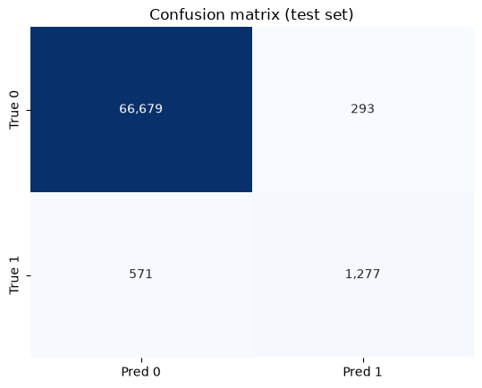 | 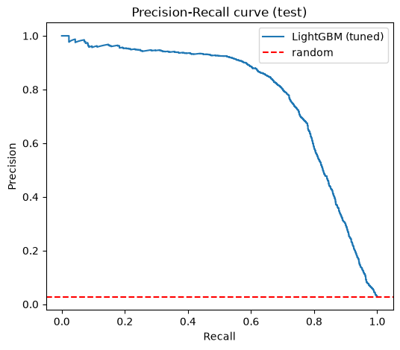
Figure 10: Left: confusion matrix (test set). Right: precision-recall curve (test set)
Reading the result: of every 10 users the model flags, about 8 are real spammers (precision 81%), and it catches about 7 in 10 of all spammers (recall 69%). Accuracy (98.7%) is not the headline figure, since always predicting 'not a spammer' scores 97.3%.
Threshold trade-off. The decision threshold can be moved depending on the business use. F1 is flat between 0.30 and 0.38, so the model is not sensitive to the exact cutoff.
Threshold | Users flagged | Precision | Recall | F1 | Suggested use
0.10 | 2,712 | 0.552 | 0.811 | 0.657 | Wide net for manual review
0.30 | 1,723 | 0.773 | 0.721 | 0.746 | Balanced, more recall
0.376 | 1,569 | 0.813 | 0.691 | 0.747 | Chosen (best F1 on validation)
0.50 | 1,363 | 0.862 | 0.636 | 0.732 | Fewer false alarms
0.80 | 965 | 0.928 | 0.484 | 0.636 | Automatic blocking

5.11 Feature importance and insights
Why: To understand what drives the predictions and check that they make business sense.
How: Importance by gain (the share of total loss reduction contributed by each feature) from the final LightGBM model.
Finding: X19 alone carries about 34.5% of the total gain, and the seven code columns (X2 to X8) together carry about 34.3%.
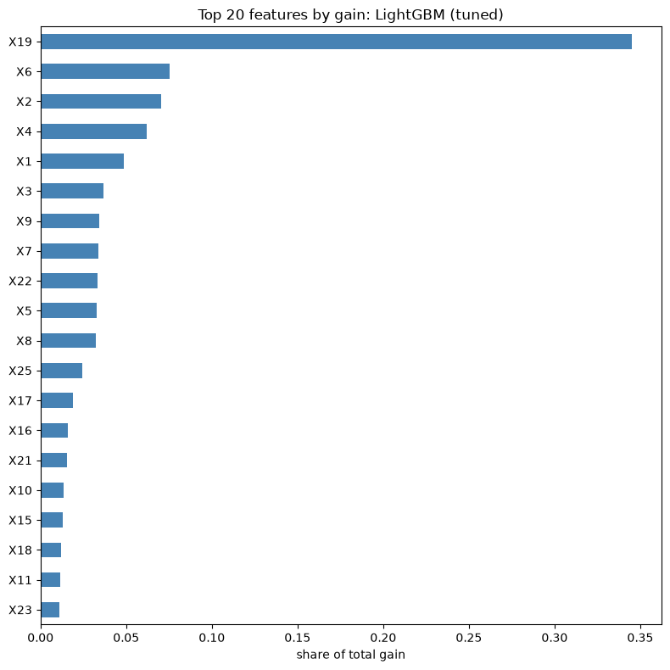  Figure 11: Top 20 features by gain: LightGBM (tuned)
  Rank | Feature | Share of gain
  1 | X19 | 34.5%
  2 | X6 | 7.5%
  3 | X2 | 7.0%
  4 | X4 | 6.2%
  5 | X1 | 4.9%
  6 | X3 | 3.7%
  7 | X9 | 3.4%
  8 | X7 | 3.4%
  9 | X22 | 3.3%
  10 | X5 | 3.3%
  11 | X8 | 3.2%
  12 | X25 | 2.4%
  13 | X17 | 1.9%
  14 | X16 | 1.6%
  15 | X21 | 1.5%
Insights: (1) the model relies on two groups of information, the X19 behaviour count and the user-segment codes X2 to X8; (2) X22, X9 and X25, whose large values indicate genuine users, add signal from the opposite side; (3) importance by gain describes how the model works, not causation; the columns are anonymised, so the business meaning of each cannot be stated.

5.12 Deployment: Streamlit application
Why: A model is only useful if someone can use it. A small web application lets moderators score one user or a whole file without writing code.
How: The saved LightGBM model, its threshold and the training medians are loaded by a Streamlit app (app.py). The app applies the same preparation as training (same columns, X10_is_1 flag, median for a missing X13) before predicting.
Finding: The app has three pages and a sidebar that switches the decision threshold between presets taken from the test-set trade-off table.
- Single user: enter the 17 most influential features (the rest are held at training medians); the app shows the spam probability, a colour-coded risk level, a bar with the threshold marked, and a chart of which features pushed the score up or down.
- Batch scoring: upload a CSV or Excel file; the app scores every user, shows the share flagged and the score distribution, lists the highest-risk users, and offers a download. If the file contains a label column, it also reports PR-AUC, precision, recall, F1 and a confusion matrix.
- About the model: test metrics, feature importance, the threshold trade-off table and a summary of how the model was built.
- Operating modes: Balanced (threshold 0.376, best F1), Wide net (0.10, recall 0.81), Strict (0.80, precision 0.93) and Custom.
How to run: pip install streamlit, then streamlit run app.py from the folder that holds app.py, lightgbm_spammer_model.pkl, model_metadata.json, feature_defaults.json and sample_users.csv.

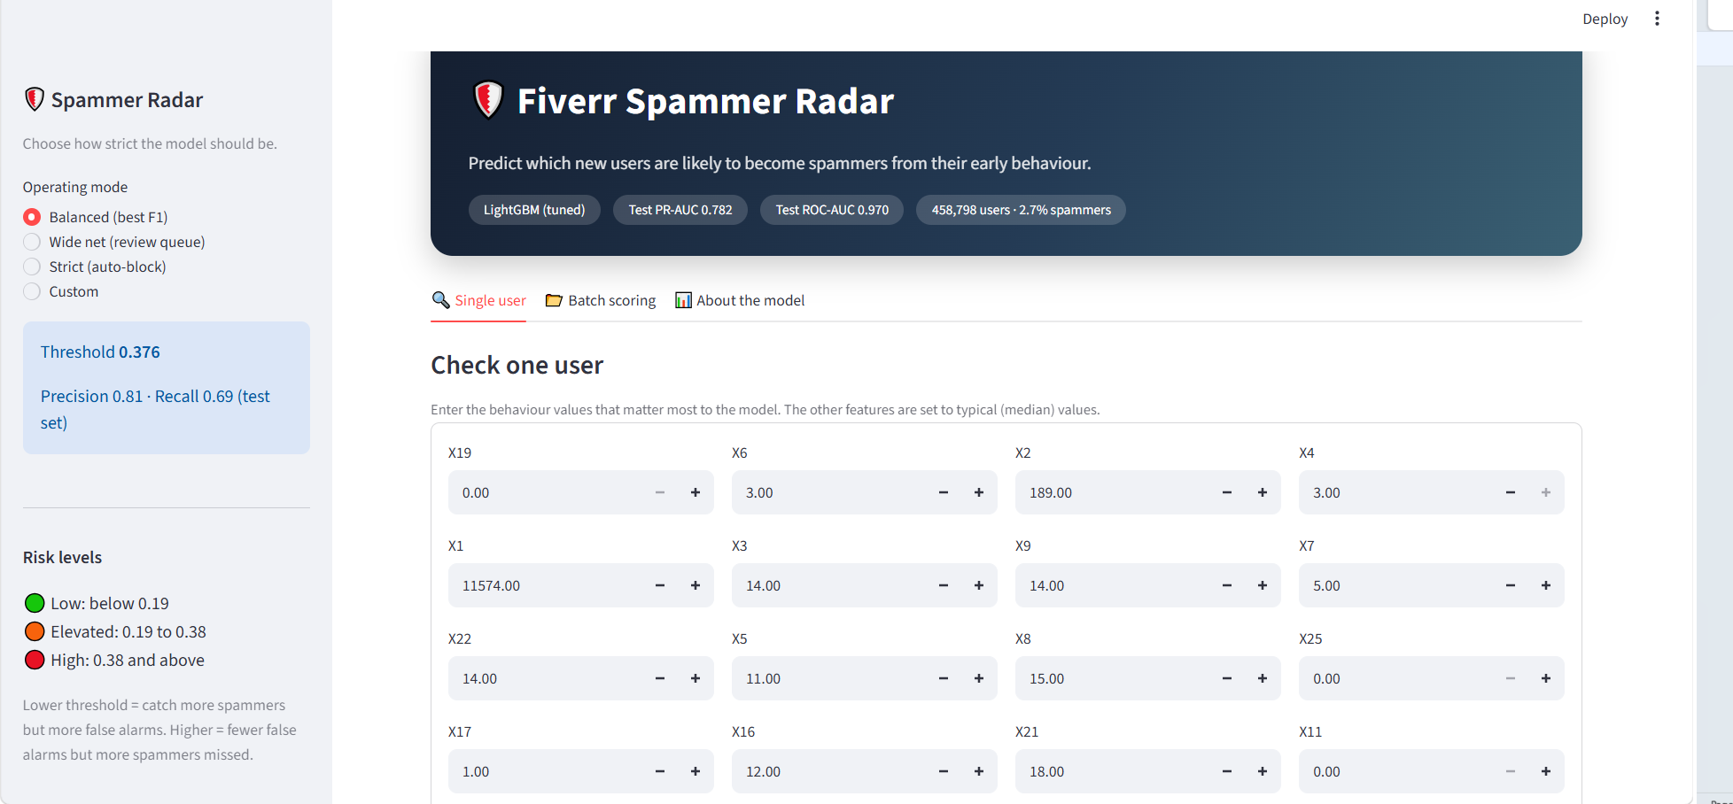
Figure 12: Streamlit app: single-user prediction page

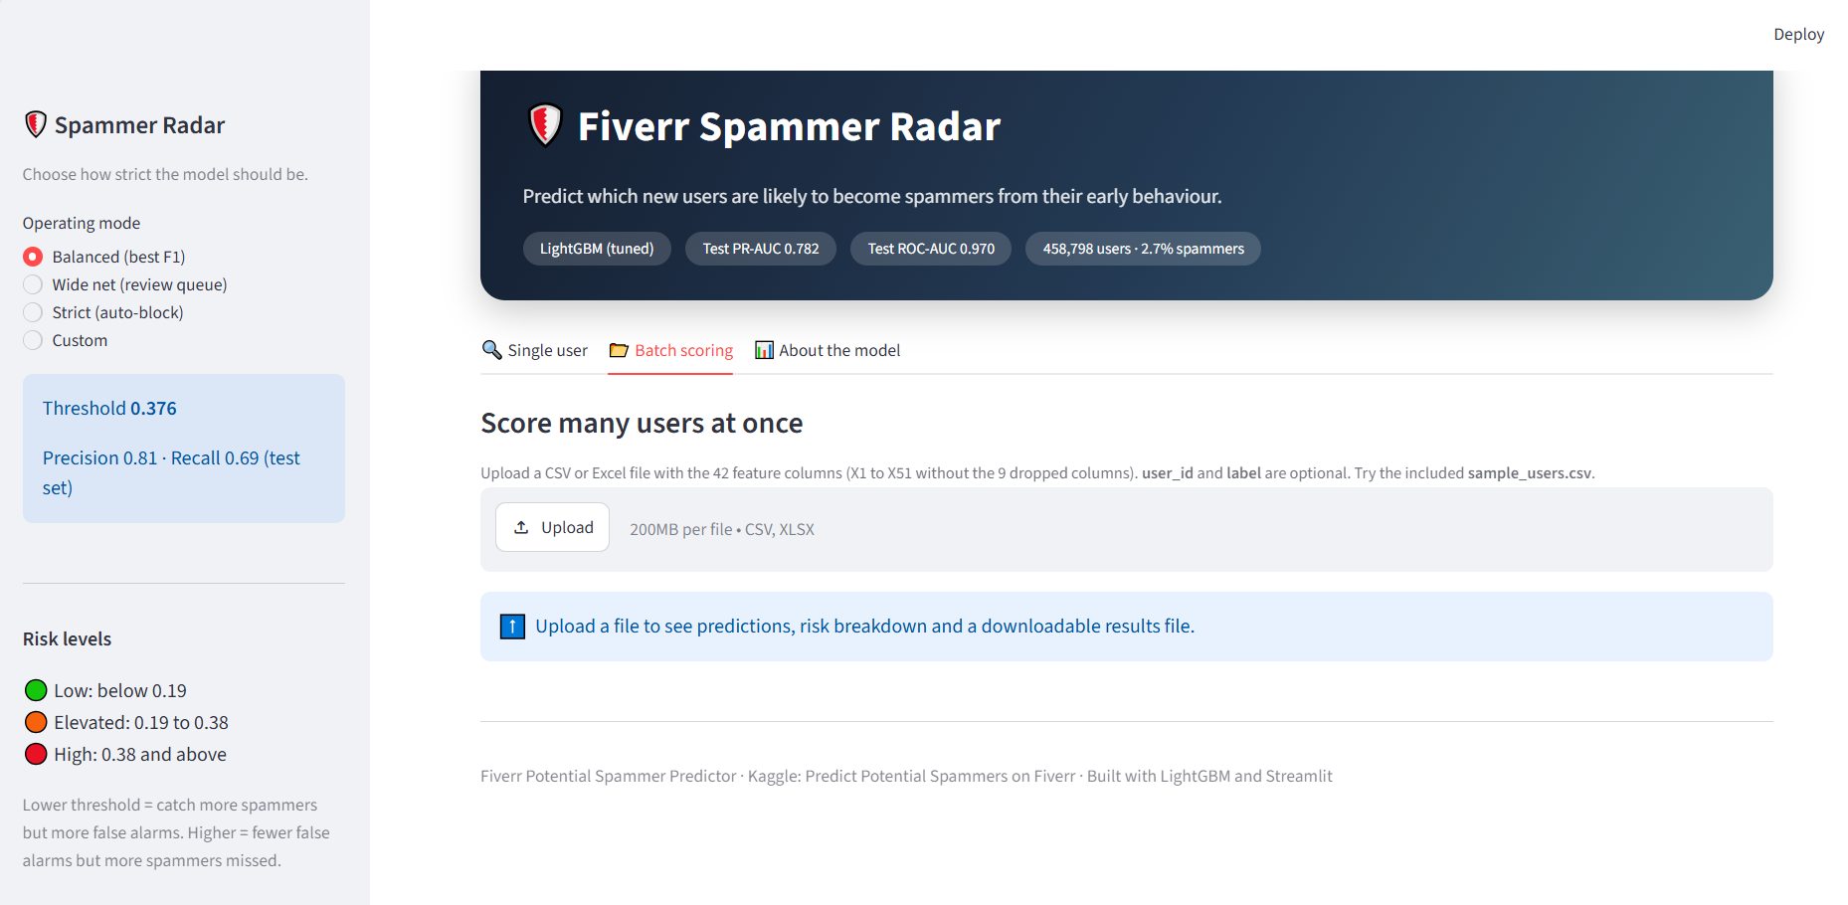
Figure 13: Streamlit app: batch scoring page (sample_users.csv uploaded)

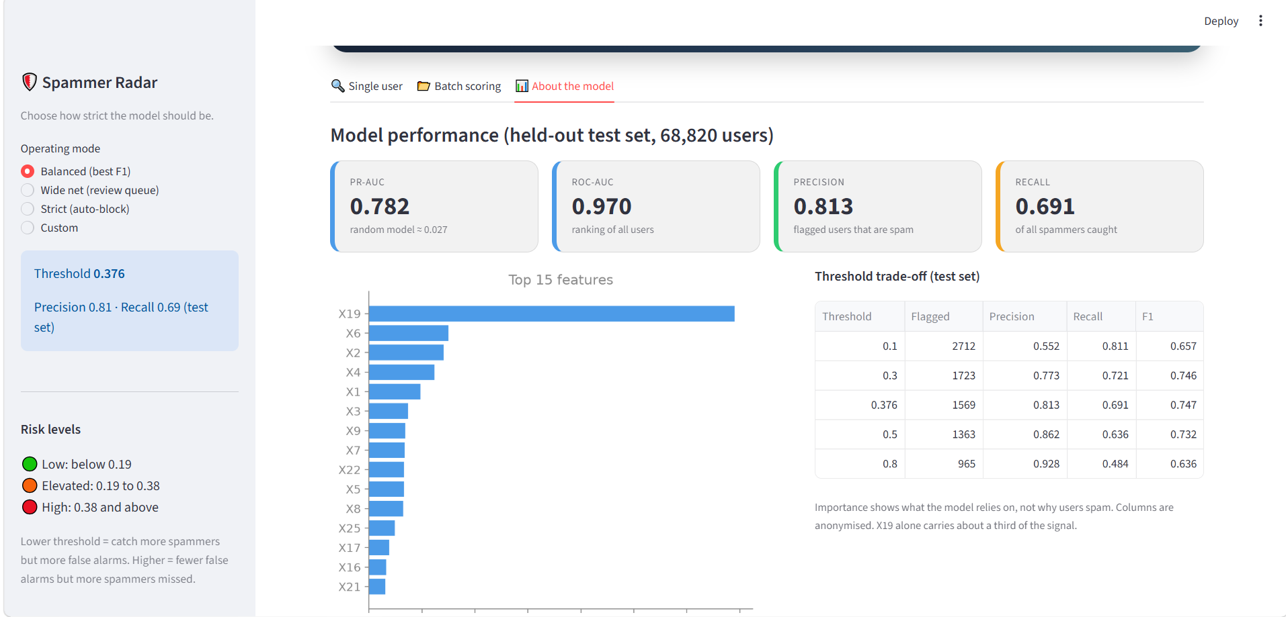
Figure 14: Streamlit app: About the model page

5.13 Limitations and conclusion
- About 41% of spammers have X19 = 0 and must be caught through the code columns and other features, which caps recall.
- 91 groups of behaviorally identical users have mixed labels (726 users), so a small share of errors is unavoidable.
- Only one labeled file was available (no external test file), so a stratified hold-out test set was created; the final score is for this hold-out set.
- Columns are anonymize, so findings are statistical patterns and not explained behaviour.
- Early stopping used the validation set; the test score is the unbiased figure.
- Future work: probability calibration, SMOTE or other resampling, model ensembling (LightGBM + XGBoost), time-based validation if sign-up dates become available, and monitoring for drift.
Conclusion. A tuned LightGBM classifier identifies potential Fiverr spammers with a test PR-AUC of 0.782 and ROC-AUC of 0.970, catching about 69% of spammers with 81% precision at the chosen threshold. Tree-based boosting clearly outperformed linear, distance-based and probabilistic models because the signal is non-linear and concentrated in a few behaviours and user segments.

6. Resources
Data set source: Kaggle competition 'Predict Potential Spammers on Fiverr': https://www.kaggle.com/competitions/predict-potential-spammers-on-fiverr (458,798 users, 51 anonymised behaviour features, binary label).
Software: Python 3 in Jupyter Notebook; pandas, NumPy, Matplotlib, Seaborn, scikit-learn, XGBoost, LightGBM, joblib.

