X-ray Data Analysis in Real Time (XDART)

Contents
Scanning Area Detector (ttheta_scan) 3
Getting Started: 3
HDF5 Viewer 4
Metadata Panel 5
Data Viewer Panel 6
Integrator Panel 7
Wrangler Panel 8
Appendix 10
pyFAI Geometry 10

Scanning Area Detector (ttheta_scan)

Getting Started:
When first opened, XDART will produce a screen as follows:
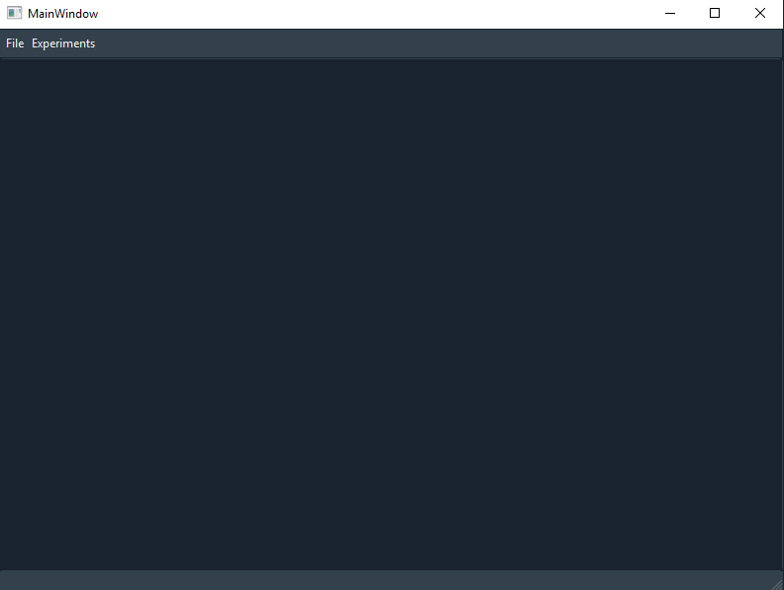
Under “Experiments” in the top toolbar, select “ttheta_scan” to launch the interface. This will create a new tab, shown below:
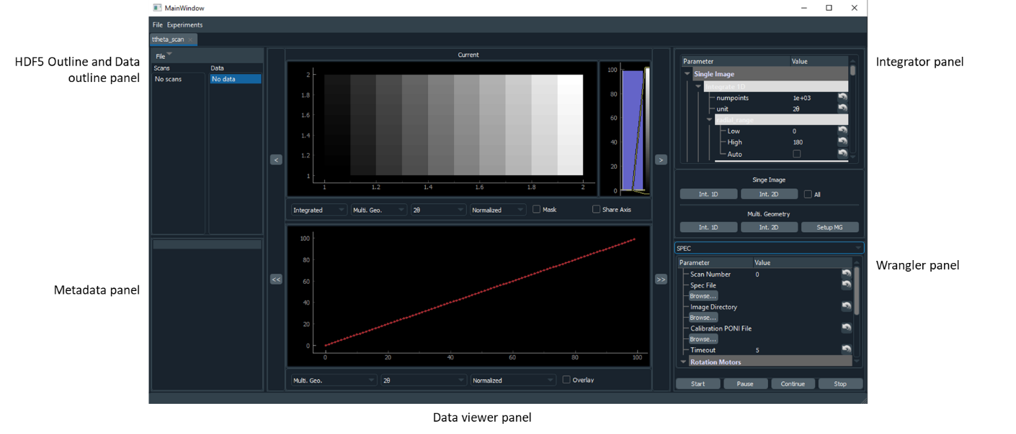
The tab is split into five sections, the HDF5 Viewer, Metadata, Data viewer, Integrator, and Wrangler panels. Each is explained in subsequent sections.

HDF5 Viewer
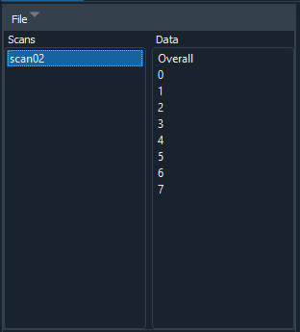
The HDF5 viewer displays the contents of the current data file in two lists. First is a view of the scans in the data file, and second a view of all images in the scan. If no data file is loaded, the list will display “No Scans”. Double clicking on a scan in the “Scans” list will load that scan into memory. Clicking on an image in the data list will display that image. Clicking “Overall” will display the overall data.
The “File” menu contains the following options:
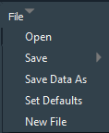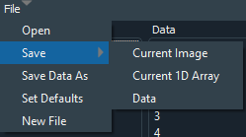
- Open: opens new data file (HDF5 format)
- Save:
  - Current image: saves the currently displayed image, available formats are displayed in the file dialog
  - Current 1D Array: saves the currently displayed array, either csv or xye format.
  - Data: saves the data to the HDF5 file
- Save data as: saves data to new HDF5 file
- Set Defaults: brings up window to set default parameters for integrator and wrangler. Can save and load defaults from json file.
- New File: creates new HDF5 data file

Set Defaults
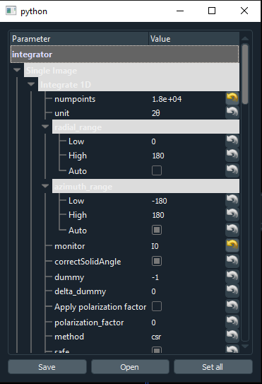
“Set Defaults” will create the above pop-up window. The “Set all” button will set all the current values as the default values, which can be reloaded using the circle arrow button in the parameter trees. “Save” will pull up a save dialog to save all defaults, and “Open” will load defaults in from a file and set them.

Metadata Panel
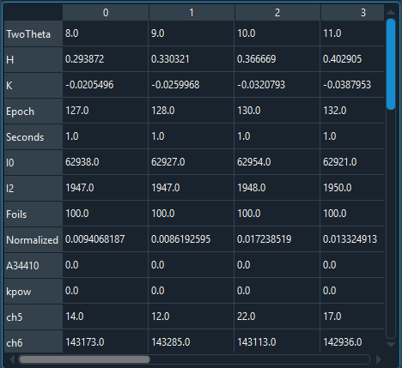
The metadata panel displays all metadata from the overall scan or individual images depending on selection in HDF5 Viewer panel.

Data Viewer Panel
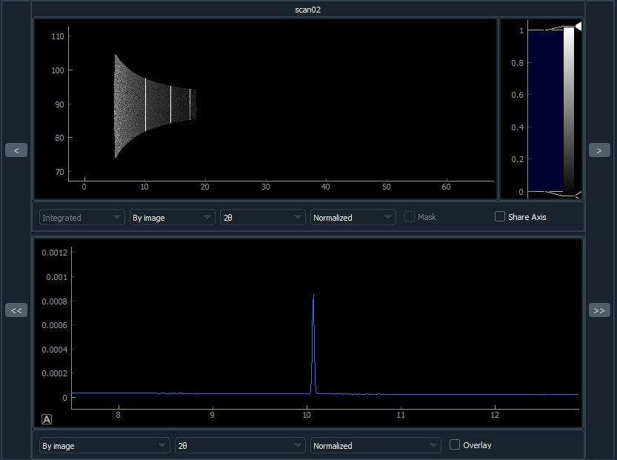
The data viewer panel displays image data (top) and integrated data (bottom). Arrows on the left and right cycle through images in the overall scan. These are disabled if “Overall” is selected. If the double right arrow button is pushed and a scan is actively being loaded, it will automatically move to the latest image during collection.
For both display areas, dragging the left mouse button will display a box, releasing the mouse button will zoom into that area. Right clicking will bring out the full view. If the ranges are not already set to automatically adjust to new data, a letter “A” in a box will appear in the lower left of the panel. Clicking this will enable automatic range adjustment.
Image options:
- Integrated vs Raw: whether raw or integrated data is displayed. Only available with individual images.
- By Image vs Multigeometry: method for integration, either image by image or using pyFAI’s multigeometry class.
- Unit: unit for X axis.
- Normalized, Raw, Pixel Count: What data is displayed for integrated data.
- Mask: whether the mask is overlaid on top.
- Share Axis: whether to share the same X-axis range between top and bottom data.
Array options:
- By Image vs Multigeometry: method for integration, either image by image or using pyFAI’s multigeometry class.
- Unit: unit for X axis.
- Normalized, Raw, Pixel Count: What data is displayed for integrated data.
- Overlay: whether to overlay the overall data with individual image data. NOTE: when saving the 1D arrays, only individual image data will be saved, not the overlaid data.

Integrator Panel
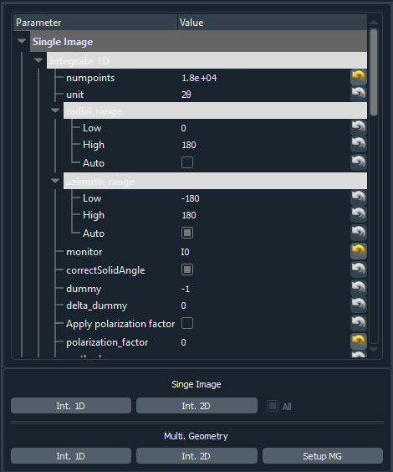
This panel controls the integration for data loaded from the file. Parameters are split into single image integration and multigeometry integration. For both options, there are 1D and 2D settings. For an explanation of the “Single Image” parameters, see integrate1d and integrate2d at https://pyfai.readthedocs.io/en/latest/api/pyFAI.html#module-pyFAI.azimuthalIntegrator. For an explanation of the multigeometry parameters, see MultiGeometry, integrate1d, and integrate2d at https://pyfai.readthedocs.io/en/latest/api/pyFAI.html#module-pyFAI.multi_geometry.
Beneath the parameter tree there are five buttons and one check box. The “Single Image” buttons start integrating individual images. If “All” is checked, it will integrate all images in the data object and update the overall data. If a single image is selected in the HDF5 Viewer, and “All” is not checked, than only the current image will be integrated and the overall data will not be updated. Newly integrated data will not be saved until “Save Data” is used in the HDF5 Viewer panel.

Wrangler Panel
XDART is designed to have flexible data intake. This is handled by the “Wrangler” panel. The default is a static SPEC wrangler. Currently SPEC and Live SPEC are the only available Wranglers. All wranglers will save data to the active data file (if no data file is opened than the user will be prompted for a new data file). This is automatically loaded for the first scan. The user can load older scans if they want to look at older data or re-integrate older data in the file. Integration will be disabled if the loaded scan name matches the scan name currently being wrangled. CAUTION: WRANLGER WILL OVERWRITE EXISTING DATA IF IT HAS THE SAME SCAN NUMBER!

SPEC

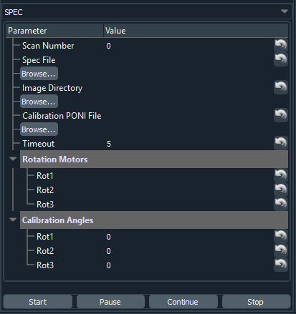
The SPEC wrangler is designed to work with data collected using SPEC. It requires the following input from the user:
- Scan Number: number used in the SPEC file, denoted in the file by #S
- Spec File: Path to the relevant Spec File. “Browse…” will bring up a file dialog to search for this path.
- Image Directory: Directory with image data
- Calibration PONI File: PONI file from calibration
- Timeout: How long to wait for new image data to be available. The Wrangler will continue to look for new data until this limit is reached.
- Rotation Motors: The name of the rotation motors in the Spec file. These must be the names in the row denoted by #L. NOTE: For 2-1, the two-theta motor is entered in Rot2. pyFAI geometry is displayed in the appendix, more info at https://pyfai.readthedocs.io/en/latest/usage/tutorial/Geometry/geometry.html.
- Calibration Angles: Angles at which calibration was done. Will be 0 if direct beam approach was used.
The four buttons have the following functions:
- Start: start looking for data. Can be launched with an active scan running.
- Pause: pauses data wrangling
- Continue: continues looking for data
- Stop: stops data wrangling
While data wrangling is in progress, all parameters will be frozen until data wrangling completes or the “Stop” button is pushed. “Pause” does not allow for adjustment of parameters.

Live SPEC
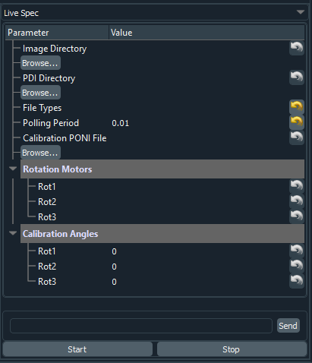
Live SPEC is designed to also work with Spec data, but to directly interface with Spec instead of relying on the Spec file. Inputs are:
- Image Directory: directory where images are stored. Should be the detector computer directory.
- PDI Directory: directory where pdi files will be stored.
- File Types: File types to look for, separated by spaces. Should be pdi and raw for most cases.
- Polling Period: how often to check for new files.
- Calibration PONI File, Rotation Motors, Calibration Angles: see SPEC
Beneath the parameters is a command line. Commands entered here are sent on to SPEC, operates much like the SPEC command line. Up and down arrows will cycle through old commands. The “Start” and “Stop” buttons trigger polling for new files and wrangling images. The command line is active regardless of whether or not polling is active.

Appendix

pyFAI Geometry
