**R1 program metadata updates**

There will be annual HS code & country adjustment announced by Census & Statistics Department, HK

[https://www.censtatd.gov.hk/trader/declaration/ccp/index_tc.jsp](https://www.censtatd.gov.hk/trader/declaration/ccp/index_tc.jsp%20)

link above may be changed due to new updated version of Census & Statistics Dept, HK website starting Apr 2021

Prominent HS code adjustment every 5 years: 2007, 2012, 2017, 2022, etc;

Minor adjustment in other years are expected.

* [2017年修改部分（於1.1.2017生效）](https://www.censtatd.gov.hk/FileManager/EN/Content_93/HKIECL2017_amendment_booklet_20161102.pdf) https://www.censtatd.gov.hk/FileManager/EN/Common/pdf.gif
* 2017年版 [第1冊](https://www.censtatd.gov.hk/hkstat/sub/sc230_tc.jsp?productCode=B2XX0011) https://www.censtatd.gov.hk/FileManager/EN/Common/pdf.gif[/ 第2冊](https://www.censtatd.gov.hk/hkstat/sub/sc230_tc.jsp?productCode=B2XX0012) https://www.censtatd.gov.hk/FileManager/EN/Common/pdf.gif
* [2012年修改部分（於1.1.2012生效）](https://www.censtatd.gov.hk/FileManager/EN/Content_93/HKIECL2012_amendment_booklet_20130624.pdf) https://www.censtatd.gov.hk/FileManager/EN/Common/pdf.gif
* 2012年版 [第1冊](https://www.censtatd.gov.hk/fd.jsp?file=B2XX00192012XXXXB0100.pdf&product_id=B2XX0011&lang=1) https://www.censtatd.gov.hk/FileManager/EN/Common/pdf.gif[/ 第2冊](https://www.censtatd.gov.hk/fd.jsp?file=B2XX00202012XXXXB0100.pdf&product_id=B2XX0012&lang=1) https://www.censtatd.gov.hk/FileManager/EN/Common/pdf.gif
* [2007年修改部分（於9.2.2007生效）](https://www.censtatd.gov.hk/FileManager/EN/Content_93/HKIECL2007_amend_wef20080209_booklet_20081121.pdf) https://www.censtatd.gov.hk/FileManager/EN/Common/pdf.gif
* [2007年修改部分（於1.1.2007生效)](https://www.censtatd.gov.hk/FileManager/EN/Content_93/HKIECL2007_amend_booklet_20081121.pdf) https://www.censtatd.gov.hk/FileManager/EN/Common/pdf.gif
* 2007年版 [第1冊](https://www.censtatd.gov.hk/fd.jsp?file=B2XX00112007XXXXB0300.pdf&product_id=B2XX0011&lang=1) https://www.censtatd.gov.hk/FileManager/EN/Common/pdf.gif[/第2冊](https://www.censtatd.gov.hk/fd.jsp?file=B2XX00122007XXXXB0400.pdf&product_id=B2XX0012&lang=1) https://www.censtatd.gov.hk/FileManager/EN/Common/pdf.gif

**Using 2021 updated version for illustration:**

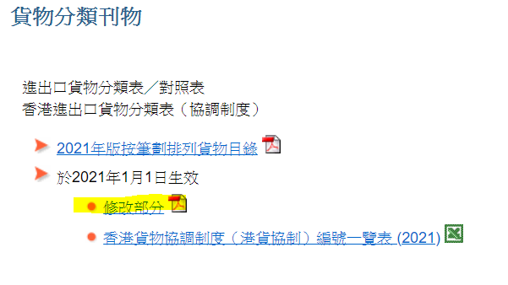

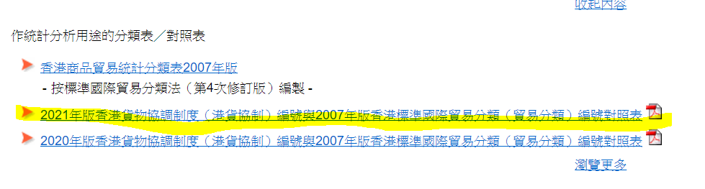

Download the above highlighted link pdf

Save the pdf files in folder: 2021 amendment

* HKIECL2021_amendment_booklet.pdf
* Correlation2021_HK-HS.pdf

**HKIECL2021_amendment_booklet.pdf**

* HS-8 digit code Chinese & English Names adjustment
* Highlighted are newly added HS-8 digit code

(63079010, 63079090, 71042011, 71042019, 71049021, 71049029)

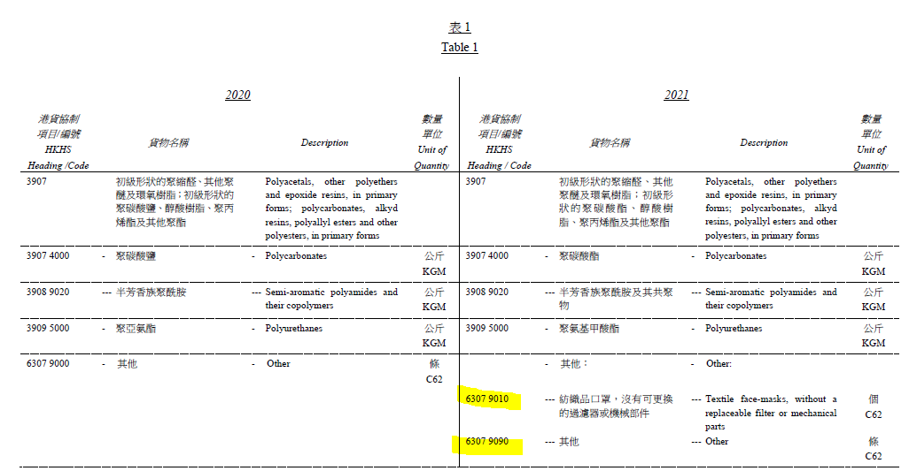

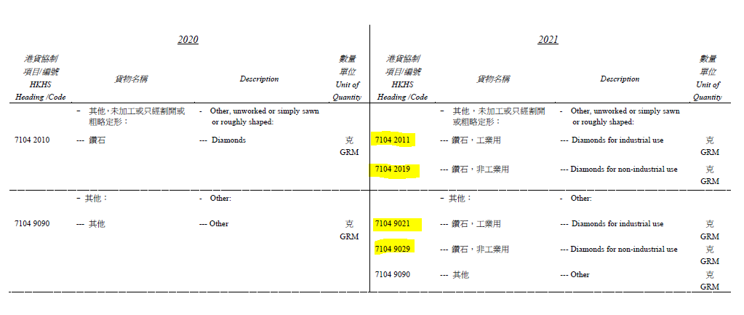

Country info adjustment

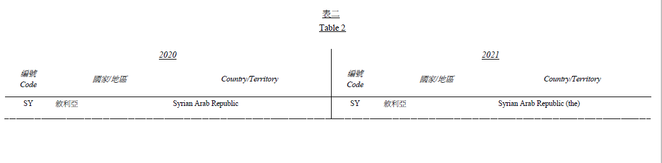

**Correlation2021_HK-HS.pdf**

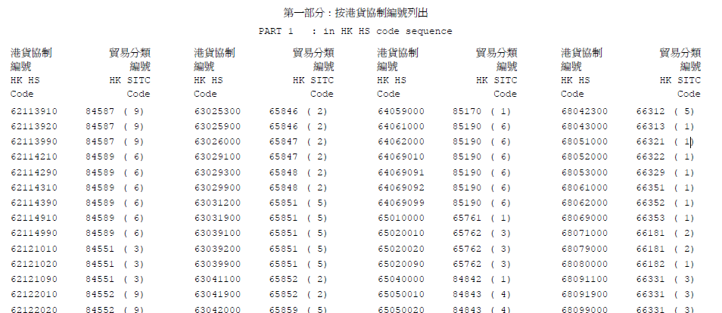

* This is the mapping file for converting HS-8 digit to SITC-5 digit code

e.g. 63079010 to 65893

2 files in metadata folder are related, to be adjusted.

geography.xlsx

* adjust the country information when there are drastic changes

sitc2hs.xlsx

* adding new rows for SITC-5 and HS-8 code conversion