Accessibility Report - Chap001.pdf
Generated on: 2025-05-13 at 15:07:14
File analyzed: Chap001.pdf
Summary: Found 5 image(s) missing alt text.

Location | Image | Alt Text
Page 1, Image 1 | 
Page 5, Image 1 | 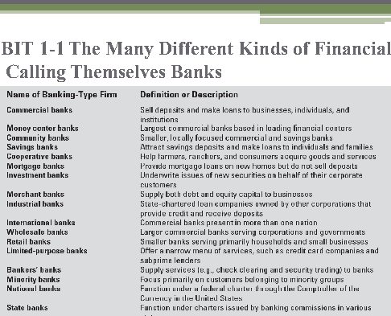
Page 12, Image 1 | 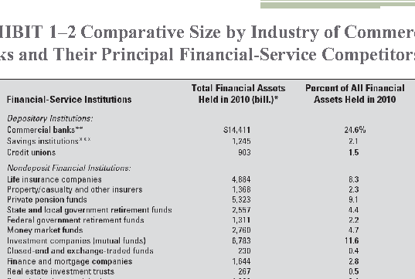
Page 15, Image 1 | 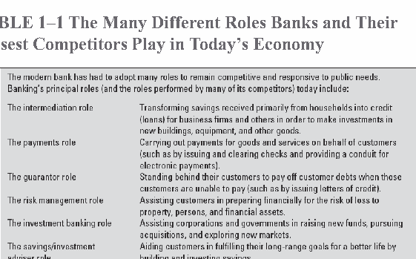
Page 16, Image 1 | 

