Final Project: create your own R package

Linda Doobay

April 18, 2018

## LIS4930.724S18 - R Programming - lexp package

The lexp package takes input x (country), reads the world bank repository data for life expectancy at birth, unzips, format and filters the data and returns a timeseries chart for the inputed country for the period of 1960 to 2015.

Below is the code that can be used to test the package:

library(lexp)  
#---- call lexp function for a particular country to obtain a timeseries chart of Life Expectancy from 1960 to 2015 ---------#  
lexpCountry <- "Brazil"  
plotCountry <- getCDCData(lexpCountry)  
plotCountry

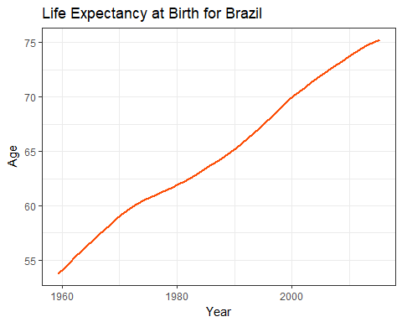

#---- call lexp function using an invalid Country Name ---------#  
lexpCountry <- "Michigan"  
plotCountry <- getCDCData(lexpCountry)  
plotCountry

## [1] "Please enter a valid country name with first letter capitalized"