Main()

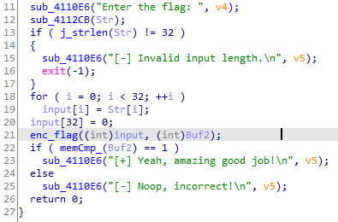

sau khi enc_flag, kqua se dc luu vao buf2 va so sanh vs chuoi o memCmp_(buf2)

Enc_flag()

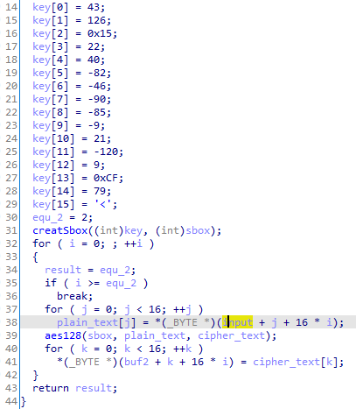

len(fake_flag) = 32 se dc chua lam 2 phan 16 ky tu va dc enc = aes128

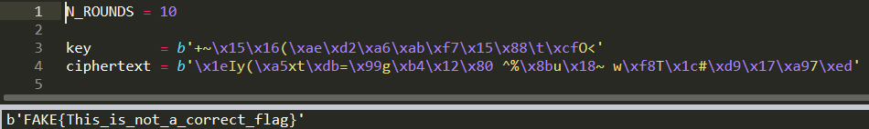

Real executed code:

e dung capa-explorer mo tu encode base64 len

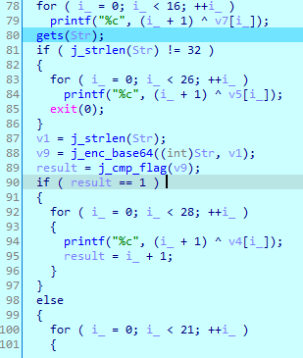

for o dong 78 in “Enter the flag: “, dong 81 => len(flag) = 32

flag dc enc = base64

cmp_flag:

