

02/03/2021

**To Whom It May Concern**

This is certified that Mrs. Neha Mishra is working with us as Business Analyst since 21-Jan-2019 , on a permanent basis. Her permanent address is as under :

**Permanent Address** **Current Address**

1/645, Sector 1,Vikas Nagar 3rd Floor House Number 532, Sector 47,

,Lucknow, Uttar Pradesh, Gurgaon - 122011

226022

Yours sincerely,

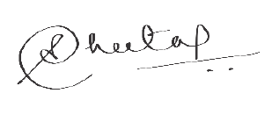

Sheetal Sandhu

Head – Human Resources (India)

Registered Office –7th, 8th, 9th & 10th Building No. 6 Sector 48 Tikri IT/ITES SEZ, Candor Gurgaon, Sector 48, Gurugram, Haryana 122001, India

2 / Evalueserve SEZ (Gurgaon) Private Limited ©2019 Evalueserve

