GYM MANAGEMENT SYSTEM
Object-Oriented Programming Project
Java Swing Desktop Application
Brought to you by:
Omar Khaled Adi ( 202510305 )
Bishara Hinn ( 202510008 )
Object-Oriented Programming Course
Al Ain University — College of Engineering

Introduction
This project is a Java-based Gym Management System built with the Swing graphical user interface (GUI) toolkit. The application provides a single desktop program that a gym receptionist or administrator can use to manage members, trainers, membership plans, workout schedules, and financial records (payments and refunds).
The system starts at a login screen and, once the user signs in, opens a main dashboard that gives access to each management module through a sidebar and a menu bar. All records are stored on disk as CSV files, so the data entered in one session is still available the next time the application is opened.

Objectives
- Provide a login screen with username and password verification.
- Manage gym member information, including adding, editing, and deleting members.
- Manage trainer information, their specialization, and the member they are assigned to.
- Display the available membership plans and their prices.
- Schedule workout sessions for members with an assigned trainer, day, and time.
- Record financial transactions (payments and refunds) for each member.
- Validate user input and store all data persistently in CSV files.
- Apply object-oriented programming concepts together with Java Swing GUI components.

Tools and Technologies
- Language: Java (standard JDK, no external dependencies).
- GUI toolkit: Java Swing (JFrame, JPanel, and related components).
- Data storage: Plain-text CSV files written and read with java.nio.file.
- Paradigm: Object-Oriented Programming (encapsulation, inheritance, polymorphism).
- Version control: Git and GitHub for collaboration.

Running the Application
The program entry point is the Main class. On start-up it applies the global theme, loads any previously saved data from the CSV files, and then displays the login screen. The login is validated against a built-in administrator account:
- Username: admin
- Password: 1234
After a successful login, the main dashboard opens in maximized mode and the user can navigate between modules.

System Features

Login Screen
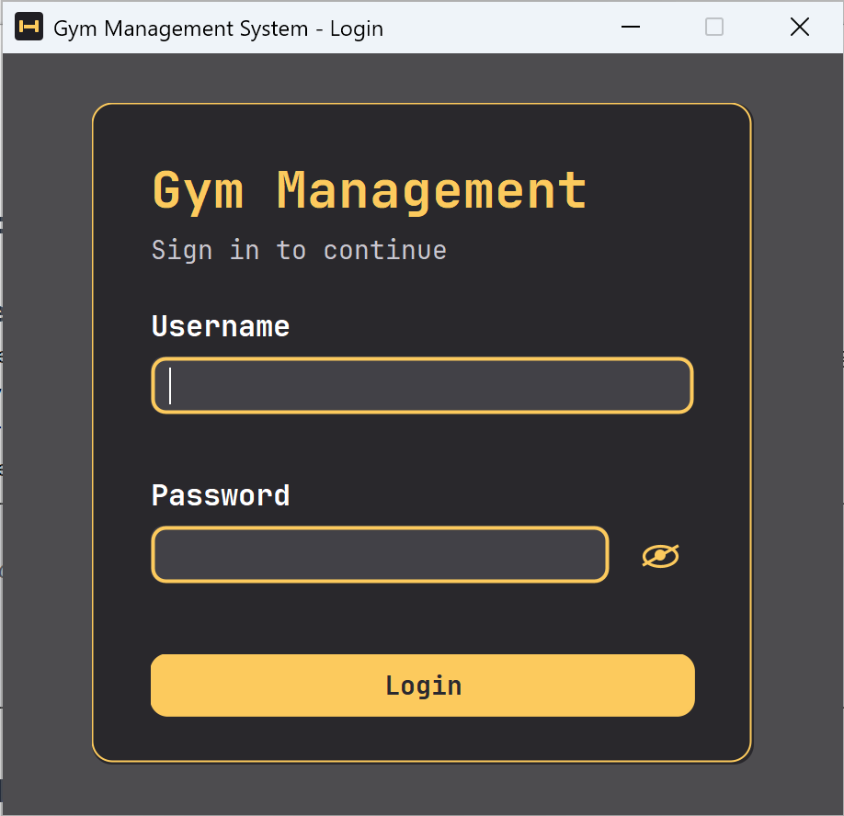
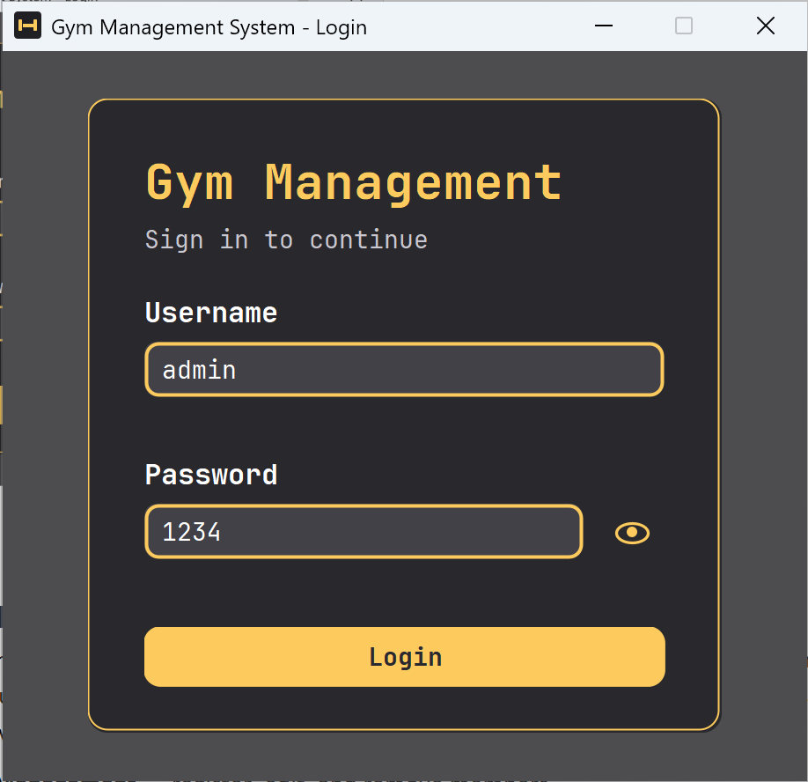
The login screen asks for a username and password. Each field shows an inline error message if it is left empty or if the credentials are incorrect, and the text that was typed is preserved. Pressing Enter in either field also attempts to sign in. When the credentials are correct, the main dashboard opens.
Figure 1: Login screen.

Main Dashboard
After signing in, the dashboard opens maximized and shows a welcome page with the prompt to choose a module. Navigation is provided in two ways: a sidebar on the left and a menu bar at the top. The available options are:
- Member Management — register, edit, and remove members.
- Trainer Management — add trainers and assign them to members.
- Membership Plans — view the available plans and prices.
- Workout Schedule — schedule training sessions.
- Financing — record member payments and refunds.
- Dashboard Home, Log Out, and Exit — return to the welcome page, sign out, or close the app safely.
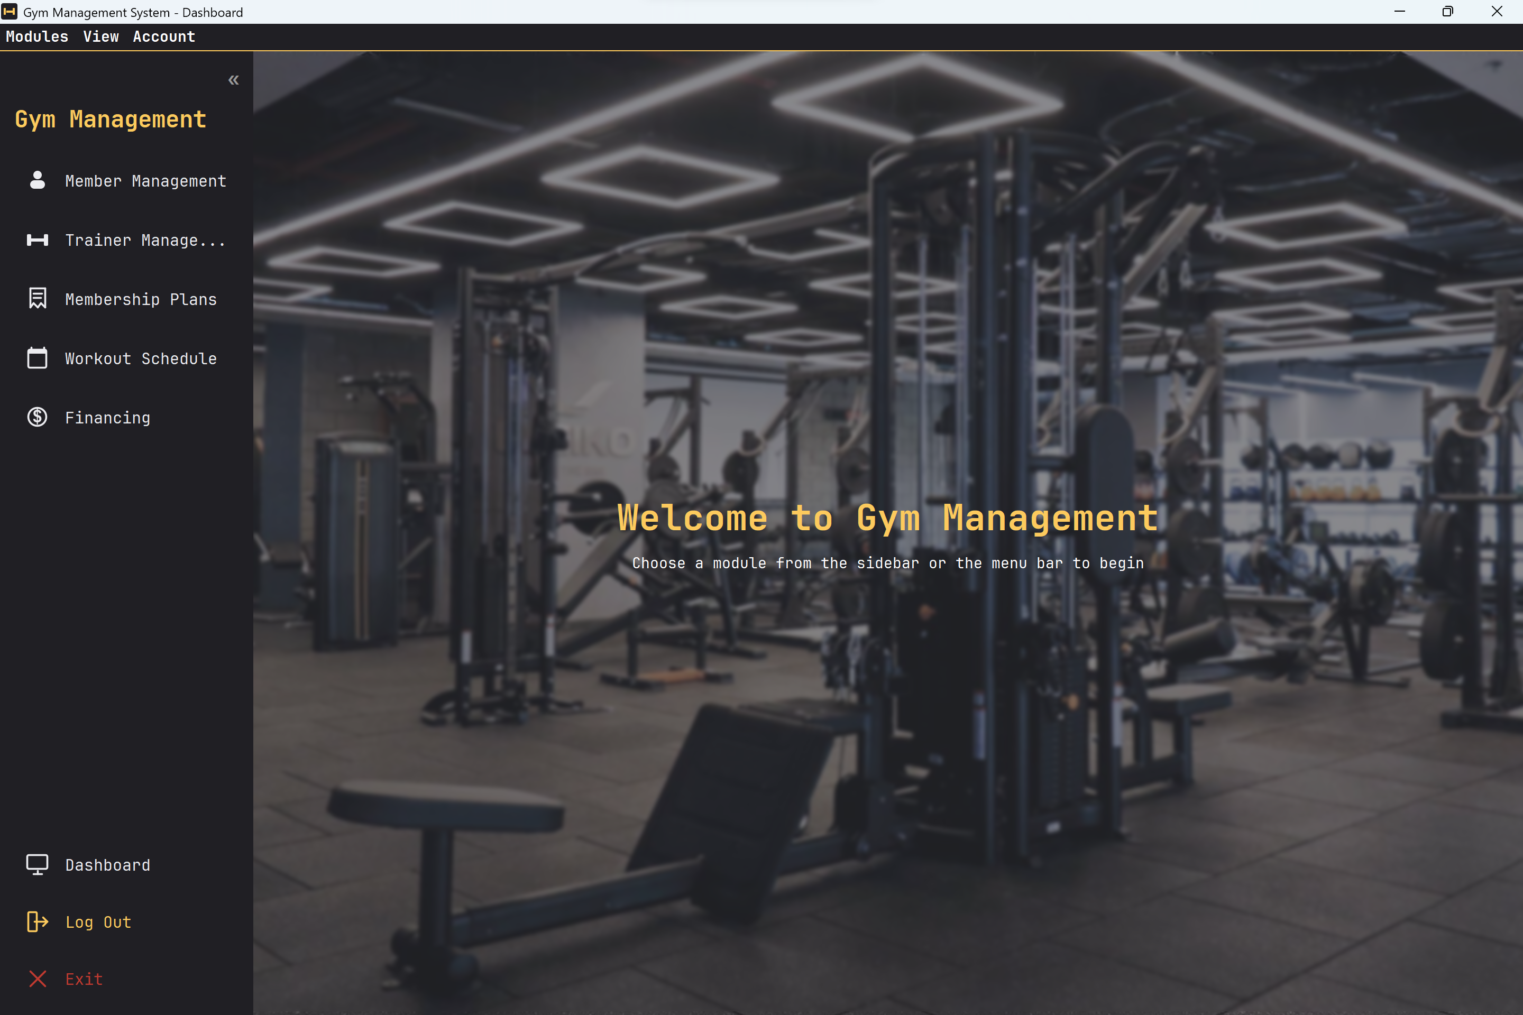
Figure 2: Main dashboard with the sidebar and welcome page.

Member Management
The Member Management screen is used to register and maintain members. It collects the following details:
- Member Name
- Age
- Phone Number
- Email
- Gender (Male or Female, chosen with radio buttons)
- Membership Type (Monthly, Quarterly, or Yearly, chosen from a combo box)
- Fitness Goals (Weight Loss, Muscle Gain, Cardio, chosen with check boxes)
- Additional Notes (free text)
Members are listed in a table below the form. Selecting a row loads it back into the form so it can be updated. The buttons are Add Member (which becomes Save Changes while editing), Delete, Clear, and Back. Empty or invalid fields are rejected before a member is saved.
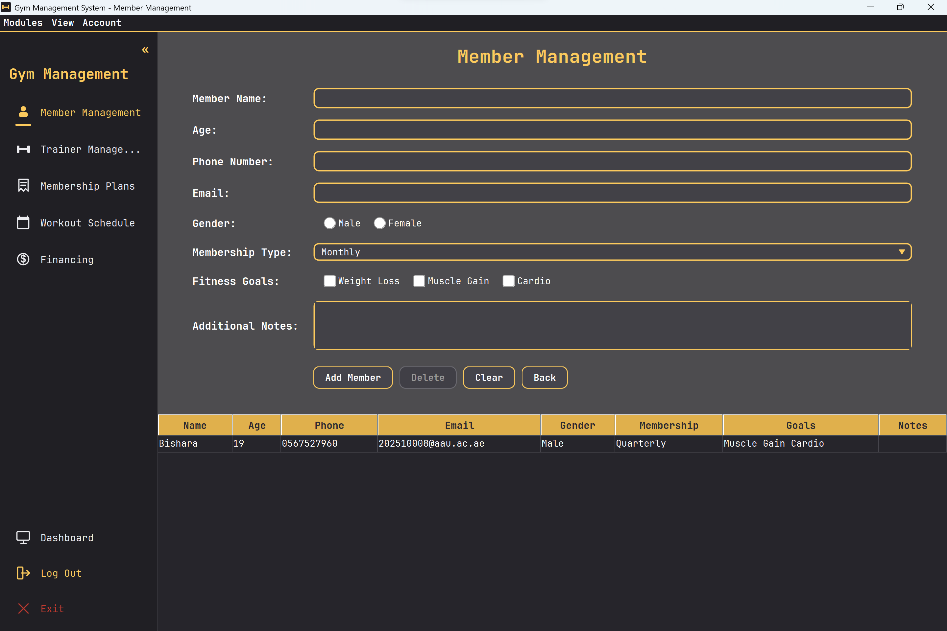
Figure 3: Member Management screen.

Trainer Management
The Trainer Management screen lets the user add trainers and assign them to members. It collects:
- Trainer Name
- Phone Number
- Email
- Specialization (Weight Loss, Muscle Gain, Cardio, Strength Training, or General Fitness)
- Assign to Member (None, or one of the existing members)
Saved trainers appear in a table showing the name, phone, email, specialization, and assigned member. As with members, a row can be selected to edit or delete it. The buttons are Add Trainer (Save Changes while editing), Delete, Clear, and Back.
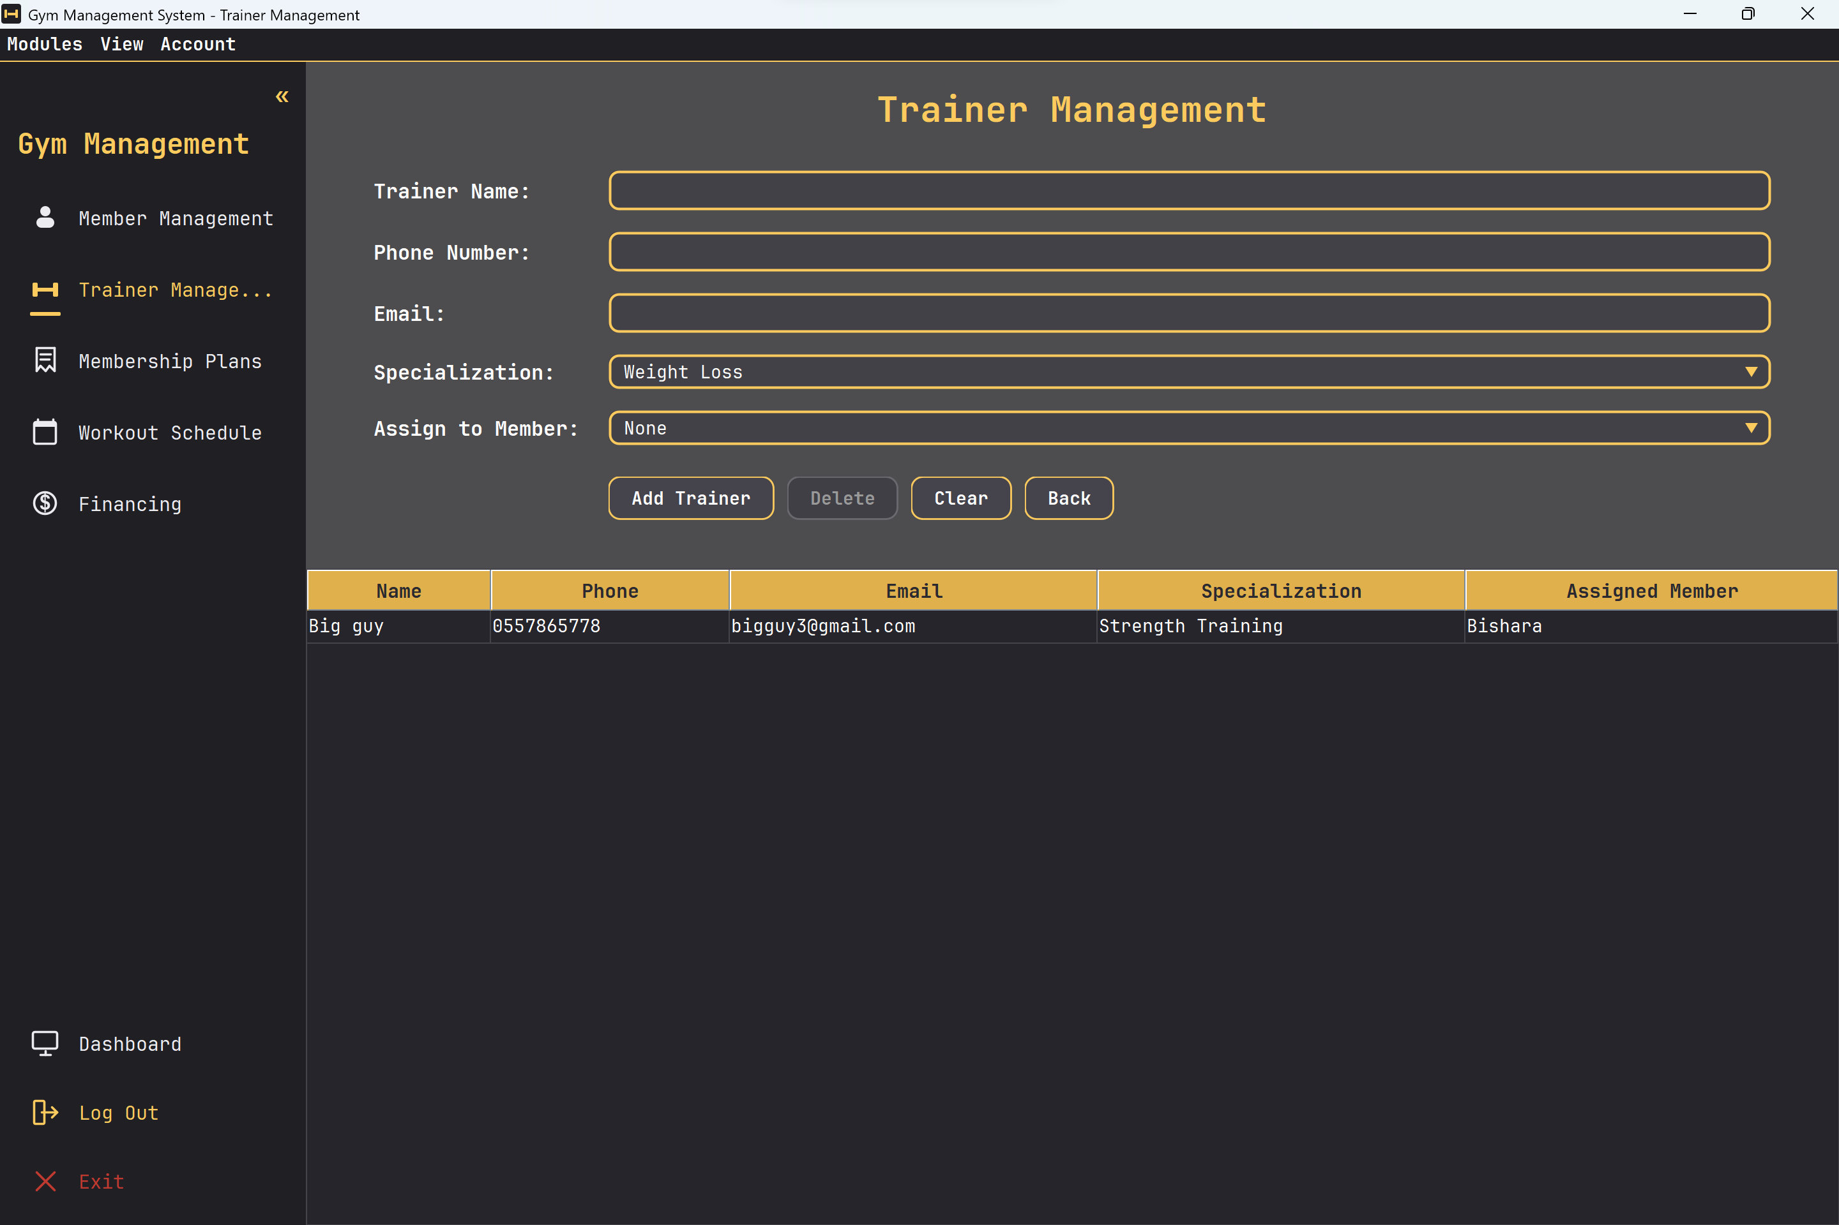
Figure 4: Trainer Management screen.

Membership Plans
The Membership Plans screen displays the three plans the gym offers. The plans and their prices come from a single shared definition in the code, so the same prices are used everywhere in the system:
- Monthly Plan — 100 AED — access for 1 month.
- Quarterly Plan — 250 AED — access for 3 months.
- Yearly Plan — 900 AED — access for 12 months.
This screen is informational only; it presents the plans and provides a Back button to return to the dashboard.
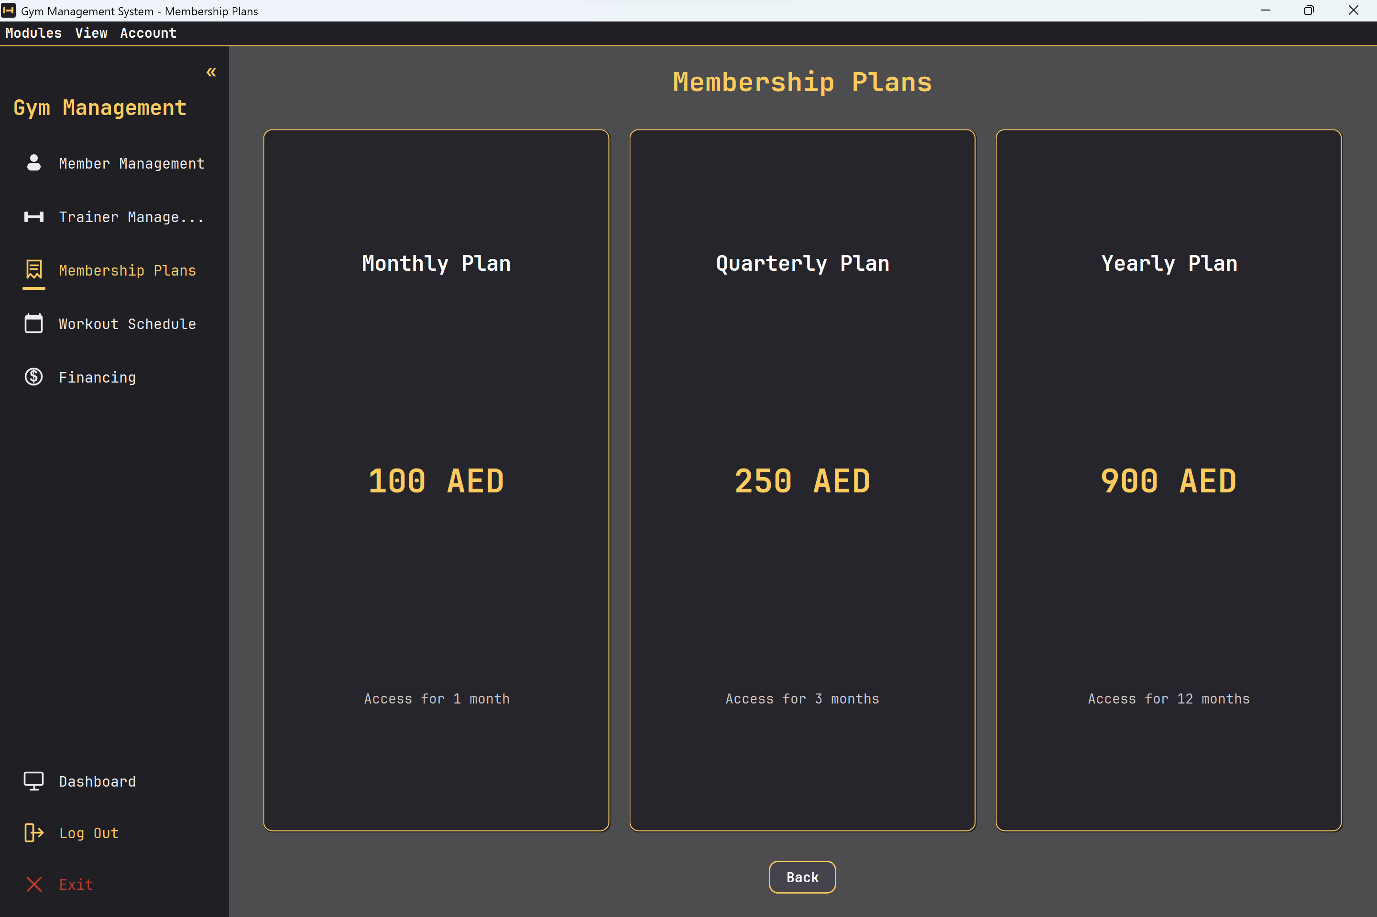
Figure 5: Membership Plans screen.

Workout Schedule
The Workout Schedule screen is used to book a training session for a member. The user selects:
- Member (from the registered members)
- Trainer (from the registered trainers)
- Workout Type (Cardio, Strength Training, Weight Loss, Muscle Gain, or General Fitness)
- Day (Monday through Sunday)
- Time (Morning, Afternoon, or Evening)
Saved schedules are listed in a table and can be selected for editing or deletion. The buttons are Save Schedule (Save Changes while editing), Delete, Clear, and Back.
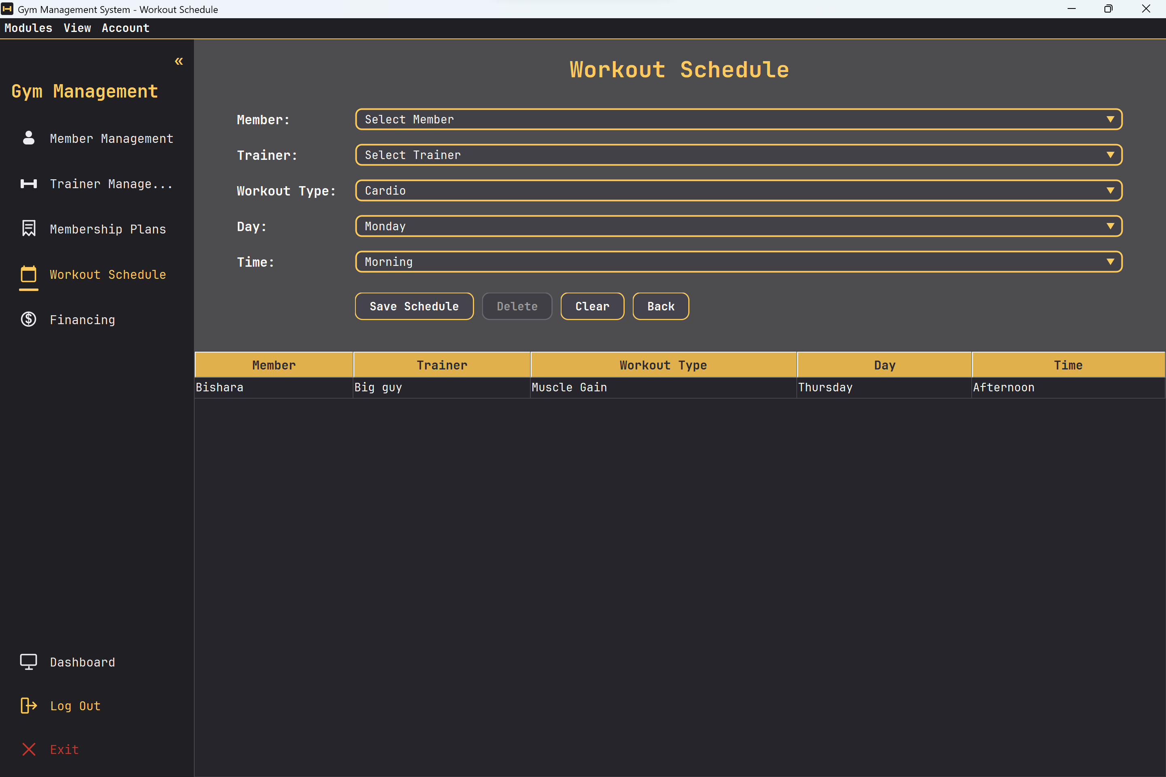
Figure 6: Workout Schedule screen.

Financing (Payments and Refunds)
The Financing screen records money movements for a member. Each entry has a Transaction Type of either Payment or Refund. The user selects:
- Member (from the registered members)
- Transaction Type (Payment or Refund)
- Membership Type (Monthly, Quarterly, or Yearly)
- Date (in YYYY-MM-DD format)
- Amount (a positive number for a payment, or a negative number for a refund)
The amount is validated against the transaction type: a payment must be a positive number and a refund must be a negative number. Saved entries appear in a table with the columns Member, Type, Membership Type, Date, and Amount. The buttons are Add Entry, Clear, and Back.
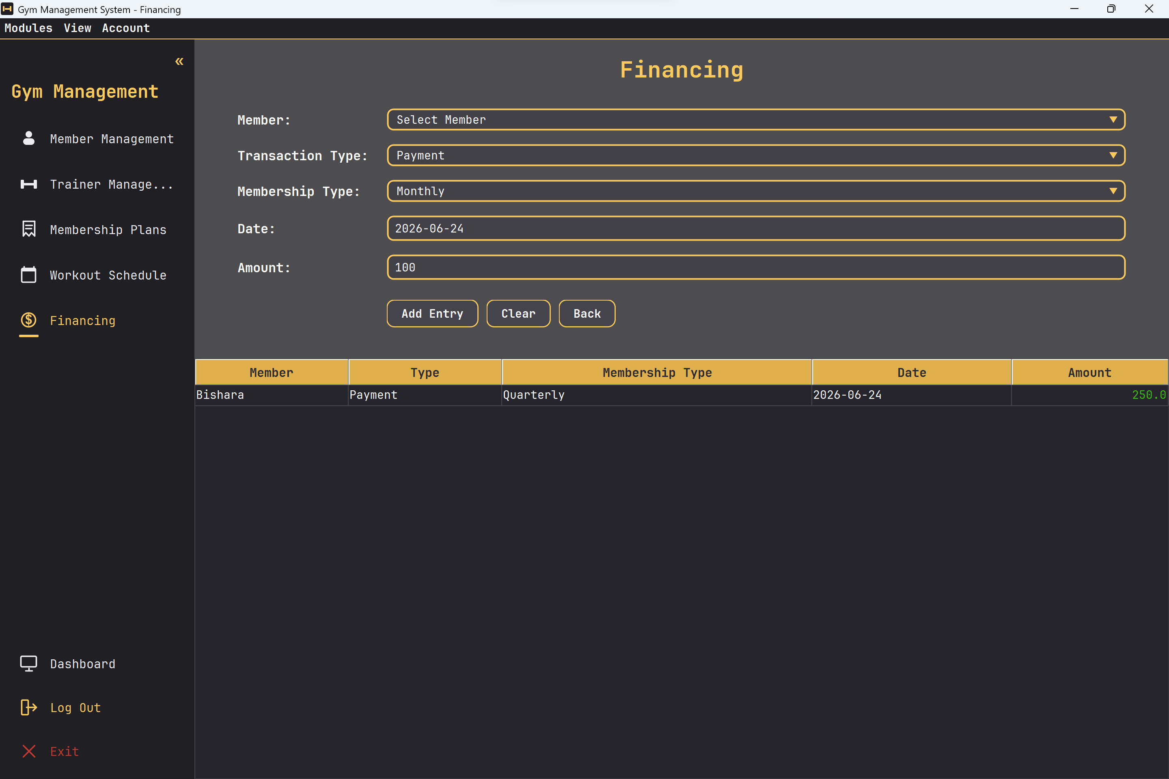
Figure 7: Financing screen (payments and refunds).

Project Structure
The source code is organized into four packages, each with a clear responsibility:
- model — plain data classes that represent the domain: Member, Trainer, WorkoutSchedule, Payment, and the MembershipPlan enum.
- data — GymDatabase, the in-memory store that holds all records, and FileManager, which reads and writes those records as CSV files.
- ui — the Swing interface: LoginFrame, DashboardFrame, and one panel per module (MemberPanel, TrainerPanel, MembershipPanel, WorkoutSchedulePanel, FinancingPanel), together with reusable styled components.
- util — ValidationUtil, a set of small reusable input-validation helpers.
The Main class ties everything together: it applies the application theme, creates the GymDatabase, and shows the login screen.

Data Persistence
All records are stored as CSV files inside a local data folder (members.csv, trainers.csv, workouts.csv, and payments.csv). When the application starts, the GymDatabase constructor loads each file through FileManager. After every change — adding, editing, or deleting a record — the affected file is rewritten, so the data is always kept in sync with what is shown on screen. Values that contain commas or quotation marks are escaped so they remain valid CSV.

Input Validation
The util.ValidationUtil class centralizes the checks used by the form screens so the same rules are applied consistently:
- Required fields — text fields may not be empty.
- Age — must be a positive whole number.
- Phone number — must be 7 to 15 digits.
- Email — must match a basic name@domain.tld pattern.
- Amount — must be a positive number for a payment, or a negative number for a refund.
- Date — must be a valid date in YYYY-MM-DD format.

UML Class Diagrams
The system is described with two complementary UML class diagrams. The first covers the domain model and how records are stored and persisted; the second covers the application start-up and the user-interface layer. The low-level Swing styling helpers are omitted from the diagrams to keep them readable.

Domain Model and Persistence
The model classes are simple data holders with private fields and public getter methods (encapsulation). GymDatabase aggregates lists of these objects and delegates loading and saving to FileManager. MembershipPlan is an enum that keeps each plan's label, price, and description in one place.
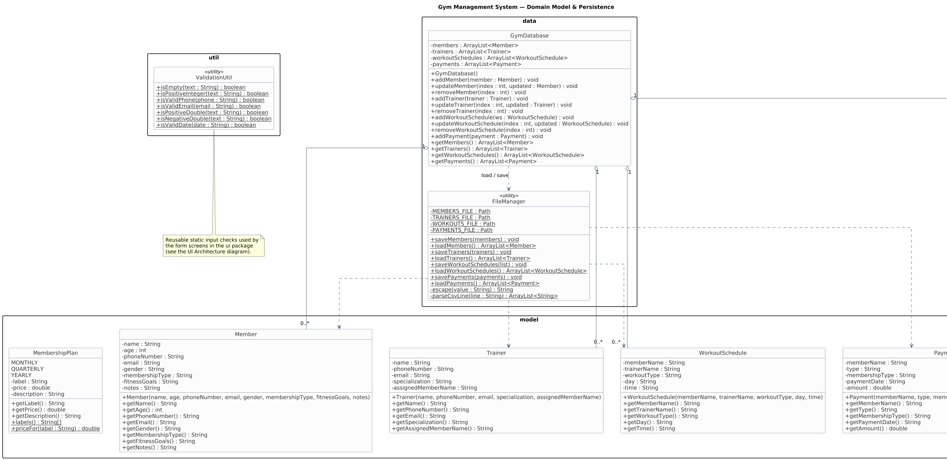
Figure 8: Domain model and persistence (model, data, and util packages).

Application and UI Architecture
Main launches the application. LoginFrame and DashboardFrame extend JFrame, while the feature panels extend JPanel (inheritance). The dashboard hosts the five module panels, and every screen shares the single GymDatabase instance that holds the data.
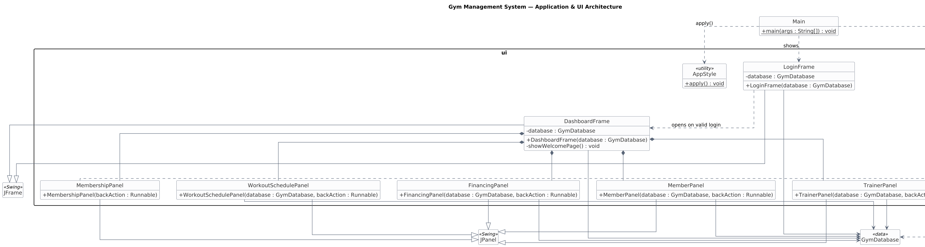
Figure 9: Application start-up and UI architecture (Main and the ui package).

Object-Oriented Programming Concepts Used
The project applies the core object-oriented programming concepts taught in the course:
- Classes and objects — the system is divided into focused classes such as Member, Trainer, GymDatabase, and the UI panels, each created and used as objects.
- Encapsulation — the model classes keep their fields private and expose them only through public getter methods, so their data is accessed in a controlled way.
- Constructors — each class defines constructors that initialize an object's state, for example new Member(...) or new GymDatabase().
- Inheritance — LoginFrame and DashboardFrame extend JFrame, and the module panels extend JPanel, reusing the behavior of the Swing base classes.
- Polymorphism — custom components override Swing methods such as paintComponent to draw rounded, themed widgets, and the navigation actions are passed around as Runnable callbacks that are invoked uniformly.
- Enumerations — MembershipPlan is an enum that defines the fixed set of plans together with their prices, giving the system a single, type-safe source of truth.
- Collections — ArrayList is used throughout GymDatabase to hold and manage groups of records.

Conclusion
The Gym Management System was successfully developed as a Java Swing desktop application. It provides an easy way to manage members, trainers, membership plans, workout schedules, and financial records, with input validation and persistent CSV storage. The project demonstrates the practical use of object-oriented programming principles — encapsulation, inheritance, polymorphism, and enumerations — alongside a clean, navigable graphical interface.

