TESTING PLAN

SECTION A: MANUAL QA & TEST STRATEGY
Manual Tests
ID and Title: TestID_01- Page load correctly with valid user id parameter
Priority: P0
Risk Rationale: High
Steps:
- Load https://qae-assignment-tau.vercel.app/
- Add parameter ?user-id=candidate-wHfCSeDQhVNk
Expected Result
Page load correctly and Upcoming Matches list display a list of matches available

ID and Title: TestID_02- Upcoming Football Matches section display list of matches by default
Priority: P1
Risk Rationale: High
Steps:
- Load https://qae-assignment-tau.vercel.app/
- Add parameter ?user-id=candidate-wHfCSeDQhVNk
- Verify Date and Odds buttons have All as default value
Expected Result
Page load correctly and Upcoming Matches list display a list of all matches available

ID and Title: TestID_03- Date range update the list of matches according to the range chosen
Priority: P1
Risk Rationale: High
Steps:
- Load https://qae-assignment-tau.vercel.app/
- Add parameter ?user-id=candidate-wHfCSeDQhVNk
- Click on Date button
- Click on Start date in the calendar displayed
- Click on another date in the calendar
- A range of dates must be displayed on the calendar
- Click on Appy button
Expected Result
Upcoming Football Matches list display a list of matches available in the range of dates chosen.

ID and Title: TestID_04- Change Odds range and verify list of matches
Priority: P1
Risk Rationale: High
Steps:
- Load https://qae-assignment-tau.vercel.app/
- Add parameter ?user-id=candidate-wHfCSeDQhVNk
- Click on Odds button
- Update the range for the odds. Range goes from 1 to 10 by default
- Click on Appy button
Expected Result
Upcoming Football Matches list display a list of matches available in the range of dates chosen.

ID and Title: TestID_05 – Add a valid bet in Bet Slip section and place the bet
Priority: P1
Risk Rationale: High
Steps:
- Load https://qae-assignment-tau.vercel.app/
- Add parameter ?user-id=candidate-wHfCSeDQhVNk
- Click on Date button
- Click on Start date in the calendar displayed
- Click on another date in the calendar
- A range of dates must be displayed on the calendar
- Click on Appy button
- Choose any Match and choose the option 1, X or 2 according the bet you want to do
- In Bet Slip section verify the Match and the option chosen are loaded
- In Stake input add the amount for your bet
- Click on Place Bet button
Expected Result
A success popup must be displayed with the label “Bet Placed Successfully!”

Reported Bugs

Bug ID & Title: BugID_001 – Min Odds and Max Odds must not be the same
Severity: High
Reproduction Steps:
- Load https://qae-assignment-tau.vercel.app/
- Add parameter ?user-id=candidate-wHfCSeDQhVNk
- Click on Odds button
- Move max odds until the same position as Min odds
- Click on Apply button
Expected Results
Max odds must be bigger than Min odds. Or an alert message must be displayed letting the user know that the Max Odds must be bigger than Min odds. Or Apply buttons must be disable until Min and Max odds are different.
Actual result
Min odds and Max Odds can be the same and Apply button is updating the list of matches.
Business Impact: List of matches is going to be empty because there are not matches with all the options 1, X or 2 with the same value
Evidence:
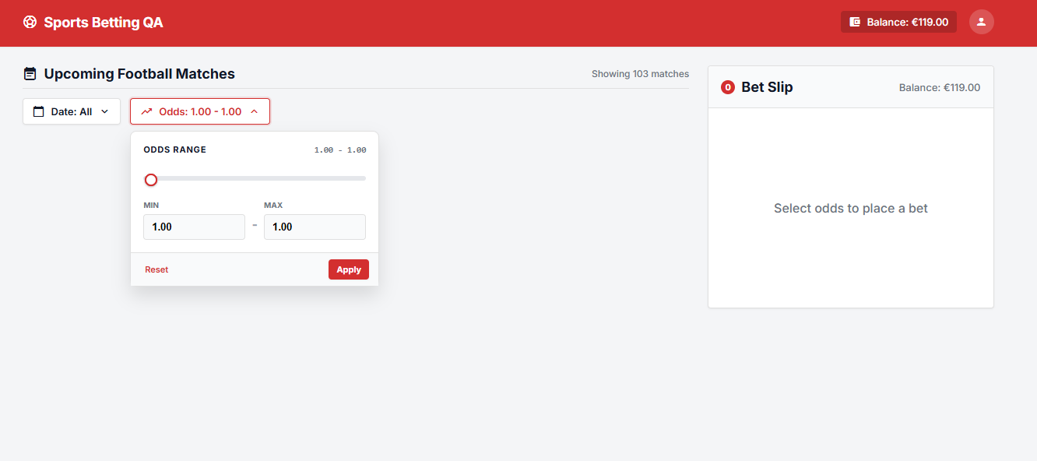

Bug ID & Title: BugID_002 – Upcoming Football Matches section must display just UPCOMING matches
Severity: High
Reproduction Steps:
- Load https://qae-assignment-tau.vercel.app/
- Add parameter ?user-id=candidate-wHfCSeDQhVNk
- Verify status of the matches – Upcoming
Expected Results
All the matches listed in Upcoming Football Matches section must have Upcoming status.
Actual result
With filters by default all the matches are being displayed Past and Upcoming, however this section is just for Upcoming matches.
Business Impact: List of matches displayed is wrong. This section must display Upcoming matches and all the matches must be displayed in another section called All Football Matches or something similar.
Evidence:
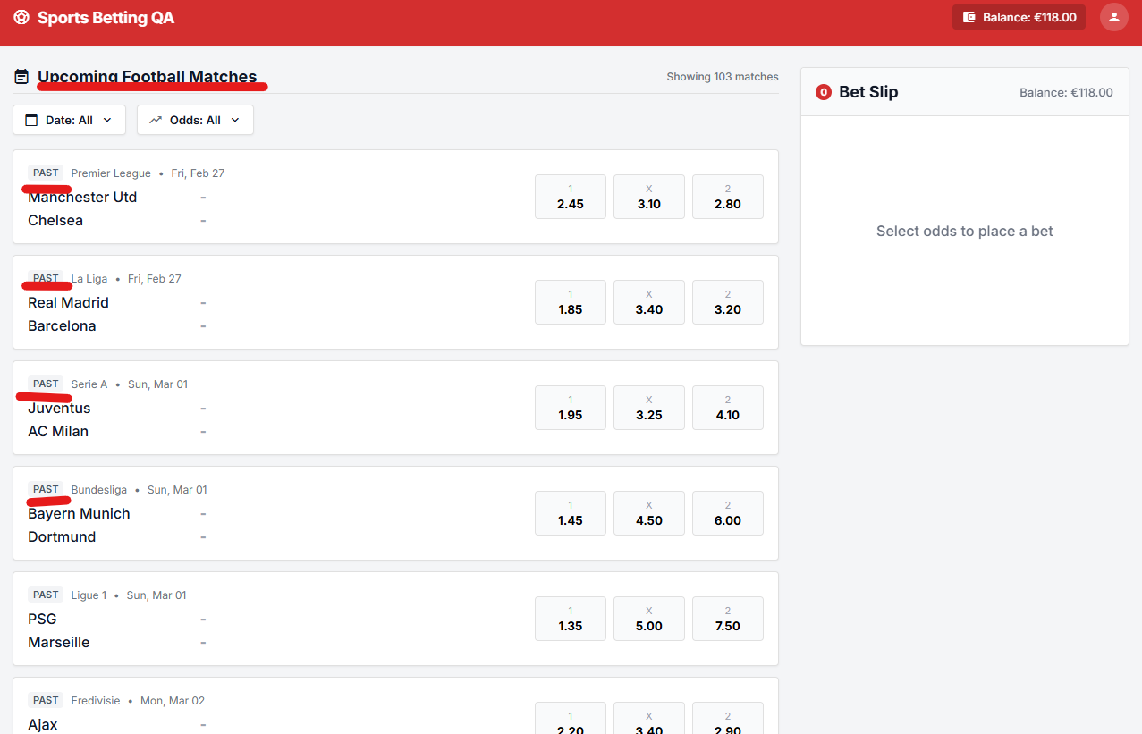

More bugs found:
- After click on Place Bet and close the popup, the balance does not change until the page is reloaded.
- If Date or Odds filters are opened, but Apply button is not clicked the filters don’t close even if the user clicks outside the filter or choose a match and place a bet. Filter option continue opened until page reloaded or Reset/Apply buttons are clicked.
- When a range of dates display a list of matches, if you choose exactly the date of a match and apply the filter, then the list matches does not display the match for that date. Example: Leeds vs Norwich in sept 25th.

Overall Testing Approach
The testing strategy will use a risk-based, layered approach, combining manual analysis with automated functional testing.
The primary focus will be validating that users can:
- Successfully load the Upcoming Football Matches page.
- See the expected football-match content.
- Validate the list of matches with the response of /api/matches.
- Interact with the calendar. Select a valid date range.
- Receive the expected match results.
- Empty list of matches and negative scenarios.
- Odds and odds range.
Automation will be implemented using:
- Python
- Pytest
- Selenium WebDriver
- Page Object Model (POM)
The automated suite should focus primarily on stable, repeatable functional scenarios, while exploratory, usability, accessibility, and visual testing can initially be performed manually.

Testing Levels
The strategy should cover multiple testing levels.
Testing Level | Objective | Example
Smoke Testing | Confirm the page is fundamentally operational | Page loads and main content is displayed
Functional Testing | Validate individual features | Date filter opens and works
Integration Testing | Validate interaction between UI and match data | Applying dates/odds updates match list
Regression Testing | Ensure existing functionality continues working | Previously working date filtering remains functional
Negative Testing | Validate invalid/unavailable scenarios | Date range returns no matches
Boundary Testing | Validate edge conditions | Same start/end date
Exploratory Testing | Discover unexpected behavior | Rapidly changing filters
Compatibility Testing | Validate browser behavior | Chrome/Firefox
Accessibility Testing | Validate basic accessibility | Keyboard navigation, labels, focus
Performance Testing | Identify obvious responsiveness issues | Filter/Odds operation response time

Automation Strategy
The automation strategy should follow the Page Object Model.
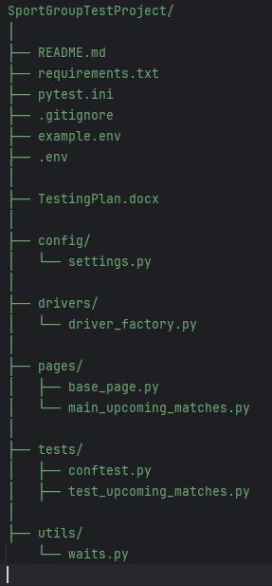
The page object should encapsulate:
- Locators
- Navigation
- User interactions
- Element state checks
Tests should primarily contain:
action
assertion
rather than Selenium implementation details.
This keeps the tests readable and aligned with business behavior.

Test Prioritization
I recommend using P0–P2 priorities.
P0 — Critical
Core functionality required for the page to work.
Examples:
- Page loads.
- Main content displayed.
- Football matches displayed.
- Date filter opens.
- Date range can be applied.
- Match list is populated.
P1 — High
Important functionality that should work but does not necessarily block the entire application.
Examples:
- Calendar interaction.
- Changing an existing date range.
- Empty-state behavior.
- Cross-browser behavior.
P2 — Medium/Low
Additional quality scenarios.
Examples:
- Unusual date combinations.
- Repeated interactions.
- Responsive behavior.
- Detailed accessibility scenarios.

Final Strategy Summary
The overall strategy can be summarized as:
Validate the critical user journey first, then progressively increase coverage through functional, negative, boundary, regression, compatibility, accessibility, usability, and exploratory testing.
For this particular assignment, the highest-risk areas are the date-filter, odds, list of matches, bet slip section, because it involves multiple UI states and directly affects the match data displayed to the user and success or alert messages.

