PROJECT REPORT
Submitted to
DEPARTMENT OF COMPUTER SCIENCE

VIVEKANAND EDUCATION SOCIETY’S
COLLEGE OF ARTS, SCIENCE AND COMMERCE (AUTONOMOUS), SINDHI SOCIETY, CHEMBUR, MUMBAI 400071.
UNREAL FURNITURE
For Partial Fulfilment for Degree of
Bachelor of Science (Computer Science)
Academic Year (2023-24)
COORDINATOR OF DEPARTMENT COLLEGE GUIDE
Mr. Kamlakar Bhopatkar Dr. Madhavi Vaidya
Mr. Kamlakar Bhopatkar
SUBMITTED BY
Vikas Ramtirth Jaiswal


VIVEKANAND EDUCATION SOCIETY’S COLLEGE OF ARTS, SCIENCE AND COMMERCE (AUTONOMOUS)
Sindhi Society, Chembur, Mumbai 400071.
Phones: 25227514/25227470.
NAAC Re-Accredited ‘A’ Grade

CERTIFICATE
This is to certify that Mr. Vikas Ramtirth Jaiswal of T.Y. B. Sc (Computer Science) affiliated to University of Mumbai has successfully completed a project work entitled.
UNREAL FURNITURE
As partial fulfilment of the requirement for the degree of B.Sc. (Computer Science) for the academic year 2023-2024.
COORDINATOR OF DEPARTMENT | COLLEGE GUIDE
Mr. Kamlakar Bhopatkar  Date: | Mr. Kamlakar Bhopatkar  Dr. Madhavi Vaidya
Examiner: | College Seal

Acknowledgement:
I have great pleasure in presenting this project entitled “Unreal Furniture” and I grab this opportunity to convey my immense regards towards all the people who with their invaluable contributions made this project successful.
It gives me great pleasure in presenting this project report. Its justification will never complete if I don’t express my vote of thanks to our V.E.S. College and Principal Dr. Anita Kanwar
I sincerely thank and express my profound gratitude to our Project Guides
Mr. Kamlakar Bhopatkar and Dr. Madhavi Vaidya for timely and prestigious guidance required for the project completion at each phase of the project development.
I also owe to my friends who have been a constant source of help to solve the problems that cropped up during the development of the project, positive criticism, suggestions, constant support, encouragement and guidance towards the successful completion of the project.

SR. NO. | TOPIC | PAGE NO.
 | PRELIMINARY INVESTIGATION
1 | Organisational overview | 5
2 | Description of Existing System. | 5
3 | Limitations of the Existing system. | 6
4 | Description Proposed system and its Modules. | 7
5 | Advantages of Proposed System | 9
6 | Technologies used | 9
 | SYSTEM ANALYSIS
7 | Use Case Diagram. | 10
8 | Activity Diagram. | 13
9 | NoSQL Schema Design | 15
10 | Class Diagram | 16
 | SYSTEM IMPLEMENTATION
11 | Sequence Diagram | 18
12 | Test Cases | 20
13 | Component Diagram | 26
14 | Deployment Diagram | 27
15 | Images of Application | 29
16 | Future Enhancements | 34
17 | References | 34


GARAGE FINDER PRO!

Preliminary Investigation
UNREAL FURNITURE
Organizational Overview:
Automobile garages are one of the best companions for the drivers on roads for vehicle repair purposes. It helps drivers to repair their vehicles depending upon the vehicle type whether it is a 4-Wheeler, 3-Wheeler, 2-Wheeler or an Electric Vehicle. Some Automobile garages not only repair vehicles of different types but also sell various vehicle spares parts and increasing their business. While there are various ways to find automobile garages, Google Maps has emerged as a popular choice among drivers. With its extensive database and user-friendly interface, drivers can easily locate nearby auto garages and make informed decisions based on ratings and reviews. GoMechanic is also a good option for on-road vehicle repair services. As the number of vehicles on road are increasing day-by-day, the requirements for finding relevant automobile garages are also increasing.

Description of Existing System:
- Google Maps:
Google Maps is an integral part of the modern navigation ecosystem used by almost everyone. The existing system Google Maps is a widely popular mapping service that helps users with directions, navigation, location information and various other points of interest including auto garages.

Google Maps primarily relies on user-generated data and business listings to display auto garages. Auto garage owners can create their garage profile by creating their business email id and registering their garage on the Google Maps. Information like name of the garage, address, contact details, operating hours and images can be added to their Google Maps profile. The Information present on Google Maps can be used by users for searching the relevant auto garage. When a user searches for an auto garage, it displays various nearby auto garages and depending on the user’s desire, he or she can contact that garage or can directly get directions for that particular garage and can get their vehicles repaired. After a successful repair, the vehicle owner can submit a rating and review for the auto garage which will be publicly shared with the other users using Google Maps. Currently, most of the automobile garage owners have their garages registered on the Google Maps service which helps users to find garages in almost every state of India.

Overall, Google Maps service uses internet and it helps users finding their relevant nearby automobile garages and get their vehicle repaired. It helps users by giving them the contact details and the best routes to reach the garage. Once the vehicle repair is completed, users have the option to submit a rating and review for the auto garage on Google Maps. These reviews provide valuable feedback to other users, helping them make informed decisions when selecting a garage.

- GoMechanic:
GoMechanic is a service-based application that helps users to get their vehicles repaired by providing an on-road service. It has their own mechanics and towing services which can be called for service through their application itself as per the requirements. It also provides various vehicle spares parts that user can purchase for their vehicle. Currently, GoMechanic is providing services in almost every state of India. They are also providing their services have in Malaysia also. This widespread availability ensures that users can access their on-road repair services regardless of their location within the country. They also provide various care packages for vehicles which is subscription-based package for the safety of your vehicle. These subscription-based packages provide users with added convenience and peace of mind by including regular maintenance, inspections, and other safety measures for their vehicles. By opting for these care packages, users can ensure the optimal functioning for their vehicles making convenient for them to request assistance.

Limitations of Existing System:
Addressing these limitations is crucial to provide users with a more enhanced and efficient system like "Garage Finder Pro"
- Lack of specific information about the repair capabilities of each garage.
- Incomplete garage profiles with limited details about services offered and pricing information.
- Difficulty in finding garages for specific vehicle types (4-wheelers, 3-wheelers, 2-wheelers, electric vehicles).
- Insufficient information about the expertise of mechanics and availability of parts or equipment.
- Challenges in assessing the suitability and quality of a garage based on available information.
- Limited insights and analytics for both garage owners and users.
- Inefficiency and inconvenience in tracking the progress and status of job cards.

Proposed System:
"Garage Finder Pro" is an innovative app designed to overcome the limitations of current systems and provide best user experience for finding and choosing auto garages. This app focuses on connecting users with garages that have the specific capabilities to repair their vehicle type whether it is a 4-wheeler, 3-wheeler, 2-wheeler or an electric vehicle. The app provides different garage profiles allowing users to view services offered, operating hours, towing service and customer reviews and ratings. This empowers users to make informed decisions ensuring they find the best auto garage for their needs. Users can also access detailed job cards that provide information about the requested or accepted work, estimated costs, and job card status. This transparency allows users to track the progress of their vehicle repairs easily. Additionally, the app offers valuable analytics and insights to garage owners, including metrics such as the number of customers, job cards assigned, in progress, completed, pending and cancelled.

- Registration and Sign-in:
- User launches the "Garage Finder Pro" app.
- The user is presented with the option to register or sign in if they already have an account.
- Details like user-type (user or garageowner) and mobile number are taken from user.
- The garage owner will also be required to provide more information like services offered, operating hours, towing service availability, etc.
- Garage owners can also upload images of their garage to showcase their facilities and location for the user to reach to their garage.
- The details of the user will get stored in the firestore.
- After successful registration or sign-in, the user is directed to the home screen.

- Searching and Selecting Garages:
- On the home screen, the user will see a search bar and filters to refine their search.
- The user enters their location or enables location services for automatic detection.
- Based on the entered location the app displays a list of nearby garages.
- The user can apply filters such as vehicle type (4-wheeler, 3-wheeler, 2-wheeler, electric), services offered, operating hours, minimum service cost, etc.
- The user selects a garage from the search results to view its profile.

- Viewing Garage Profile:
- The user is directed to the selected garage's profile page.
- The profile page displays details about the garage, including services offered, operating hours, towing service availability, directions and customer reviews and ratings.
- The user can scroll through customer reviews to get an idea of the garage's reputation.
- If the user wants to proceed with this garage, they can proceed to the next step. Otherwise, they can go back and select a different garage.

- Confirming Services and Towing Requirements:
- The user selects the desired services they require from the garage's profile page.
- If towing service is required, the user can select the option accordingly.
- The location of the vehicle is automatically detected and is available to the towing service man.

- Notifications:
  - The app sends notifications to both user and garageowner for various events, including new changes in job card status, customer payments, and new reviews.
  - The garageowner will also receive notifications for required towing services, and the user will receive notifications for the same when the garageowner accepts the request.
  - The app provides notifications to keep garage owners informed about upcoming requests.

- Tracking Repair:
- After confirming the services and towing requirements, the user can proceed to navigate to garage using garage’s location provided in app.
- The user can easily track the progress of their vehicle repairs by accessing the job card and viewing its status (in progress, completed, pending, cancelled).

- Job Cards:
  - Garage owners can view all the job cards and can filter them according to their statuses (pending, in progress, cancelled, completed).
  - The job card will contain the information about the user, vehicle, requested services and cost, status, etc.

- Analytics and Insights:
  - Garage owners can view valuable insights of their garage which will help them to enhance their services.
  - Garage owners can get insights about the number of the number of job cards (in progress, completed, pending).

- Sharing Reviews:
  - After the repair is completed, the user receives a notification about the status.
  - The user can provide a review and rating for the garage based on their experience.
  - The review is submitted and added to the garage's profile for other users to see.
Advantages of Proposed System:
Some of the Advantages of the Proposed System:
- Specific capability-based garage search.
- Garage profiles with detailed information.
- Convenient job card management.
- Detailed analytics and insights for garage owners.
- Integration of third-party APIs and libraries, enhances user experience.
- Enhanced user trust and confidence results in retaining customers.

Technologies required for developing the proposed system:
- Android Studio (Kotlin): Android Studio is the official Integrated Development Environment (IDE) for Google’s Android operating system. Whereas, Kotlin is a High-level programming language. It is one of the official languages of google supported for android application development.

- Firebase: Firebase is a comprehensive mobile and web development platform offered by Google. It provides a range of backend services including database management, user authentication, cloud storage, and hosting. Firebase simplifies the development process by offering ready-to-use tools and infrastructure for building high-quality applications.

System Analysis

Use Case

A use case diagram serves as a visual representation of the operations a system undertakes. It comprises key elements such as use cases, actors, and their interconnections. Use cases essentially embody a series of actions that coalesce into a singular unit of work tailored for an actor, who signifies an external user engaging with these operations. In essence, this diagram acts as a pivotal tool for elucidating how a system functions and how external users interact with it, offering a concise yet comprehensive overview of system behaviour.

ELEMENTS OF USE CASE DIAGRAM:
Actor:
Actors in a use case diagram represent entities playing specific roles in a system, typically reflecting real-world user roles. They interact with use cases and should include stakeholders relevant to the system's functionality, with no need to depict entities that don't impact the modeled functions. Actors are symbolized as stick figures outside the system's boundary.

Use Case:
A use case in a diagram visually represents distinct business functions within a system. To identify use cases, begin by listing discrete business functions as basic scenarios. Each function can be categorized as a potential use case. In a use case diagram, use cases are depicted as ellipses, effectively encapsulating the system's specific functionalities. This approach provides a systematic means of representing the core functions the system executes in response to user interactions or external events.

System Boundary:
The system boundary, depicted as a rectangle in a use case diagram, defines the system's scope by encapsulating all its use cases. It distinguishes the system's internal operations from its interactions with the external environment, aiding in effective system communication and design.

Relationships:
The following relationships can be established among use cases:
Extends:
In a use case diagram, one use case can extend another, indicating that the behaviour of the extension use case can be inserted into the extended use case under specific conditions. This relationship is useful for depicting optional functionalities that come after a particular use case. It's represented by a dashed arrow from the optional use case to the base use case, with the label "«extend»," making it clear that the extended use case can be enhanced or extended with additional features when certain conditions are met.

Include:
In a use case diagram, one use case can include another, denoting that the behaviour of the included use case is merged into the behaviour of the including use case. Often, the outcome of the included use case influences the including one. This relationship is represented by a dashed arrow from the base use case to the included use case, labelled "«include»," indicating the integral nature of the included functionality within the encompassing use case.

Basic scenarios for use case
- Registering account
- Logging in
- Adding Vehicle Details
- Adding Garage Details
- Searching Garages
- Sending Request
- Creating Jobcard
- Updating Jobcard
- Reviewing Jobcard
- Making Jobcard Payment
- Viewing Insights

Use Case Diagram:
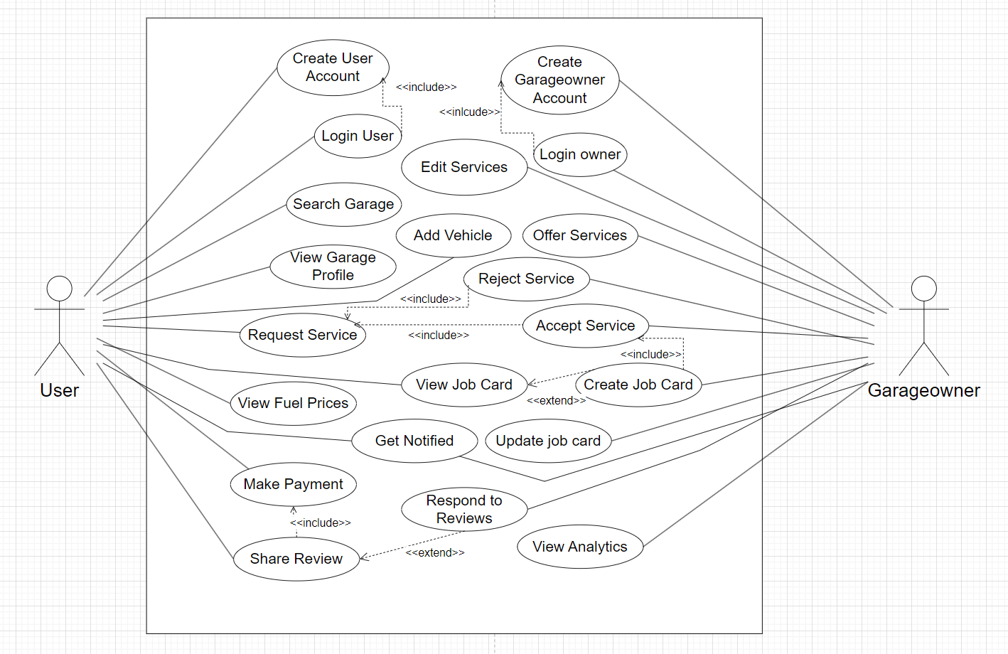

Activity Diagram

Activity diagrams, akin to flowcharts, depict the sequence of actions or control flow within a system, commonly used in business process modeling and describing use case steps. They feature sequential and concurrent activities, with a defined start (initial state) and end (final state). These diagrams employ symbols for activities, flows, decisions, guards, merge points, time events, and more, enabling comprehensive visualization of intricate processes and system behaviours.

Initial State or Start Point:
In activity diagrams, a small filled circle followed by an arrow symbolizes the initial action state or the starting point for the diagram's activities.

Activity or Action State:
An action state, representing uninterrupted object actions, is portrayed as a rounded rectangle, facilitating visual clarity in diagrams.

Action Flow:
Action flows, known as edges or paths, delineate transitions between action states in diagrams. Typically depicted as arrowed lines, they clarify the sequential progression of activities.

Decisions and Branching:
In Activity diagram, a diamond symbolizes a decision point with multiple paths. To depict activities that hinge on decisions, place a diamond between them. Each outgoing path should be labelled with a condition or guard expression.

Synchronisation:
A fork node in an activity diagram serves to divide a single incoming flow into multiple concurrent flows. It is symbolized as a straight, slightly thicker line, visually indicating the branching of parallel activities.

Swimlanes:
Swim lanes in activity diagrams group related activities into distinct columns, providing a visual organization that clarifies responsibilities or divisions within a process or system. Each lane typically represents a specific entity, role, or department involved in the activities.

Final State or End Point:
In activity diagrams, an arrow directed towards a filled circle enclosed within another circle symbolizes the final action state. This marks the conclusion of an activity or within the diagram's flow, providing clear visual cues for the endpoint.

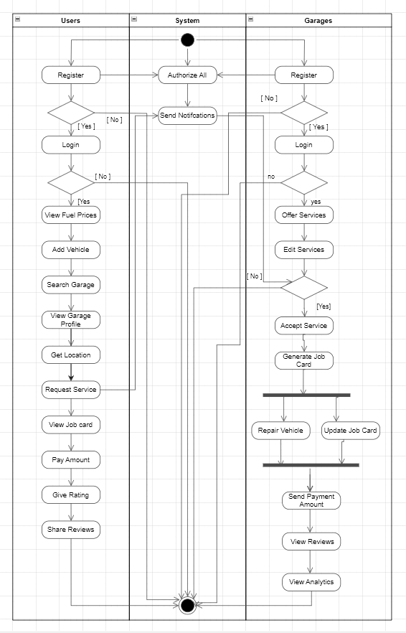
Activity Diagram

NoSQL Schema Design
In a traditional SQL database, ERD diagrams are used to represent the structure of the data with entities (tables) and their relationships. However, in NoSQL databases, which include document-oriented databases like Firebase Firestore, graph databases, and key-value stores, the data structure is quite different. Therefore, instead of drawing an ERD (which is kind of wrong for Firebase projects because it is non-relational), we can represent the database using boxes.

Entities as Collections:
In NoSQL databases, entities are typically organized as collections in document-based databases. These collections serve as containers for related data, similar to how tables represent entities in SQL databases. This flexible schema approach allows for the storage of diverse data structures within each collection, offering adaptability in data modeling.

Attributes as Fields:
In NoSQL databases, entities use fields to store data instead of traditional columns. These fields can accommodate diverse data types, including nested objects and arrays. This flexibility allows for the efficient storage of complex and varied data structures, making NoSQL databases suitable for handling diverse data models and unstructured information.

NoSQL Schema Design
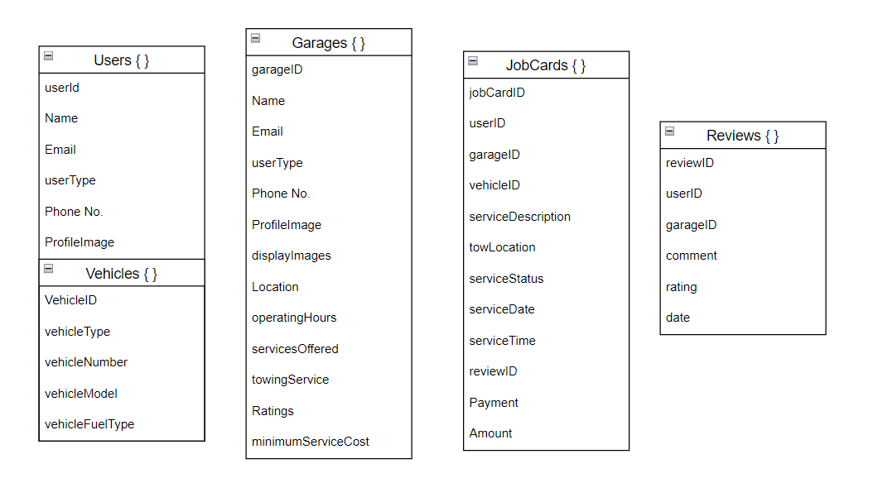

Class Diagram

A class diagram is a fundamental concept in object-oriented modeling and design, often used in software engineering to represent the structure and relationships of classes within a system. Given your background in Android development using Kotlin and Google Firebase, class diagrams can be a useful tool for visualizing the architecture of your Android applications.

Classes:
In a class diagram, classes are represented as rectangles with three compartments. The top compartment typically contains the class name, the middle compartment lists the class attributes (variables), and the bottom compartment includes the class methods (functions).

Attributes:
Class attributes are the properties or variables that belong to a class. They're listed in the middle compartment of the class rectangle.

Methods:
Class methods represent the functions or operations that a class can perform. These are listed in the bottom compartment of the class rectangle.

Associations:
In object-oriented programming and UML (Unified Modeling Language), there are several types of associations that represent different kinds of relationships between classes. Here are some common types of associations:

Association:
This is a basic relationship between classes, indicating that one class is associated with another in some way. It's a generic term for any connection between classes.

Aggregation:
Aggregation represents a "whole-part" relationship, where one class (the whole) contains or is composed of other classes (the parts). It's typically depicted as a diamond shape.

Composition:
Composition is a stronger form of aggregation, indicating that the parts are essential to the whole and can't exist independently. It's also depicted with a diamond shape.

Class Diagram

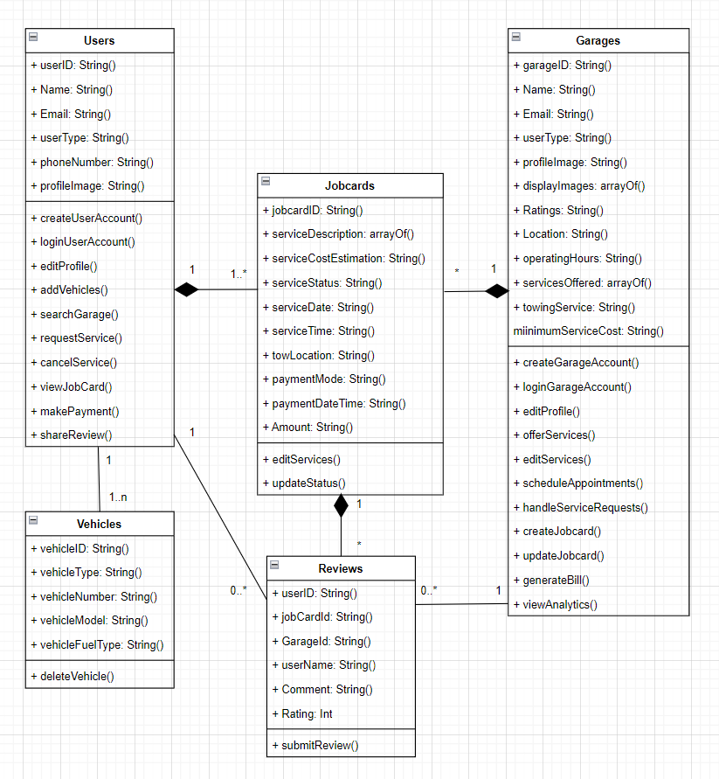

Sequence Diagram

A sequence diagram is a visual representation in software engineering that depicts the interactions between different components or objects within a system over a specific period. It illustrates the flow of messages or actions between these entities, helping developers understand the order and timing of these interactions. Sequence diagrams are commonly used to model and document the behaviour of software systems, making them a valuable tool in the design and analysis of complex systems.

In short, A sequence diagram is a UML (Unified Modeling Language) diagram that provides a detailed view of how various components or objects in a software system interact with each other.

Participants:
In a sequence diagram, participants are represented by lifelines, typically depicted as vertical lines. These lifelines represent objects, classes, or components involved in the interaction. Messages flow between these lifelines to represent interactions.

Messages:
Messages are depicted as arrows that flow between lifelines. They represent communication or interactions between objects. Messages can be synchronous, asynchronous, or create/destroy messages, depending on the type of interaction.

Activation Bar:
An activation bar is a horizontal bar along a lifeline that shows the period during which an object is active and processing a message. It helps visualize the timing of interactions.

Focus on Time:
Sequence diagrams are especially useful for emphasizing the chronological order of interactions. Developers can see how messages are exchanged over time, aiding in understanding system behaviour and potential bottlenecks.

Lifelines:
Lifelines visually represent the lifespan or existence of the associated object or component within the sequence diagram. The top of the lifeline represents the creation of the object, and the bottom represents its destruction, if applicable.

Sequence Diagram

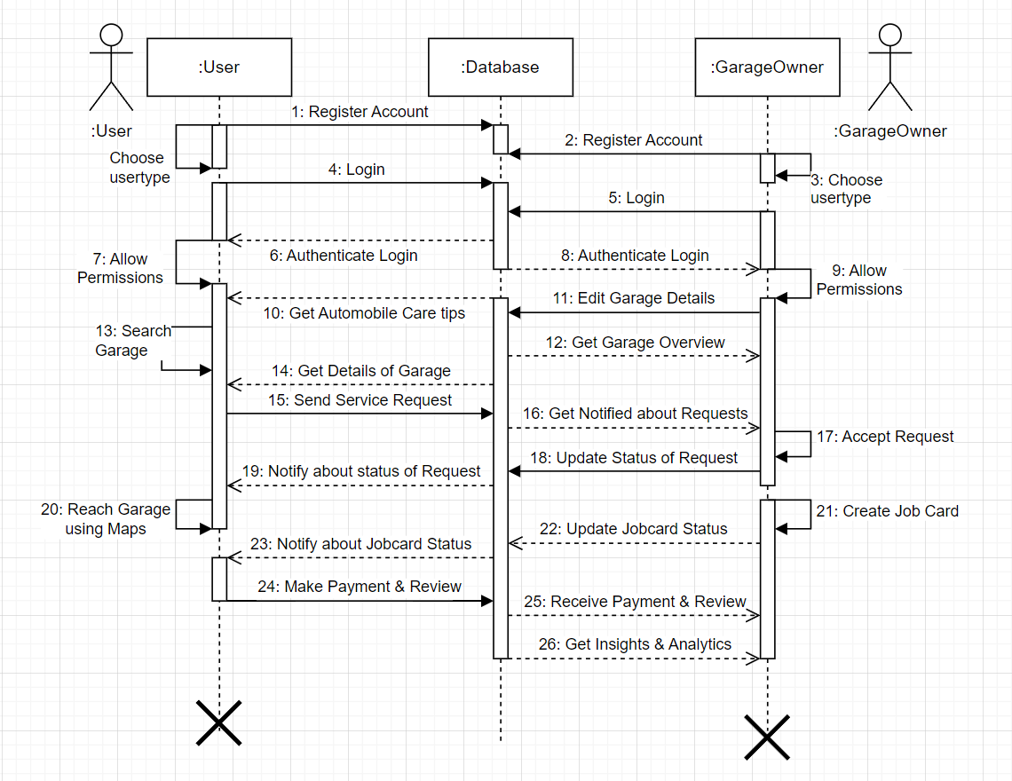

Test Cases

TestCaseID | Module | Form | Test Conditions | Steps | Input Test Data | Expected Output | Actual Output | Status
TC1 | Registration | Registration Form | Provide valid Details by following all validations | 1. Click on Sign-up Button 2. Select User Type 3. Fill Sign-up Details | 1. User Type 2. Name 3. Email 4. Password 5. Re-Password 6. Accept T&Cs | 1. Registered Successfully 2. Verify Email Address | 1. Registered Successfully 2. Verify Email Address | Pass
TC2 | Login | Sign-in Form | Enter Valid Credentials | 1. Click on Sign-in Button | 1. Enter Email 2. Enter Password | Login Successful | Login Successful | Pass
TC3 | Login | Sign-in Form | Enter Invalid Credentials | 1. Enter Invalid Credentials | 1. Enter Invalid Credentials | Invalid Credentials | Invalid Credentials | Pass
TC4 | Google Sign-in | Sign-in Form | Select Valid Google Email ID | 1. Select Google Account | 1. Select Google Account | Login Successful | Login Successful | Pass
TC5 | Forgot Password | Sign-in Form | Enter Valid Email | 1. Enter Valid Email | 1. Enter Valid Email | Password Reset | Password Reset | Pass
TC6 | Forgot Password | Sign-in Form | Enter Unregistered Email | 1. Enter Unregistered Email | 1. Enter Unregistered Email | Email is not registered | Email is not registered | Pass
TC7 | Login | Sign-in Form | User should be already Signed in | 1. Sign in and Restart the App | Not Applicable | Directly Signs you in, no need for re-login | Directly Signs you in, no need for re-login | Pass
TC8 | User | Home Page | Allow Location Permissions & Turn on Location Services | 1. Allow Location Permissions 2. Turn on GPS Service | Not Applicable | Location of user | Location of user | Pass
TC9 | User | Home Page | Allow Location Permissions & Turn on Location Services | 1. Allow Location Permissions 2. Turn on GPS Service | Not Applicable | Local Fuel Prices of Petrol, Diesel & CNG | Local Fuel Prices of Petrol, Diesel & CNG | Pass
TC10 | All | Offline Page | No Internet Connection / Device connected to WIFI but no internet | 1. Turn off wifi/data connection | Not Applicable | Offline Page Appears. | Offline Page Appears | Pass
TC11 | User | Profile Page | Click on Sign out Button | 1. Go to Profile Page 2. Click on Sign out Button | Not Applicable | Return to Sign in Page | Return to Sign in Page | Pass
TC12 | User | Profile Page | Open Profile Page & Internet Connection | 1. Go to Profile Page | Not Applicable | Displays Details of the user | Displays Details of the user | Pass
TC13 | User | Profile Page | Add Vehicle | 1. Open Profile Page 2. Click on add Vehicle Button 3. Fill Details and Submit | 1. Vehicle Name 2. Vehicle Number 3. Vehicle Model 4. Vehicle Fuel Type 5. Vehicle Type | Vehicle Added Successfully and Displays on Profile | Vehicle Added Successfully and Displays on Profile | Pass
TC14 | User | Profile Page | Add Contact | 1. Open Profile Page 2. Click on add Contact 3. Fill Contact and Submit | 1. Contact Number | Contact Number Added Successfully | Contact Number Added Successfully | Pass
TC15 | Garage | Garage Profile Page | Add Garage Details | 1. Open Profile Page 2. Click on Edit Profile 3. Add details and upload profile Image | 1. Garage Name 2. Operating hours 3. Towing Service 4. Minimum service cost 5. Profile Image | Profile Updated Successfully | Profile Updated Successfully | Pass
TC16 | Garage | Garage Profile Page | Add Garage Showcase Image | 1. Click on Edit Showcase Images Icon | 1. Select Images from gallery | Showcase Images Added Successfully and Reflecting on Profile | Showcase Images Added Successfully and Reflecting on Profile | Pass
TC17 | Garage | Garage Profile Page | Open Profile Page & Internet Connection | 1. Open Profile Page | Not Applicable | Current Rating & Recent Reviews will be displayed on Profile | Current Rating & Recent Reviews will be displayed on Profile | Pass
TC18 | Garage | Garage Home Page | Open Home Page of the Garage Profile | 1. Sign in as a Garage Owner | Not Applicable | Displays All the current Jobcards under Garage and Earnings Insight | Displays All the current Jobcards under Garage and Earnings insight | Pass
TC19 | User | Garage Search Page | Open Garage Search Page | 1. Open garage Search Page | Not Applicable | Displays Different Garages Details | Displays Different Garages Details | Pass
TC20 | User | Garage Search Page | Open Garage Search Page and Click on More Details of any garage | 1. Open garage Search Page 2. Click on More Details | Not Applicable | Displays a Detailed Profile of that Garage | Displays a Detailed Profile Of that Garage | Pass
TC21 | User | Garage Search Page | Open Garage Search Page, click on any garage's More Details and Click on Contact | 1. Open garage Search Page 2. Click on More Details of Any garage 3. Click on Contact | Not Applicable | Contacts Garages on their stored numbers | Contact Garages on their stored numbers | Pass
TC22 | User | Garage Search Page | Open Garage Search Page, click on any garage's More Details and Click on Google Maps under Directions | 1. Open garage Search Page 2. Click on More Details of Any garage 3. Click on Google Maps | Not Applicable | User gets the Precise Location of the garage and can navigate to it | User gets the Precise Location of the garage and can navigate to it | Pass
TC23 | User | Garage Search Page | Open garage Search page and Click on Request Service from a garage | 1. Open garage Search page 2. Click on Request Service 3. Fill Details and Request Submit | 1. Service Name 2. Vehicle Details 3. Tow Service | Respective Garage Owner gets Request Notification and can View it | Respective Garage Owner gets Request Notification and can view it | Pass
TC24 | Garage | Garage Request Process panel | Open garage request process panel and change the dropdown to new requests | 1. Open Garage Request Process panel 2. Check new requests and accept it | 1. Select new Requests from Drop Down | Request gets Accepted and the respective user gets notified | Request gets Accepted and the respective user gets notified | Pass
TC25 | Garage | Garage Request Process panel | Open garage request process panel and update the jobcard status | 1. Open Garage Request Process panel 2. Go to relevant jobcard and click on view more 3. Select status type from dropdown 4. Click on Update job card | 1. Click on View More 2.Select relevant jobcard update 3. Click update jobcard | Job card gets Updated and the respective user gets notified | Job card gets Updated and the respective user gets notified | Pass
TC26 | User | User Request Process Panel | Open user request process panel and check completed jobcards and make payments | 1. Open user request process panel 2. Select Completed Jobcards from dropdown 3. Select a relevant job card and view more 4. Make Payments Accordingly | 1. Click on View More 2.Select relevant jobcard Completed 3. Click on Make Payment | Payment Successful and the respective garage owner will be notified about it | Payment Successful and the respective garage owner will be notified about it | Pass
TC27 | User | User Request Process Panel | Open user request process panel and check completed jobcards and click on leave a review | 1. Open user request process panel 2. Select Completed Jobcards from dropdown 3. Select a relevant job card and view more 4. Make Ratings and Reviews Accordingly | 1. Rating 2.Review | Rating and Review gets submitted and reflects on the respective garage owners’ profile | Rating and Review gets submitted and reflects on the respective garage owners’ profile | Pass
TC28 | Garage | Garage Profile Page | Open garage Profile page and click on edit banner image icon | 1. Sign in as a Garage Owner 2. Open Profile Page 3. Click edit Banner image icon 4. Select Camera or gallery 5. Click on OK and banner gets updated | 1. Select Relevant Image | Garage Profile Banner Image Gets Updated | Garage Profile Banner Image Gets Updated | Pass
TC29 | Garage | Garage Profile Page | Open garage Profile page and click on edit showcase image icon | 1. Sign in as a Garage Owner 2. Open Profile Page 3. Click edit showcase image icon 4. Select Max 7 Images from gallery 5. Click on OK and showcase images gets updated | 1. Select Max 7 Relevant Images from Gallery | Garage Profile showcase Images Gets Updated | Garage Profile showcase Images Gets Updated | Pass
TC30 | Garage | Garage Profile Page | Open garage Profile Page and click on edit specialization icon | 1. Sign in as a Garage Owner 2. Open Profile Page 3. Click on edit Specialization 4. Add your Top 5 Specialization using dropdowns 5. Click on Update Specialization button | 1. Top 5 garage Specialization using drop down menus | Garage Specializations gets updated and reflects on the respective profile | Garage Specializations gets updated and reflects on the respective profile | Pass
TC31 | User | Profile Page | Open Profile Page and click on delete a vehicle icon and click on yes on alert box | 1. Open user profile page 2. Click on detail vehicle icon 3. Click on yes on alert box | Not Applicable | The Respective Vehicle gets Deleted from user profile | The Respective Vehicles gets deleted from user profile | Pass
TC32 | Garage | Garage Home Page | Open garage home page and switch on the garage status to make its status as Open | 1. Open Garage home Page 2. Switch the Status by clicking on it | Not Applicable | The respective garage gets status as Open and now is visible to other users | The respective garage gets status as Open and now is visible to other users | Pass
TC33 | Garage | Garage Insights Page | Open garage Insights page | 1. Open garage insights page | Not Applicable | Relevant Visualized graphs will be displayed | Relevant Visualized graphs will be displayed | Pass
TC34 | User | Garage Search Page | Open garage search and request a service and check on the Tow Required | 1. Open garage search page 2. request a service by filling details and check tow required | 1. Service Name 2. Vehicle Details 3. Tow Service | The precise location of the user will be shared with the requested garage owner | The precise location of the user will be shared with the requested garage owner | Pass

Component Diagram

A component diagram is a type of UML (Unified Modeling Language) diagram used in software engineering to visualize the high-level structure and organization of a software system or application. While it may not be directly related to your Android development and Firebase expertise, understanding component diagrams can still be valuable in the context of software design and architecture.

A component diagram is primarily focused on depicting the various components or modular units that make up a software system and how they interact with each other. These components can represent classes, packages, libraries, or even physical modules, depending on the level of abstraction you want to depict.

Components:
Components are the fundamental building blocks of a system. They encapsulate a set of related functionalities and can be represented as rectangles in the diagram. Each component typically corresponds to a software module or a class.

Composite Components:
In larger systems, it's common to group related components into higher-level composite components. These composite components can be represented as larger rectangles containing other components, showing a higher level of abstraction.

Database Component:
Represent the database as a separate component within your component diagram. This component should have a name that clearly identifies it as the database, such as "Database" or the name of the specific database system you are using, like "MySQL," "Firebase Firestore", etc.

Connectors:
Connectors are used to depict the relationships between components and interfaces. They define how data or control flows between components.

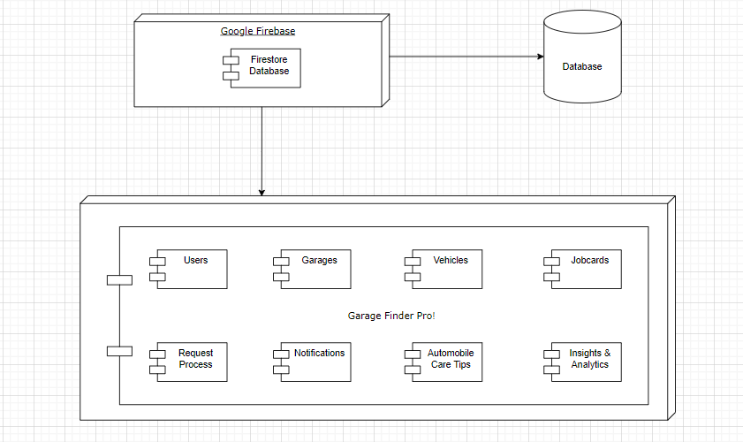
Component Diagram

Deployment Diagram
A deployment diagram is a type of diagram in the Unified Modeling Language (UML) that is used to visualize and describe the architecture of a system as it is deployed in a real-world environment. Deployment diagrams can be valuable for understanding how your mobile app interacts with backend services, servers, and other components when it's deployed in a production environment.

Nodes:
Nodes represent physical or virtual computational resources in your deployment. In your case, these could be servers, cloud services, or even mobile devices. For example, you might have a node for your Android devices and another for the Firebase server.

Dashed Lines:
The dependency on node on components is depicted using dashed lines. This means that a node uses the services of the components that are executing on another node
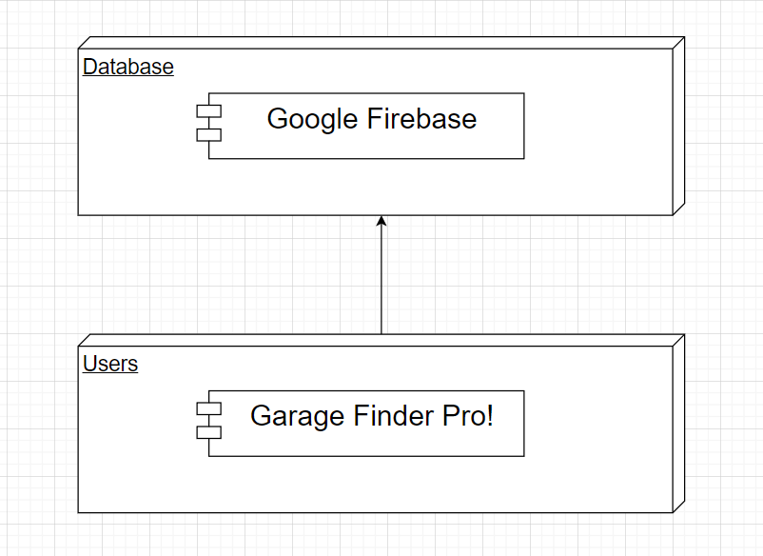
Deployment Diagram

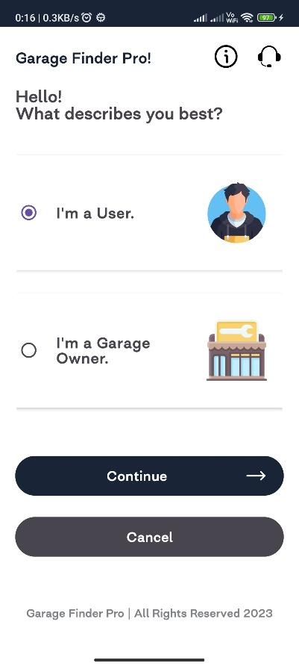
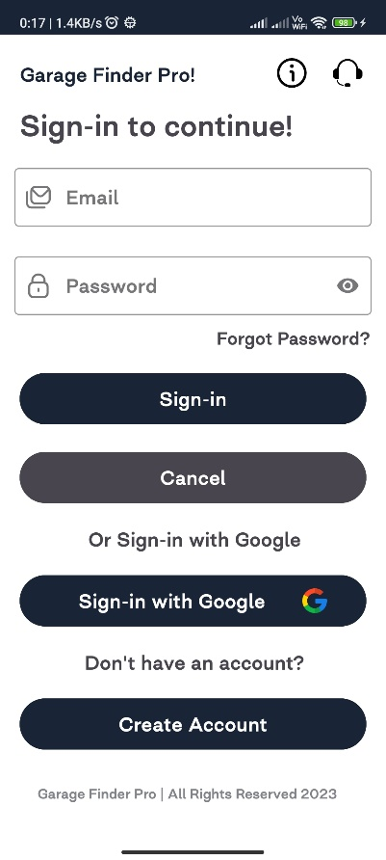
Images of Application
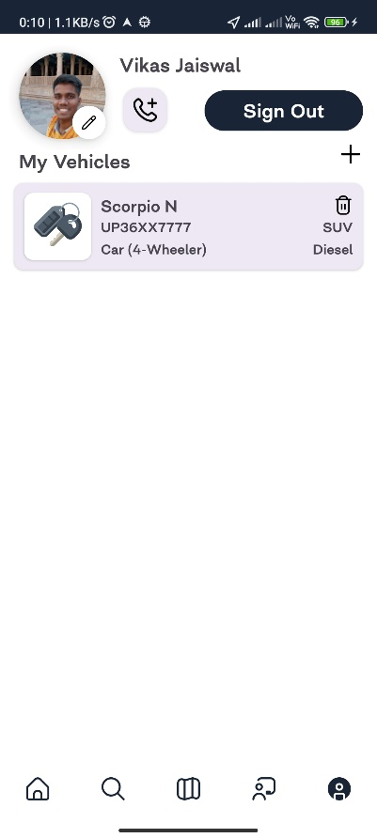
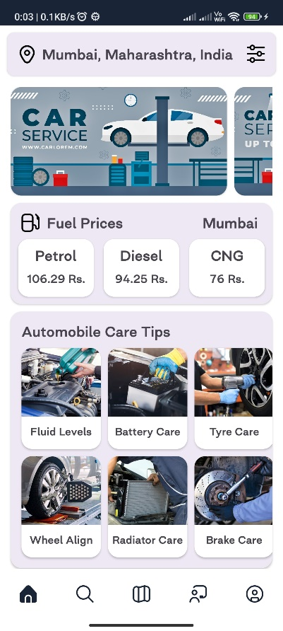
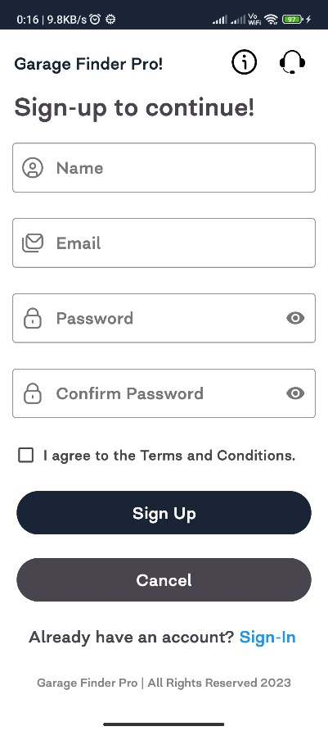

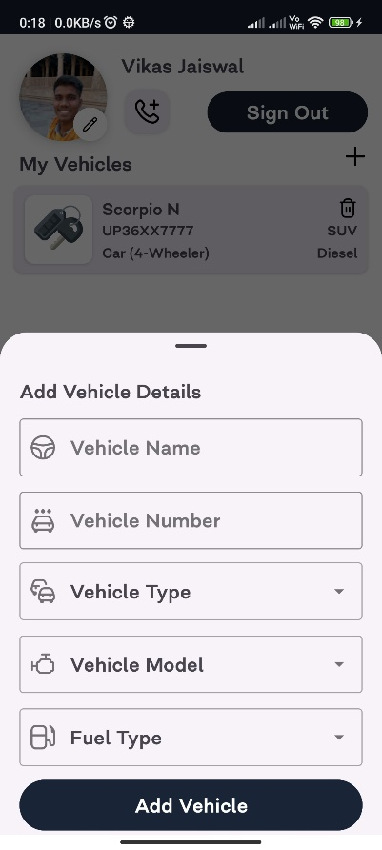
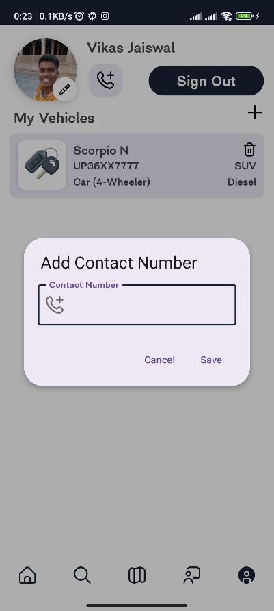
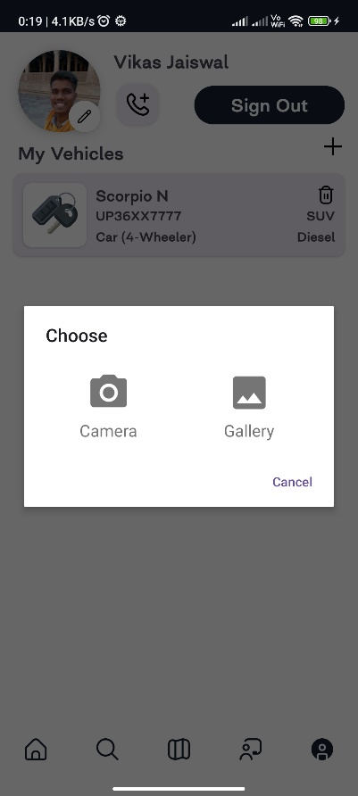
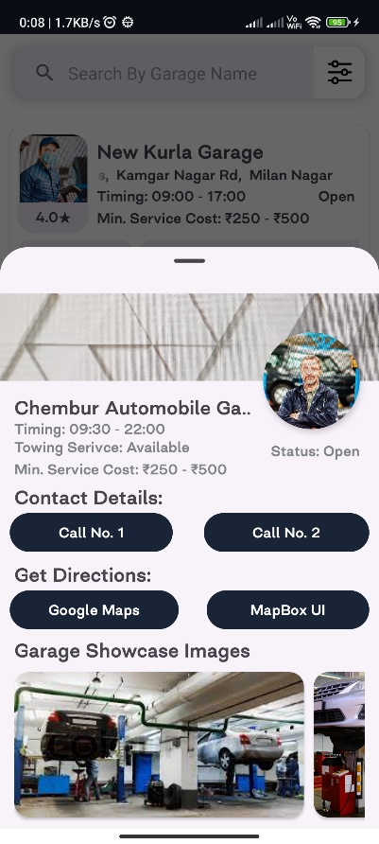
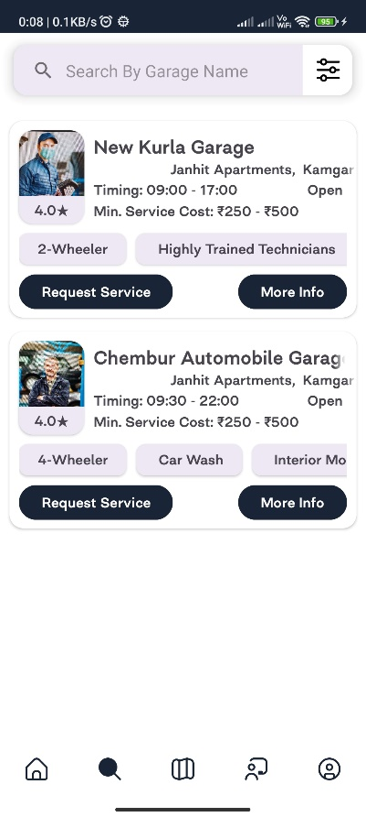
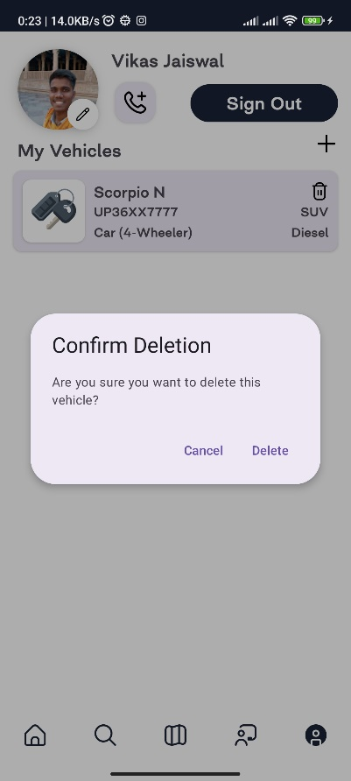

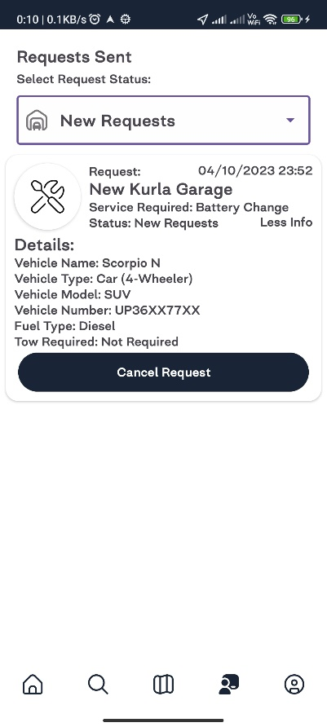
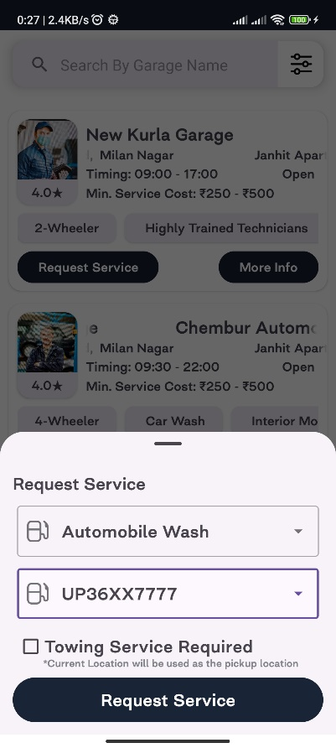
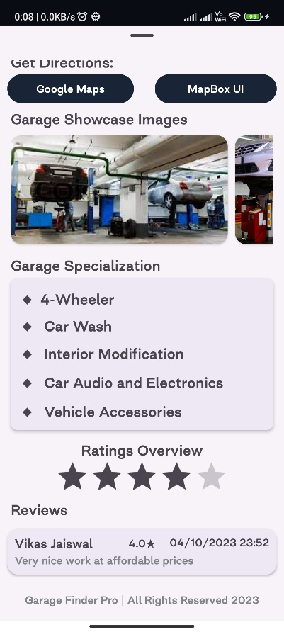
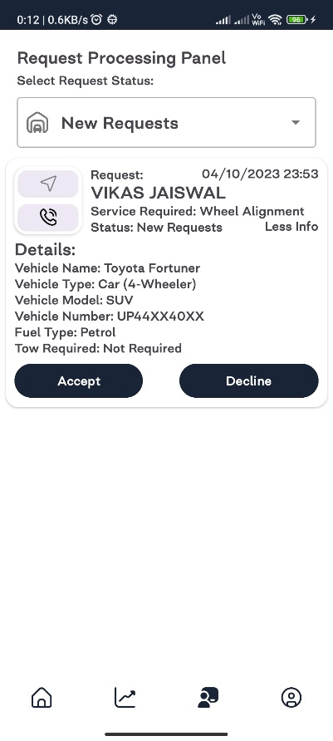
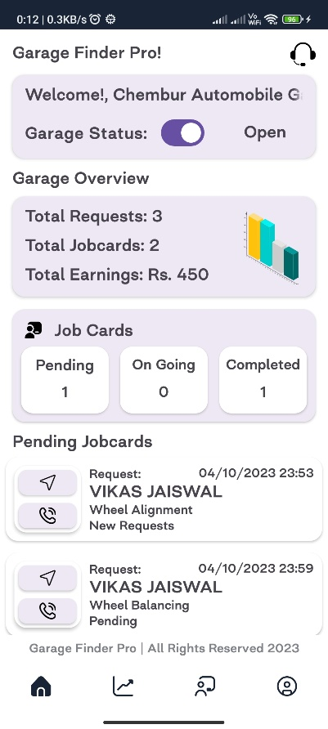
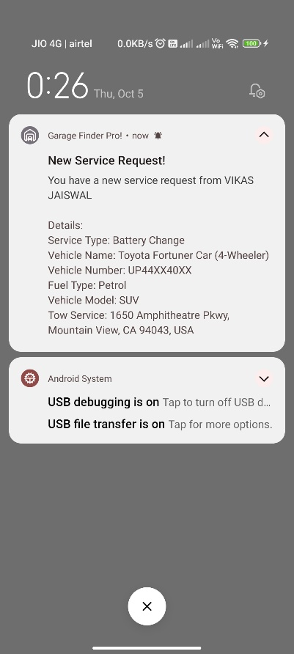

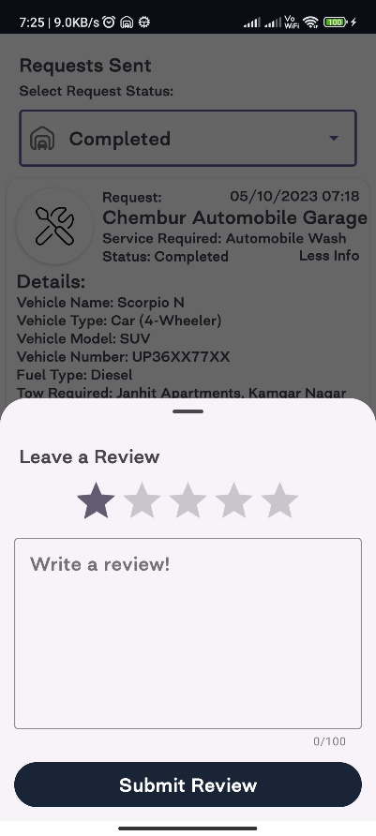
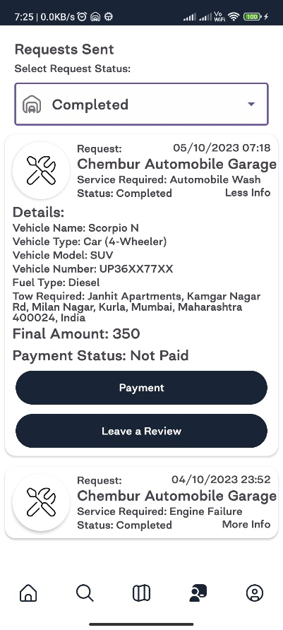
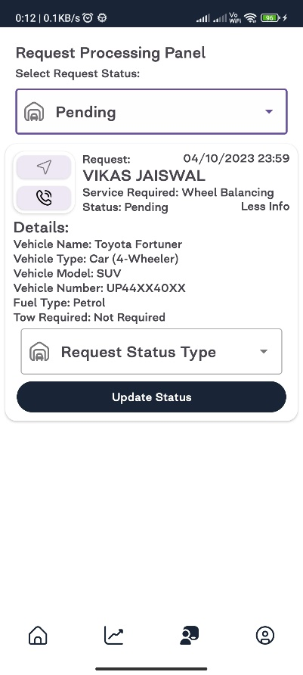
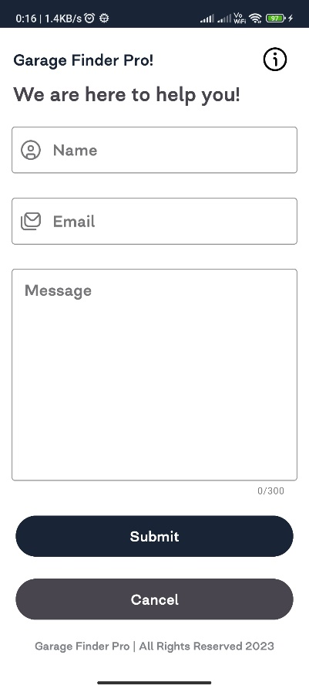
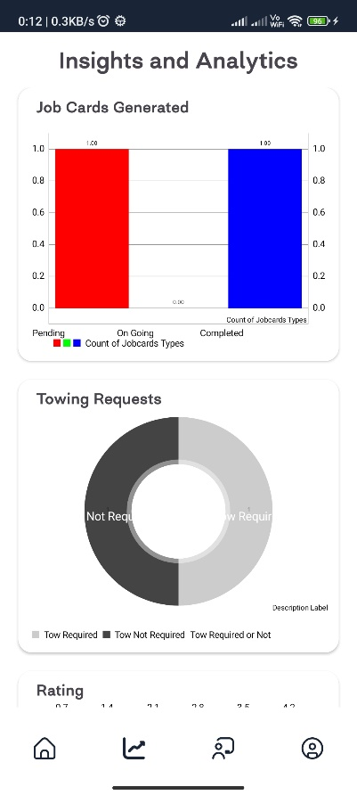
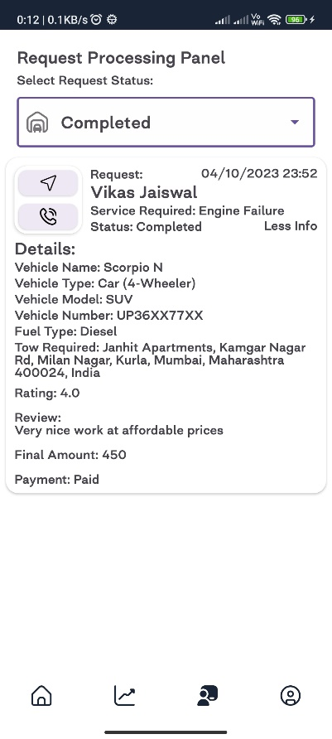

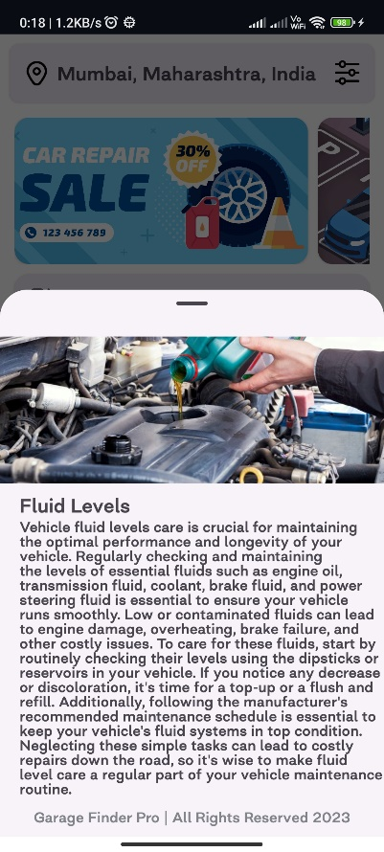
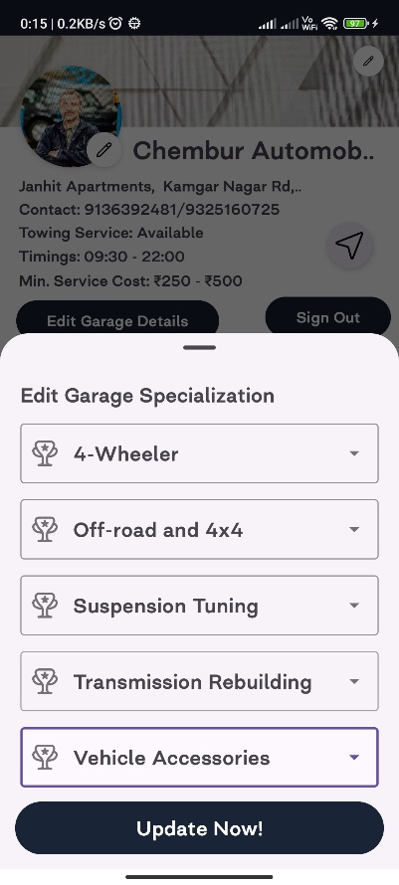
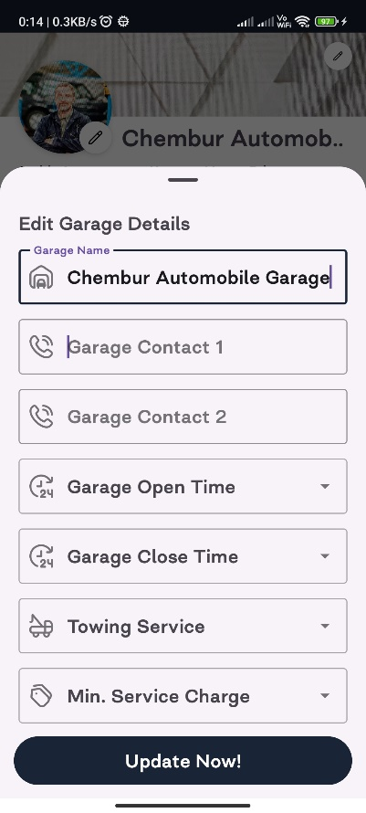
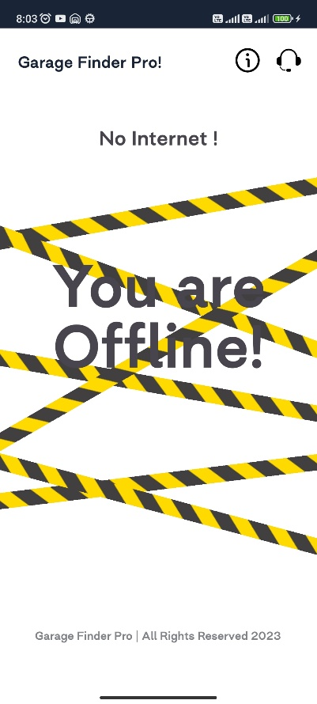

Future Enhancements
Advanced Search Filtering:
Advanced search filters for finding the best garages, using Firebase's Firestore database to query and filter results based on criteria like location, ratings, and services offered.

Enhanced Analytics:
Garage owners can have relevant data to track customer behaviour, monitor garage performance, and make data-driven decisions for improvements.

Offline Mode:
Allow users to access basic functionalities even when they have limited or no internet connectivity, ensuring usability in areas with poor network coverage.

Realtime Map View:
Show real-time locations of nearby active garages on a map, integrating Google Maps for live updates and user-friendly navigation.

Garage Management Tools:
Enhance the garage owner dashboard with tools for better business management, such as inventory tracking and employee scheduling.

References
Source: https://medium.com/firebase-developers/android-firebase-authentication-with-google-1c2f6ca3a738

Source: https://github.com/Dhaval2404/ImagePicker

Source: https://medium.com/@hasperong/pick-multiple-images-from-gallery-using-kotlin-12a715458783

Source: https://www.geeksforgeeks.org/create-and-add-data-to-firebase-firestore-in-android/

Source: https://www.geeksforgeeks.org/android-recyclerview-in-kotlin/

Source: https://youtu.be/L_6poZGNXOo?si=s1FfKC9PHvsNeze4

Source: https://androidgeek.co/notifications-in-kotlin-beginner-in-depth-guide-13fa7d0748fc

