Customer Interview :

Photos with people:
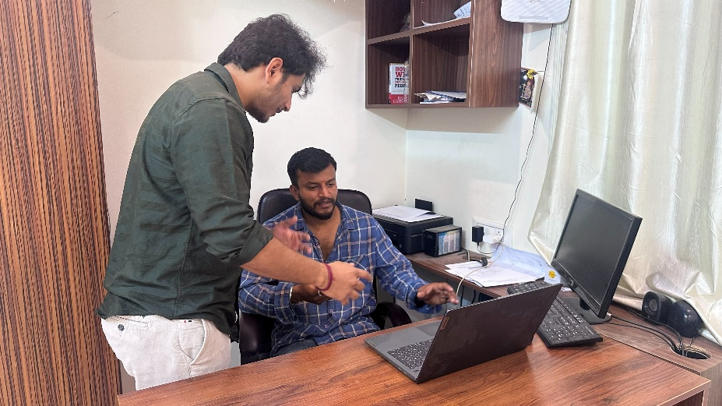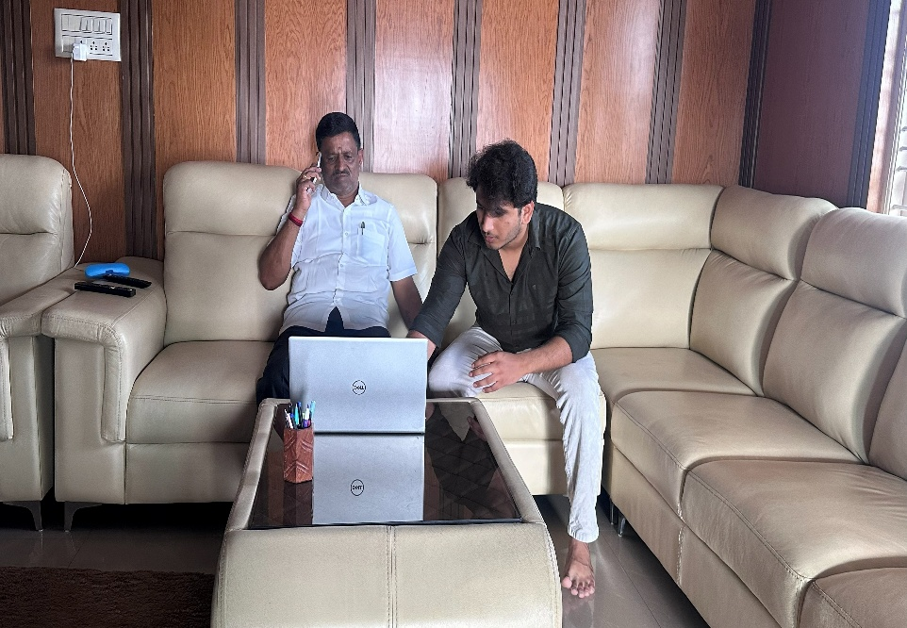

Customer Interaction:
Person 1:
Name: Rahul Sharma
Age: 21
Profession: Business Analyst Intern
Background:
- Works with Excel sheets and business reports daily
- Needs to analyze data and present insights to team
Pain Points:
- Takes a lot of time to go through large datasets
- Manually creating charts is repetitive
- Difficult to quickly extract key insights
Needs:
- Quick data analysis
- Automatic charts and dashboards
- Clear summary of important insights

Person 2:
Name: Prem Nair
Age: 20
Profession: Student (CSE)
Background:
- Works on academic projects involving reports and datasets
- Uses Excel and PDFs for assignments
Pain Points:
- Time-consuming to understand large documents
- Struggles to identify important data points
- Creating visualizations manually is difficult
Needs:
- Easy understanding of data
- Instant visualization (charts/graphs)

