Problem 1

Creating forms, should we use already built-in validations and functions to create the form or hardcode from the beginning. For example add/modify/delete/search can be implemented using an interactive table module which includes modify/delete/search all in one.

Solution

We decided to hardcode the functionalities in different forms to learn the basics in form handling.

Implementing the functionalities of song module

User add Song input form

* Problem 2

Uploading a file or submitting a url that contain the file, there should be an option for user to select one of them, separate input methods should be processed accordingly.

* Solution

Implemented a JavaScript to get different user inputs accordingly. When user have selected an option it will make the relevant option to appear.

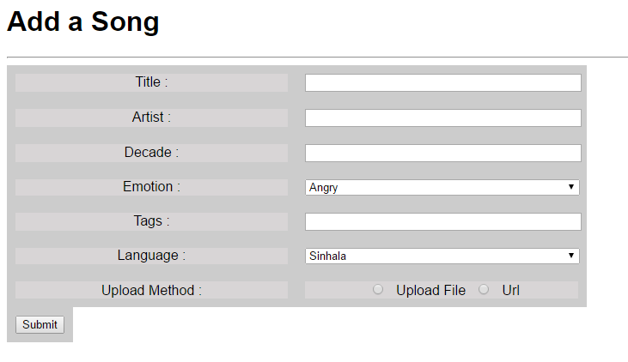

User view Song form

* Problem

How to load the audio file using the path name from the database to the html, and to give the user the basic audio controls.

* Solution

Audio controls are given using the basic html5 audio elements, audio will be played back to the user loading the audio path as source path to the said element. Then it will be echoed to within php file to generate the html content.

