Laboratory Work 4
Student: Matygul Khaisar
Group: SE-2402
Course: Storage Systems
Professor: Tulebayev Yersultan

Goal of Lab: To know the application scenarios of SmartQoS. To be able to configure SmartQoS. To help storage engineers get familiar with operations related to SmartQoS and SmartMigration. To consolidate knowledge on the use of SmartQoS through case studies and scenario-based practices.

1. Introduction
This report documents the configuration and management of SmartQoS and SmartMigration on a Huawei OceanStor all-flash storage system.

- Here is LUN group with 20gb, unmapped which means it is not connected to any host yet, it is created successfully but not connected.
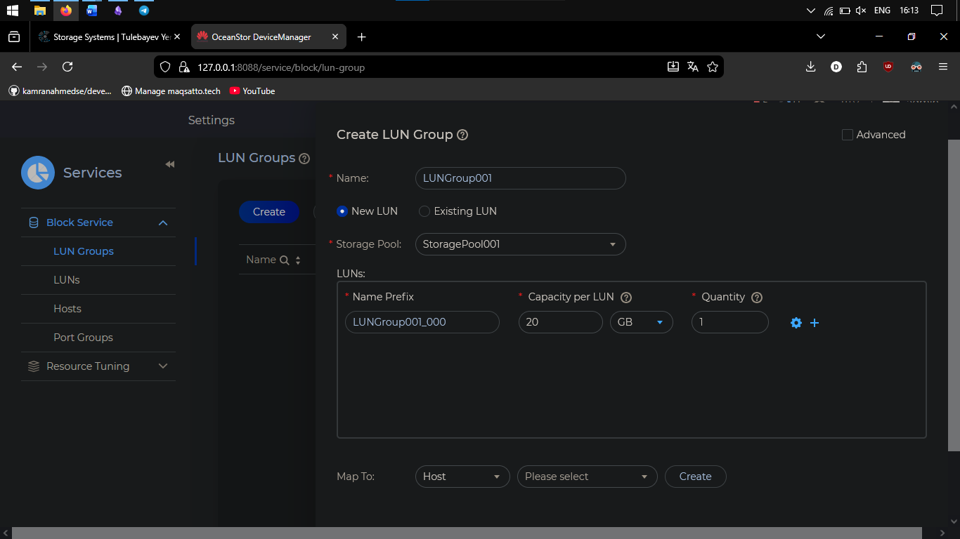
- We created Host named “Host001” os Windows, then entered our IP address, and FC initiator.
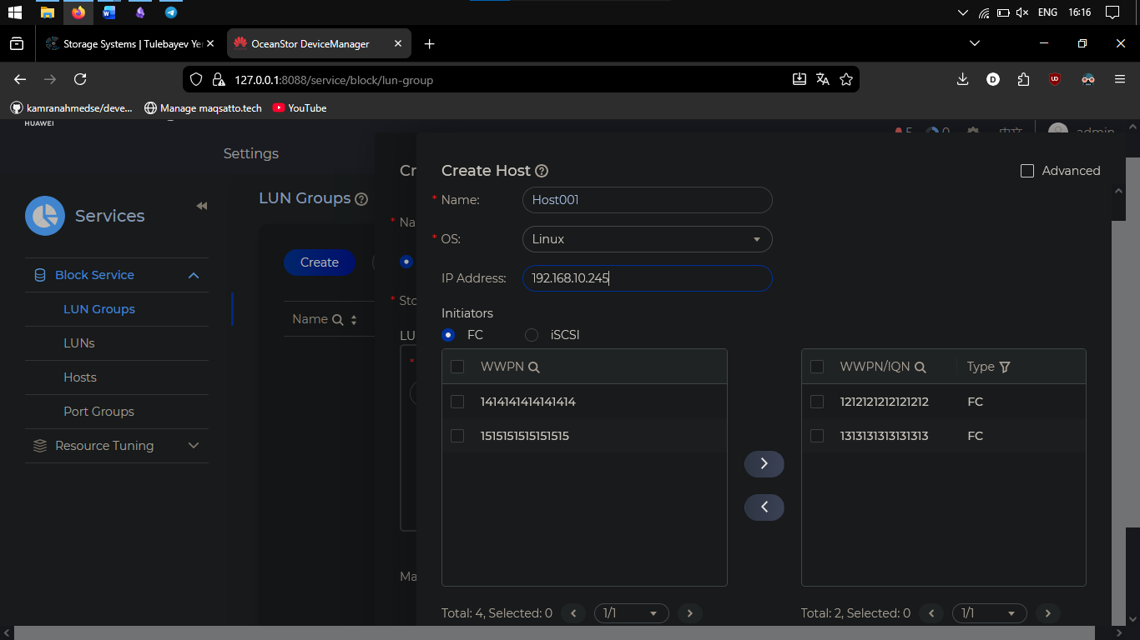
- This means that we successfully added 2 initiators into host.
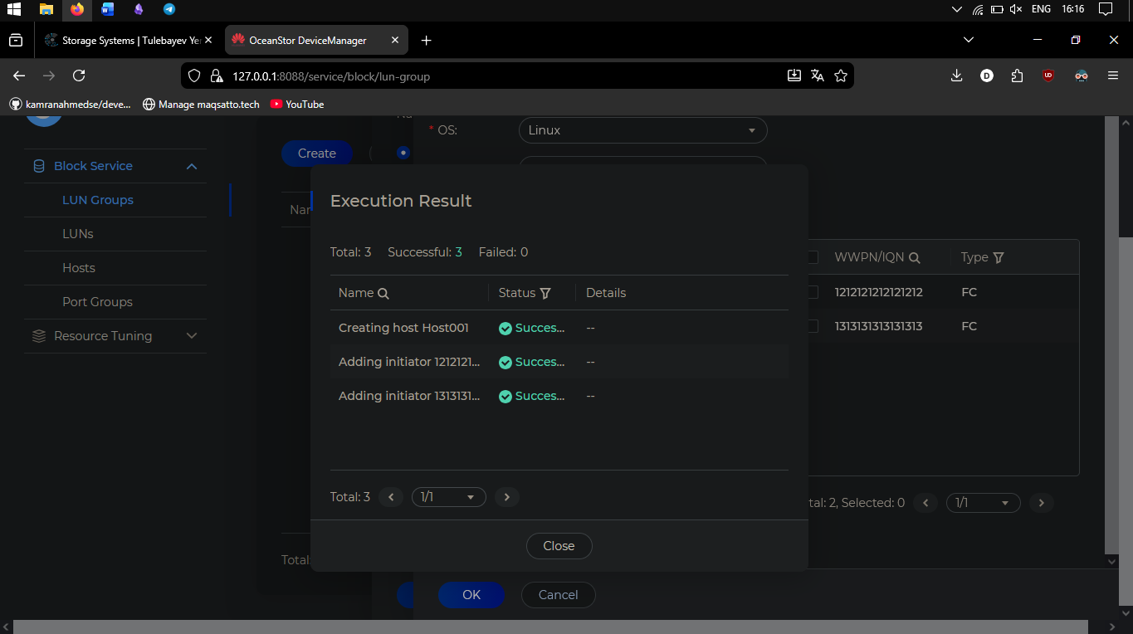
- We successfully added Host001 into Hostgroup001 after we created it.
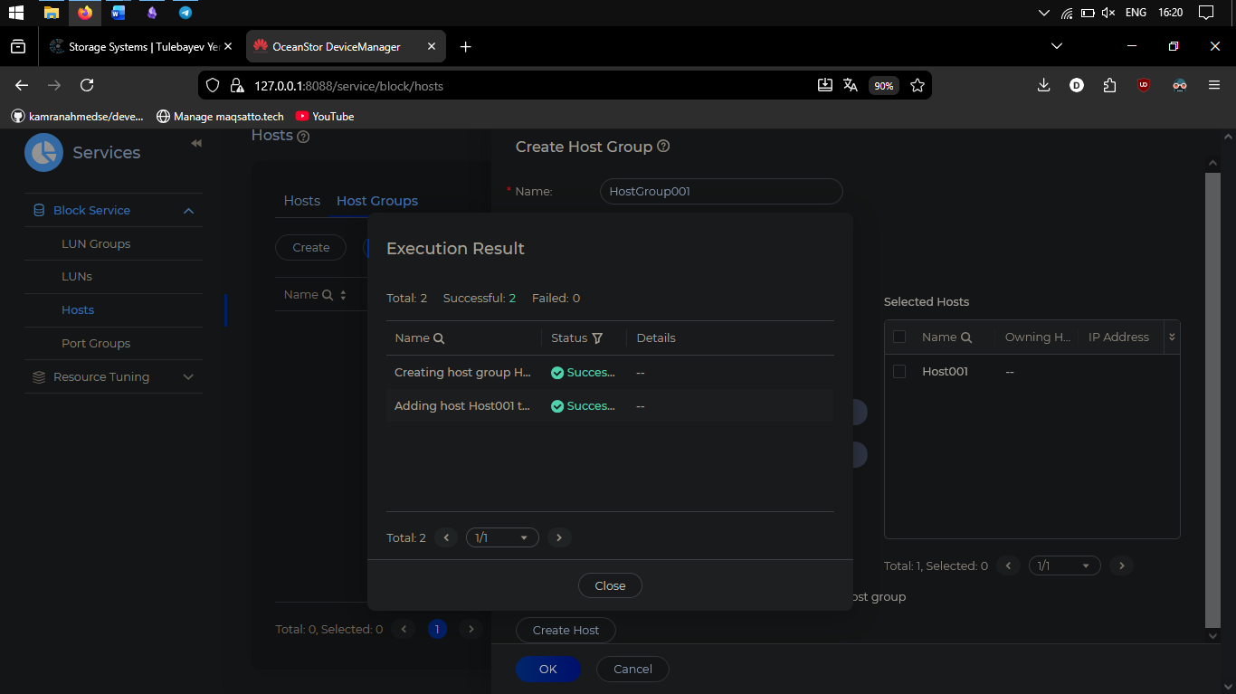

- We mapped LUNGroup001 to HostGroup001 successfully.
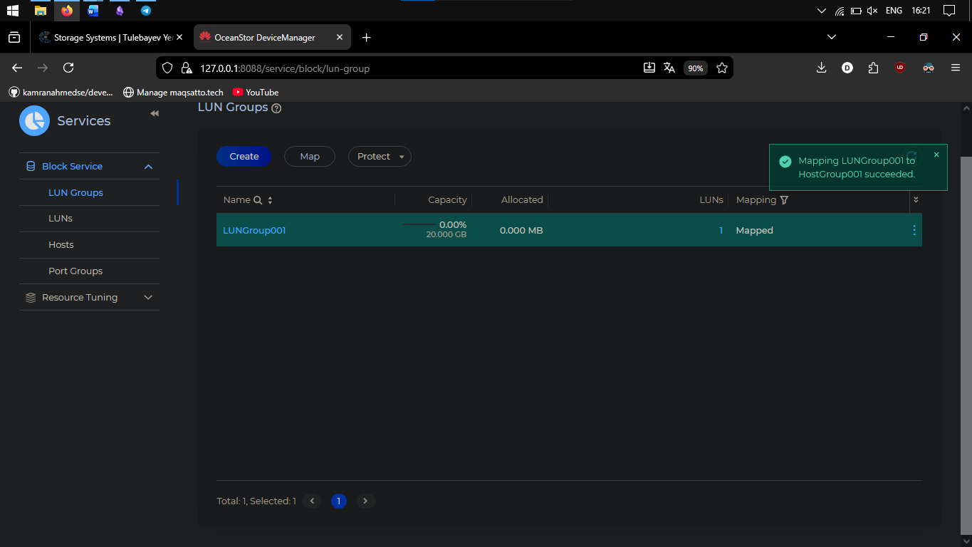

- As we can see capacity 9 gb from 20 gb, health status: Normal, Running status is online, owning storage pool 001, application type is default, owning LUNGroup001.
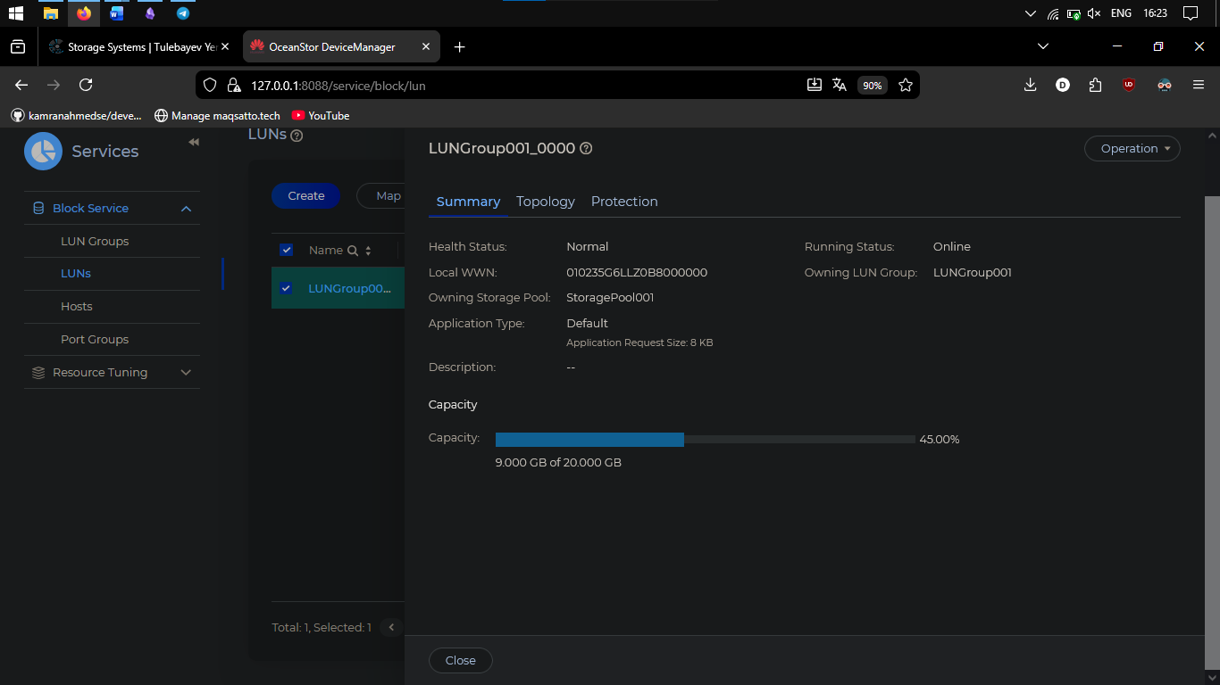

Task 1 (Configurating SmartQoS)
Question: How to set indicators (bandwidth and IOPS) to implement traffic control?
Answer: In SmartQoS policy, set IOPS and bandwidth limits for LUNs. Example: limit non-critical LUN_1 to max 200 IOPS to save resources for critical LUN_0.

Question: Why can the SmartQoS policy be adjusted based on the performance data of LUNs?
Answer: Because SmartQoS monitors real-time performance metrics (IOPS, latency, bandwidth). If a LUN is overloaded, limits can be increased; if underused, limits can be decreased to optimize storage performance dynamically.

2.4 Tasks
Task 1: Configuring SmartQoS
Step 1 – Draw a flowchart for configuring SmartQoS.
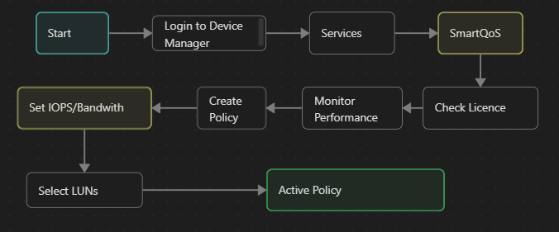

Step 2 – View SmartQoS licence information

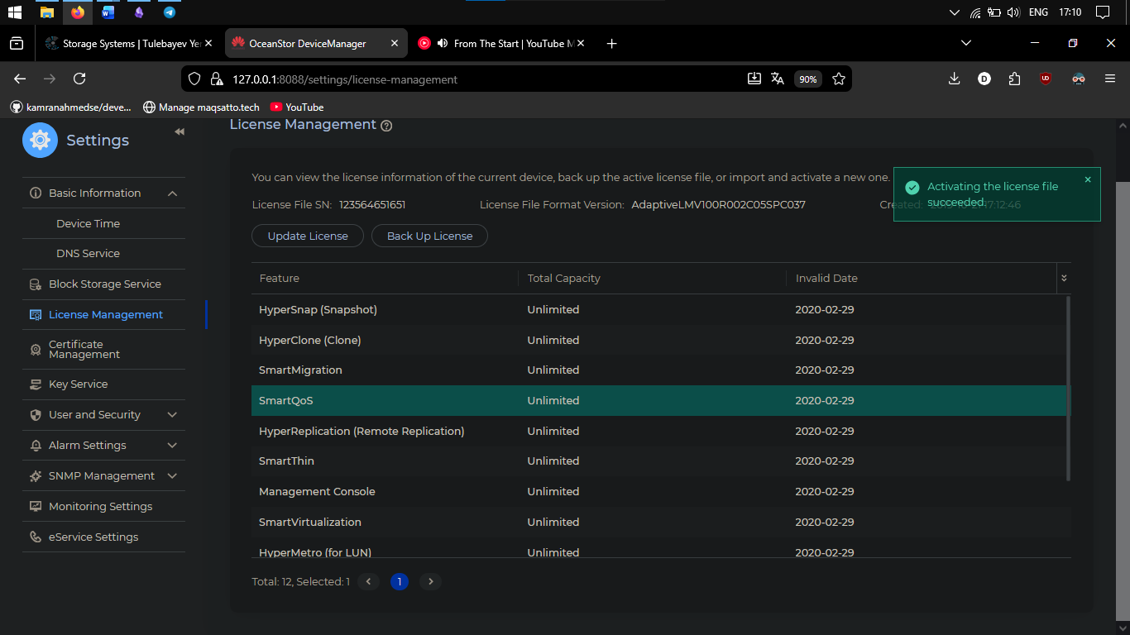
Go to Settings → License Management → find SmartQoS in the list → verify status is Active.

Step 3 – Monitor service performance
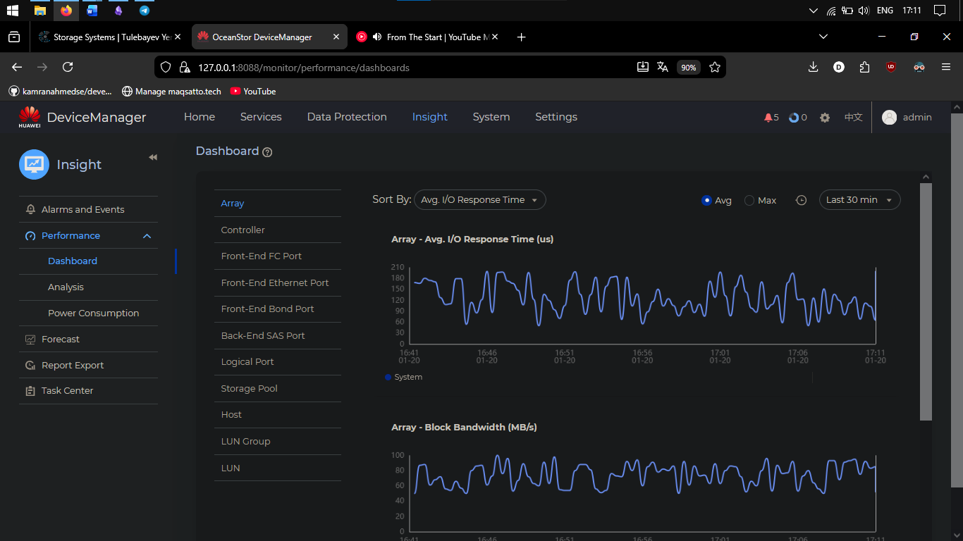
This is the Performance Dashboard in DeviceManager showing real-time storage metrics. Used Performance Dashboard to monitor real-time I/O response time and bandwidth. Analyzed LUN-specific metrics to identify LUN_1 as requiring QoS limits due to high activity.

Step 4 – Create SmartQoS Policy
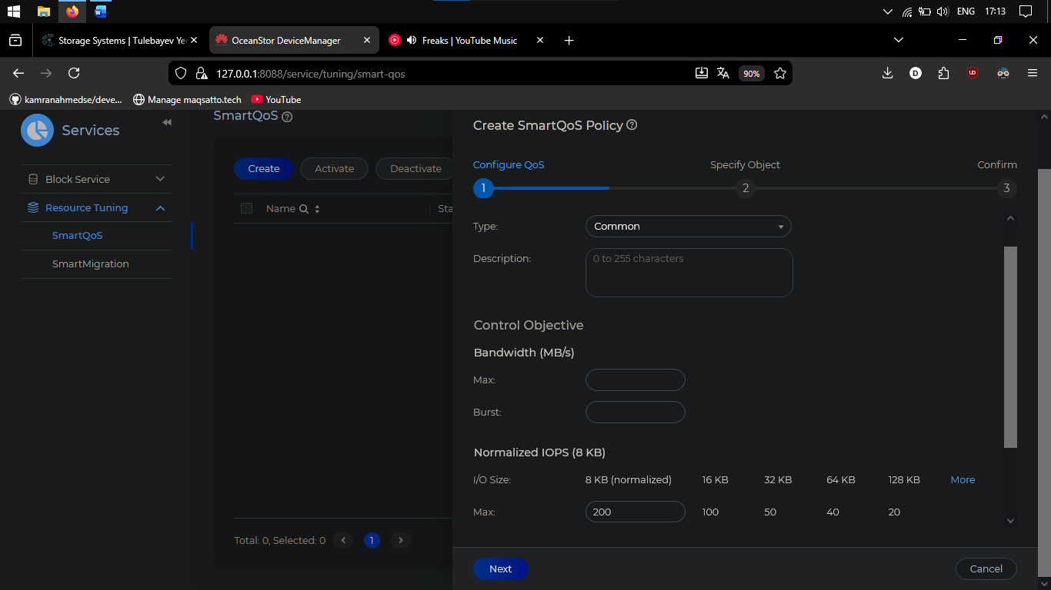
Clicked 'Create' in SmartQoS interface, created Policy01 with max IOPS = 200, applied to LUN_1, and activated the policy.
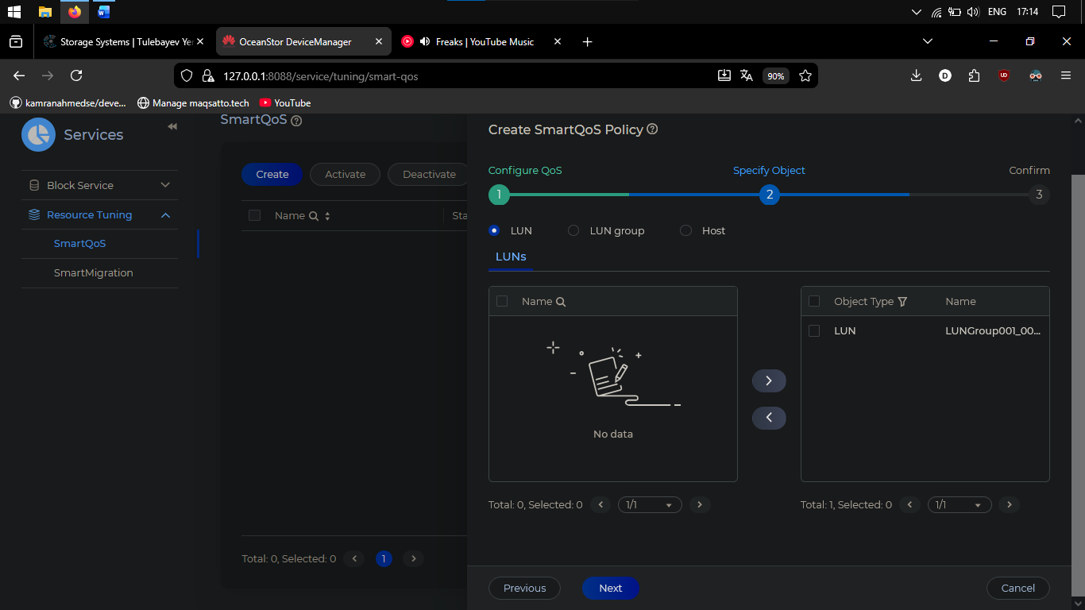
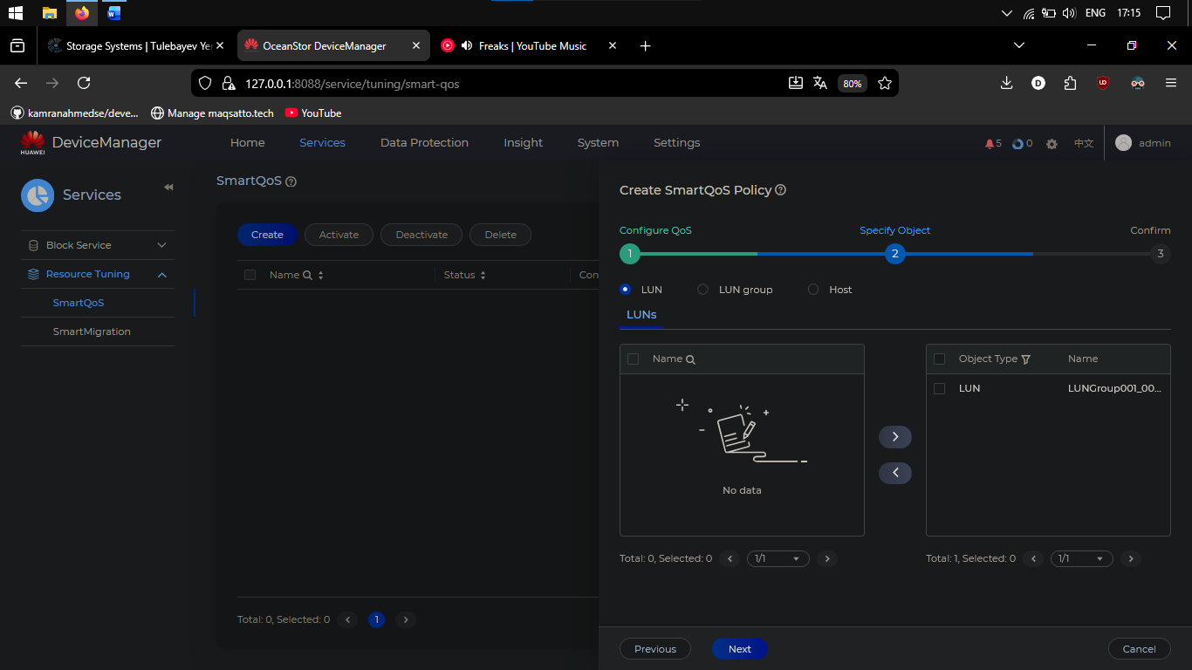
We successfully added LUNs to SmartQoS policy01, and activated it.
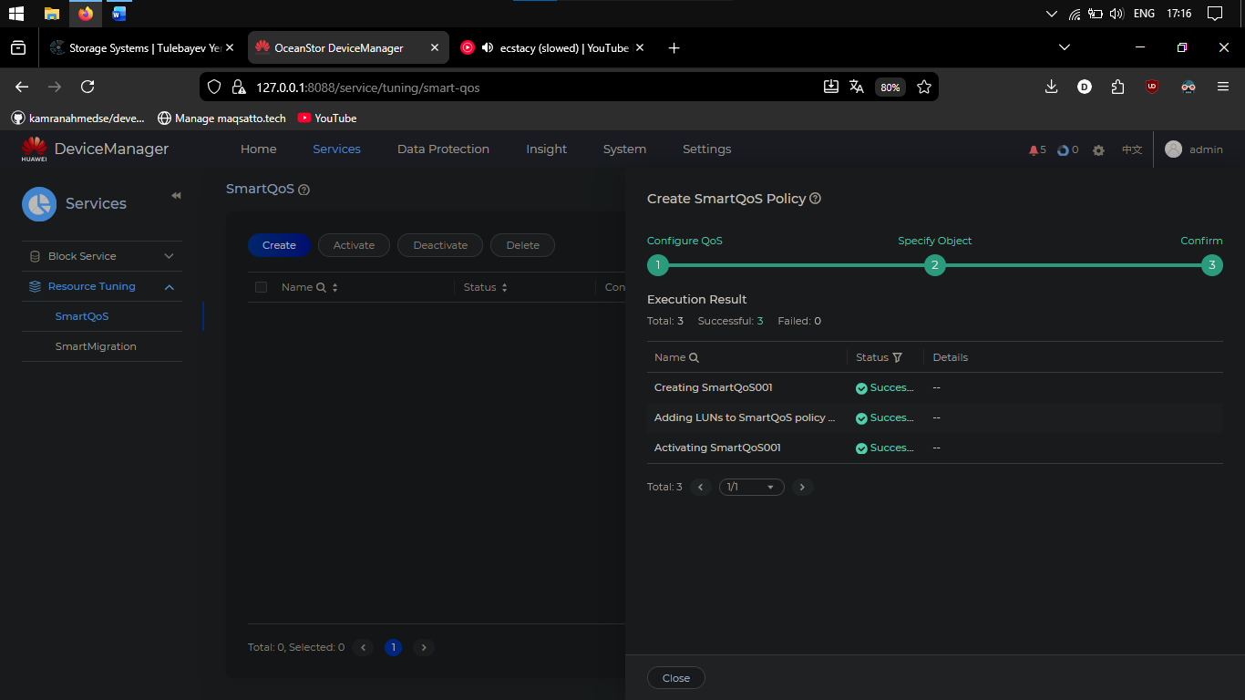

Task 2: Managing SmartQoS
After configuring SmartQoS we need manage it to adjust data flows, thereby property allocating storage resources.

Step 1 – Add control object.
On DeviceManager I added new control objects to the SmartQoS policy as required.
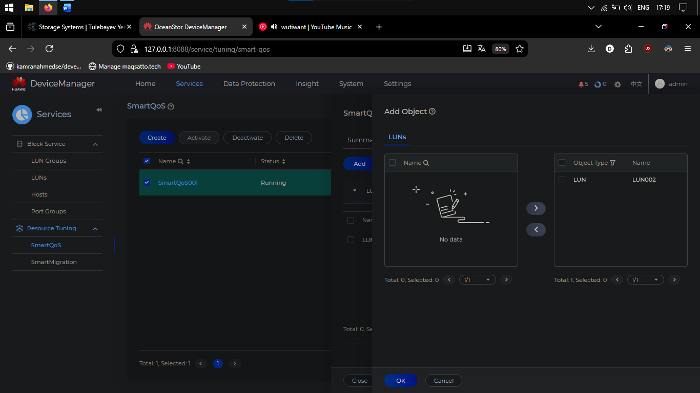
We successfully added LUN002 new control objects to the SmartQoS Policy01
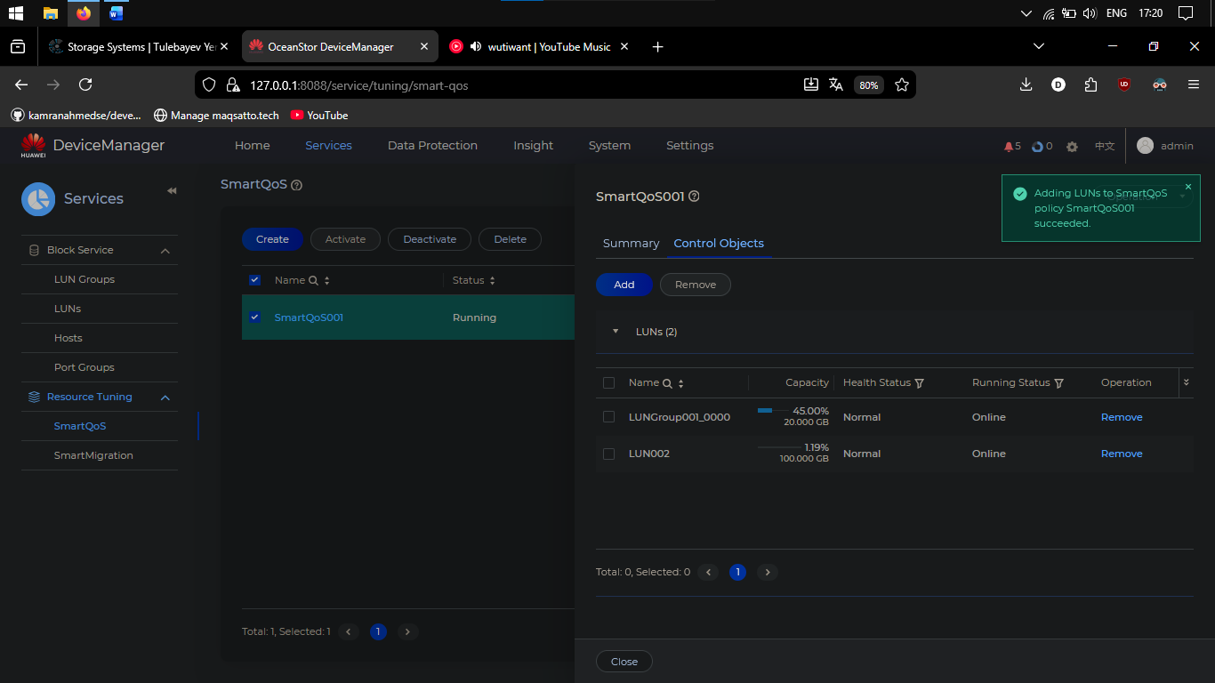

Step 2 – Remove control object
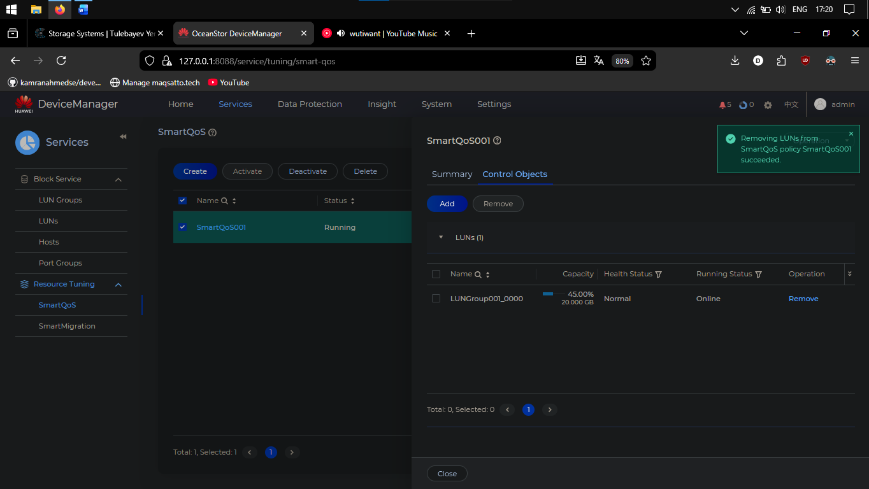
Step 3 – Activate and deactivate a SmartQoS policy.
A SmartQoS policy takes effect after activation. If only one application type runs on the storage system, or all LUNs/LUN groups require the same resources, SmartQoS policies can be deactivated since performance adjustment isn't needed. Help the engineer activate and deactivate Policy01.

Activation:
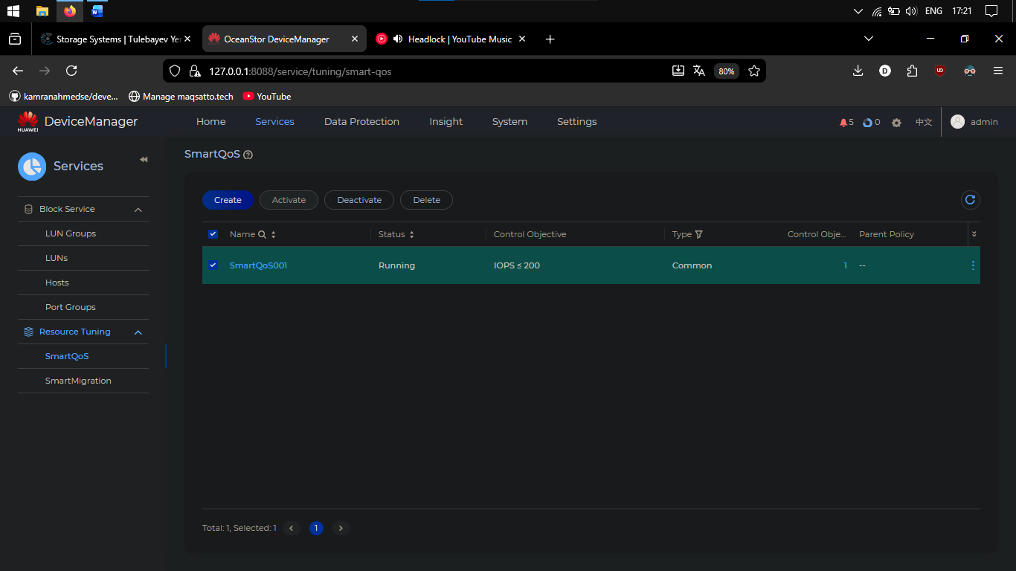

Deactivation:
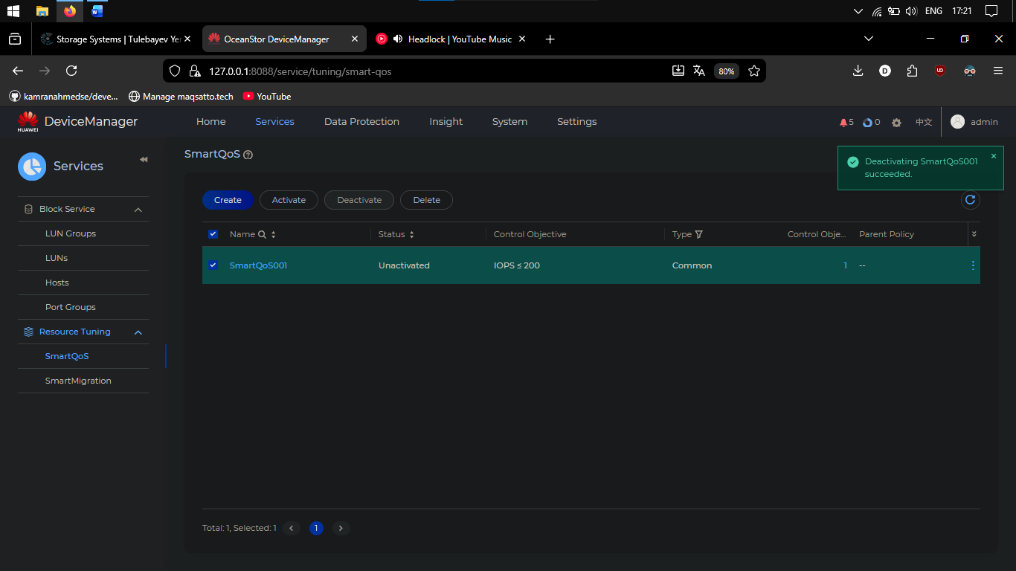
Step 4 – Modify a SmartQoS policy
Policy01 > Modify > Normilixed IOPS max: 200>300
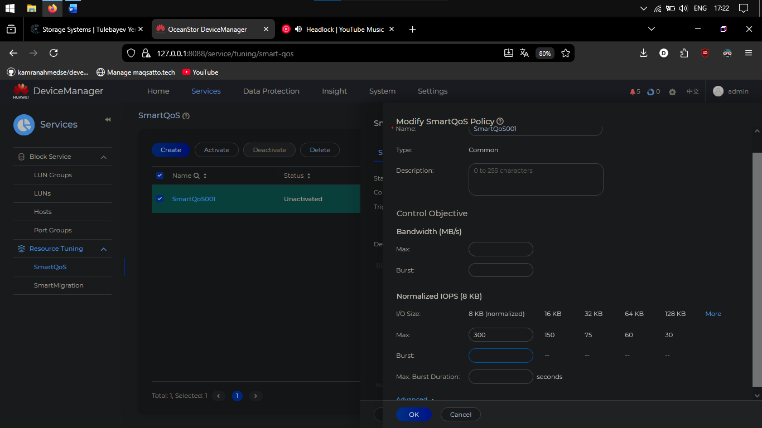

Step 5 – Delete a SmartQoS policy.
Critical services have been moved to other storage systems, so there’s no longer a need for performance limits between service types. The SmartQoS policy is no longer required.
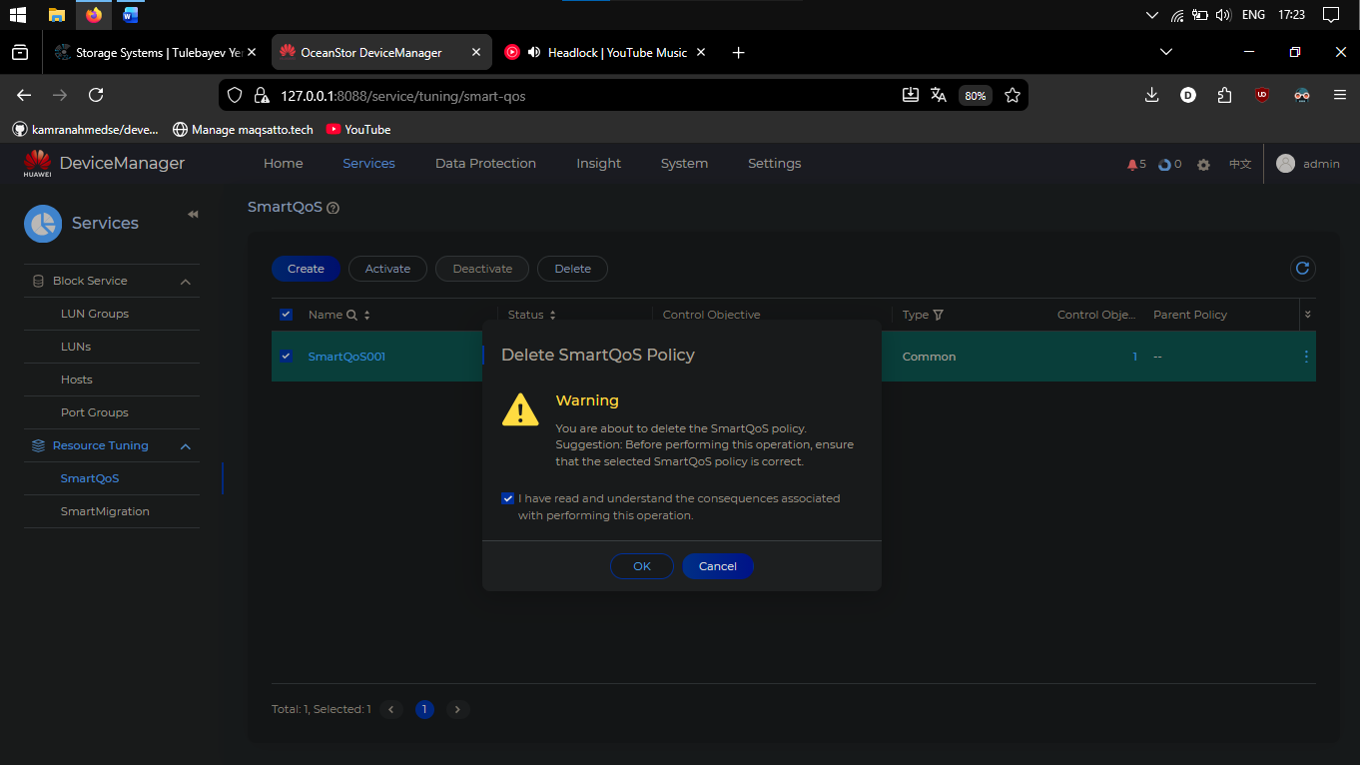

Task 2 Managing SmartMigration
Question: What are the difference between SmartMigration and Hyperclone?

Answer: SmartMigration is for live, zero-downtime data migration between storage systems, while HyperClone is for creating instant, independent point-in-time copies of data for backup or testing.

Step 1 – Draw flowchart for configuration SmartMigration.
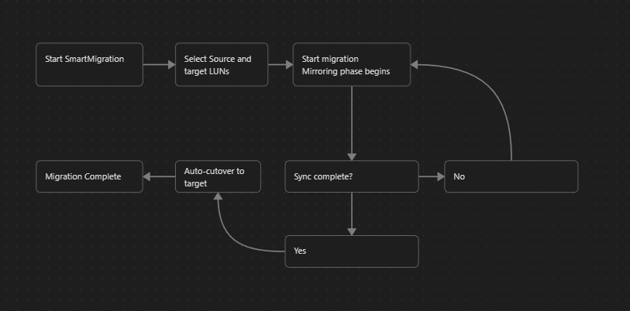
Step 2 – view SmartMigration licence information
Settings > License Management > SmartMigration
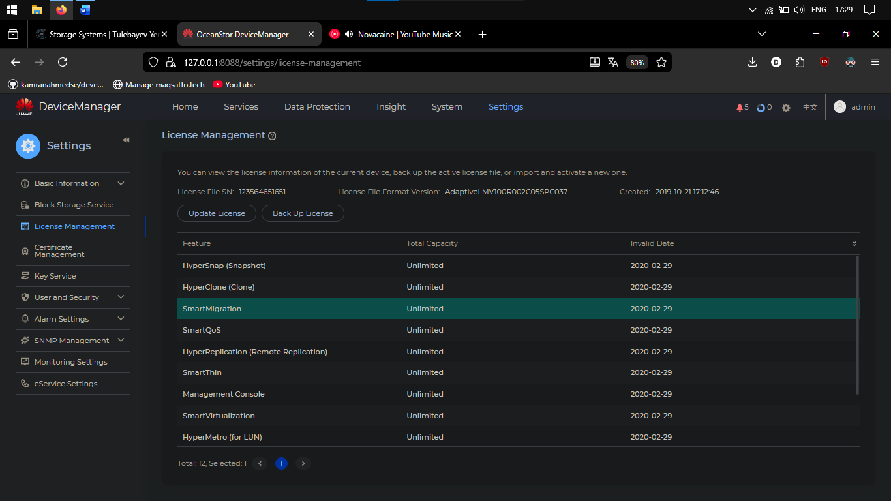

Step 3 – Create a SmartMigration task
Services > SmartMigration > Create
Avialiable LUNs: LUNGroup001 > Selected
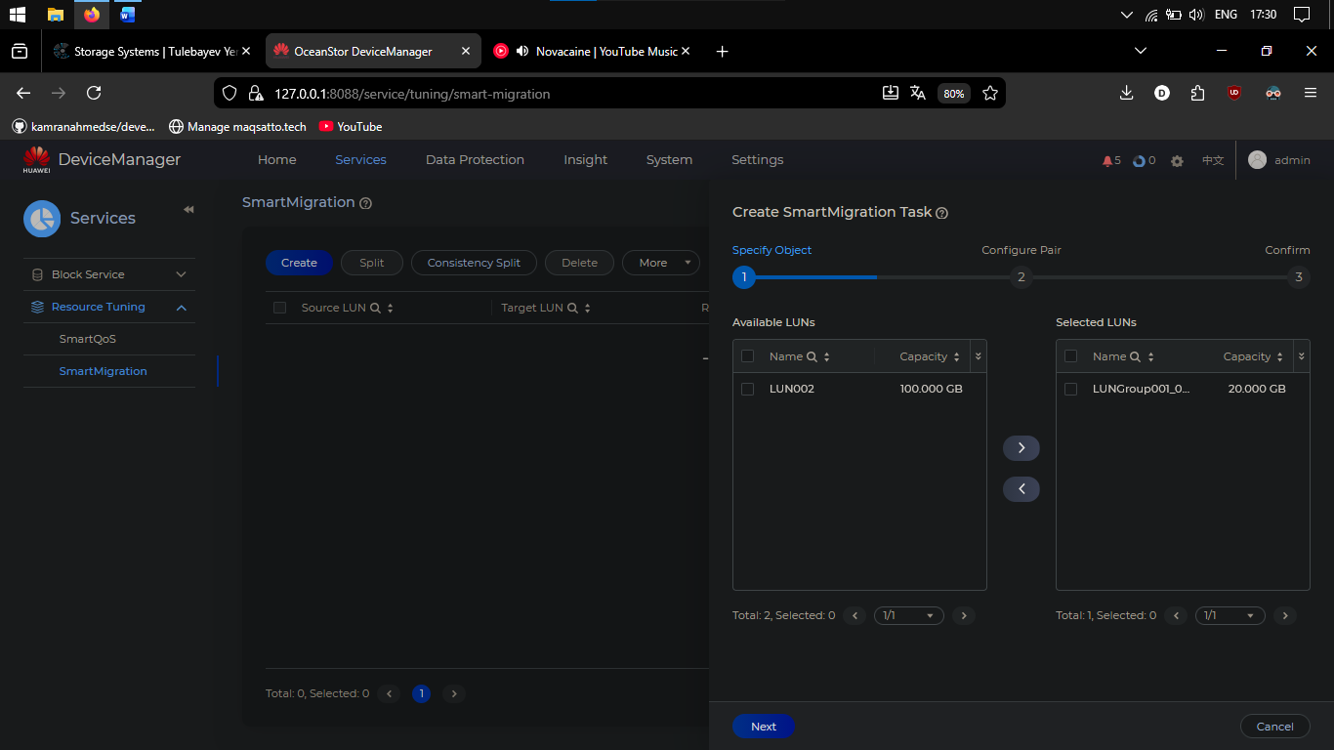
Splitting mode: Manual
Default Migration rate: low
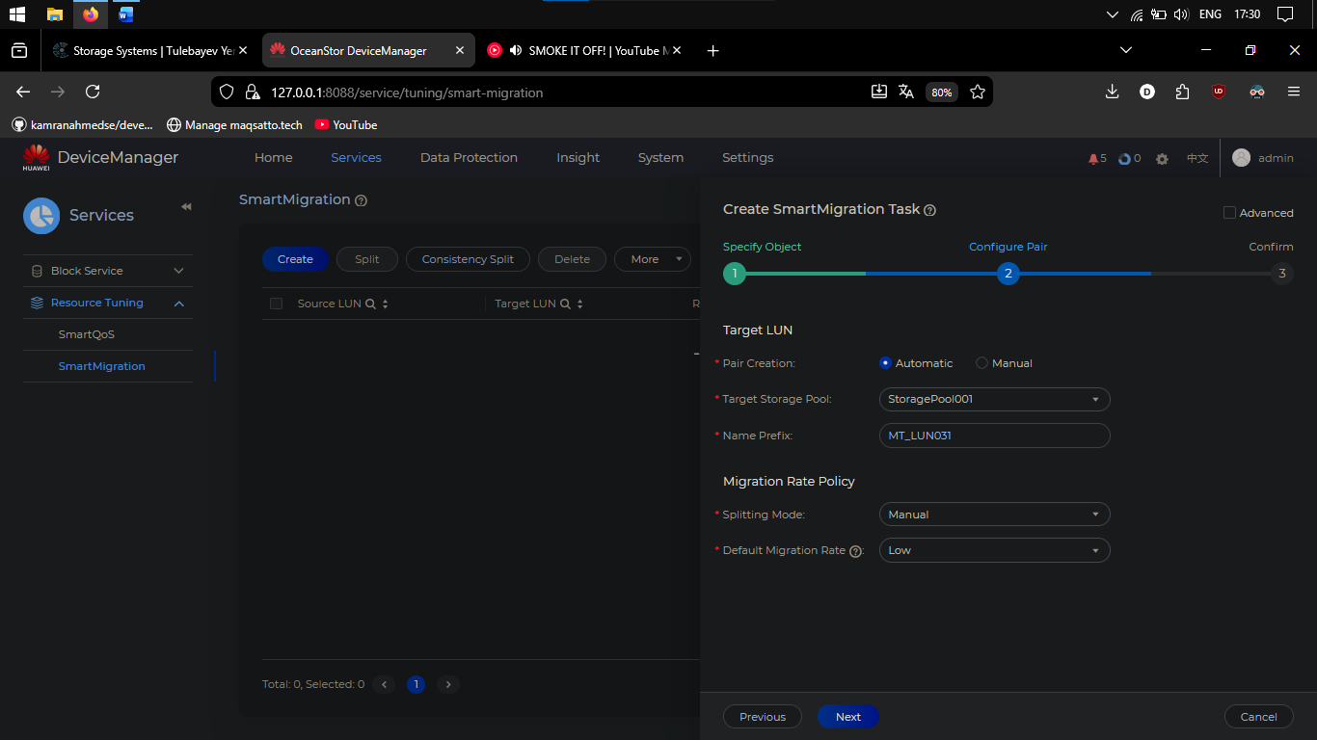

All settings done
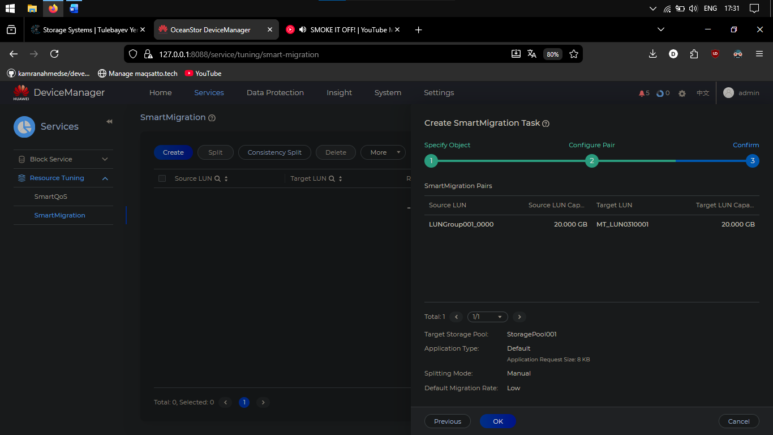
SmartMigration created successfully
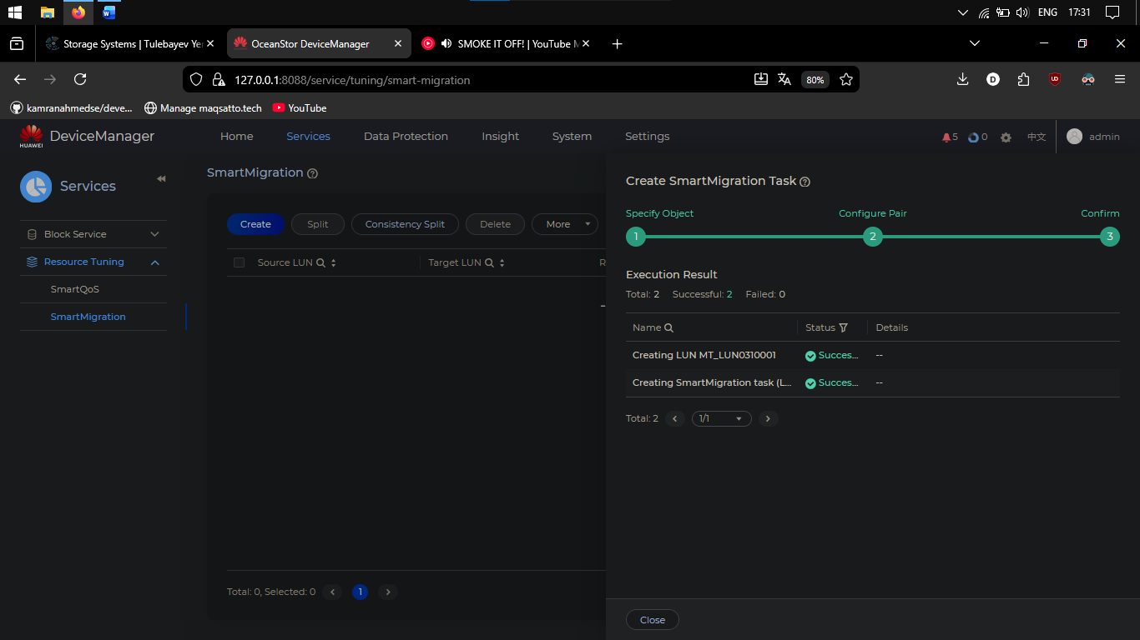
Step 4 – split a SmartMigration pair
The SmartMigration pair must be split manually to preserve a point-in-time copy of the source LUN's data on the target LUN.
This copy can then be used for enterprise application testing.
Help the engineer split the SmartMigration pair and stop synchronization between the source and target LUNs.
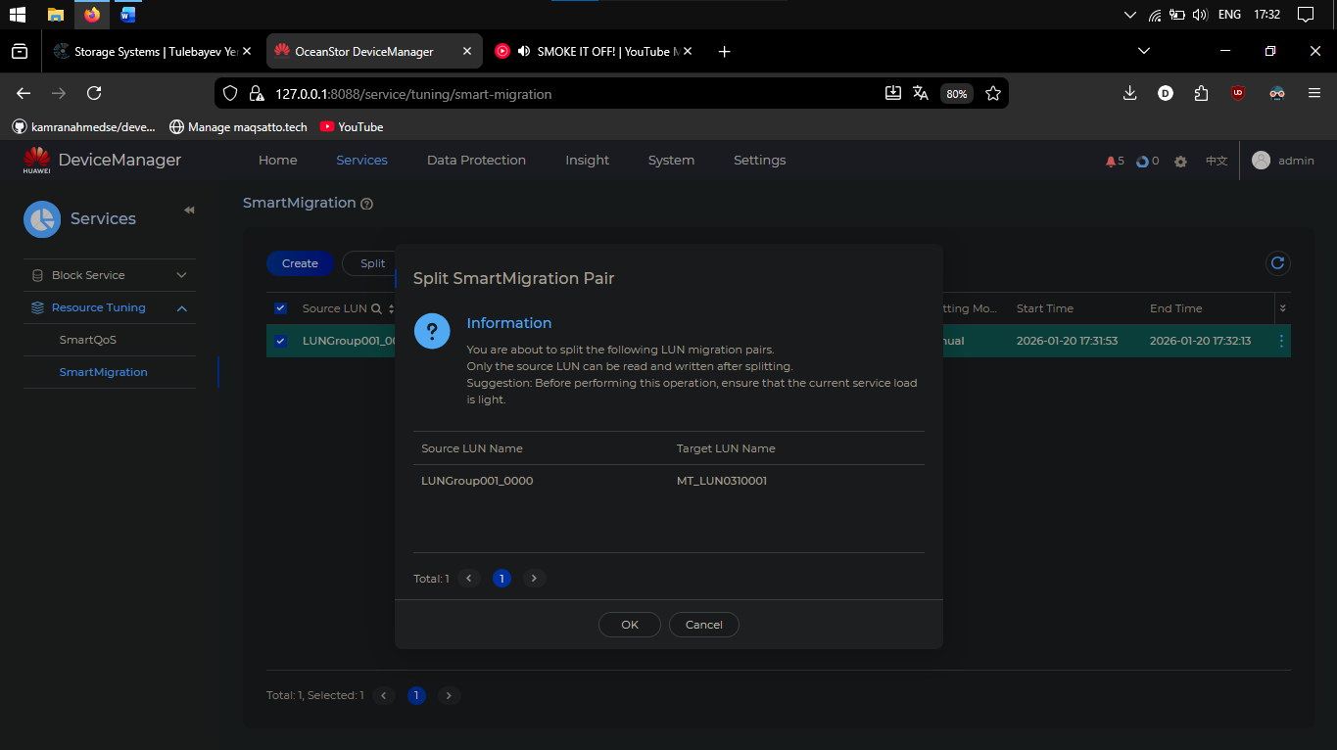
Successfully split
Question: Can SmartMigration be used to migrate data between heterogeneous storage systems?
Answer: Yes, SmartMigration can be used to migrate data between heterogeneous storage systems, but with important prerequisites and limitations depending on the specific storage vendor implementation.

Task 2 Managing SmartMigration
Step 1 – Modify migration rate
The engineer plans to migrate at night when load is light.
A Low migration rate could take too long and impact daytime performance.
Change the migration rate to Highest to complete the transfer faster.
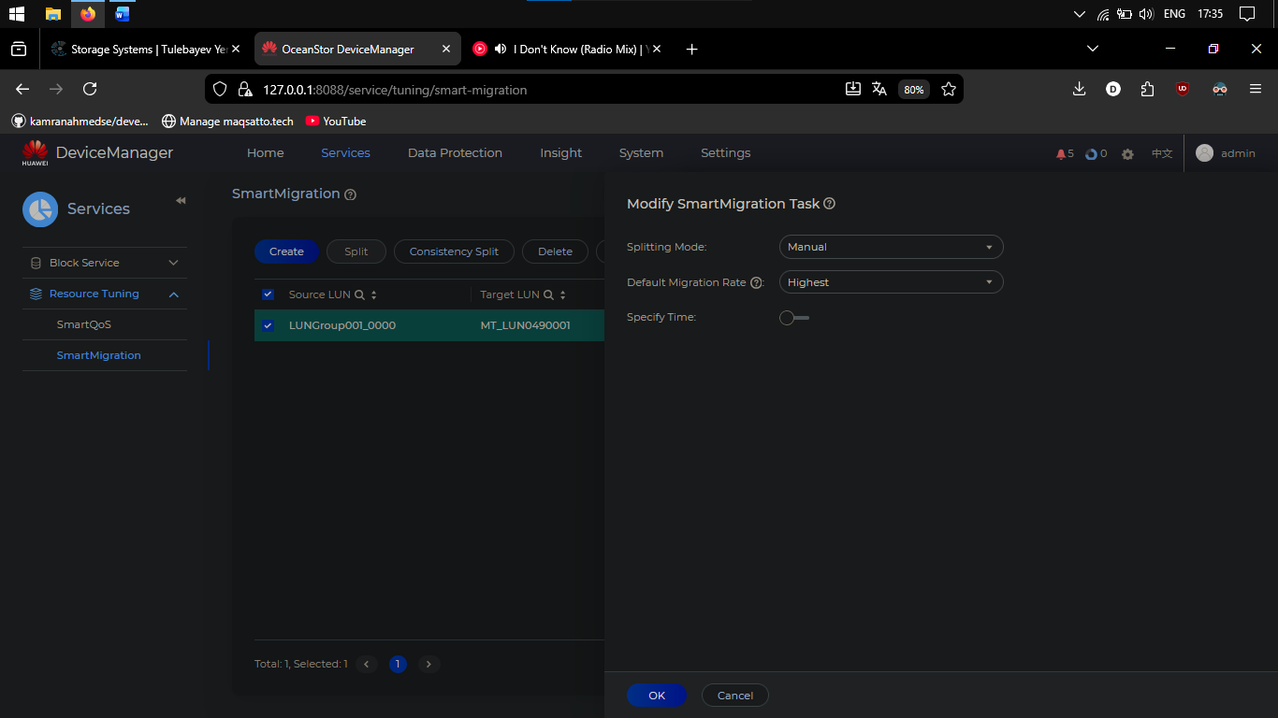 Step 2 – Deleting SmartMigration.
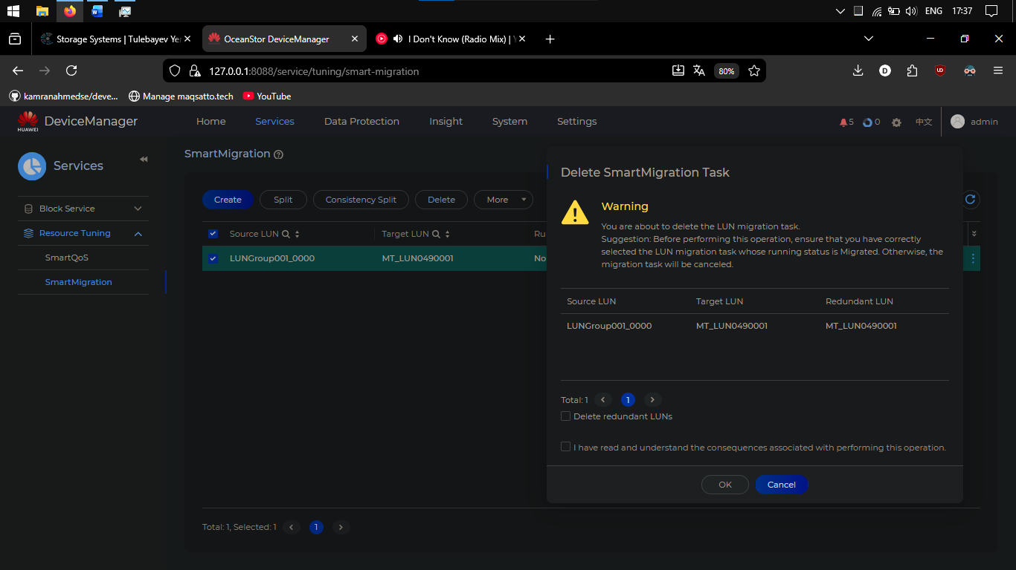

Discussion: In addition to the migration rate what property of SmartMigration can be modified?
SmartMigration is a powerful, zero-downtime data migration technology essential for modern storage management. It enables seamless live transfer of data between storage systems, ensuring continuous business operations during hardware upgrades, rebalancing, or technology refreshes. By employing intelligent background synchronization and mirrored I/O, it eliminates service disruption. Its flexibility allows fine-tuning through adjustable migration rates, scheduling, and split modes, balancing speed with system impact. Ultimately, SmartMigration enhances agility, optimizes storage performance, and simplifies lifecycle management, proving indispensable for maintaining efficient, resilient, and scalable IT infrastructure in dynamic enterprise environments.

Summary and Conclusion:
In this lab, I configured and managed SmartQoS and SmartMigration on a Huawei OceanStor storage system. For SmartQoS, I created policies to control LUN performance by setting IOPS and bandwidth limits, dynamically adjusting based on real-time metrics to optimize resource allocation. For SmartMigration, I performed live data migration between LUNs, modifying migration rates and manually splitting pairs to create point-in-time copies for testing. Both tools were licensed, monitored, and operated via DeviceManager’s intuitive interface.
SmartQoS and SmartMigration are essential tools for modern storage management. SmartQoS ensures performance isolation and efficient resource distribution, while SmartMigration enables seamless, zero-downtime data mobility. Together, they enhance storage agility, resilience, and scalability, allowing administrators to maintain high service levels during upgrades, rebalancing, and daily operations. Mastery of these technologies is critical for optimizing enterprise storage environments in dynamic, data-driven organizations.

