INVERTED PENDULUM

**Aim is to have states: 1, 0, 0**

C(1,1:nT) = 1; %cos(theta)

C(2,1:nT) = 0; %sin(theta) - balancing verticaly

C(3,1:nT) = 0; %theta_dot - no movement

In polar coordinates

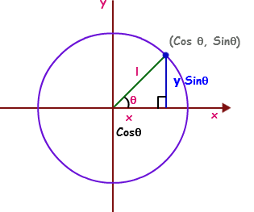

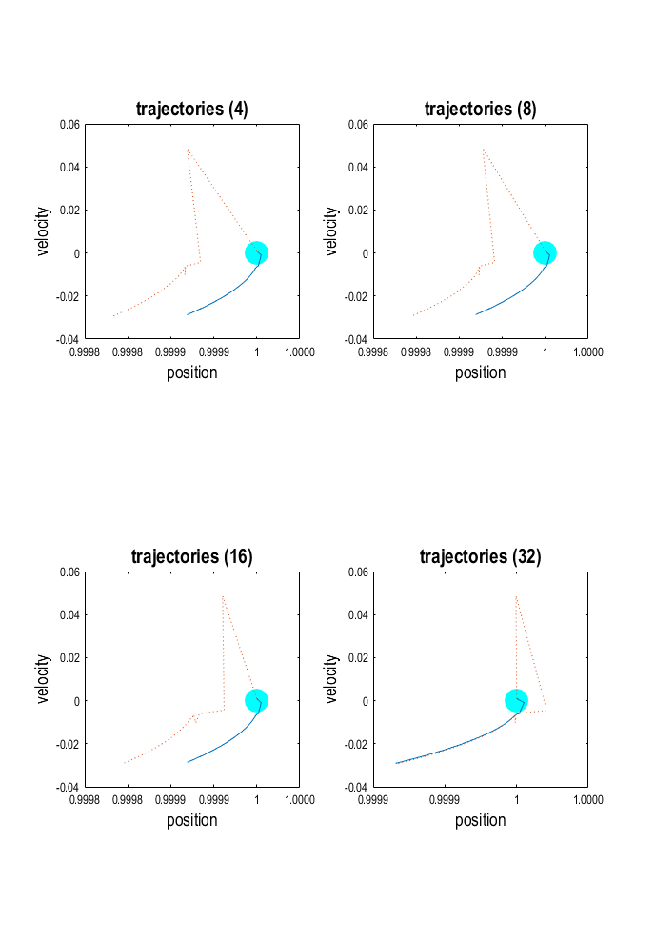

From Generative Process

% true model-states - u

%--------------------------------------------------------------------------

% pU.x = true hidden states

% pU.v = true causal states v{1} = response (Y)

From Recognition Process

% conditional moments of model-states - q(u)

%--------------------------------------------------------------------------

% qU.a = Action

% qU.x = Conditional expectation of hidden states

% qU.v = Conditional expectation of causal states

plot(DEM.pU.x{1}(1,:),DEM.pU.x{1}(3,:))

plot(DEM.qU.x{1}(1,:),DEM.qU.x{1}(3,:),':'),hold off

% This implementation of DEM is the same as spm_DEM but integrates both the

% generative process and model inversion in parallel. Its functionality is

% exactly the same apart from the fact that confounds are not accommodated

% explicitly. The generative model is specified by DEM.G and the veridical

% causes by DEM.C; these may or may not be used as priors on the causes for

% the inversion model DEM.M (i.e., DEM.U = DEM.C). Clearly, DEM.G does not

% require any priors or precision components; it will use the values of the

% parameters specified in the prior expectation fields.

DEM.pU.v{1}(1,:)

DEM.pU.v{1}(1,:)





TO DO TESTS: CHANGE U : NEW PRIORS

MORE ACTION?

THEN REMOVE THE GENERATIVE PROCESS

Line 448 SPM ADEM

% evaluate generative process

%------------------------------------------------------------------

[pu,dg,df] = spm_ADEM_diff(G,pu);

% and pass response to qu.y

%==================================================================

for i = 1:n

y = spm_unvec(pu.v{i},{G.v});

qu.y{i} = y{1};

end

SIZE

ros_in_adem_457 = [iY n ]

ros_in_adem_457 =

size 20 observations 7 interval steps …. N=7

17 7

SHOULD BE ABLE TO SUB IN qu.Y (e.g. from AI gym ) and go on and evaluate … KEEP THIS

% evaluate generative model

%------------------------------------------------------------------

[E,dE] = spm_DEM_eval(M,qu,qp);