Revision history
2016-10-09 Added note “For periodic uploads, if no new card swipe or other event occurs, the controller repeats the latest record.”
2016-05-26 Updated table of contents
2015-5-6_Third edition Added OEM integration support firmware must be 6.56or later, type changed to (0x17)
2013-5-28_Second edition Added Record retrieval procedure notes
2013-5-4_Second edition controller firmware must be 5.38
The communication command was extended by 20 bytes to a total of 64 bytes
Controller used in the examples: 229999901 = 0x0DB5851D
During testing, replace 1D 85 B5 0D with the SN of the controller in use (the hexadecimal value of another controller , can be obtained by searching for the controller or by converting the SN to little-endian hexadecimal) – This lets you reuse the example commands
Primary card used in the examples:0D D7 37 00 = 0x0037D70D = 3659533 (decimal)

2013-3-11_ First edition

Table of contents
1 Operation examples(for controller SN229999901 ) 2
1.1 Open the NetAssist network debugging toolNetAssist 3
1.2 Set the controller IP address 5
1.3 For all commands below, set the target host to the controller IP address. 10
1.4 Query controller status(0x20) 11
1.5 Read date and time(0x32) 13
1.6 Set date and time(0x30) 14
1.7 Get the record at a specified index(0xB0) 15
1.8 Set the last-read record index(0xB2) 17
1.9 Record retrieval procedure 18
1.10 Remote door opening(0x40) 19
1.11 Add or update a privilege(0x50) 20
1.12 Delete a privilege(delete one) (0x52) 21
1.13 Clear all privileges(remove all) (0x54) 22
1.14 Read privilege count (0x58) 23
1.15 Query a privilege (0x5A) 24
1.16 Get the privilege at a specified index(0x5C) 25
1.17 Set door-control parameters(0x80) 27
1.18 Read door-control parameters(0x82) 28
1.19 Receive-server configuration 29

Operation examples(for controller SN229999901 )

Open the NetAssist network debugging toolNetAssist
Local IP address(the PC IP address. here192.168.168.101is the current test PC IP)
Set the local port to: 61003
Click Connect. After a successful connection, the button changes to Disconnect.
Receive-area settings: select Show receive time and Hex display
Send-area settings: select Send as hexadecimal
Clear the input
Target host: 255.255.255.255 [hereis used to Search for controllers, specify the controller IP for other commands]
Target port: 60000
The configured interface is shown below
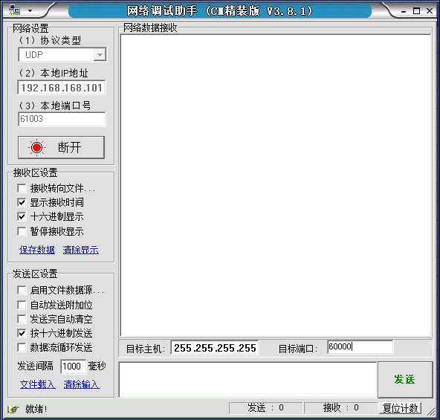

Enter or paste the command bytes in the small box below, then click Send. Received data appears in the large network-data receive area. [All operations use hexadecimal values]

Set the controller IP address

Set the IP address with IPConfig2015(Method 1, recommended)
Run IPConfig2015_V2.15 to search for devices (Note: first set the PC IP address to 192.168.168.101)
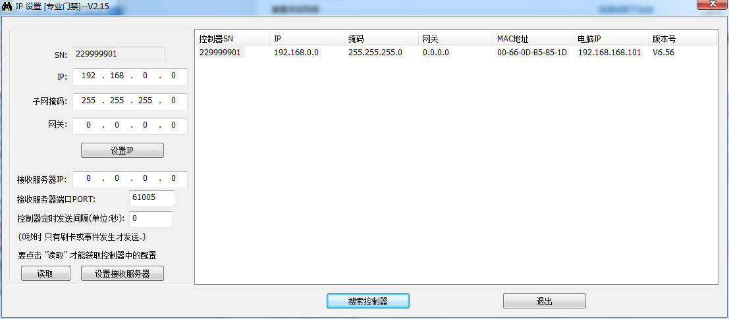
Controller device serial number: 229999901 , Note that the device firmware version is V6.56, this version or lateris required [last column]
IP address to set: 192.168.168.123
Subnet mask: 255.255.255.0
Gateway: 192.168.168.254
Enter the required values, then click Set IP
Click Search Controllers again to obtain the following information
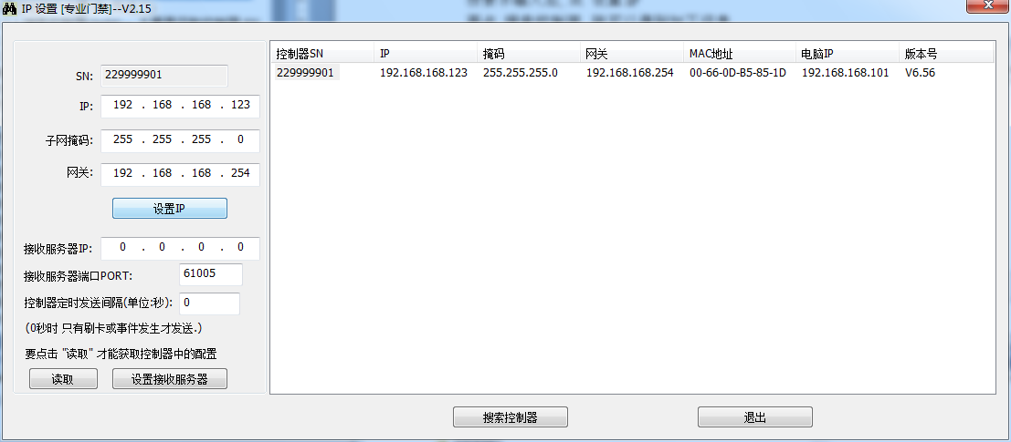

Set the IP address using a short packet (Method 2)

Search for controllers(0x94) – primarily to obtain the controller SN
Target host: 255.255.255.255 Target port 60000

Request packet
17 94 00 00 00 00 00 00 00 00 00 00 00 00 00 00 00 00 00 00 00 00 00 00 00 00 00 00 00 00 00 00 00 00 00 00 00 00 00 00 00 00 00 00 00 00 00 00 00 00 00 00 00 00 00 00 00 00 00 00 00 00 00 00
Response packet
The receive interface is shown below (Important: Target host is automatically Change it to192.168.168.100, 【 Receive from 192.168.168.100 : 60000】： the IP shown here is not the controller IP; use the value returned in the command data)
【Receive from 192.168.168.100 : 60000】：( <- - - ignore this line)
【2015-04-29 16:16:38:146】17 94 00 00 1D 85 B5 0D C0 A8 00 00 FF FF FF 00 00 00 00 00 00 66 0D B5 85 1D 06 56 20 15 04 29 00 00 00 00 00 00 00 00 00 00 00 00 00 00 00 00 00 00 00 00 00 00 00 00 00 00 00 00 00 00 00 00
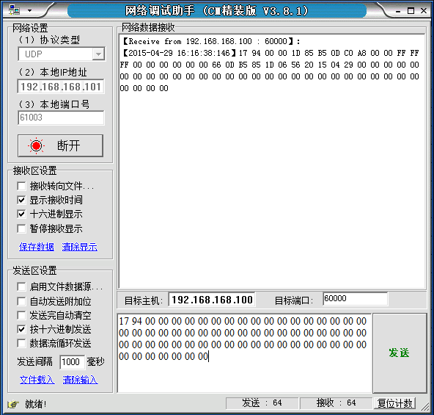
Analyze the received packet
17 94 00 00 command bytes
1D 85 B5 0D device serial number 0x0DB5851D = 229999901 This is a two-door bidirectional controller. The following examples use this device serial number
C0 A8 00 00 Controller IP address: 192.168.0.0 [This is the factory-default IP and must be changed before deployment]
FF FF FF 00 controller subnet Subnet mask 255.255.255.0
00 00 00 00 Gateway is 0.0.0.0 (not configured)
00 66 0D B5 85 1D MAC ADDRESS 00-66-0D-B5-85-1D
06 56 Firmware version (BCD ENCODED)indicates 6.56
20 15 04 29Firmware release date(BCD ENCODED) indicates 2015-04-29released
00 00 00 00 00 00 00 00 00 00 00 00 00 00 00 00 00 00 00 00 00 00 00 00 00 00 00 00 00 00 00 00 ignore

Set the controller IP address address(0x96)
Target host: 255.255.255.255 Target port 60000
Be sure to change Target host(because 192.168.168.100 is not the controller IP; NetAssist inserted it automatically)
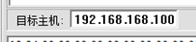
Change it to
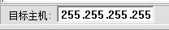

Controller device serial number: 1D 85 B5 0D device serial number 0x0DB5851D = 229999901
IP address to set: 192.168.168.123 (hexadecimal C0 A8 A8 7B)
Subnet mask: 255.255.255.0 (hexadecimal FF FF FF 00)
Gateway: 192.168.168.254 (hexadecimal C0 A8 A8 FE)
Force signature: 55 AA AA 55
Request packet
17 96 00 00 1D 85 B5 0D C0 A8 A8 7B FF FF FF 00 C0 A8 A8 FE 55 AA AA 55 00 00 00 00 00 00 00 00 00 00 00 00 00 00 00 00 00 00 00 00 00 00 00 00 00 00 00 00 00 00 00 00 00 00 00 00 00 00 00 00

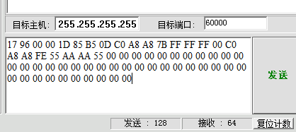
This command does not return a response. To verify that the request was applied correctly, UseSearch for controllersretrieve.

Again, Search for controllerssend:
17 94 00 00 00 00 00 00 00 00 00 00 00 00 00 00 00 00 00 00 00 00 00 00 00 00 00 00 00 00 00 00 00 00 00 00 00 00 00 00 00 00 00 00 00 00 00 00 00 00 00 00 00 00 00 00 00 00 00 00 00 00 00 00
Received packet: (returned valuesIP: 192.168.168.123, Subnet mask: 255.255.255.0, Gateway: 192.168.168.254)
17 94 00 00 1D 85 B5 0D C0 A8 A8 7B FF FF FF 00 C0 A8 A8 FE 00 66 0D B5 85 1D 06 56 20 15 04 29 00 00 00 00 00 00 00 00 00 00 00 00 00 00 00 00 00 00 00 00 00 00 00 00 00 00 00 00 00 00 00 00

The interface appears as follows:
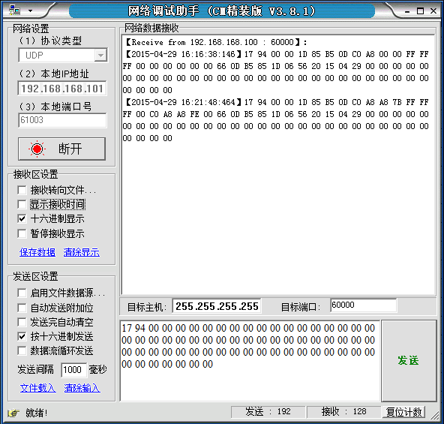

For all commands below, set the target host to the controller IP address.

Query controller status(0x20)
Target host: 192.168.168.123 Target port 60000
Controller device serial number: 1D 85 B5 0D device serial number 0x0DB5851D = 229999901
Request packet:
17 20 00 00 1D 85 B5 0D 00 00 00 00 00 00 00 00 00 00 00 00 00 00 00 00 00 00 00 00 00 00 00 00 00 00 00 00 00 00 00 00 00 00 00 00 00 00 00 00 00 00 00 00 00 00 00 00 00 00 00 00 00 00 00 00
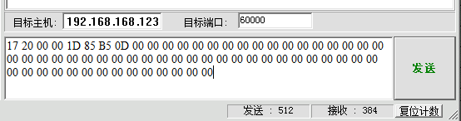
Response packet:
17 20 00 00 1D 85 B5 0D 04 00 00 00 01 00 01 01 0D D7 37 00 20 13 04 03 21 09 24 06 01 01 00 00 00 00 00 00 00 22 28 26 00 00 00 00 00 00 00 00 00 00 00 00 00 00 00 00 00 00 00 00 00 00 00 00
17 20 00 00 1D 85 B5 0D 04 00 00 00 01 00 01 01 0D D7 37 00 20 15 04 29 16 37 39 06 01 01 00 00 00 00 00 00 00 16 42 25 00 00 00 00 00 00 00 00 00 00 00 15 04 29 00 00 00 00 00 00 00 00 00 00

:Analyze Response packet:
17 20 00 00 command code
1D 85 B5 0D device serial number 0x0DB5851D = 229999901
04 00 00 00 Index of the latest record=0x00000004 = 4
01 card-swipe record
00 access denied
01 Door 1
01 entry
0D D7 37 00 card number=0x0037D70D = 3659533
20 15 04 29 16 37 39 card-swipe time 2015-04-29 16:37:39
06 record reason code [no privilege] -- see “card-swipe record notes.xls” file
01 Door 1door-sensor status(open) (or sensor not connected)
01 Door 2door-sensor status(open) (or sensor not connected)
00 not applicable to this two-door controller, Door 3door-sensor status ignore
00 not applicable to this two-door controller, Door 4door-sensor status ignore
00 Door 1exit button released
00 Door 2exit button released
00 not applicable to this two-door controller, Door 3exit-button status ignore
00 not applicable to this two-door controller, Door 4exit-button status ignore
00no fault
16 42 25 Current controller time 16:42:25
00 00 00 00 sequence number(ignore)
00 00 00 00 reserved(ignore)
00 special information(may ignore)
00 relay status(all zero indicates, 1door locked, 2door locked)[may ignore]
00 No fire-alarm or forced-lock action
15 04 29 Current controller date 2015-04-29
00 00 00 00 00 00 00 00 00 00remaining bytes: ignore

Read date and time(0x32)
Target host: 192.168.168.123 Target port 60000
Controller device serial number: 1D 85 B5 0D device serial number 0x0DB5851D = 229999901
Request packet:
17 32 00 00 1D 85 B5 0D 00 00 00 00 00 00 00 00 00 00 00 00 00 00 00 00 00 00 00 00 00 00 00 00 00 00 00 00 00 00 00 00 00 00 00 00 00 00 00 00 00 00 00 00 00 00 00 00 00 00 00 00 00 00 00 00

Response packet:
17 32 00 00 1D 85 B5 0D 20 15 04 29 16 57 37 00 00 00 00 00 00 00 00 00 00 00 00 00 00 00 00 00 00 00 00 00 00 00 00 00 00 00 00 00 00 00 00 00 00 00 00 00 00 00 00 00 00 00 00 00 00 00 00 00
:Analyze Response packet:
17 32 00 00 command code
1D 85 B5 0D device serial number 0x0DB5851D = 229999901
20 15 04 29 16 57 37 Controller clock 2015-04-29 16:57:37
00 00 00 00 00 00 00 00 00 00 00 00 00 00 00 00 00 00 00 00 00 00 00 00 00 00 00 00 00 00 00 00 00 00 00 00 00 00 00 00 00 00 00 00 00 00 00 00 00 remaining bytes: ignore

Set date and time(0x30)
Target host: 192.168.168.123 Target port 60000
Controller device serial number: 1D 85 B5 0D device serial number 0x0DB5851D = 229999901
Request packet: (set 2015-12-31 23:58:39)
17 30 00 00 1D 85 B5 0D 20 15 12 30 23 58 39 00 00 00 00 00 00 00 00 00 00 00 00 00 00 00 00 00 00 00 00 00 00 00 00 00 00 00 00 00 00 00 00 00 00 00 00 00 00 00 00 00 00 00 00 00 00 00 00 00
Response packet:
17 30 00 00 1D 85 B5 0D 20 15 12 30 23 58 39 00 00 00 00 00 00 00 00 00 00 00 00 00 00 00 00 00 00 00 00 00 00 00 00 00 00 00 00 00 00 00 00 00 00 00 00 00 00 00 00 00 00 00 00 00 00 00 00 00
[Request packet and Response packetin the date/time fields :match, indicating Set date and timesucceeded]

Restore the current time
Request packet: (set 2015-04-29 17:23:30)
17 30 00 00 1D 85 B5 0D 20 15 04 29 17 23 30 00 00 00 00 00 00 00 00 00 00 00 00 00 00 00 00 00 00 00 00 00 00 00 00 00 00 00 00 00 00 00 00 00 00 00 00 00 00 00 00 00 00 00 00 00 00 00 00 00

Get the record at a specified index(0xB0)
Target host: 192.168.168.123 Target port 60000
Controller device serial number: 1D 85 B5 0D device serial number 0x0DB5851D = 229999901

1. Request packet (retrieve record index 0x00000001)
17 B0 00 00 1D 85 B5 0D 01 00 00 00 00 00 00 00 00 00 00 00 00 00 00 00 00 00 00 00 00 00 00 00 00 00 00 00 00 00 00 00 00 00 00 00 00 00 00 00 00 00 00 00 00 00 00 00 00 00 00 00 00 00 00 00
Response packet
17 B0 00 00 1D 85 B5 0D 01 00 00 00 01 00 01 01 0B 12 27 01 20 15 04 29 16 37 13 06 00 00 00 00 00 00 00 00 00 00 00 00 00 00 00 00 00 00 00 00 00 00 00 00 00 00 00 00 00 00 00 00 00 00 00 00

Analyze the packet
17 B0 00 00command code
1D 85 B5 0Ddevice serial number 0x0DB5851D = 229999901
01 00 00 00 card-swipe record index = 1
01 Record type: card-swipe record
00 access denied
01 Door 1
01 entry
0B 12 27 01 card number = 0x0127120B (hexadecimal) = 19337739 (decimal)
20 15 04 29 16 37 13 card-swipe time: 2015-04-29 16:37:13
06 record reason code [indicatesno privilege]
00 00 00 00 00 00 00 00 00 00 00 00 00 00 00 00 ignore the remaining bytes

2. Request packet (retrieve the oldest record using index 0x00000000) [This command is suitable when card-swipe recordexceed 200,000]
17 B0 00 00 1D 85 B5 0D 00 00 00 00 00 00 00 00 00 00 00 00 00 00 00 00 00 00 00 00 00 00 00 00 00 00 00 00 00 00 00 00 00 00 00 00 00 00 00 00 00 00 00 00 00 00 00 00 00 00 00 00 00 00 00 00
Response packet
17 B0 00 00 1D 85 B5 0D 01 00 00 00 01 00 01 01 0B 12 27 01 20 15 04 29 16 37 13 06 00 00 00 00 00 00 00 00 00 00 00 00 00 00 00 00 00 00 00 00 00 00 00 00 00 00 00 00 00 00 00 00 00 00 00 00
The oldest record index is0x00000001

3. Request packet (retrieve the latest record using index 0xffffffff)
17 B0 00 00 1D 85 B5 0D FF FF FF FF 00 00 00 00 00 00 00 00 00 00 00 00 00 00 00 00 00 00 00 00 00 00 00 00 00 00 00 00 00 00 00 00 00 00 00 00 00 00 00 00 00 00 00 00 00 00 00 00 00 00 00 00
Response packet
17 B0 00 00 1D 85 B5 0D 04 00 00 00 01 00 01 01 0D D7 37 00 20 15 04 29 16 37 39 06 00 00 00 00 00 00 00 00 00 00 00 00 00 00 00 00 00 00 00 00 00 00 00 00 00 00 00 00 00 00 00 00 00 00 00 00
The latest record index is 0x00000004

Record indexes normally increase sequentially, and can reach0xffffff = 16,777,215 (more than ten million) . Because storage is limited, the controller retains only the latest 200,000 records. when indexexceeds200,000after, old indexslot is overwritten, therefore query theseindex, returntypeis0xff, indicatesdoes not exist.

Set the last-read record index(0xB2)
Target host: 192.168.168.123 Target port 60000
Controller device serial number: 1D 85 B5 0D device serial number 0x0DB5851D = 229999901

Note: set value must not exceed the latest card-swipe record index value

Request packet (set last-read index is 3)
17 B2 00 00 1D 85 B5 0D 03 00 00 00 55 AA AA 55 00 00 00 00 00 00 00 00 00 00 00 00 00 00 00 00 00 00 00 00 00 00 00 00 00 00 00 00 00 00 00 00 00 00 00 00 00 00 00 00 00 00 00 00 00 00 00 00
Response packet
17 B2 00 00 1D 85 B5 0D 01 00 00 00 00 00 00 00 00 00 00 00 00 00 00 00 00 00 00 00 00 00 00 00 00 00 00 00 00 00 00 00 00 00 00 00 00 00 00 00 00 00 00 00 00 00 00 00 00 00 00 00 00 00 00 00
Status byte 01 indicates success.

Useretrievelast-read indexto confirm
Request packet
17 B4 00 00 1D 85 B5 0D 00 00 00 0000 00 00 0000 00 00 00 00 00 00 00 00 00 00 00 00 00 00 00 00 00 00 00 00 00 00 00 00 00 00 00 00 00 00 00 00 00 00 00 00 00 00 00 00 00 00 00 00 00 00 00
Response packet
17 B4 00 00 1D 85 B5 0D 03 00 00 00 00 00 00 00 00 00 00 00 00 00 00 00 00 00 00 00 00 00 00 00 00 00 00 00 00 00 00 00 00 00 00 00 00 00 00 00 00 00 00 00 00 00 00 00 00 00 00 00 00 00 00 00
03 00 00 00is the configured value.

Record retrieval procedure
Option 1:
1. Use 0xB4command retrievelast-read index recordIndex
2. Use 0xB0command Get the record at a specified index retrieve records starting at recordIndex + 1 until an empty record is returned
3. Use 0xB2command Set the last-read record index set value is last retrieved card-swipe recordindex
These three steps complete record retrieval.

Option 2:
1. Usedatabasequery look up corresponding controller last-read index recordIndex (use 0 if none exists)
2. Use 0xB0command Get the record at a specified index retrieve records starting at recordIndex + 1 until an empty record is returned
3. databaseis recordunder corresponding controller last afterread card-swipe recordindex
These three steps complete record retrieval.

Remote door opening(0x40)
Target host: 192.168.168.123 Target port 60000
Controller device serial number: 1D 85 B5 0D device serial number 0x0DB5851D = 229999901

1. Request packet(open Door 1)
17 40 00 00 1D 85 B5 0D 01 00 00 00 00 00 00 00 00 00 00 00 00 00 00 00 00 00 00 00 00 00 00 00 00 00 00 00 00 00 00 00 00 00 00 00 00 00 00 00 00 00 00 00 00 00 00 00 00 00 00 00 00 00 00 00
Response packet
17 40 00 00 1D 85 B5 0D 01 00 00 00 00 00 00 00 00 00 00 00 00 00 00 00 00 00 00 00 00 00 00 00 00 00 00 00 00 00 00 00 00 00 00 00 00 00 00 00 00 00 00 00 00 00 00 00 00 00 00 00 00 00 00 00
On success, the status byte is 01

2. Request packet(open Door 2)
17 40 00 00 1D 85 B5 0D 02 00 00 00 00 00 00 00 00 00 00 00 00 00 00 00 00 00 00 00 00 00 00 00 00 00 00 00 00 00 00 00 00 00 00 00 00 00 00 00 00 00 00 00 00 00 00 00 00 00 00 00 00 00 00 00
Response packet
17 40 00 00 1D 85 B5 0D 01 00 00 00 00 00 00 00 00 00 00 00 00 00 00 00 00 00 00 00 00 00 00 00 00 00 00 00 00 00 00 00 00 00 00 00 00 00 00 00 00 00 00 00 00 00 00 00 00 00 00 00 00 00 00 00
On success, the status byte is 01

Add or update a privilege(0x50)
Target host: 192.168.168.123 Target port 60000
Controller device serial number: 1D 85 B5 0D device serial number 0x0DB5851D = 229999901

Request packet Addedcard number0D D7 37 00, Usecurrent controller all with door
17 50 00 00 1D 85 B5 0D 0D D7 37 00 20 10 01 01 20 29 12 31 01 01 01 01 00 00 00 00 00 00 00 00 00 00 00 00 00 00 00 00 00 00 00 00 00 00 00 00 00 00 00 00 00 00 00 00 00 00 00 00 00 00 00 00
:Analyze Request packet
17 50 00 00 function code
1D 85 B5 0D device serial number
0D D7 37 00 to add or update: card number = 0x0037D70D = 3659533 (decimal)
20 10 01 01 Start date: 2010-01-01 (must be later than 2001)
20 29 12 31 Expiration date: 2029-12-31
01 access granted Door 1 [valid for one-, two-, and four-door controllers]
01 access granted Door 2 [valid for two- and four-door controllers]
01 access granted Door 3 [valid for four-door controllers]
01 access granted Door 4 [valid for four-door controllers]
00 00 00 00 00 00 00 00 00 00 00 00 00 00 00 00 00 00 00 00 00 00 00 00 00 00 00 00 00 00 00 00 00 00 00 00 00 00 00 00 remaining bytes: ignore

Response packet (add/update succeeded)
17 50 00 00 1D 85 B5 0D 01 00 00 00 00 00 00 00 00 00 00 00 00 00 00 00 00 00 00 00 00 00 00 00 00 00 00 00 00 00 00 00 00 00 00 00 00 00 00 00 00 00 00 00 00 00 00 00 00 00 00 00 00 00 00 00
Status byte 01 indicates success.

At this point, swiping card number is = 0x0037D70D = 3659533 (decimal), 1Door 1 relay activates.

Delete a privilege(delete one) (0x52)
Target host: 192.168.168.123 Target port 60000
Controller device serial number: 1D 85 B5 0D device serial number 0x0DB5851D = 229999901

Request packet
Delete card number0D D7 37 00 = 0x0037D70D = 3659533 (decimal)
17 52 00 00 1D 85 B5 0D 0D D7 37 00 00 00 00 00 00 00 00 00 00 00 00 00 00 00 00 00 00 00 00 00 00 00 00 00 00 00 00 00 00 00 00 00 00 00 00 00 00 00 00 00 00 00 00 00 00 00 00 00 00 00 00 00

Response packet (single deletion succeeded)
17 52 00 00 1D 85 B5 0D 01 00 00 00 00 00 00 00 00 00 00 00 00 00 00 00 00 00 00 00 00 00 00 00 00 00 00 00 00 00 00 00 00 00 00 00 00 00 00 00 00 00 00 00 00 00 00 00 00 00 00 00 00 00 00 00
Status byte 01 indicates success.

At this point, swiping card number is = 0x0037D70D = 3659533 (decimal), 1Door 1 relay does not activate.

Clear all privileges(remove all) (0x54)
Target host: 192.168.168.123 Target port 60000
Controller device serial number: 1D 85 B5 0D device serial number 0x0DB5851D = 229999901

Request packet
17 54 00 00 1D 85 B5 0D 55 AA AA 55 00 00 00 00 00 00 00 00 00 00 00 00 00 00 00 00 00 00 00 00 00 00 00 00 00 00 00 00 00 00 00 00 00 00 00 00 00 00 00 00 00 00 00 00 00 00 00 00 00 00 00 00
Response packet (clear operation succeeded)
17 54 00 00 1D 85 B5 0D 01 00 00 00 00 00 00 00 00 00 00 00 00 00 00 00 00 00 00 00 00 00 00 00 00 00 00 00 00 00 00 00 00 00 00 00 00 00 00 00 00 00 00 00 00 00 00 00 00 00 00 00 00 00 00 00
Status byte 01 indicates success.

may UseQuery controller statusverify privilegecount is is 0.

Read privilege count (0x58)
Target host: 192.168.168.123 Target port 60000
Controller device serial number: 1D 85 B5 0D device serial number 0x0DB5851D = 229999901

Request packet
17 58 00 00 1D 85 B5 0D 00 00 00 00 00 00 00 00 00 00 00 00 00 00 00 00 00 00 00 00 00 00 00 00 00 00 00 00 00 00 00 00 00 00 00 00 00 00 00 00 00 00 00 00 00 00 00 00 00 00 00 00 00 00 00 00
Response packet
17 58 00 00 1D 85 B5 0D 00 00 00 00 00 00 00 00 00 00 00 00 00 00 00 00 00 00 00 00 00 00 00 00 00 00 00 00 00 00 00 00 00 00 00 00 00 00 00 00 00 00 00 00 00 00 00 00 00 00 00 00 00 00 00 00
The controller contains 0 privileges

Query a privilege (0x5A)
Target host: 192.168.168.123 Target port 60000
Controller device serial number: 1D 85 B5 0D device serial number 0x0DB5851D = 229999901

Request packet (query card number is 0D D7 37 00)
17 5A 00 00 1D 85 B5 0D 0D D7 37 00 00 00 00 00 00 00 00 00 00 00 00 00 00 00 00 00 00 00 00 00 00 00 00 00 00 00 00 00 00 00 00 00 00 00 00 00 00 00 00 00 00 00 00 00 00 00 00 00 00 00 00 00
Response packet
no privilege: (card number field is 0)
17 5A 00 00 1D 85 B5 0D 00 00 00 00 00 00 00 00 00 00 00 00 00 00 00 00 00 00 00 00 00 00 00 00 00 00 00 00 00 00 00 00 00 00 00 00 00 00 00 00 00 00 00 00 00 00 00 00 00 00 00 00 00 00 00 00

Add privileges for card0D D7 37 00
Request packet
17 50 00 00 1D 85 B5 0D 0D D7 37 00 20 10 01 01 20 29 12 31 01 01 01 01 00 00 00 00 00 00 00 00 00 00 00 00 00 00 00 00 00 00 00 00 00 00 00 00 00 00 00 00 00 00 00 00 00 00 00 00 00 00 00 00

Query again
Request packet
17 5A 00 00 1D 85 B5 0D 0D D7 37 00 00 00 00 00 00 00 00 00 00 00 00 00 00 00 00 00 00 00 00 00 00 00 00 00 00 00 00 00 00 00 00 00 00 00 00 00 00 00 00 00 00 00 00 00 00 00 00 00 00 00 00 00

Response when a privilege exists: (card number field is queried card number)
17 5A 00 00 1D 85 B5 0D 0D D7 37 00 20 10 01 01 20 29 12 31 01 01 01 01 00 00 00 00 00 00 00 00 00 00 00 00 00 00 00 00 00 00 00 00 00 00 00 00 00 00 00 00 00 00 00 00 00 00 00 00 00 00 00 00

Get the privilege at a specified index(0x5C)
Target host: 192.168.168.123 Target port 60000
Controller device serial number: 1D 85 B5 0D device serial number 0x0DB5851D = 229999901

Request packet (query index is 1, note indexfrom 1start)
17 5C 00 00 1D 85 B5 0D 01 00 00 00 00 00 00 00 00 00 00 00 00 00 00 00 00 00 00 00 00 00 00 00 00 00 00 00 00 00 00 00 00 00 00 00 00 00 00 00 00 00 00 00 00 00 00 00 00 00 00 00 00 00 00 00
Response packet
17 5C 00 00 1D 85 B5 0D 0D D7 37 00 20 10 01 01 20 29 12 31 01 01 01 01 00 00 00 00 00 00 00 00 00 00 00 00 00 00 00 00 00 00 00 00 00 00 00 00 00 00 00 00 00 00 00 00 00 00 00 00 00 00 00 00
card number field is 0D D7 37 00, indicatesprivilege at index 1 card number is 3659533

Delete privilege for3659533
Request packet
Delete card number0D D7 37 00 = 0x0037D70D = 3659533 (decimal)
17 52 00 00 1D 85 B5 0D 0D D7 37 00 00 00 00 00 00 00 00 00 00 00 00 00 00 00 00 00 00 00 00 00 00 00 00 00 00 00 00 00 00 00 00 00 00 00 00 00 00 00 00 00 00 00 00 00 00 00 00 00 00 00 00 00
Then:
Request packet (query index is 1, note indexfrom 1start)
17 5C 00 00 1D 85 B5 0D 01 00 00 00 00 00 00 00 00 00 00 00 00 00 00 00 00 00 00 00 00 00 00 00 00 00 00 00 00 00 00 00 00 00 00 00 00 00 00 00 00 00 00 00 00 00 00 00 00 00 00 00 00 00 00 00
Response packet
17 5C 00 00 1D 85 B5 0D FF FF FF FF 00 00 00 00 00 00 00 00 00 00 00 00 00 00 00 00 00 00 00 00 00 00 00 00 00 00 00 00 00 00 00 00 00 00 00 00 00 00 00 00 00 00 00 00 00 00 00 00 00 00 00 00
card number field is FF FF FF FF, indicatesthis position was deleted

Request packet (query index is 2, note indexfrom 1start)
17 5C 00 00 1D 85 B5 0D 02 00 00 00 00 00 00 00 00 00 00 00 00 00 00 00 00 00 00 00 00 00 00 00 00 00 00 00 00 00 00 00 00 00 00 00 00 00 00 00 00 00 00 00 00 00 00 00 00 00 00 00 00 00 00 00
Response packet
17 5C 00 00 1D 85 B5 0D 00 00 00 00 00 00 00 00 00 00 00 00 00 00 00 00 00 00 00 00 00 00 00 00 00 00 00 00 00 00 00 00 00 00 00 00 00 00 00 00 00 00 00 00 00 00 00 00 00 00 00 00 00 00 00 00
card number field is 00 00 00 00, indicatesthis position has no privilege, and no privileges exist after this index
Again, Add privileges for card0D D7 37 00
Request packet
17 50 00 00 1D 85 B5 0D 0D D7 37 00 20 10 01 01 20 29 12 31 01 01 01 01 00 00 00 00 00 00 00 00 00 00 00 00 00 00 00 00 00 00 00 00 00 00 00 00 00 00 00 00 00 00 00 00 00 00 00 00 00 00 00 00

Set door-control parameters(0x80)
Target host: 192.168.168.123 Target port 60000
Controller device serial number: 1D 85 B5 0D device serial number 0x0DB5851D = 229999901

Request packet (set 1door online unlock doorduration 3)
17 80 00 00 1D 85 B5 0D 01 03 03 00 00 00 00 00 00 00 00 00 00 00 00 00 00 00 00 00 00 00 00 00 00 00 00 00 00 00 00 00 00 00 00 00 00 00 00 00 00 00 00 00 00 00 00 00 00 00 00 00 00 00 00 00
:Analyze Request packet
17 80 00 00 commandcode
1D 85 B5 0D device serial number
01 Select Door 1
03 Set control mode 03 (online)
03 set unlock doorduration (that is, is keep unlock door duration): 3
00 00 00 00 00 00 00 00 00 00 00 00 00 00 00 00 00 00 00 00 00 00 00 00 00 00 00 00 00 00 00 00 00 00 00 00 00 00 00 00 00 00 00 00 00 00 00 00 00 00 00 00 00

Response packet
17 80 00 00 1D 85 B5 0D 01 03 03 00 00 00 00 00 00 00 00 00 00 00 00 00 00 00 00 00 00 00 00 00 00 00 00 00 00 00 00 00 00 00 00 00 00 00 00 00 00 00 00 00 00 00 00 00 00 00 00 00 00 00 00 00
On success, the response matches the configured values

Read door-control parameters(0x82)
Target host: 192.168.168.123 Target port 60000
Controller device serial number: 1D 85 B5 0D device serial number 0x0DB5851D = 229999901

Request packet (readDoor 1 control modeand unlock doorduration )
17 82 00 00 1D 85 B5 0D 01 00 00 00 00 00 00 00 00 00 00 00 00 00 00 00 00 00 00 00 00 00 00 00 00 00 00 00 00 00 00 00 00 00 00 00 00 00 00 00 00 00 00 00 00 00 00 00 00 00 00 00 00 00 00 00

Response packet
17 82 00 00 1D 85 B5 0D 01 03 03 00 00 00 00 00 00 00 00 00 00 00 00 00 00 00 00 00 00 00 00 00 00 00 00 00 00 00 00 00 00 00 00 00 00 00 00 00 00 00 00 00 00 00 00 00 00 00 00 00 00 00 00 00

Receive-server configuration

UseIPConfig2015 tool(Method 1, recommended)
Run IPConfig2015 to search for devices (Note: first set the PC IP address to 192.168.168.101)
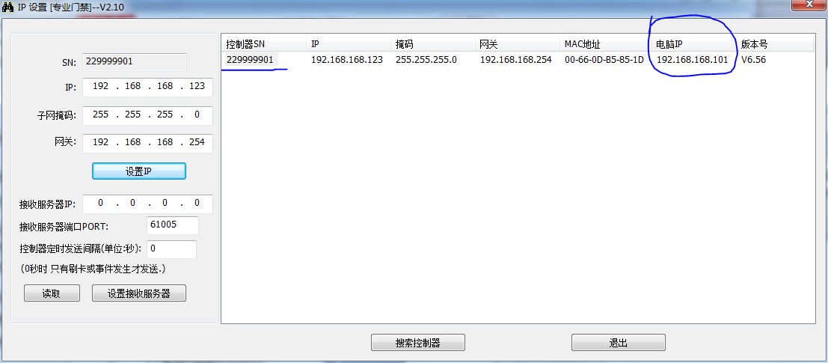

:Click “read”, may retrievecurrent controller receive server information.

Controller device serial number: 229999901
Set receive-server IP: 192.168.168.101 [current PC IP]
(To disable controller uploads, set the receive-server IP to 0.0.0.0)
Receive-server port: 61005
send every 5 seconds: 05
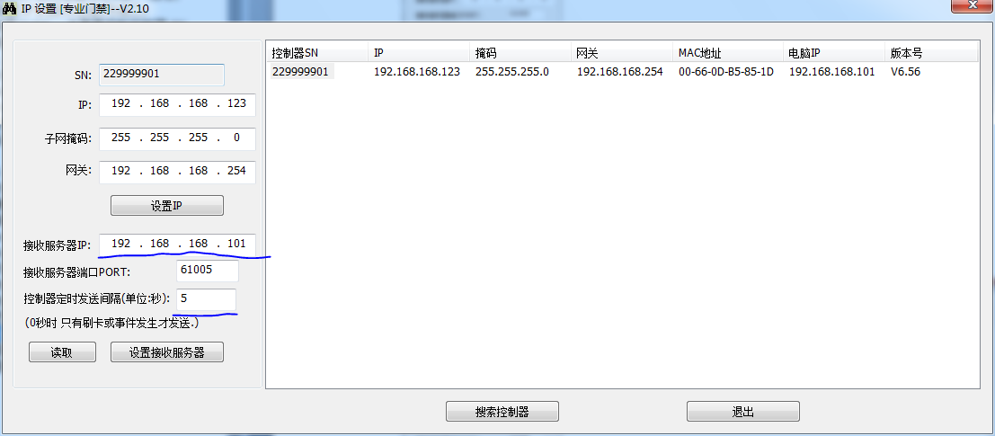
: “set receive server”.

Thenrun a NetAssist, configure as followsset (note the port number 61005)
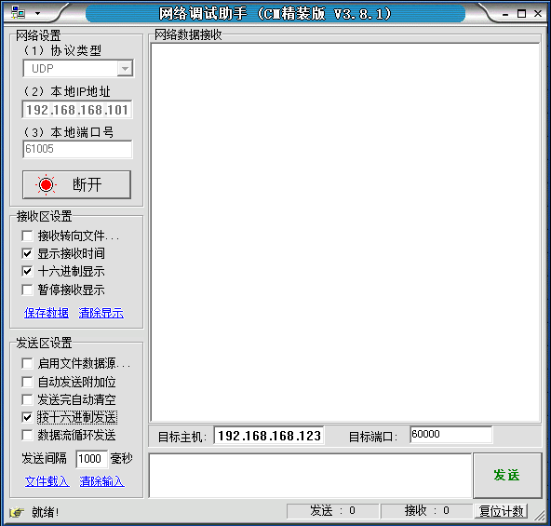
[require Local IP address and local port and set match, and then connect.]
Data is then received automatically.

received data and Query controller status response are identical except for the type(here is 19, while query type is 17), remaining bytes: all fields match [see Query controller status field ]

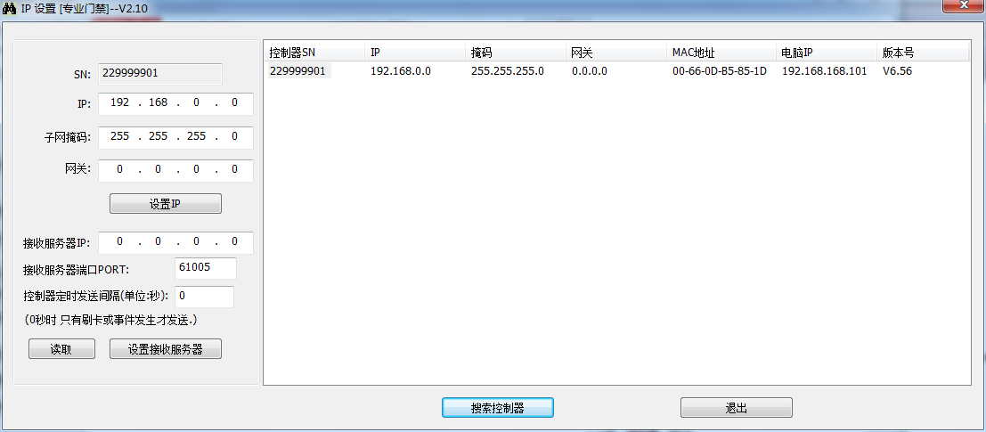
Controller device serial number: 1D 85 B5 0D device serial number 0x0DB5851D = 229999901
IP address to set: 192.168.168.123
Subnet mask: 255.255.255.0
Gateway: 192.168.168.254
Enter the required values, then click Set IP
Click Search Controllers again to obtain the following information

Useshort-packet configuration(Method 2)

Set receive-server IP and port(0x90)
Target host: 192.168.168.123 Target port 60000
Controller device serial number: 1D 85 B5 0D device serial number 0x0DB5851D = 229999901
Receive-server IP: 192.168.168.101 [current PC IP]
(To disable controller uploads, set the receive-server IP to 0.0.0.0)
Receive-server port: 61005
send every 5 seconds: 05
Request packet [set receive-server IP 192.168.168.101, port 61005 =0xEE4Dsend every 5 seconds: 05]
17 90 00 00 1D 85 B5 0D C0 A8 A8 65 4D EE 05 00 00 00 00 00 00 00 00 00 00 00 00 00 00 00 00 00 00 00 00 00 00 00 00 00 00 00 00 00 00 00 00 00 00 00 00 00 00 00 00 00 00 00 00 00 00 00 00 00

Response packet
17 90 00 00 1D 85 B5 0D 01 00 00 00 00 00 00 00 00 00 00 00 00 00 00 00 00 00 00 00 00 00 00 00 00 00 00 00 00 00 00 00 00 00 00 00 00 00 00 00 00 00 00 00 00 00 00 00 00 00 00 00 00 00 00 00
Status byte 01 indicates success.

After completing the settings above, Again, run a NetAssist, configure as followsset (note the port number 61005)
[require Local IP address and local port and set match, and then connect.]
Data is then received automatically.

received data and Query controller status response are identical except for the type(here is 19, while query type is 17), remaining bytes: all fields match [see Query controller status field ]

For periodic uploads, if no new card swipe or other event occurs, the controller repeats the latest record.

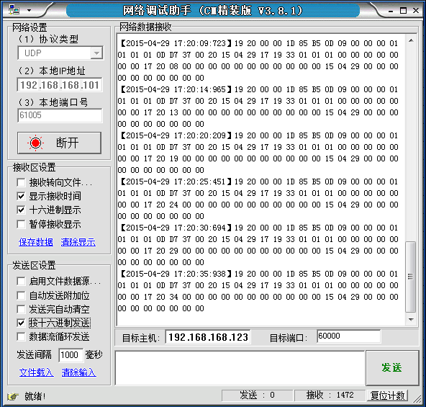

Request packet [set receive-server IP 192.168.168.101, port 61005 =0xEE4Dupload automatically when a new record is created (do not send cyclically set interval to 0 seconds)]
17 90 00 00 1D 85 B5 0D C0 A8 A8 65 4D EE 00 00 00 00 00 00 00 00 00 00 00 00 00 00 00 00 00 00 00 00 00 00 00 00 00 00 00 00 00 00 00 00 00 00 00 00 00 00 00 00 00 00 00 00 00 00 00 00 00 00

Response packet
17 90 00 00 1D 85 B5 0D 01 00 00 00 00 00 00 00 00 00 00 00 00 00 00 00 00 00 00 00 00 00 00 00 00 00 00 00 00 00 00 00 00 00 00 00 00 00 00 00 00 00 00 00 00 00 00 00 00 00 00 00 00 00 00 00
Status byte 01 indicates success.

Records are uploaded only when a card swipe or another event occurs

Again, again Request packet [set receive-server IP 192.168.168.101, port 61005 =0xEE4Dsend every 5 seconds: 05]
17 90 00 00 1D 85 B5 0D C0 A8 A8 65 4D EE 05 00 00 00 00 00 00 00 00 00 00 00 00 00 00 00 00 00 00 00 00 00 00 00 00 00 00 00 00 00 00 00 00 00 00 00 00 00 00 00 00 00 00 00 00 00 00 00 00 00

Read receive-server IP and port(0x92)
Target host: 192.168.168.123 Target port 60000
Controller device serial number: 1D 85 B5 0D device serial number 0x0DB5851D = 229999901
Request packet
17 92 00 00 1D 85 B5 0D 00 00 00 00 00 00 00 00 00 00 00 00 00 00 00 00 00 00 00 00 00 00 00 00 00 00 00 00 00 00 00 00 00 00 00 00 00 00 00 00 00 00 00 00 00 00 00 00 00 00 00 00 00 00 00 00
Response packet
17 92 00 00 1D 85 B5 0D C0 A8 A8 65 4D EE 05 00 00 00 00 00 00 00 00 00 00 00 00 00 00 00 00 00 00 00 00 00 00 00 00 00 00 00 00 00 00 00 00 00 00 00 00 00 00 00 00 00 00 00 00 00 00 00 00 00
Analyze the packet
17 92 00 00 (This is the response to reading the receive-server IP and port)
1D 85 B5 0D device serial number = 0x0DB5851D = 229999901 (decimal)
C0 A8 A8 65Receive-server IP: 192.168.168.101 (0xc0= 192)
4D EEReceive-server port: 61005 [0xEE4D = 61005]
05periodic upload interval is 5 [normal run send every 5 seconds with swipe cardsend immediately]
00 00 00 00 00 00 00 00 00 00 00 00 00 00 00 00 00 00 00 00 00 00 00 00 00 00 00 00 00 00 00 00 00 00 00 00 00 00 00 00 00 00 00 00 00 00 00 00 00

