Developing with the current access-control software [V7.67 or later] (updated 2015-05-21)

Raw card-swipe records

Query raw card-swipe records
This query returns raw controller card-swipe records. It includes only records matched to a user name; unmatched users are filtered out. Change INNER to LEFT to include them.
SELECT t_d_SwipeRecord.f_RecID AS 'Index',
t_d_SwipeRecord.f_CardNO AS 'Card number',
t_b_Consumer.f_ConsumerNO AS 'Employee number',
t_b_Consumer.f_ConsumerName AS 'Name',
t_b_Group.f_GroupName AS 'Department',
t_d_SwipeRecord.f_ReadDate AS 'Time',
t_b_Reader.f_ReaderName AS 'Location',
CASE WHEN t_d_SwipeRecord.f_Character =1 THEN 'Access granted' ELSE 'Access denied' END AS 'Result',
CASE WHEN t_d_SwipeRecord.f_InOut=0 THEN 'Exit' ELSE 'Entry' END AS 'Direction',
t_b_Door.f_DoorName AS 'Door name',
t_d_SwipeRecord.f_RecordAll AS 'Raw data for one record'
FROM (((t_d_SwipeRecord INNER JOIN t_b_Consumer ON ( t_b_Consumer.f_ConsumerID = t_d_SwipeRecord.f_ConsumerID))
LEFT JOIN t_b_Reader on ( t_b_Reader.f_ReaderID = t_d_SwipeRecord.f_ReaderID) )
LEFT JOIN t_b_Group ON (t_b_Consumer.f_GroupID = t_b_Group.f_GroupID ))
LEFT JOIN t_b_Door ON (t_b_Door.f_ControllerID = t_b_Reader.f_ControllerID
and ((f_ControllerSN>400000000 and t_b_Door.f_DoorNO = t_b_Reader.f_ReaderNO)
or (f_ControllerSN<400000000 and (((t_b_Door.f_DoorNO*2) = t_b_Reader.f_ReaderNO) or ((t_b_Door.f_DoorNO*2-1) = t_b_Reader.f_ReaderNO))))
)
WHERE ( ((((f_RecOption - (f_RecOption % 2)) / 2) % 2) =0))

Query door-sensor and alarm event records
Do not assign card numbers below 100 to users; those values are reserved for alarm events.

To query door-sensor events, enable “Record button operations and door open/close times [door sensor required]” in Software > Tools > Extended Functions > enter 5678 > Settings.

Use the following query to retrieve alarm events, then interpret them using the descriptions below.
SELECT t_d_SwipeRecord.f_RecID AS 'Index',
t_d_SwipeRecord.f_CardNO AS 'Card number',
'' AS 'Employee number',
'' AS 'Name',
'' AS 'Department',
t_d_SwipeRecord.f_ReadDate AS 'Time',
t_b_Reader.f_ReaderName AS 'Location',
t_b_Door.f_DoorName AS 'Door name',
CASE WHEN t_d_SwipeRecord.f_Character =1 THEN 'Access granted' ELSE 'Access denied' END AS 'Result',
t_d_SwipeRecord.f_RecordAll AS 'Raw data'
FROM ((t_d_SwipeRecord LEFT JOIN t_b_Reader on ( t_b_Reader.f_ReaderID = t_d_SwipeRecord.f_ReaderID) )
LEFT JOIN t_b_Door ON (t_b_Door.f_ControllerID = t_b_Reader.f_ControllerID
and ((f_ControllerSN>400000000 and t_b_Door.f_DoorNO = t_b_Reader.f_ReaderNO)
or (f_ControllerSN<400000000 and (((t_b_Door.f_DoorNO*2) = t_b_Reader.f_ReaderNO) or ((t_b_Door.f_DoorNO*2-1) = t_b_Reader.f_ReaderNO))))
))
WHERE t_d_SwipeRecord.f_CardNO < 100 and ( ((((f_RecOption - (f_RecOption % 2)) / 2) % 2) =1))

Card number | Description
0 | Controller powered on
1 | Button or remote door opening  To distinguish the source, use these conditions:  t_d_SwipeRecord.f_CardNO =1 and  ((((t_d_SwipeRecord.f_RecOption -  (t_d_SwipeRecord.f_RecOption % 2)) / 2) % 4) =1) means button opening,  t_d_SwipeRecord.f_CardNO =1 and  ((((t_d_SwipeRecord.f_RecOption -  (t_d_SwipeRecord.f_RecOption % 2)) / 2) % 4) =3) means remote opening
5 | Button denied: forced door closure
6 | Button denied: door offline
8 | Door opened [sensor signal]
9 | Door closed [sensor signal]
10 | Super-PIN door opening
81 | Duress alarm
84 | Door-held-open alarm
85 | Forced-entry alarm
86 | Fire alarm
87 | Forced door closure
88 | Intrusion alarm
89 | Smoke/gas/temperature alarm
90 | Emergency call alarm

Using raw card-swipe records
Use SQL Server rather than an Access database.
Open the access-control software and enable real-time retrieval: Options > shortcut menu > Auto-login mode > Real-time retrieval, then enable automatic login. Supported since V7.65.

Query raw card-swipe records to obtain the latest data for attendance, occupancy counting, door control, and other processing. Remote opening can be performed with the commands below.

View user photos
For card number 12133, find 12133.jpg in the PHOTO directory under the software installation folder.

Calling commands with N3000 command-line parameters

Basic operation
a. In a command prompt, change to the installation directory C:\AccessControl.
b. Run N3000 -USER “abc” -PASSWORD “123” followed by the required command parameters.
Specify the user name and password directly.

c. Operation logs are written to DOC\n3k_autorun.log.
Privilege upload: Err = -203 means communication failed.
Record retrieval: Err = -13 means communication failed.
Time synchronization: Err = -1 means communication failed.

Remote door opening
Command format (triggered by a record): N3000 -USER "abc" -PASSWORD "123" -OPEN Raw data for one record

Command format (specified controller SN):
N3000 -USER "abc" -PASSWORD "123" -OPEN 9-digit controller SN door number (1, 2, 3, or 4)
The specified controller SN must be registered in the database.

Command format (specified door name): N3000 -USER "abc" -PASSWORD "123" -OPEN Door name

Example:
From a raw card-swipe record, use the “Raw data for one record'”field; for example: 19a798b100001656E1D05E0000000000511BCD9800930000

In a command prompt, change to C:\AccessControl:
N3000 -USER "abc" -PASSWORD "123" -Open 19a798b100001656E1D05E0000000000511BCD9800930000
The corresponding door on the controller that generated the record opens.

Example 2:
N3000 -USER "abc" -PASSWORD "123" -Open 410123456 1
Open door 1 on controller 410123456.

Example 3:
N3000 -USER "abc" -PASSWORD "123" -Open "m001-Door 1"
Open "m001-Door 1"

Upload privileges
Command format (upload privileges to all controllers):
N3000 -USER "abc" -PASSWORD "123" -UploadPrivilege

Command format (upload privileges to the specified controller SN):
N3000 -USER "abc" -PASSWORD "123" -UploadPrivilege Controller SN

Retrieve records
Command format (retrieve records from all controllers):
N3000 -USER "abc" -PASSWORD "123" -GetRecord

Command format (retrieve records from the specified controller SN):
N3000 -USER "abc" -PASSWORD "123" -GetRecord Controller SN

Synchronize time
Command format (synchronize all controllers to the current PC time):
N3000 -USER "abc" -PASSWORD "123" -SetTime

Command format (synchronize the specified controller SN to the current PC time):
N3000 -USER "abc" -PASSWORD "123" -SetTimeController SN

PC-simulated card input
Command format (specified controller SN):
N3000 -USER "abc" -PASSWORD "123" -PCAsCardInput 9-digit controller SN door number (1, 2, 3, or 4) Card number
Command format (specified controller SN):
N3000 -USER "abc" -PASSWORD "123" -PCAsCardInput 9-digit controller SN door number (1, 2, 3, or 4) Card number mobile communication password

The specified controller SN must be registered in the database.

Example:
In a command prompt, change to C:\AccessControl:
N3000 -USER "abc" -PASSWORD "123" -PCAsCardInput 410123456 1 3003456
Use simulated card 3003456 to open door 1 on controller 410123456.

N3000 -USER "abc" -PASSWORD "123" -PCAsCardInput 410123456 1 3003456 654321
Use simulated card 3003456 to open door 1 on controller 410123456. [default password: 654321]

Upload controller basic configuration
Command format (upload basic settings to all controllers):
N3000 -USER "abc" -PASSWORD "123" -Configure

Command format (upload basic settings to the specified controller SN):
N3000 -USER "abc" -PASSWORD "123" -Configure Controller SN

Get the controller serial number for a door
Command format (specified door name): N3000 -USER "abc" -PASSWORD "123" – GETSN Door name
A return value of 0 means not found; otherwise, the value is the 9-digit controller SN.

Get door status
Command format (specified door name): N3000 -user abc -password 123 -GetDoorStatusDoor name
Status return value: 1 = open, 2 = closed, 0 or -1 = not connected/communication failure.

Set door control mode
Set normally-open mode (specified door name): N3000 -USER "abc" -PASSWORD "123" -SETDOORNO Door name
Set normally-closed mode (specified door name): N3000 -USER "abc" -PASSWORD "123" -SETDOORNC Door name
Set normal modeCommand format (specified door name): N3000 -USER "abc" -PASSWORD "123" -SETDOORONLINE Door name

Calling commands through the TCP interface

Basic operation
Software V7.67 or later is required.
- Open the access-control software, log in, then choose Tools > Function screen > right-click > TCP Server > Enable.
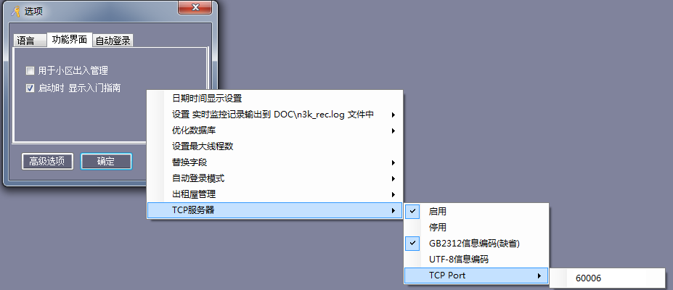

- Switch to the main console. “TCP Server Enabled” appears; click “Real-time Monitoring”.

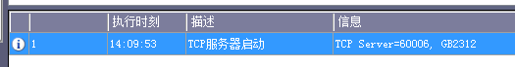
c. Connect a TCP client to the TCP server port (default 60006).
After connection, card-swipe information from real-time monitoring is sent automatically to the client.
When a door-sensor signal changes, the current status of all doors is sent automatically to the client.

Card and non-card events (same as software real-time monitoring):
Card-swipe record example:
Rec: 0d4d1c53000000b7C1DC120100000000A41E6E7410900000
ReasonNo: 6
Card number: 18013377
Employee number: 1
Name: N18013377
Department:
Time: 2015-05-04 14:35:28 Monday
Location: m001-Door 1
Direction: Entry
Status: card denied: no privilege

(Enable door-sensor/button event recording and alarms to receive the following information.)
Non-card record (door sensor, button, alarm event, remote opening, etc.) example:
Rec: 0d4d1c53000000ec0700000000000000A41E547612800000
ReasonNo: 33
Time: 2015-05-04 14:50:40 Monday
Location: m001-Door 1
Status: Button denied: interlock

Notes:
Rec: 0d4d1c53000000b7C1DC120100000000A41E6E7410900000 This line is the raw record data and can be used as a unique identifier. Identical values indicate duplicate records.

The current status of all doors starts with a DoorStatus line.
Each following line contains door name, status, and code separated by commas. Status is open, closed, or communication failure.
Codes: 0 = communication failure, 1 = open, 2 = closed.
Example:
DoorStatus
Main entrance,Open,1
Office,Closed,2
Warehouse,Communication failure,0

d. Send N3000 -USER “abc” -PASSWORD “123” followed by the required command parameters.
Specify the user name and password directly.

- Test with NetAssist.exe. Note that NetAssist.exe supports only GB2312 encoding.
Select TCP Client mode and port 60006.
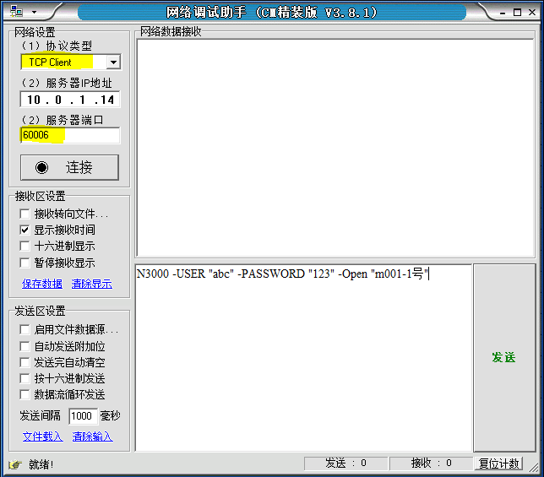

Click Connect, then enter the following command to open “m001-Door 1” remotely.
N3000 -USER "abc" -PASSWORD "123" -Open "m001-Door 1"

Click Send; a response should be returned.
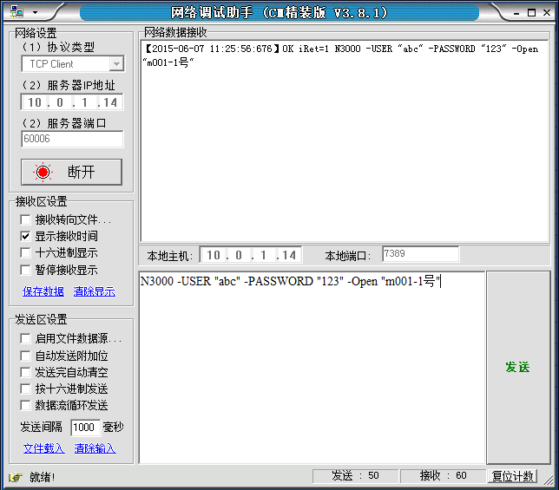

Card swipes and door openings are then sent automatically to NetAssist.exe.

Remote door opening
Command format (specified door name): N3000 -USER "abc" -PASSWORD "123" -OPEN Door name

Example:
N3000 -USER "abc" -PASSWORD "123" -Open "m001-Door 1"
Open "m001-Door 1"

Response
The response echoes the command on one line and the return value on another (-1 = failure, 1 = success).
On success:
N3000 -USER "abc" -PASSWORD "123" -Open "m001-Door 1"
iRet=1, OK

On failure:
N3000 -USER "abc" -PASSWORD "123" -Open "m001-Door 1"
iRet=-1, Failed

Get all door statuses
Command format (specified door name): N3000 -user abc -password 123 -GetAllDoorStatus
Returns the door-status information from system real-time monitoring.
Codes: 0 = communication failure, 1 = open, 2 = closed.

Example: if a door is absent from the returned data, it is not being monitored in real time.
Request:
N3000 -user abc -password 123 -GetAllDoorStatus
Response:
N3000 -user abc -password 123 -GetAllDoorStatus
iRet= 1, OK
DoorStatus:
Main entrance,Open,1
Office,Closed,2
Warehouse,Communication failure,0

If real-time monitoring is not active, the response is:
N3000 -user abc -password 123 -GetAllDoorStatus
iRet=3, OK
DoorStatus:

If the user name or password is incorrect, the response is shown below (123a is an incorrect password).
N3000 -user abc -password 123a -GetAllDoorStatus
iRet=-1, Failed

Get door status
Command format (specified door name): N3000 -user abc -password 123 -GetDoorStatusDoor name
Status return value: 1 = open, 2 = closed, 0 or -1 = not connected/communication failure.
Response
The response echoes the command on one line and the return value on another (-1 = failure, 1 = success).

Example:
Request:
N3000 -USER "abc" -PASSWORD "123" –GetDoorStatus "m001-Door 1"

Response values: 1 = door open, 2 = door closed, 0 or -1 = not connected/communication failure.
Door open:
N3000 -USER "abc" -PASSWORD "123" –GetDoorStatus "m001-Door 1"
iRet= 1, OK

Door closed:
N3000 -USER "abc" -PASSWORD "123" -GetDoorStatus "m001-Door 1"
iRet=2, OK

Not connected:
N3000 -USER "abc" -PASSWORD "123" -GetDoorStatus "m001-Door 1"
iRet=0, Failed

Set door control mode
Normally open, normally closed, or online
Set normally-open mode (specified door name): N3000 -USER "abc" -PASSWORD "123" -SETDOORNO Door name
Set normally-closed mode (specified door name): N3000 -USER "abc" -PASSWORD "123" -SETDOORNC Door name
Set normal modeCommand format (specified door name): N3000 -USER "abc" -PASSWORD "123" -SETDOORONLINE Door name

Response
The response echoes the command on one line and the return value on another (-1 = failure, 1 = success).

Example
Request: set normal online mode
N3000 -USER "abc" -PASSWORD "123" -SETDOORONLINE "m001-Door 1"
Response:
On success:
N3000 -USER "abc" -PASSWORD "123" -SETDOORONLINE "m001-Door 1"
iRet=1, OK

On failure:
N3000 -USER "abc" -PASSWORD "123" -SETDOORONLINE "m001-Door 1"
iRet=-1, Failed

Get the controller serial number for a door
Command format (specified door name): N3000 -USER "abc" -PASSWORD "123" –GETSN Door name
A return value of 0 means not found; otherwise, the value is the 9-digit controller SN.

Example
N3000 -USER "abc" -PASSWORD "123" –GETSN "m001-Door 1"
Response
The response echoes the command and then returns a value.
N3000 -USER "abc" -PASSWORD "123" -GETSN "m001-Door 1"
iRet=233145404, OK

Synchronize time
Command format (synchronize the controller for the specified door to the current PC time):
N3000 -USER "abc" -PASSWORD "123" -SetTimeDoor name

Example
N3000 -USER "abc" -PASSWORD "123" –SetTime "m001-Door 1"
Response
The response echoes the command and then returns a value.
On success:
N3000 -USER "abc" -PASSWORD "123" -SetTime "m001-Door 1"
iRet=1, OK

On failure:
N3000 -USER "abc" -PASSWORD "123" -SetTime "m001-Door 1"
iRet=-1, Failed

Implementing scheduled operations
Windows 7 Administrative Tools includes Task Scheduler.
Control Panel > System and Security > Administrative Tools > Task Scheduler.
Press F1, search Windows Help for “Task Scheduler”, and open Task Scheduler.

Create a task
Action > New > C:\iCCard\N3000 -AutoLogin -GetRecord
Confirm the prompt to add parameters.
Trigger > Daily at 10:05; configure the desired interval.

Microsoft Task Scheduler provides extensive scheduling options.

It can run the software even when no user is logged in.

Configure real-time monitoring output files

Retrieve monitoring data and view door status in real time.
- In the software, choose Tools > Automatic Login and enable automatic login.
Then use the shortcut menu to output real-time monitoring records: card swipes to DOC\n3k_rec2.log and non-card events to DOC\n3k_rec3.log.
Then choose shortcut menu > Auto-login mode > Real-time monitoring.
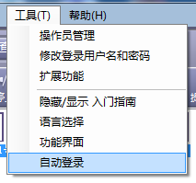
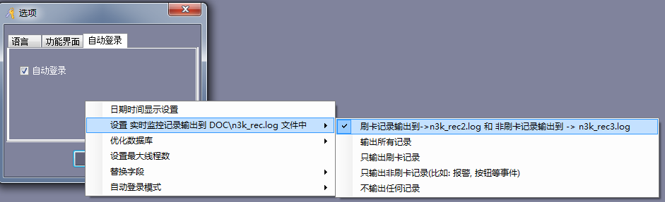
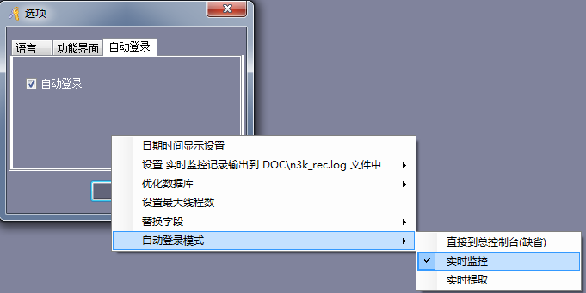

- After logging in again, real-time monitoring starts automatically.
- DOC\n3k_rec2.log contains card-swipe records and DOC\n3k_rec3.log contains non-card events such as door sensors, buttons, alarms, and remote openings.

Example card-swipe record in n3k_rec2.log:
Rec: 0d4d1c53000000b7C1DC120100000000A41E6E7410900000
Card number: 18013377
Employee number: 1
Name: N18013377
Department:
Time: 2015-05-04 14:35:28 Monday
Location: m001-Door 1-Entry
Status: card denied: no privilege

Example non-card record in n3k_rec3.log:
Rec: 0d4d1c53000000ec0700000000000000A41E547612800000
Time: 2015-05-04 14:50:40 Monday
Location: m001-Door 1
Status: Button denied: interlock

For more examples, see “SDK Development (access-control software)\Reference Data\All card and non-card record output examples_20150504.rar”.
For record status descriptions, see “SDK Development (low-level protocol)\01 Short-Packet Protocol (Basic)\Card record descriptions.xls”.

- DOC\n3k_monitor.log contains the current operating status of doors under real-time monitoring.
The first line is the update timestamp with millisecond precision.
Starting on line 2, each entry contains door name and status separated by a comma. Status is open, closed, or communication failure.
Example:
2015-04-28 00:29:03.233
Main entrance,Open
Office,Closed
Warehouse,Communication failure
- See “SDK Development (access-control software)\Reference Data\All card and non-card record output examples_20150504.rar”.

View user photos
For card number 12133, find 12133.jpg in the PHOTO directory.

