版本说明
2016-10-09 增加说明 “定时上报信息如果没有刷卡或其他信息，就重复上传当前最新的一条信息。”
2016-05-26 更新目录
2015-5-6_第三版本 修改 引入品牌开发支持 驱动必须是 6.56或以上, 类型改为 (0x17)
2013-5-28_第二版本 增加 提取记录操作说明
2013-5-4_第二版本 控制器驱动必须是 5.38
通信指令扩展了20字节, 达到64字节
操作实例的控制器: 229999901 = 0x0DB5851D
测试时, 可以将 1D 85 B5 0D 改为 实际使用的控制器SN (其他控制器的十六进制值 , 可以通过搜索得到控制器的SN的十六进制值, 或直接转换后低位放前) – 这样指令就可以复制使用
案例中: 使用的主要卡是0D D7 37 00 = 0x0037D70D = 3659533 (十进制)

2013-3-11_ 第一版本

目录
1 操作实例(针对控制器序列号229999901 ) 2
1.1 打开网络调试助手NetAssist 3
1.2 设置控制器的IP 4
1.3 从以下指令开始, 目标主机一定要指定控制器的IP. 9
1.4 查询控制器状态(0x20) 9
1.5 读取日期时间(0x32) 11
1.6 设置日期时间(0x30) 12
1.7 获取指定索引号的记录(0xB0) 13
1.8 设置已读取过的记录索引号(0xB2) 15
1.9 提取记录操作 16
1.10 远程开门(0x40) 17
1.11 权限添加或修改(0x50) 18
1.12 权限删除(单个删除) (0x52) 19
1.13 权限清空(全部清掉) (0x54) 20
1.14 权限数读取 (0x58) 21
1.15 权限查询 (0x5A) 22
1.16 获取指定索引号的权限(0x5C) 23
1.17 设置门控制参数(0x80) 25
1.18 读取门控制参数(0x82) 26
1.19 接收服务器配置 27

操作实例(针对控制器序列号229999901 )

打开网络调试助手NetAssist
本地IP地址(是电脑的IP. 此处192.168.168.101是当前测试电脑IP)
本地端口号 改为: 61003
点”连接” , 成功后会显示 “断开”
接收区设置 选择 显示接收时间, 十六进制显示
发送区设置 选择 按十六进制发送
清除输入
目标主机: 255.255.255.255 [此处是为了搜索控制器才设, 其他指令时要填入指定IP]
目标端口: 60000
设置好的界面如下
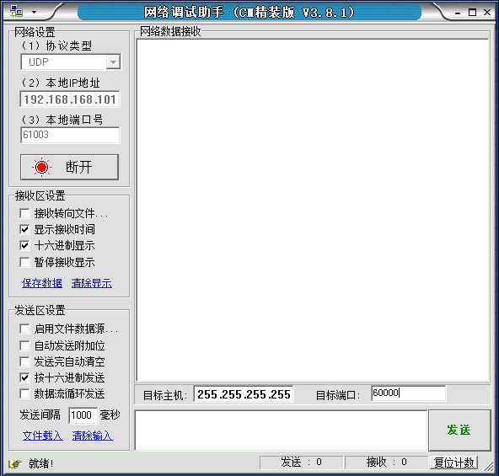

在下面的小方框中输入或粘贴指令代码, 然后点发送. 在网络数据接收区的大方框中显示接收到的数据. [所有的操作采用 十六制 进行]

设置控制器的IP

通过IPConfig2015 工具设置IP(方法一 推荐)
运行IPConfig2015_V2.15, 可以搜索到设备 (注意电脑IP: 要先设为 192.168.168.101)
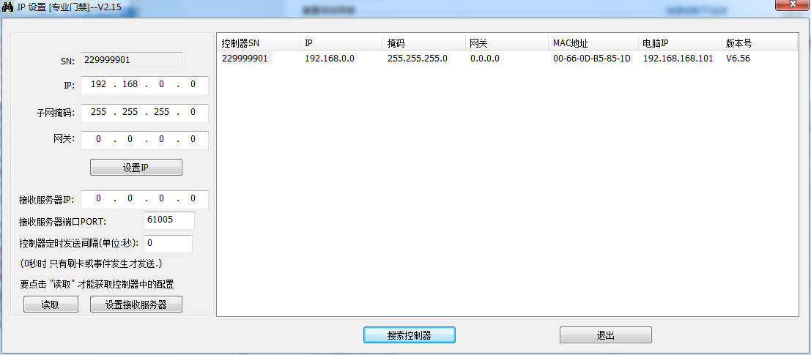
控制器设备序列号: 229999901 , 注意设备驱动版本号是 V6.56, 必须是此版本或以上才可以操作 [最后一列信息]
要设置的IP地址: 192.168.168.123
掩码: 255.255.255.0
网关: 192.168.168.254
按要求输入后, 点 设置IP
再点 搜索控制器, 就可以得到如下信息
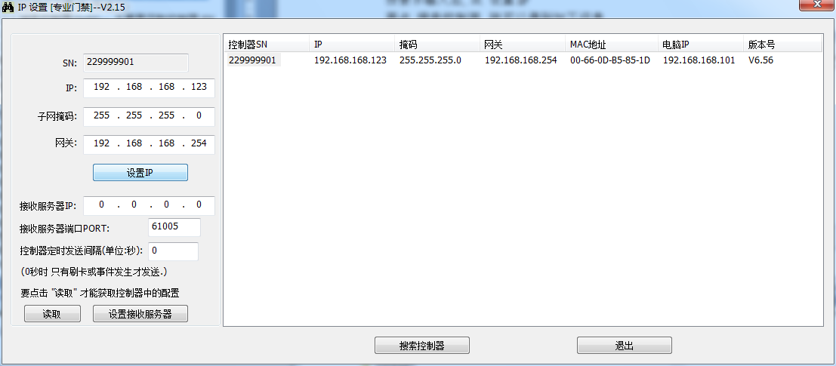

通过短报文设置IP (方法二)

搜索控制器(0x94) – 主要是获取控制器SN
目标主机: 255.255.255.255 目标端口 60000

发出报文
17 94 00 00 00 00 00 00 00 00 00 00 00 00 00 00 00 00 00 00 00 00 00 00 00 00 00 00 00 00 00 00 00 00 00 00 00 00 00 00 00 00 00 00 00 00 00 00 00 00 00 00 00 00 00 00 00 00 00 00 00 00 00 00
接收报文
接收界面如下 (特别说明: 目标主机自动被改为192.168.168.100, 【 Receive from 192.168.168.100 : 60000】： 这其中的IP地址不是控制器IP, 以指令中读取的为准)
【Receive from 192.168.168.100 : 60000】：( <- - - 这行是不要考虑的)
【2015-04-29 16:16:38:146】17 94 00 00 1D 85 B5 0D C0 A8 00 00 FF FF FF 00 00 00 00 00 00 66 0D B5 85 1D 06 56 20 15 04 29 00 00 00 00 00 00 00 00 00 00 00 00 00 00 00 00 00 00 00 00 00 00 00 00 00 00 00 00 00 00 00 00
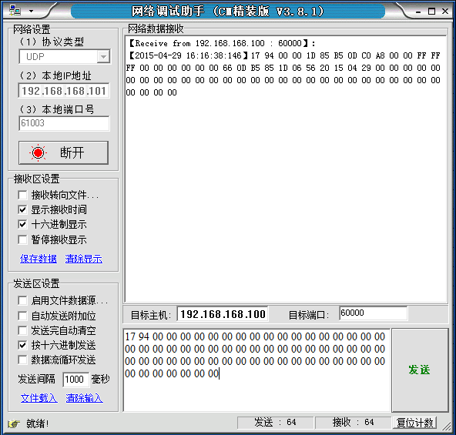
分析接收到的报文
17 94 00 00 指令部分
1D 85 B5 0D 设备序列号 0x0DB5851D = 229999901 这是双门双向控制器. 以下就以此设备序列号进行操作
C0 A8 00 00 控制器IP地址: 192.168.0.0 [这是出厂时的默认IP, 实际中要使用必须重新设置]
FF FF FF 00 控制器子网掩码 255.255.255.0
00 00 00 00 网关为 0.0.0.0 (未设置)
00 66 0D B5 85 1D MAC地址 00-66-0D-B5-85-1D
06 56 驱动版本 (BCD码显示)表示 6.56
20 15 04 29驱动发行年月日(BCD码显示) 表示 2015年04月29日发行
00 00 00 00 00 00 00 00 00 00 00 00 00 00 00 00 00 00 00 00 00 00 00 00 00 00 00 00 00 00 00 00 不用考虑

设置控制器的IP地址(0x96)
目标主机: 255.255.255.255 目标端口 60000
注意一定要改目标主机(因为192.168.168.100不是控制器的IP, 而是NetAssist自动修改的)
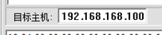
改为
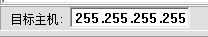

控制器设备序列号: 1D 85 B5 0D 设备序列号 0x0DB5851D = 229999901
要设置的IP地址: 192.168.168.123 (十六进制显示 C0 A8 A8 7B)
掩码: 255.255.255.0 (十六进制显示 FF FF FF 00)
网关: 192.168.168.254 (十六进制显示 C0 A8 A8 FE)
强制标识: 55 AA AA 55
发出报文
17 96 00 00 1D 85 B5 0D C0 A8 A8 7B FF FF FF 00 C0 A8 A8 FE 55 AA AA 55 00 00 00 00 00 00 00 00 00 00 00 00 00 00 00 00 00 00 00 00 00 00 00 00 00 00 00 00 00 00 00 00 00 00 00 00 00 00 00 00

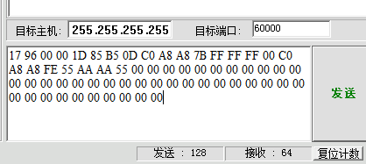
此指令发出后, 不会有数据返回. 要确认”发出指令”是否正确, 通过搜索控制器获取.

再搜索控制器发出:
17 94 00 00 00 00 00 00 00 00 00 00 00 00 00 00 00 00 00 00 00 00 00 00 00 00 00 00 00 00 00 00 00 00 00 00 00 00 00 00 00 00 00 00 00 00 00 00 00 00 00 00 00 00 00 00 00 00 00 00 00 00 00 00
接收到报文: (得到信息IP: 192.168.168.123, 掩码: 255.255.255.0, 网关: 192.168.168.254)
17 94 00 00 1D 85 B5 0D C0 A8 A8 7B FF FF FF 00 C0 A8 A8 FE 00 66 0D B5 85 1D 06 56 20 15 04 29 00 00 00 00 00 00 00 00 00 00 00 00 00 00 00 00 00 00 00 00 00 00 00 00 00 00 00 00 00 00 00 00

界面显示如下:
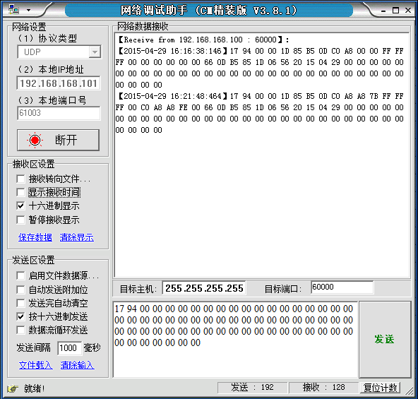

从以下指令开始, 目标主机一定要指定控制器的IP.

查询控制器状态(0x20)
目标主机: 192.168.168.123 目标端口 60000
控制器设备序列号: 1D 85 B5 0D 设备序列号 0x0DB5851D = 229999901
发出报文:
17 20 00 00 1D 85 B5 0D 00 00 00 00 00 00 00 00 00 00 00 00 00 00 00 00 00 00 00 00 00 00 00 00 00 00 00 00 00 00 00 00 00 00 00 00 00 00 00 00 00 00 00 00 00 00 00 00 00 00 00 00 00 00 00 00
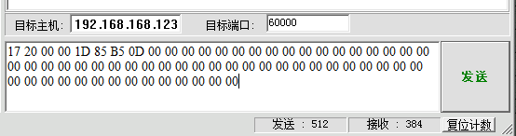
接收报文:
17 20 00 00 1D 85 B5 0D 04 00 00 00 01 00 01 01 0D D7 37 00 20 13 04 03 21 09 24 06 01 01 00 00 00 00 00 00 00 22 28 26 00 00 00 00 00 00 00 00 00 00 00 00 00 00 00 00 00 00 00 00 00 00 00 00
17 20 00 00 1D 85 B5 0D 04 00 00 00 01 00 01 01 0D D7 37 00 20 15 04 29 16 37 39 06 01 01 00 00 00 00 00 00 00 16 42 25 00 00 00 00 00 00 00 00 00 00 00 15 04 29 00 00 00 00 00 00 00 00 00 00

分析接收报文:
17 20 00 00 指令代码部分
1D 85 B5 0D 设备序列号 0x0DB5851D = 229999901
04 00 00 00 最后一条记录的索引号=0x00000004 = 4
01 刷卡记录
00 不通过
01 一号门
01 进门
0D D7 37 00 卡号=0x0037D70D = 3659533
20 15 04 29 16 37 39 刷卡时间 2015年04月29日 16:37:39
06 记录原因代码 [没有权限] -- 可以查 “刷卡记录说明.xls”文件
01 一号门门磁状态(打开) (或未接门磁)
01 二号门门磁状态(打开) (或未接门磁)
00 因为是双门控制器, 三号门门磁状态 不用考虑
00 因为是双门控制器, 四号门门磁状态 不用考虑
00 一号门按钮松开
00 二号门按钮松开
00 因为是双门控制器, 三号门按钮状态 不用考虑
00 因为是双门控制器, 四号门按钮状态 不用考虑
00无故障
16 42 25 控制器当前时间 16点42分25秒
00 00 00 00 流水号(不用考虑)
00 00 00 00 备用(不用考虑)
00 特殊信息(可以不用考虑)
00 继电器状态(全为0表示, 1号门上锁, 2号门上锁)[可以不用考虑]
00 没有火警/强制锁门动作
15 04 29 控制器当前日期 2015年04月29日
00 00 00 00 00 00 00 00 00 00其他不用考虑

读取日期时间(0x32)
目标主机: 192.168.168.123 目标端口 60000
控制器设备序列号: 1D 85 B5 0D 设备序列号 0x0DB5851D = 229999901
发出报文:
17 32 00 00 1D 85 B5 0D 00 00 00 00 00 00 00 00 00 00 00 00 00 00 00 00 00 00 00 00 00 00 00 00 00 00 00 00 00 00 00 00 00 00 00 00 00 00 00 00 00 00 00 00 00 00 00 00 00 00 00 00 00 00 00 00

接收报文:
17 32 00 00 1D 85 B5 0D 20 15 04 29 16 57 37 00 00 00 00 00 00 00 00 00 00 00 00 00 00 00 00 00 00 00 00 00 00 00 00 00 00 00 00 00 00 00 00 00 00 00 00 00 00 00 00 00 00 00 00 00 00 00 00 00
分析接收报文:
17 32 00 00 指令代码部分
1D 85 B5 0D 设备序列号 0x0DB5851D = 229999901
20 15 04 29 16 57 37 控制器时钟 2015年04月29日 16:57:37
00 00 00 00 00 00 00 00 00 00 00 00 00 00 00 00 00 00 00 00 00 00 00 00 00 00 00 00 00 00 00 00 00 00 00 00 00 00 00 00 00 00 00 00 00 00 00 00 00 其他不用考虑

设置日期时间(0x30)
目标主机: 192.168.168.123 目标端口 60000
控制器设备序列号: 1D 85 B5 0D 设备序列号 0x0DB5851D = 229999901
发出报文: (设置2015年12月31日 23点58分39秒)
17 30 00 00 1D 85 B5 0D 20 15 12 30 23 58 39 00 00 00 00 00 00 00 00 00 00 00 00 00 00 00 00 00 00 00 00 00 00 00 00 00 00 00 00 00 00 00 00 00 00 00 00 00 00 00 00 00 00 00 00 00 00 00 00 00
接收报文:
17 30 00 00 1D 85 B5 0D 20 15 12 30 23 58 39 00 00 00 00 00 00 00 00 00 00 00 00 00 00 00 00 00 00 00 00 00 00 00 00 00 00 00 00 00 00 00 00 00 00 00 00 00 00 00 00 00 00 00 00 00 00 00 00 00
[发出报文与接收报文在日期时间部分是一致的, 表明设置日期时间成功]

恢复为当前时间
发出报文: (设置2015年04月29日 17点23分30秒)
17 30 00 00 1D 85 B5 0D 20 15 04 29 17 23 30 00 00 00 00 00 00 00 00 00 00 00 00 00 00 00 00 00 00 00 00 00 00 00 00 00 00 00 00 00 00 00 00 00 00 00 00 00 00 00 00 00 00 00 00 00 00 00 00 00

获取指定索引号的记录(0xB0)
目标主机: 192.168.168.123 目标端口 60000
控制器设备序列号: 1D 85 B5 0D 设备序列号 0x0DB5851D = 229999901

一. 发出报文 (取索引号 0x00000001的记录)
17 B0 00 00 1D 85 B5 0D 01 00 00 00 00 00 00 00 00 00 00 00 00 00 00 00 00 00 00 00 00 00 00 00 00 00 00 00 00 00 00 00 00 00 00 00 00 00 00 00 00 00 00 00 00 00 00 00 00 00 00 00 00 00 00 00
接收报文
17 B0 00 00 1D 85 B5 0D 01 00 00 00 01 00 01 01 0B 12 27 01 20 15 04 29 16 37 13 06 00 00 00 00 00 00 00 00 00 00 00 00 00 00 00 00 00 00 00 00 00 00 00 00 00 00 00 00 00 00 00 00 00 00 00 00

分析报文
17 B0 00 00指令代码部分
1D 85 B5 0D设备序列号 0x0DB5851D = 229999901
01 00 00 00 刷卡记录的索引号 = 1
01 记录类型: 刷卡记录
00 不允许通过
01 一号门
01 进门
0B 12 27 01 卡号 = 0x0127120B (十六进制) = 19337739 (十进制)
20 15 04 29 16 37 13 刷卡时间: 2015年04月29日 16:37:13
06 记录原因代码 [表示没有权限]
00 00 00 00 00 00 00 00 00 00 00 00 00 00 00 00 其他不考虑

二. 发出报文 (取最早的一条记录 通过索引号 0x00000000) [此指令适合于 刷卡记录超过20万时环境下使用]
17 B0 00 00 1D 85 B5 0D 00 00 00 00 00 00 00 00 00 00 00 00 00 00 00 00 00 00 00 00 00 00 00 00 00 00 00 00 00 00 00 00 00 00 00 00 00 00 00 00 00 00 00 00 00 00 00 00 00 00 00 00 00 00 00 00
接收报文
17 B0 00 00 1D 85 B5 0D 01 00 00 00 01 00 01 01 0B 12 27 01 20 15 04 29 16 37 13 06 00 00 00 00 00 00 00 00 00 00 00 00 00 00 00 00 00 00 00 00 00 00 00 00 00 00 00 00 00 00 00 00 00 00 00 00
获取到最早的一条记录的索引号为0x00000001

三. 发出报文 (取最新的一条记录 通过索引 0xffffffff)
17 B0 00 00 1D 85 B5 0D FF FF FF FF 00 00 00 00 00 00 00 00 00 00 00 00 00 00 00 00 00 00 00 00 00 00 00 00 00 00 00 00 00 00 00 00 00 00 00 00 00 00 00 00 00 00 00 00 00 00 00 00 00 00 00 00
接收报文
17 B0 00 00 1D 85 B5 0D 04 00 00 00 01 00 01 01 0D D7 37 00 20 15 04 29 16 37 39 06 00 00 00 00 00 00 00 00 00 00 00 00 00 00 00 00 00 00 00 00 00 00 00 00 00 00 00 00 00 00 00 00 00 00 00 00
获取到最新的一条记录的索引号为 0x00000004

记录索引号正常情况下是顺序递增的, 最大可达0xffffff = 16,777,215 (超过1千万) . 由于存储空间有限, 控制器上只会保留最近的20万个记录. 当索引号超过20万后, 旧的索引号位的记录就会被覆盖, 所以这时查询这些索引号的记录, 返回的记录类型将是0xff, 表示不存在了.

设置已读取过的记录索引号(0xB2)
目标主机: 192.168.168.123 目标端口 60000
控制器设备序列号: 1D 85 B5 0D 设备序列号 0x0DB5851D = 229999901

注意: 设置的值不能超过最新刷卡记录的索引值

发出报文 (设为已读取过的记录索引号为3)
17 B2 00 00 1D 85 B5 0D 03 00 00 00 55 AA AA 55 00 00 00 00 00 00 00 00 00 00 00 00 00 00 00 00 00 00 00 00 00 00 00 00 00 00 00 00 00 00 00 00 00 00 00 00 00 00 00 00 00 00 00 00 00 00 00 00
接收报文
17 B2 00 00 1D 85 B5 0D 01 00 00 00 00 00 00 00 00 00 00 00 00 00 00 00 00 00 00 00 00 00 00 00 00 00 00 00 00 00 00 00 00 00 00 00 00 00 00 00 00 00 00 00 00 00 00 00 00 00 00 00 00 00 00 00
信息位01表示成功.

通过获取已读取过的记录索引号进行确认
发出报文
17 B4 00 00 1D 85 B5 0D 00 00 00 0000 00 00 0000 00 00 00 00 00 00 00 00 00 00 00 00 00 00 00 00 00 00 00 00 00 00 00 00 00 00 00 00 00 00 00 00 00 00 00 00 00 00 00 00 00 00 00 00 00 00 00
接收报文
17 B4 00 00 1D 85 B5 0D 03 00 00 00 00 00 00 00 00 00 00 00 00 00 00 00 00 00 00 00 00 00 00 00 00 00 00 00 00 00 00 00 00 00 00 00 00 00 00 00 00 00 00 00 00 00 00 00 00 00 00 00 00 00 00 00
03 00 00 00为设置的值.

提取记录操作
方案一:
1. 通过 0xB4指令 获取已读取过的记录索引号 recordIndex
2. 通过 0xB0指令 获取指定索引号的记录 从recordIndex + 1开始提取记录， 直到记录为空为止
3. 通过 0xB2指令 设置已读取过的记录索引号 设置的值为最后读取到的刷卡记录索引号
经过上面三个步骤， 整个提取记录的操作完成。

方案二:
1. 通过数据库查找对应控制器 已读取过的记录索引号 recordIndex (如果没有则为0)
2. 通过 0xB0指令 获取指定索引号的记录 从recordIndex + 1开始提取记录， 直到记录为空为止
3. 数据库是记录下对应控制器 最后读取过的刷卡记录索引号
经过上面三个步骤， 整个提取记录的操作完成。

远程开门(0x40)
目标主机: 192.168.168.123 目标端口 60000
控制器设备序列号: 1D 85 B5 0D 设备序列号 0x0DB5851D = 229999901

一. 发出报文(开1号门)
17 40 00 00 1D 85 B5 0D 01 00 00 00 00 00 00 00 00 00 00 00 00 00 00 00 00 00 00 00 00 00 00 00 00 00 00 00 00 00 00 00 00 00 00 00 00 00 00 00 00 00 00 00 00 00 00 00 00 00 00 00 00 00 00 00
接收报文
17 40 00 00 1D 85 B5 0D 01 00 00 00 00 00 00 00 00 00 00 00 00 00 00 00 00 00 00 00 00 00 00 00 00 00 00 00 00 00 00 00 00 00 00 00 00 00 00 00 00 00 00 00 00 00 00 00 00 00 00 00 00 00 00 00
成功后, 信息位返回值为01

二. 发出报文(开2号门)
17 40 00 00 1D 85 B5 0D 02 00 00 00 00 00 00 00 00 00 00 00 00 00 00 00 00 00 00 00 00 00 00 00 00 00 00 00 00 00 00 00 00 00 00 00 00 00 00 00 00 00 00 00 00 00 00 00 00 00 00 00 00 00 00 00
接收报文
17 40 00 00 1D 85 B5 0D 01 00 00 00 00 00 00 00 00 00 00 00 00 00 00 00 00 00 00 00 00 00 00 00 00 00 00 00 00 00 00 00 00 00 00 00 00 00 00 00 00 00 00 00 00 00 00 00 00 00 00 00 00 00 00 00
成功后, 信息位返回值为01

权限添加或修改(0x50)
目标主机: 192.168.168.123 目标端口 60000
控制器设备序列号: 1D 85 B5 0D 设备序列号 0x0DB5851D = 229999901

发出报文 增加卡号0D D7 37 00, 通过当前控制器的所有门
17 50 00 00 1D 85 B5 0D 0D D7 37 00 20 10 01 01 20 29 12 31 01 01 01 01 00 00 00 00 00 00 00 00 00 00 00 00 00 00 00 00 00 00 00 00 00 00 00 00 00 00 00 00 00 00 00 00 00 00 00 00 00 00 00 00
分析发出报文
17 50 00 00 功能代码
1D 85 B5 0D 设备序列号
0D D7 37 00 要添加或修改的权限中的卡号 = 0x0037D70D = 3659533 (十进制)
20 10 01 01 起始日期: 2010年01月01日 (必须大于2001年)
20 29 12 31 截止日期: 2029年12月31日
01 允许通过 一号门 [对单门, 双门, 四门控制器有效]
01 允许通过 二号门 [对双门, 四门控制器有效]
01 允许通过 三号门 [对四门控制器有效]
01 允许通过 四号门 [对四门控制器有效]
00 00 00 00 00 00 00 00 00 00 00 00 00 00 00 00 00 00 00 00 00 00 00 00 00 00 00 00 00 00 00 00 00 00 00 00 00 00 00 00 其他不用考虑

接收报文 (添加修改成功)
17 50 00 00 1D 85 B5 0D 01 00 00 00 00 00 00 00 00 00 00 00 00 00 00 00 00 00 00 00 00 00 00 00 00 00 00 00 00 00 00 00 00 00 00 00 00 00 00 00 00 00 00 00 00 00 00 00 00 00 00 00 00 00 00 00
信息位为01 表示成功.

这时 刷卡号为= 0x0037D70D = 3659533 (十进制)的卡, 1号门继电器动作.

权限删除(单个删除) (0x52)
目标主机: 192.168.168.123 目标端口 60000
控制器设备序列号: 1D 85 B5 0D 设备序列号 0x0DB5851D = 229999901

发出报文
要删除的权限卡号0D D7 37 00 = 0x0037D70D = 3659533 (十进制)
17 52 00 00 1D 85 B5 0D 0D D7 37 00 00 00 00 00 00 00 00 00 00 00 00 00 00 00 00 00 00 00 00 00 00 00 00 00 00 00 00 00 00 00 00 00 00 00 00 00 00 00 00 00 00 00 00 00 00 00 00 00 00 00 00 00

接收报文 (删除单个成功)
17 52 00 00 1D 85 B5 0D 01 00 00 00 00 00 00 00 00 00 00 00 00 00 00 00 00 00 00 00 00 00 00 00 00 00 00 00 00 00 00 00 00 00 00 00 00 00 00 00 00 00 00 00 00 00 00 00 00 00 00 00 00 00 00 00
信息位为01 表示成功.

这时 刷卡号为= 0x0037D70D = 3659533 (十进制)的卡, 1号门继电器不会动作.

权限清空(全部清掉) (0x54)
目标主机: 192.168.168.123 目标端口 60000
控制器设备序列号: 1D 85 B5 0D 设备序列号 0x0DB5851D = 229999901

发出报文
17 54 00 00 1D 85 B5 0D 55 AA AA 55 00 00 00 00 00 00 00 00 00 00 00 00 00 00 00 00 00 00 00 00 00 00 00 00 00 00 00 00 00 00 00 00 00 00 00 00 00 00 00 00 00 00 00 00 00 00 00 00 00 00 00 00
接收报文 (清空成功)
17 54 00 00 1D 85 B5 0D 01 00 00 00 00 00 00 00 00 00 00 00 00 00 00 00 00 00 00 00 00 00 00 00 00 00 00 00 00 00 00 00 00 00 00 00 00 00 00 00 00 00 00 00 00 00 00 00 00 00 00 00 00 00 00 00
信息位为01 表示成功.

可以通过查询控制器状态核实权限数是否为0.

权限数读取 (0x58)
目标主机: 192.168.168.123 目标端口 60000
控制器设备序列号: 1D 85 B5 0D 设备序列号 0x0DB5851D = 229999901

发出报文
17 58 00 00 1D 85 B5 0D 00 00 00 00 00 00 00 00 00 00 00 00 00 00 00 00 00 00 00 00 00 00 00 00 00 00 00 00 00 00 00 00 00 00 00 00 00 00 00 00 00 00 00 00 00 00 00 00 00 00 00 00 00 00 00 00
接收报文
17 58 00 00 1D 85 B5 0D 00 00 00 00 00 00 00 00 00 00 00 00 00 00 00 00 00 00 00 00 00 00 00 00 00 00 00 00 00 00 00 00 00 00 00 00 00 00 00 00 00 00 00 00 00 00 00 00 00 00 00 00 00 00 00 00
控制器中有0个权限

权限查询 (0x5A)
目标主机: 192.168.168.123 目标端口 60000
控制器设备序列号: 1D 85 B5 0D 设备序列号 0x0DB5851D = 229999901

发出报文 (查卡号为 0D D7 37 00的权限)
17 5A 00 00 1D 85 B5 0D 0D D7 37 00 00 00 00 00 00 00 00 00 00 00 00 00 00 00 00 00 00 00 00 00 00 00 00 00 00 00 00 00 00 00 00 00 00 00 00 00 00 00 00 00 00 00 00 00 00 00 00 00 00 00 00 00
接收报文
没有权限时: (卡号部分为0)
17 5A 00 00 1D 85 B5 0D 00 00 00 00 00 00 00 00 00 00 00 00 00 00 00 00 00 00 00 00 00 00 00 00 00 00 00 00 00 00 00 00 00 00 00 00 00 00 00 00 00 00 00 00 00 00 00 00 00 00 00 00 00 00 00 00

增加一个卡0D D7 37 00的权限
发出报文
17 50 00 00 1D 85 B5 0D 0D D7 37 00 20 10 01 01 20 29 12 31 01 01 01 01 00 00 00 00 00 00 00 00 00 00 00 00 00 00 00 00 00 00 00 00 00 00 00 00 00 00 00 00 00 00 00 00 00 00 00 00 00 00 00 00

再次查询
发出报文
17 5A 00 00 1D 85 B5 0D 0D D7 37 00 00 00 00 00 00 00 00 00 00 00 00 00 00 00 00 00 00 00 00 00 00 00 00 00 00 00 00 00 00 00 00 00 00 00 00 00 00 00 00 00 00 00 00 00 00 00 00 00 00 00 00 00

返回报文 有权限时: (卡号部分为要查询的卡号)
17 5A 00 00 1D 85 B5 0D 0D D7 37 00 20 10 01 01 20 29 12 31 01 01 01 01 00 00 00 00 00 00 00 00 00 00 00 00 00 00 00 00 00 00 00 00 00 00 00 00 00 00 00 00 00 00 00 00 00 00 00 00 00 00 00 00

获取指定索引号的权限(0x5C)
目标主机: 192.168.168.123 目标端口 60000
控制器设备序列号: 1D 85 B5 0D 设备序列号 0x0DB5851D = 229999901

发出报文 (查索引号为1的权限, 注意索引号从1开始)
17 5C 00 00 1D 85 B5 0D 01 00 00 00 00 00 00 00 00 00 00 00 00 00 00 00 00 00 00 00 00 00 00 00 00 00 00 00 00 00 00 00 00 00 00 00 00 00 00 00 00 00 00 00 00 00 00 00 00 00 00 00 00 00 00 00
接收报文
17 5C 00 00 1D 85 B5 0D 0D D7 37 00 20 10 01 01 20 29 12 31 01 01 01 01 00 00 00 00 00 00 00 00 00 00 00 00 00 00 00 00 00 00 00 00 00 00 00 00 00 00 00 00 00 00 00 00 00 00 00 00 00 00 00 00
卡号部分为0D D7 37 00, 表示索引1号的权限卡号为3659533

尝试删除3659533的权限
发出报文
要删除的权限卡号0D D7 37 00 = 0x0037D70D = 3659533 (十进制)
17 52 00 00 1D 85 B5 0D 0D D7 37 00 00 00 00 00 00 00 00 00 00 00 00 00 00 00 00 00 00 00 00 00 00 00 00 00 00 00 00 00 00 00 00 00 00 00 00 00 00 00 00 00 00 00 00 00 00 00 00 00 00 00 00 00
然后:
发出报文 (查索引号为1的权限, 注意索引号从1开始)
17 5C 00 00 1D 85 B5 0D 01 00 00 00 00 00 00 00 00 00 00 00 00 00 00 00 00 00 00 00 00 00 00 00 00 00 00 00 00 00 00 00 00 00 00 00 00 00 00 00 00 00 00 00 00 00 00 00 00 00 00 00 00 00 00 00
接收报文
17 5C 00 00 1D 85 B5 0D FF FF FF FF 00 00 00 00 00 00 00 00 00 00 00 00 00 00 00 00 00 00 00 00 00 00 00 00 00 00 00 00 00 00 00 00 00 00 00 00 00 00 00 00 00 00 00 00 00 00 00 00 00 00 00 00
卡号部分为FF FF FF FF, 表示此位置的权限被删除了

发出报文 (查索引号为2的权限, 注意索引号从1开始)
17 5C 00 00 1D 85 B5 0D 02 00 00 00 00 00 00 00 00 00 00 00 00 00 00 00 00 00 00 00 00 00 00 00 00 00 00 00 00 00 00 00 00 00 00 00 00 00 00 00 00 00 00 00 00 00 00 00 00 00 00 00 00 00 00 00
接收报文
17 5C 00 00 1D 85 B5 0D 00 00 00 00 00 00 00 00 00 00 00 00 00 00 00 00 00 00 00 00 00 00 00 00 00 00 00 00 00 00 00 00 00 00 00 00 00 00 00 00 00 00 00 00 00 00 00 00 00 00 00 00 00 00 00 00
卡号部分为00 00 00 00, 表示此位置的没有权限, 也表明此索引号之后不会有权限
重新增加一个卡0D D7 37 00的权限
发出报文
17 50 00 00 1D 85 B5 0D 0D D7 37 00 20 10 01 01 20 29 12 31 01 01 01 01 00 00 00 00 00 00 00 00 00 00 00 00 00 00 00 00 00 00 00 00 00 00 00 00 00 00 00 00 00 00 00 00 00 00 00 00 00 00 00 00

设置门控制参数(0x80)
目标主机: 192.168.168.123 目标端口 60000
控制器设备序列号: 1D 85 B5 0D 设备序列号 0x0DB5851D = 229999901

发出报文 (设置1号门 在线 开门延时 3秒)
17 80 00 00 1D 85 B5 0D 01 03 03 00 00 00 00 00 00 00 00 00 00 00 00 00 00 00 00 00 00 00 00 00 00 00 00 00 00 00 00 00 00 00 00 00 00 00 00 00 00 00 00 00 00 00 00 00 00 00 00 00 00 00 00 00
分析发出报文
17 80 00 00 指令代码
1D 85 B5 0D 设备序列号
01 指定一号门
03 设置控制方式为 03 为在线方式
03 设置开门延时(也就是保持开门的时长): 3秒
00 00 00 00 00 00 00 00 00 00 00 00 00 00 00 00 00 00 00 00 00 00 00 00 00 00 00 00 00 00 00 00 00 00 00 00 00 00 00 00 00 00 00 00 00 00 00 00 00 00 00 00 00

接收报文
17 80 00 00 1D 85 B5 0D 01 03 03 00 00 00 00 00 00 00 00 00 00 00 00 00 00 00 00 00 00 00 00 00 00 00 00 00 00 00 00 00 00 00 00 00 00 00 00 00 00 00 00 00 00 00 00 00 00 00 00 00 00 00 00 00
成功时, 返回值与设置一致

读取门控制参数(0x82)
目标主机: 192.168.168.123 目标端口 60000
控制器设备序列号: 1D 85 B5 0D 设备序列号 0x0DB5851D = 229999901

发出报文 (读取一号门的控制方式和开门延时)
17 82 00 00 1D 85 B5 0D 01 00 00 00 00 00 00 00 00 00 00 00 00 00 00 00 00 00 00 00 00 00 00 00 00 00 00 00 00 00 00 00 00 00 00 00 00 00 00 00 00 00 00 00 00 00 00 00 00 00 00 00 00 00 00 00

接收报文
17 82 00 00 1D 85 B5 0D 01 03 03 00 00 00 00 00 00 00 00 00 00 00 00 00 00 00 00 00 00 00 00 00 00 00 00 00 00 00 00 00 00 00 00 00 00 00 00 00 00 00 00 00 00 00 00 00 00 00 00 00 00 00 00 00

接收服务器配置

通过IPConfig2015 工具配置(方法一 推荐)
运行IPConfig2015, 可以搜索到设备 (注意电脑IP: 要先设为 192.168.168.101)
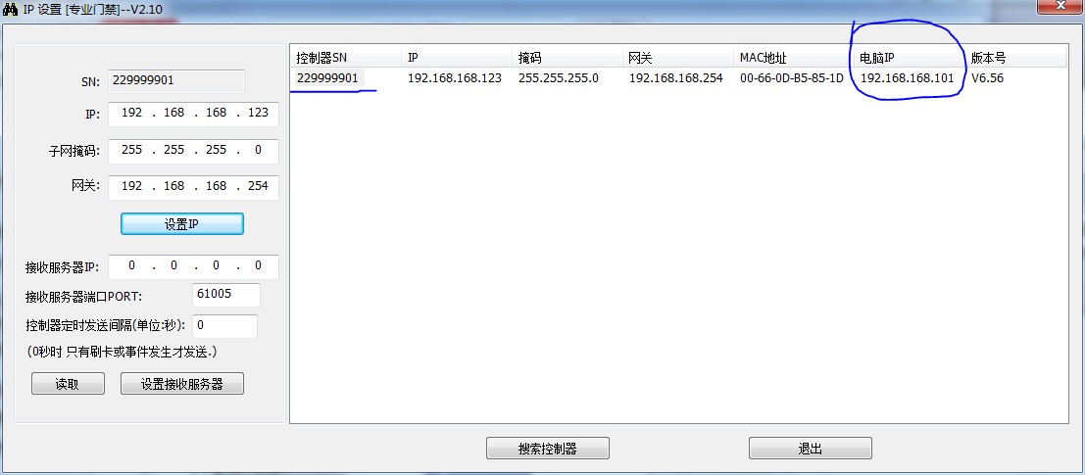

点击 “读取”, 可以获取当前控制器的接收服务器的信息.

控制器设备序列号: 229999901
设置 接收服务器的IP: 192.168.168.101 [当前电脑IP]
(如果不想让控制器发出数据, 只要将接收服务器的IP设为0.0.0.0 就行了)
接收服务器的端口: 61005
每隔5秒发送一次: 05
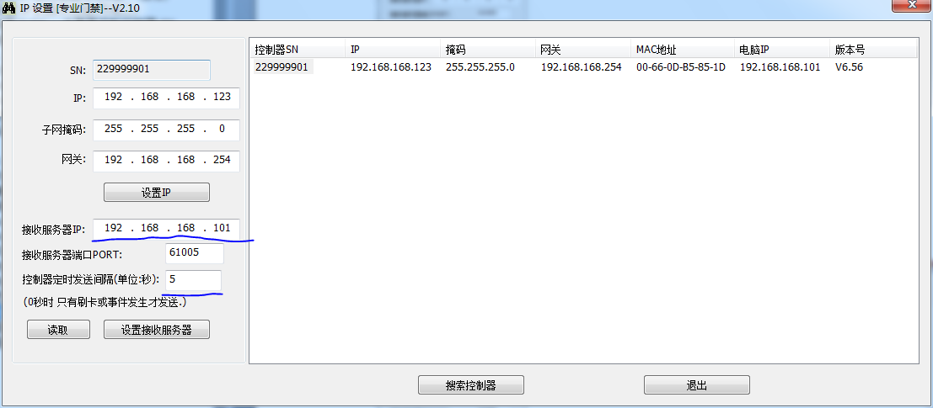
点 “设置接收服务器”.

然后运行一个NetAssist, 作如下设置 (端口号注意是 61005)
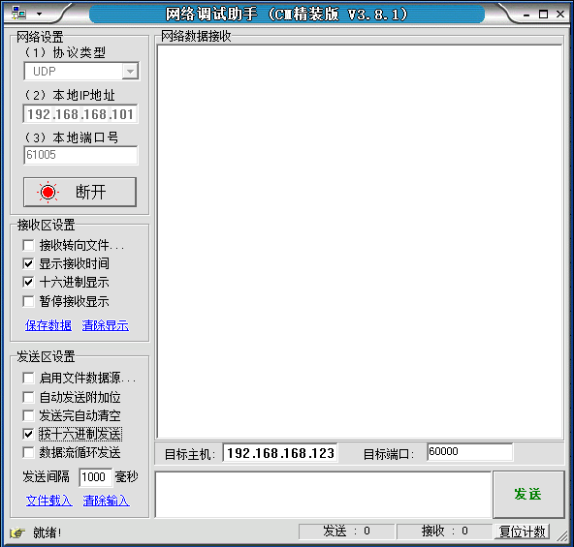
[要求 本地IP地址和本地端口号与设置的一致, 并 连接后就行.]
然后会自动接收到数据

接收到信息与查询控制器状态的信息, 除类型外(此处为19, 而查询信息是17), 其他都一样 [详见查询控制器状态部分]

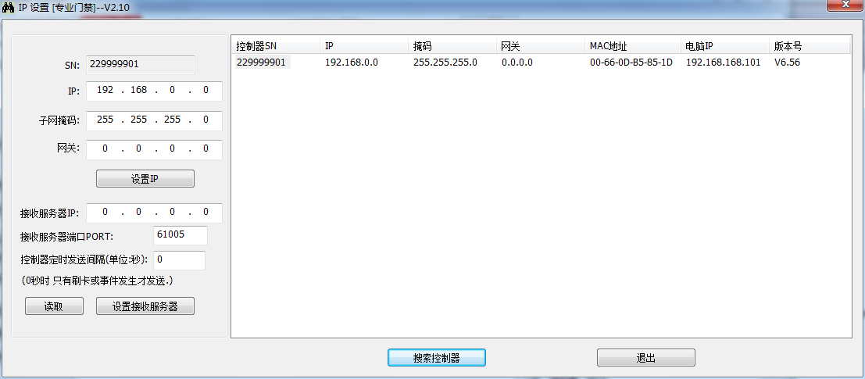
控制器设备序列号: 1D 85 B5 0D 设备序列号 0x0DB5851D = 229999901
要设置的IP地址: 192.168.168.123
掩码: 255.255.255.0
网关: 192.168.168.254
按要求输入后, 点 设置IP
再点 搜索控制器, 就可以得到如下信息

通过短报文配置(方法二)

设置接收服务器的IP和端口(0x90)
目标主机: 192.168.168.123 目标端口 60000
控制器设备序列号: 1D 85 B5 0D 设备序列号 0x0DB5851D = 229999901
接收服务器的IP: 192.168.168.101 [当前电脑IP]
(如果不想让控制器发出数据, 只要将接收服务器的IP设为0.0.0.0 就行了)
接收服务器的端口: 61005
每隔5秒发送一次: 05
发出报文 [设置 接收服务器 IP 192.168.168.101, 端口 61005 =0xEE4D每隔5秒发送一次: 05]
17 90 00 00 1D 85 B5 0D C0 A8 A8 65 4D EE 05 00 00 00 00 00 00 00 00 00 00 00 00 00 00 00 00 00 00 00 00 00 00 00 00 00 00 00 00 00 00 00 00 00 00 00 00 00 00 00 00 00 00 00 00 00 00 00 00 00

接收报文
17 90 00 00 1D 85 B5 0D 01 00 00 00 00 00 00 00 00 00 00 00 00 00 00 00 00 00 00 00 00 00 00 00 00 00 00 00 00 00 00 00 00 00 00 00 00 00 00 00 00 00 00 00 00 00 00 00 00 00 00 00 00 00 00 00
信息位为01 表示成功.

作完成上面设置后, 再运行一个NetAssist, 作如下设置 (端口号注意是 61005)
[要求 本地IP地址和本地端口号与设置的一致, 并 连接后就行.]
然后会自动接收到数据

接收到信息与查询控制器状态的信息, 除类型外(此处为19, 而查询信息是17), 其他都一样 [详见查询控制器状态部分]

定时上报信息如果没有刷卡或其他信息，就重复上传当前最新的一条信息。

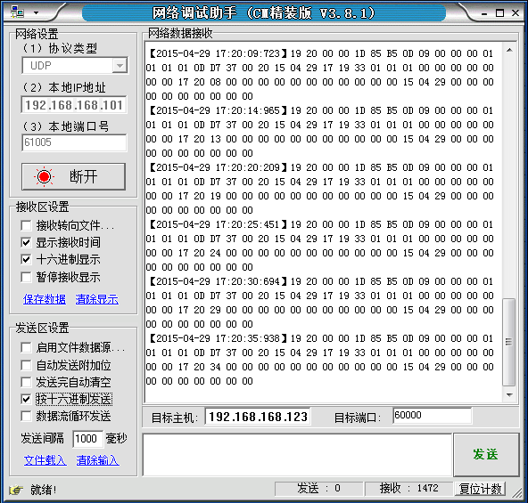

发出报文 [设置 接收服务器 IP 192.168.168.101, 端口 61005 =0xEE4D有新记录时自动上传 (不循环发送数据 设每隔0秒发送一次)]
17 90 00 00 1D 85 B5 0D C0 A8 A8 65 4D EE 00 00 00 00 00 00 00 00 00 00 00 00 00 00 00 00 00 00 00 00 00 00 00 00 00 00 00 00 00 00 00 00 00 00 00 00 00 00 00 00 00 00 00 00 00 00 00 00 00 00

接收报文
17 90 00 00 1D 85 B5 0D 01 00 00 00 00 00 00 00 00 00 00 00 00 00 00 00 00 00 00 00 00 00 00 00 00 00 00 00 00 00 00 00 00 00 00 00 00 00 00 00 00 00 00 00 00 00 00 00 00 00 00 00 00 00 00 00
信息位为01 表示成功.

这时只有刷卡或有记录时才会有记录上传

再次发出报文 [设置 接收服务器 IP 192.168.168.101, 端口 61005 =0xEE4D每隔5秒发送一次: 05]
17 90 00 00 1D 85 B5 0D C0 A8 A8 65 4D EE 05 00 00 00 00 00 00 00 00 00 00 00 00 00 00 00 00 00 00 00 00 00 00 00 00 00 00 00 00 00 00 00 00 00 00 00 00 00 00 00 00 00 00 00 00 00 00 00 00 00

读取接收服务器的IP和端口(0x92)
目标主机: 192.168.168.123 目标端口 60000
控制器设备序列号: 1D 85 B5 0D 设备序列号 0x0DB5851D = 229999901
发出报文
17 92 00 00 1D 85 B5 0D 00 00 00 00 00 00 00 00 00 00 00 00 00 00 00 00 00 00 00 00 00 00 00 00 00 00 00 00 00 00 00 00 00 00 00 00 00 00 00 00 00 00 00 00 00 00 00 00 00 00 00 00 00 00 00 00
接收报文
17 92 00 00 1D 85 B5 0D C0 A8 A8 65 4D EE 05 00 00 00 00 00 00 00 00 00 00 00 00 00 00 00 00 00 00 00 00 00 00 00 00 00 00 00 00 00 00 00 00 00 00 00 00 00 00 00 00 00 00 00 00 00 00 00 00 00
分析报文
17 92 00 00 (这是读取接收服务器IP和端口的返回报文)
1D 85 B5 0D 设备序列号 = 0x0DB5851D = 229999901 (十进制)
C0 A8 A8 65接收服务器的IP: 192.168.168.101 (0xc0= 192)
4D EE接收服务器的端口: 61005 [0xEE4D = 61005]
05定时上传信息的周期为5秒 [正常运行时每隔5秒发送一次 有刷卡时立即发送]
00 00 00 00 00 00 00 00 00 00 00 00 00 00 00 00 00 00 00 00 00 00 00 00 00 00 00 00 00 00 00 00 00 00 00 00 00 00 00 00 00 00 00 00 00 00 00 00 00

