SDK Tools User Guide
For easier navigation, open View > Document Map.

Configure the Controller IP Address
Run the tool，Enter the address in the IP field, and then click Set IP.
Note: The controller IP address and computer IP address must be on the same subnet.
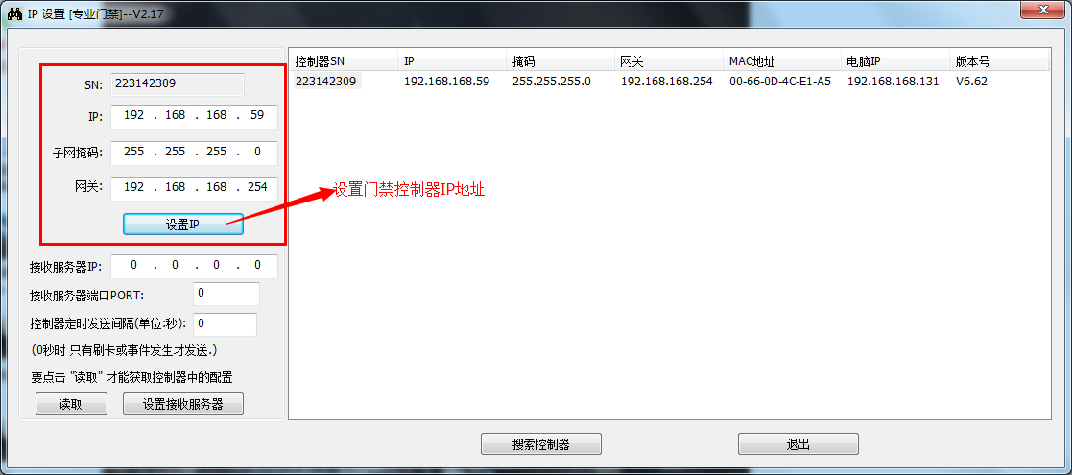

Configure the Receiving Server IP Address and Port
Run the tool，Enter the computer IP address in Receiving Server IP. Any available port may be entered in Receiving Server Port.
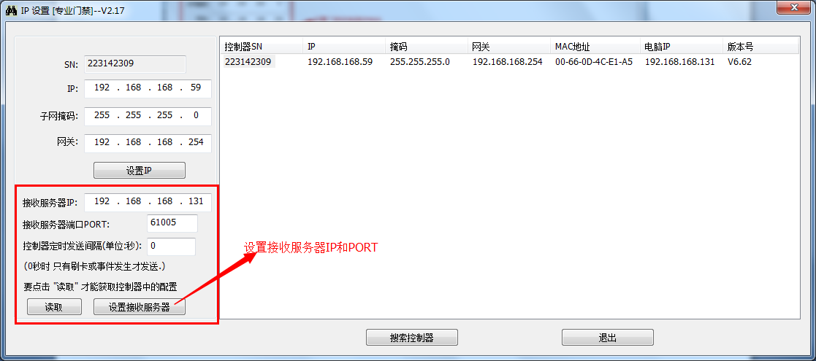
Note: If the local computer has multiple IP addresses, use the computer IP address detected by the tool.
Example: the local computer has two addresses: 169.254.132.148 and 192.168.1.138.
However, if the tool detects 169.254.132.148 as the computer IP address, set Receiving Server IP to 169.254.132.148.
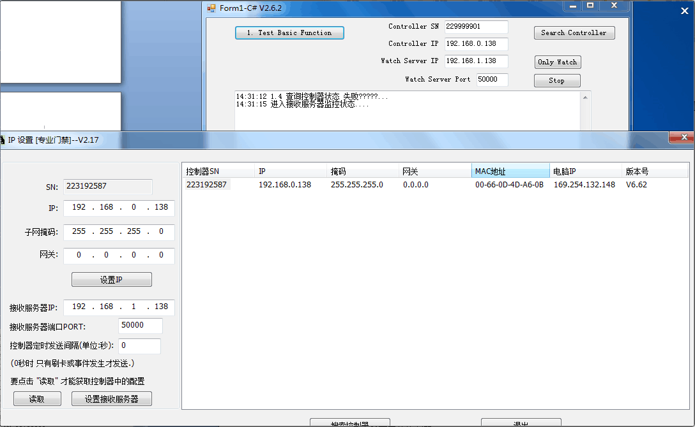

COMPLETE THE DEMO APPLICATION SETTINGS
The following example uses the C# demo application.
Controller SN corresponds to the controller serial number.
Controller IP corresponds to the controller IP address.
Watch Server IP corresponds to the receiving server IP address.
Watch Server Port corresponds to the receiving server port.
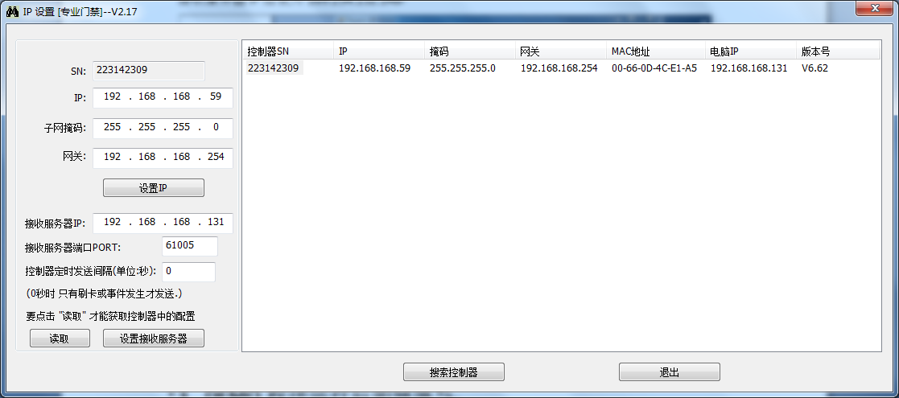
After completing the fields, the settings should match the example below.
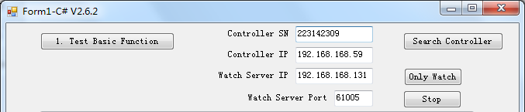

Use the Network Debugging Assistant
Run the tool，Configure it as shown below.
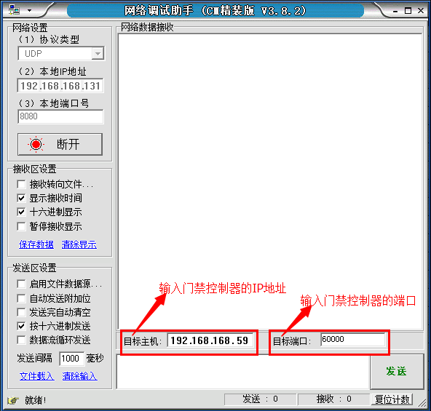
单击连接后显示断开
缺省不用修改
输入电脑IP
选UDP
Note: This checkbox must be selected; it is cleared by default. Protocol packets can be sent only after it is selected.
60000 is the default access-controller port.

Find the Local IP Address
The following steps use Windows 7 as the reference operating system.
Click the icon, and then click Open Network and Sharing Center.
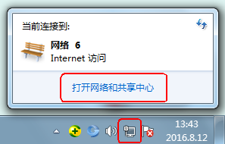
Click Local Area Connection.
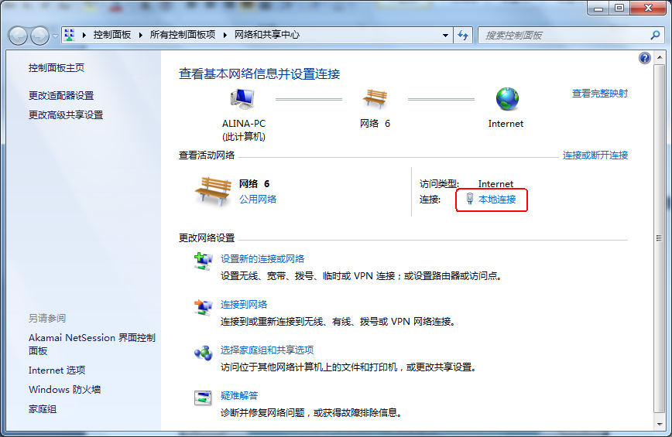
Click Properties.
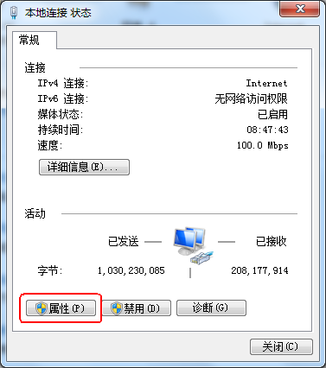
Select Internet Protocol Version 4 (TCP/IPv4).
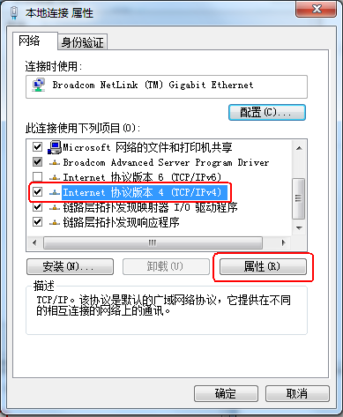
Click Properties to view the IP address.
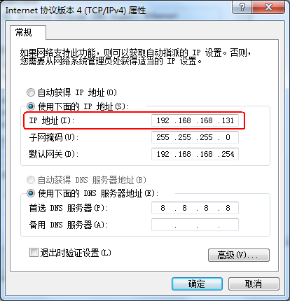

Use N3000 Commands in Command Prompt
Click the icon, and enter cmd in the search box.
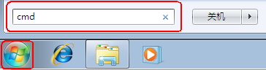
Press Enter to open Command Prompt.
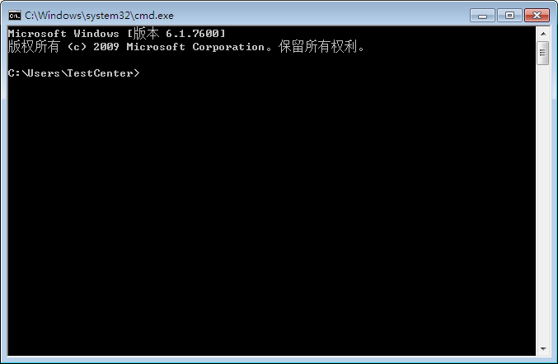
Run commands from the access-control software installation directory. The default directory is C:\AccessControl.
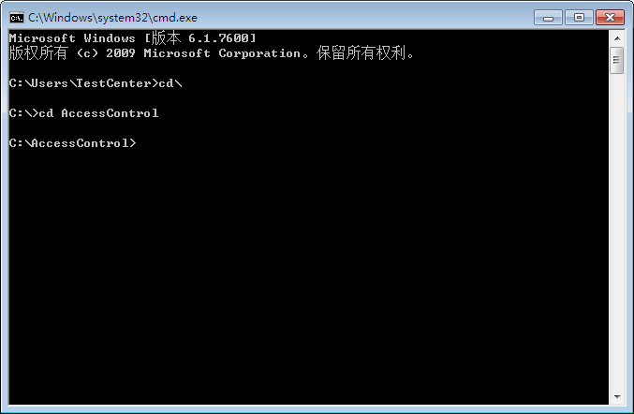
Example: N3000 -USER “abc” -PASSWORD “123” -Open “m001-1” unlocks door “m001-1”.
The operation is shown below:
