PRACTICAL: 01

**AIM :- Study of Networking Devices**

# Concept of Network and Networking

More than one devices are connected via any communication links is called network. Network can be of any type, e.g. telephone network, water supply network, computer network. The process of establishment a network is called networking. In the computer networking, there may two or more PC’s are connected with some communication media and communication devices called networking devices.

# Networking Devices at specific layer

## Physical layer : Repeater, Hub Data link layer : Switch, Bridge Network layer : Router

Application layer : Gateway

### REPEATER:

Repeater is a device which will take week signal from the one segment, amplify it,

then retransmit it into next segment. With the use of repeater, we can extend network.

* Signal attenuation or signal loss – signal degrades over distance
* Repeaters can amplify week signal and resend signal to next segment.
* Repeater can increase network range.
* Can operate at physical layer
* This rule states that no more than four repeaters can be used between hosts on a LAN.
* The Four Repeater Rule for 10-Mbps Ethernet should be used as a standard when extending LAN segments.

### HUB:

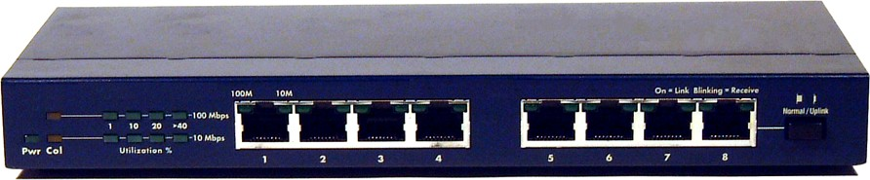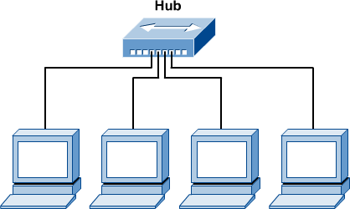

* HUB can operate at Layer 1 of OSI Model
* Hubs regenerate and retime network signals
* Hubs propagate signals through the network
* They cannot filter network traffic
* They cannot determine best path
* They are used as network concentration points
* They are really multi-port repeaters

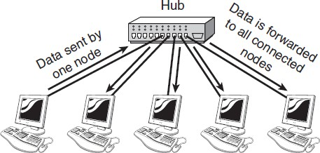

### SWITCH:

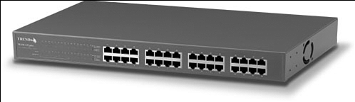

A switch corrects traffic jam problems by ensuring that data goes straight from its origin to its proper destination, with no wandering in-between. Switches remember the address of every computer on the network, and anticipate where data needs to go. Nodes connected to a switch can expect an immediate 40% to 60% increase in performance. A switch can also connect networks of different speeds together. A 100Mbps network, for example, could be connected to a slower 10Mbps network by inserting a switch between the two networks.

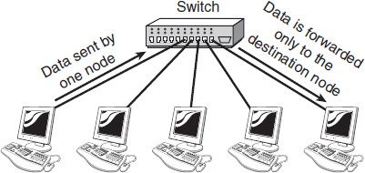

* switch can operate at Data link layer of OSI Model
* layer 3 switch can operate at network layer which is also called manageable switch
* switch has filtering circuit which can define point to point circuit for signals
* They can filter network traffic. They can determine best path than Hub.
* In this way, switches are used for migrating to faster network speeds without having to discard older legacy network hardware.
* The other advantage is that switches increase the effective bandwidth available for each host.

### BRIDGE

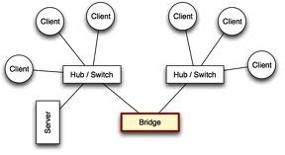

A bridge functions by blocking or forwarding data, based on the destination MAC address written into each frame of data. If the bridge believes the destination address is on a network other than that from which the data was received, it can forward the data to the other networks to which it is connected. If the address is not on the other side of the bridge, the data is blocked from passing. Bridges “learn” the MAC addresses of devices on connected networks by “listening” to network traffic and recording the network from which the traffic originates.

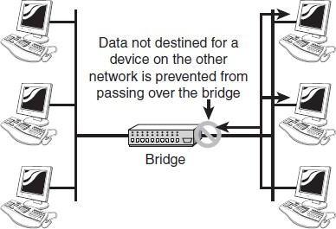

* A layer 2 device (data link)
* Connect two or more LAN segments, each of which is a separate collision domain.
* The purpose is to filter traffic on a LAN, to keep local traffic local, yet allow connectivity to other segments of the network.
* Filter traffic by looking at the MAC address
* Frame filtering

### ROUTER

Routers are more complex and more expensive than bridges. They use information within each packet to route it from one LAN to another, and communicate with each other and share information that allows them to determine the best route through a complex network of many LANs.

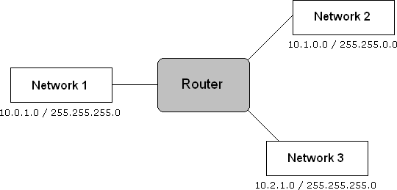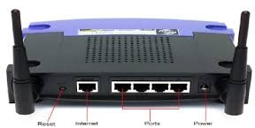

## How The Router Works?

Routers are basically designed to show a destination path to the message sent by the user. It will identify the IP address of the destination and ask for the shortest path to send the packet as early as possible. Here shortest path means, the path through which the packet reaches at the destination at the maximum speed.

For this purpose router will ask for the address to another router or network nearer to it. Suppose it finds the destination address from its nearer router or network, it won’t go for another path. Now, the packets will travel through the path, which is found in the minimum time. Now, the work of one router is over and another’s starts. Now, the second router will ask another router or network for the specific destination address and so on. The procedure will continue, until the packets reach at its proper destination address. At the destination, the server will ask for the specific site and will also collect the message for the user if it is there. Now, the same process in reverse mode will start and finally the user will get his message as early as possible.

* Define Route between source to destination.
* Connect different LAN, WAN

### GATEWAY

* Provide services to connected & authorized hosts / Nodes through Network.
* The term *gateway* is applied to any device, system, or software application that can perform the function of translating data from one format to another. The key feature of a gateway is that it converts the format of the data, not the data itself.

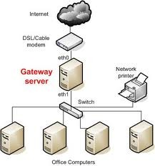

**Lab Exercise**

1. **Define topology & list name of different topologies**

### List out different kinds of addresses at layers with example

|  |  |  |  |
| --- | --- | --- | --- |
| **Form of data** | **Layer at address** | **Name of address** | **Example of address** |
|  |  |  |  |
|  |  |  |  |
|  |  |  |  |
|  |  |  |  |

1. **What is stands for RJ-45**

### Define mapping of

**ARP:**

**RARP:**

### Compare HUB & SWITCH

|  |  |  |
| --- | --- | --- |
| **No.** | **HUB** | **SWITCH** |
|  |  |  |

***Sign of Faculty.***