##### PRACTICAL: 04

##### AIM:- Introduction/installation of CISCO packet tracer, understanding of point to point network with net map, create network topology with HUB/Switch and simulate it

**About Cisco Packet tracer**

Packet Tracer is a cross-platform visual simulation tool designed by Cisco Systems that allows users to create network topologies and imitate modern computer networks. The software allows users to simulate the configuration of Cisco routers and switches using a simulated command line interface.

Packet Tracer makes use of a [drag and drop](https://en.wikipedia.org/wiki/Drag_and_drop) user interface, allowing users to add and remove simulated network devices as they see fit. The software is mainly focused towards Certified Cisco Network Associate Academy students as an educational tool for helping them learn fundamental CCNA concepts. Previously students enrolled in a CCNA Academy program could freely download and use the tool free of charge for educational use

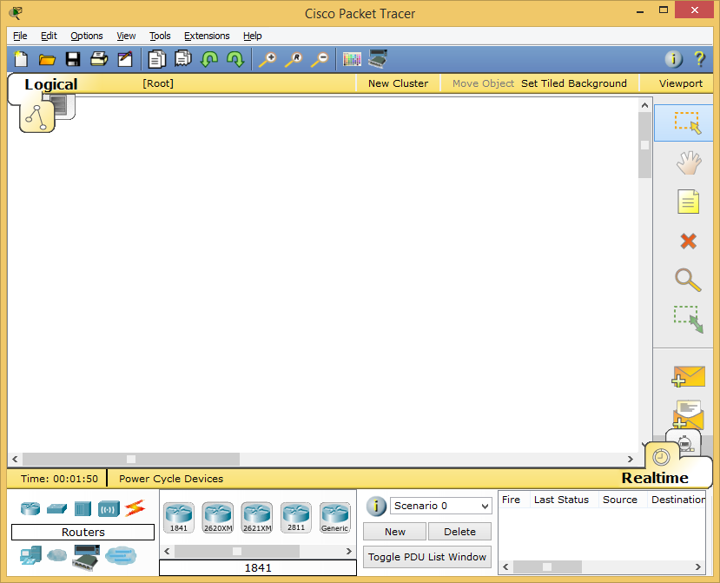

**Create a net map for point to point network using two systems and simulate it**

**Screen shot here**

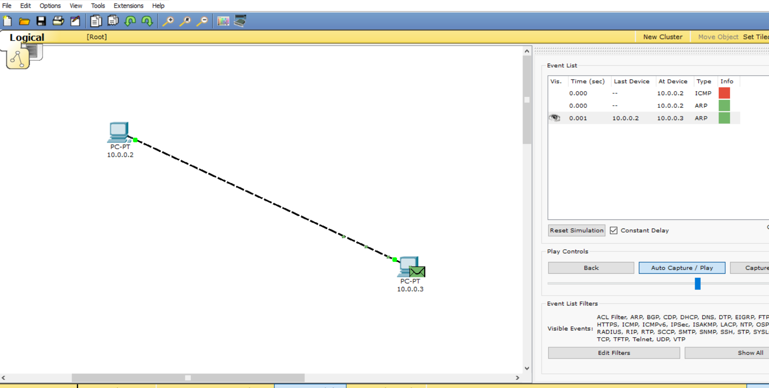

**ping 10.0.0.2**

|  |  |  |  |
| --- | --- | --- | --- |
| **PC Name** | **IP Address** | **Subnet Mask** | **Default Gateway** |
| PC 1 | 10.0.0.2 | 255.0.0.0 | 10.0.0.1 |
| PC 2 | 10.0.0.3 | 255.0.0.0 | 10.0.0.1 |

**Transfer PDU and view scenario graphically.**

**Which protocol is used to test scenario while simulation?**

**_______________________________________________________________**

**_______________________________________________________________**

**_______________________________________________________________**

**_______________________________________________________________**

**Create a topology for more than two devices using a hub and simulate it**

**Screen shot here**

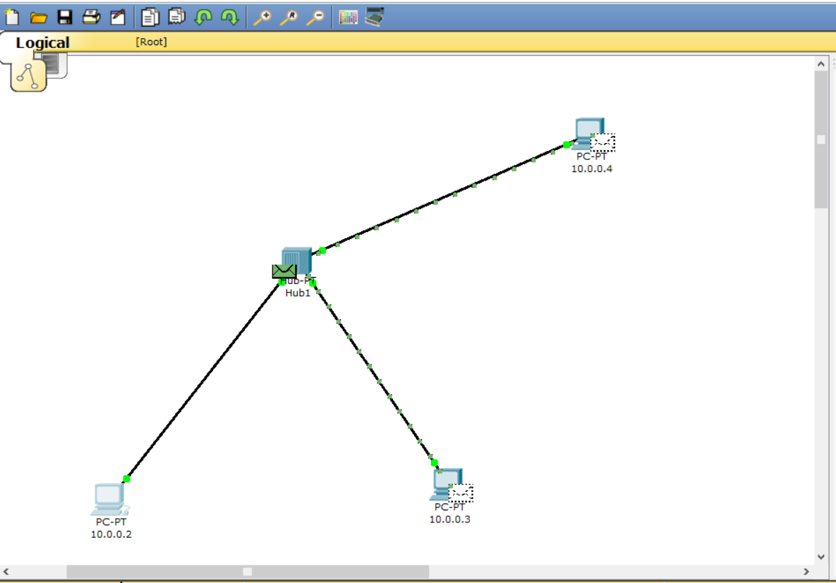 **Create a topology for more than two devices using a Switch and simulate it**

**Screen shot here**

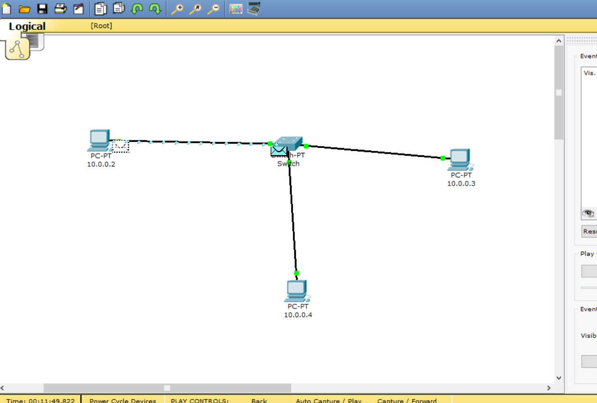

**One Network with two PC and one Switch :- (by simulator: packet tracer)**

Step 1: As shown in Figure take two PC and one generic switch from the left corner panel.

Step 2: connect them with Copper straight cable. You can select automatic option to connect them with automatically.

Step 3: Click on the PC1 then select Desktop from menu bar and select IP configuration option to configure the IP of both PC. Configure the IP as shown in the Figure 2. Configure the IP of one PC as 10.0.0.2 and other is 10.0.0.3 and set Subnet mask to 255.0.0.0

Step 4: Now both the PC are connected to the switch you can check it through the command prompt of the packet tracer or by sending packet to source to destination. To check with command prompt click on any PC then select Desktop menu from menu bar and select the command prompt option and write

**ping <IP address of other PC>**

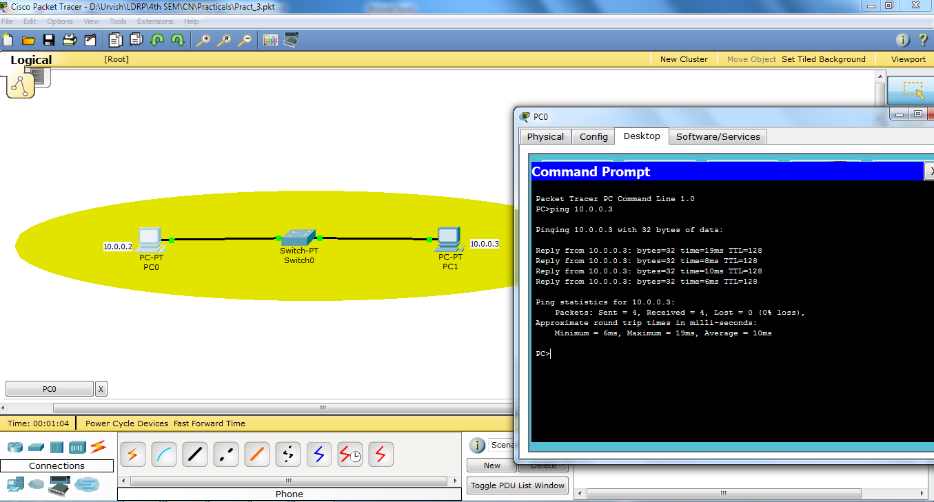

**ping 10.0.0.3**

**Conclusion:**

_______________________________________________________________________________________________________________________________________________________________________________________________________________________________________________________________________________________________________________________________________________________________________________________

***Sign of Faculty.***