##### PRACTICAL: 05

##### AIM :- Introduction of router and perform static routing

**Overview of Router**

A router is a device that forwards [data packets](http://en.wikipedia.org/wiki/Data_packet) between [computer networks](http://en.wikipedia.org/wiki/Computer_network), creating an overlay [internetwork](http://en.wikipedia.org/wiki/Internetwork). A router is connected to two or more data lines from different networks. When a data packet comes in one of the lines, the router reads the address information in the packet to determine its ultimate destination. Then, using information in its [routing table](http://en.wikipedia.org/wiki/Routing_table) or [routing policy](http://en.wikipedia.org/wiki/Routing_policy), it directs the packet to the next network on its journey. Routers perform the "traffic directing" functions on the [Internet](http://en.wikipedia.org/wiki/Internet). A data packet is typically forwarded from one router to another through the networks that constitute the internetwork until it reaches its destination node.

How The Router Works?

Routers are basically designed to show a destination path to the message sent by the user. It will identify the IP address of the destination and ask for the shortest path to send the packet as early as possible. Here shortest path means, the path through which the packet reaches at the destination at the maximum speed.

For this purpose router will ask for the address to another router or network nearer to it. Suppose it finds the destination address from its nearer router or network, it won’t go for another path. Now, the packets will travel through the path, which is found in the minimum time. Now, the work of one router is over and another’s starts. Now, the second router will ask another router or network for the specific destination address and so on. The procedure will continue, until the packets reach at its proper destination address. At the destination, the server will ask for the specific site and will also collect the message for the user if it is there. Now, the same process in reverse mode will start and finally the user will get his message as early as possible.

1. **One Network with two PC and one Switch :- (by simulator: packet tracer)**

Step 1: As shown in Figure 1 take two PC and one generic switch from the left corner panel.

Step 2: connect them with Copper straight cable. You can select automatic option to connect them with automatically.

Step 3: Click on the PC1 then select Desktop from menu bar and select IP configuration option to configure the IP of both PC. Configure the IP as shown in the Figure 2. Configure the IP of one PC as 10.0.0.2 and other is 10.0.0.3 and set Subnet mask to 255.0.0.0

Step 4: Now both the PC are connected to the switch you can check it through the command prompt of the packet tracer or by sending packet to source to destination. To check with command prompt click on any PC then select Desktop menu from menu bar and select the command prompt option and write

**ping <IP address of other PC>**

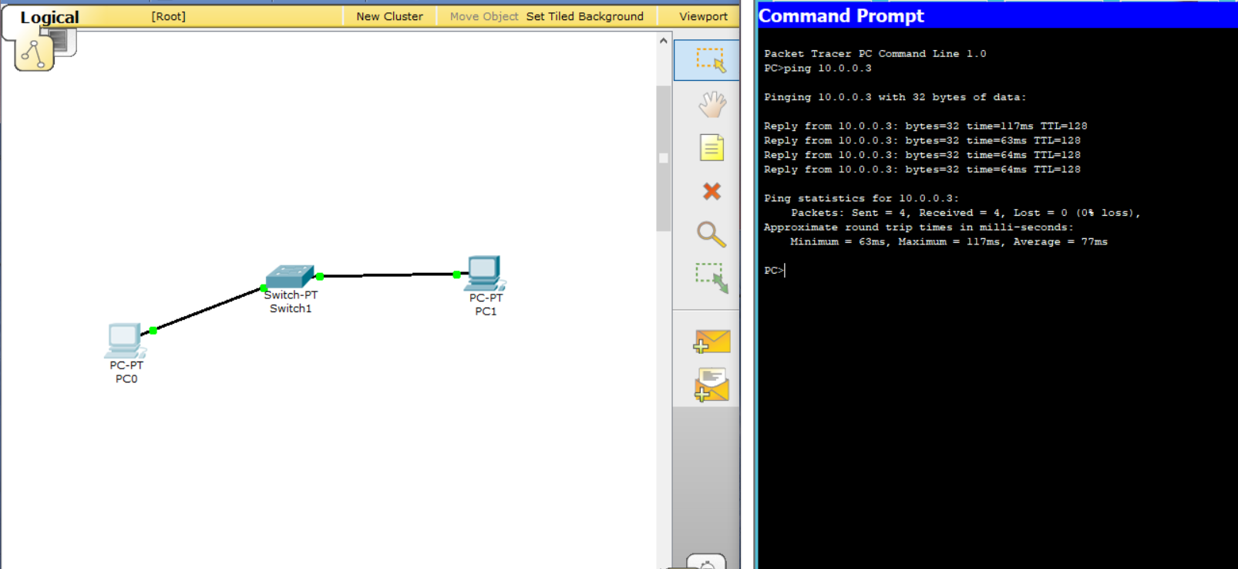

**ping 10.0.0.3**

1. **Two pc’s with router (by simulator: packet tracer)**

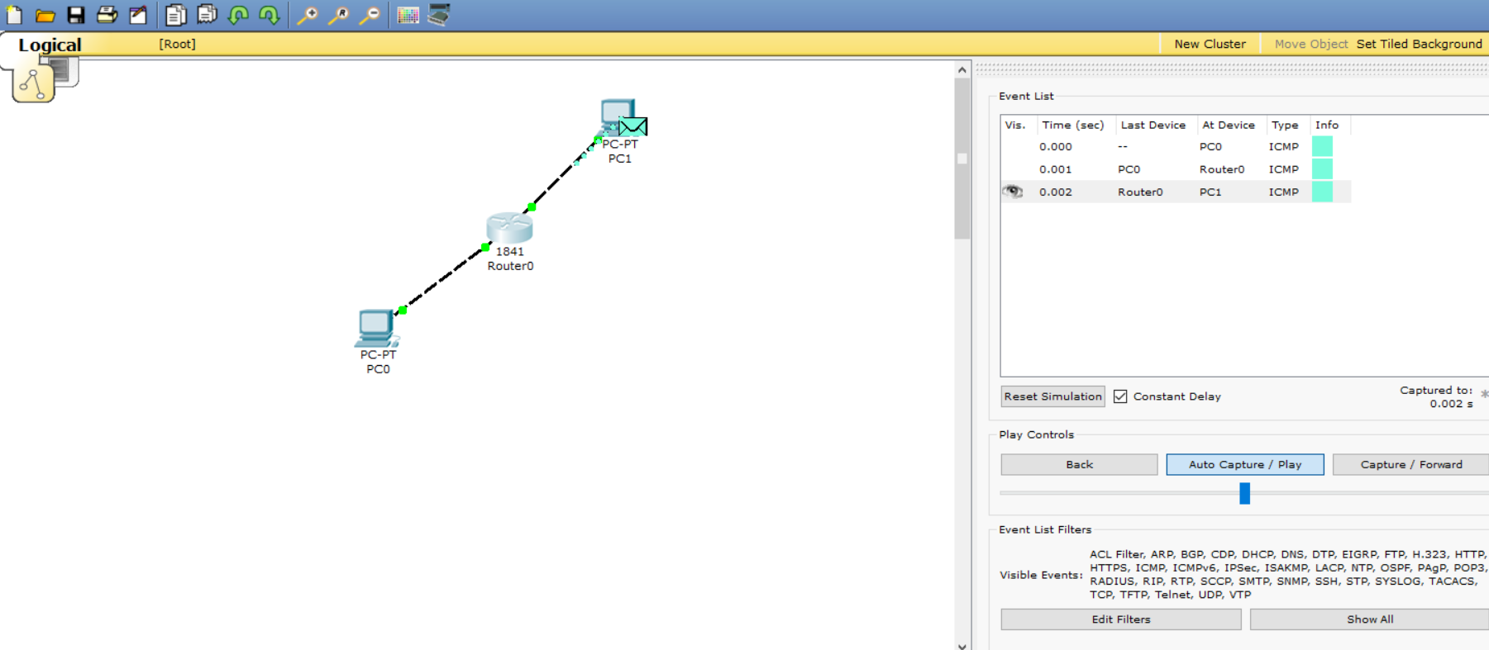

Step 1: As shown in Figure 1 put two PC and one generic router.

PC 1 for network 1 and PC 0 network 2.

Step 2: connect both PC’s to router using cable.

Step 3: Set the following IP address, subnet mask and default gateway for each PC as shown in figure.

|  |  |  |  |
| --- | --- | --- | --- |
| **PC Name** | **IP Address** | **Subnet Mask** | **Default Gateway** |
| PC 0 | 10.0.0.2 | 255.0.0.0 | 10.0.0.1 |
| PC 1 | 11.0.0.2 | 255.0.0.0 | 11.0.0.1 |

1. **To connect two different networks using two Routers: (static routing)**

**Perform by simulator (packet tracer)**

**Figure:1**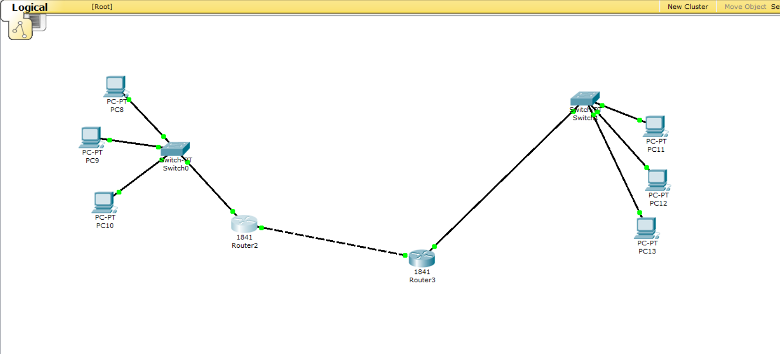

Step 1: As shown in Figure 1 put six PC, two switches and two generic routers. PC 8, PC 9 and PC 10 for network 1 and PC 11, PC 12 and PC 13 for network 2.

Step 2: connect them all (PC and Switch) with Copper straight cable.

Step 3: Connect both switches with Router using fiber optic cable And Connect both Routers using copper cross over cables.

Step 4: Set the following IP address, subnet mask and default gateway for each PC as shown in Figure 2.

|  |  |  |  |
| --- | --- | --- | --- |
| **PC Name** | **IP Address** | **Subnet Mask** | **Default Gateway** |
| PC 8 | 10.0.0.2 | 255.0.0.0 | 10.0.0.1 |
| PC 9 | 10.0.0.3 | 255.0.0.0 | 10.0.0.1 |
| PC 10 | 10.0.0.4 | 255.0.0.0 | 10.0.0.1 |
| PC 11 | 11.0.0.2 | 255.0.0.0 | 11.0.0.1 |
| PC 12 | 11.0.0.3 | 255.0.0.0 | 11.0.0.1 |
| PC 13 | 11.0.0.4 | 255.0.0.0 | 11.0.0.1 |

**Fugure:2**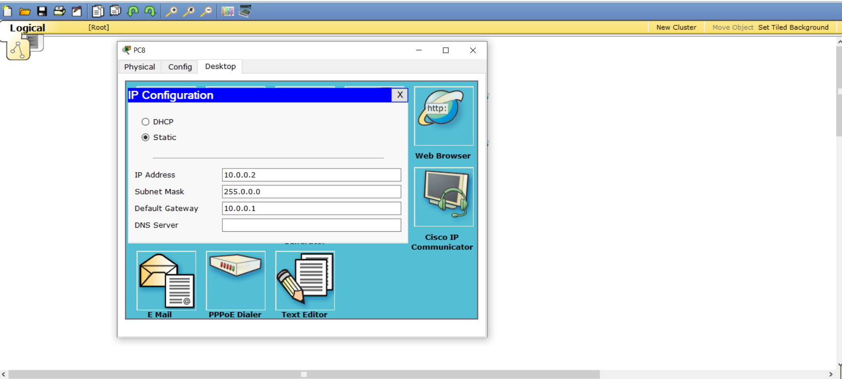

Step 5: Set the Router 1 fast Ethernet IP address in its respective interface IP configuration as shown in figure 3.

|  |  |  |
| --- | --- | --- |
| **Interface** | **IP Address** | **Subnet Mask** |
| Fast Ethernet 0/0 | 10.0.0.1 | 255.0.0.0 |
| Fast Ethernet 0/1 | 14.0.0.2 | 255.0.0.0 |

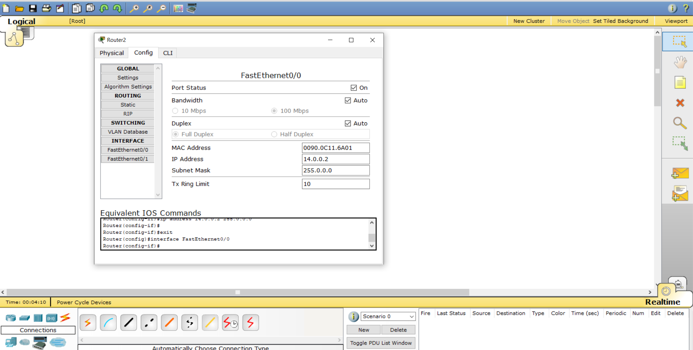

Step 6: Set the Router 2 fast Ethernet IP address in its respective interface IP configuration as shown in figure 3.

|  |  |  |
| --- | --- | --- |
| **Interface** | **IP Address** | **Subnet Mask** |
| Fast Ethernet 0/0 | 11.0.0.1 | 255.0.0.0 |
| Fast Ethernet 0/1 | 14.0.0.3 | 255.0.0.0 |

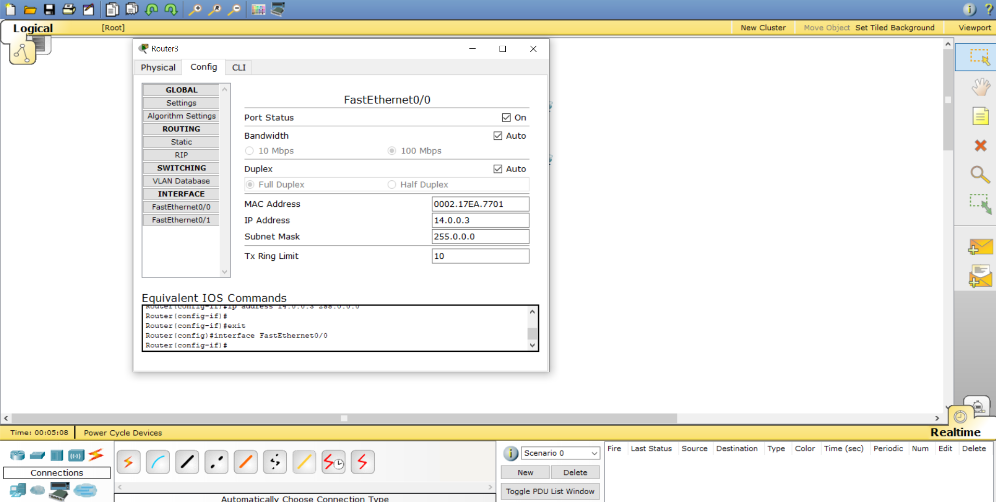

Step 7: Set the Routing Path. Select static in routing. Then configure the path for the Router 1 as Shown in the figure below.

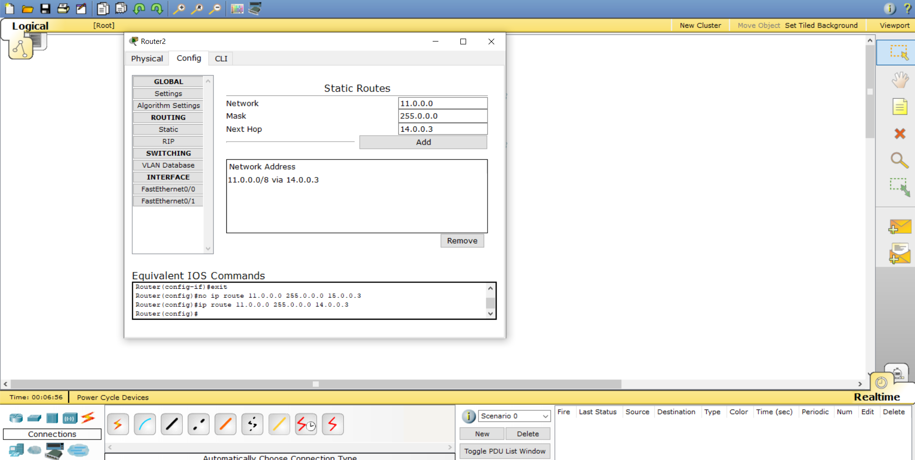

Step 8: Set the Routing Path. Select static in routing. Then configure the path for the Router 2 as Shown in the figure below.

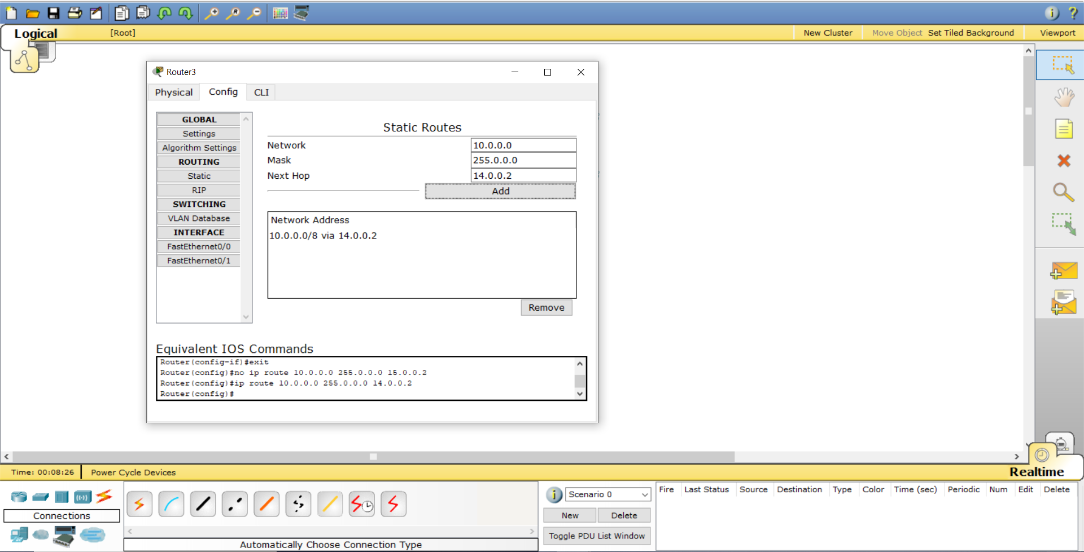

Step 6: The way to check the connection is to send the packet From One PC of One Network to Another to the PC of other network. Select Add Simple PDU option from right panel of the packet tracer and set the source and destination of the packet. The following figure gives the idea how the packet sends from source to destination.

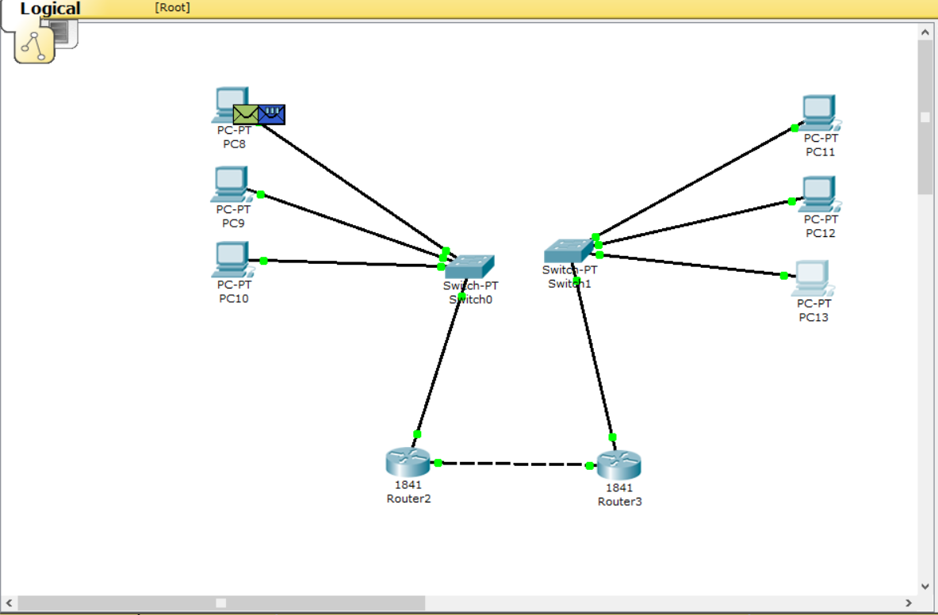

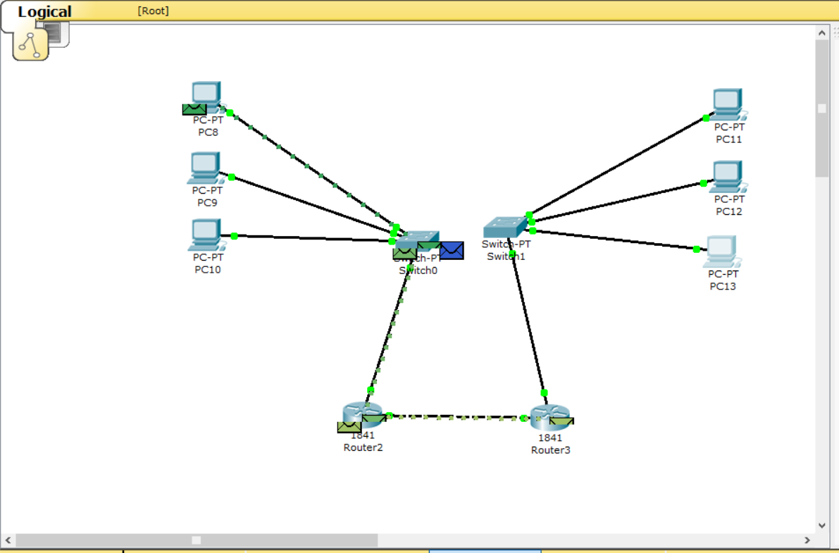

**Conclusion:**

**________________________________________________________________**

**________________________________________________________________**

**________________________________________________________________**

**________________________________________________________________**

**________________________________________________________________**

***Sign of Faculty.***