**Barebox Boot-Loader**

- Download the barebox latest version.

[veda@linux](mailto:veda@linux) # **wget** [**http://barebox.org/download/barebox-2014.03.0.tar.bz2**](http://barebox.org/download/barebox-2014.03.0.tar.bz2)

- Extract the barebox tarball

[veda@linux](mailto:veda@linux) # **tar xvf barebox-2014.03.0.tar.bz2**

- Change directory to barebox source code

[veda@linux](mailto:veda@linux) # **cd barebox-2014.03.0**



- Barebox source tree is similar to kernel source tree.

- And they provide default configurations for some boards.

- Give make help or list below path to see available default configurations for defferent boards.

[veda@linux](mailto:veda@linux) # **ls arch/arm/configs/**

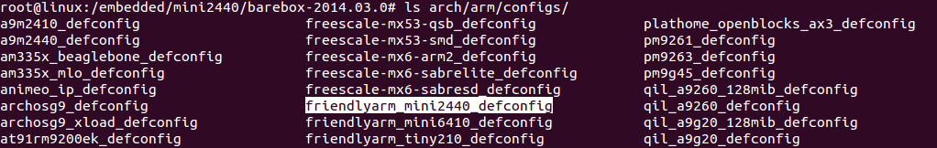

[veda@linux](mailto:veda@linux) # **make ARCH=arm friendlyarm_mini2440_defconfig**

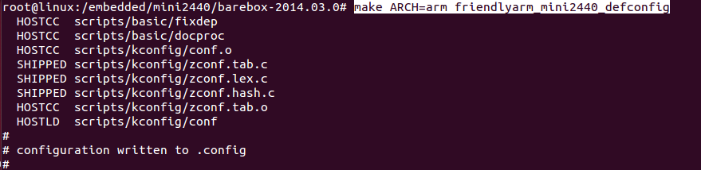

- Barebox box supports graphichical representatation of menu based program.

- If you want to change anything of default configuration give below command.

[veda@linux](mailto:veda@linux) # **make ARCH=arm menuconfig**

- After creating configuration file start the building pocess

[veda@linux](mailto:veda@linux) # **make ARCH=arm CROSS_COMPILE=arm-linux-**

- After compilation we get barebox.bin file in the root directory of barebox sourcecode.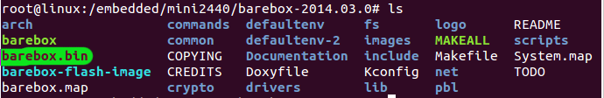

- After flashing it to Nand flash restart the target.

**Barebox commands:**

- Give help in the barebox command prompt to get supported commands.

**mini2440:/ help**

- it also supports some basic linux commands and shell commands

**Ex:** cat, ls, cp, cd, echo, mkdir, pwd, rm, rmdir, sleep, sh, clear, export, . . . etc

- Apart of those some needed commands are

**addpart - adds a partition table to a device**

**delpart - delete partition(s)**

**bootm - boot an application image**

**devinfo - Show information about devices and drivers**

**erase - erase FLASH memory**

**go - start application at address or file**

**ping - ping <destination>**

**printenv - Print value of one or all environment variables**

**saveenv - save environment to persistent storage**

**edit - Usage: (s)edit <file>**

**sedit - alias for edit**

**tftp - (up-)Load file using tftp protocol**

- bearbox initially run **/env/bin/init** script

- By default it does not have ram memory partitions

- For that we have to change the script

-Modify the script as showing below.

**mini2440:/ edit /env/bin/init**

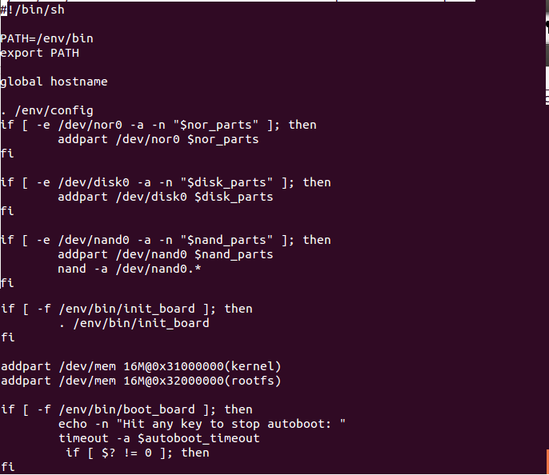

- This /**env/bin/init** file runs the **/env/config** scripts initialize environment variables at start time.

- Modify the script as showing below to introduce new environment variables.

**mini2440:/ edit /env/config**

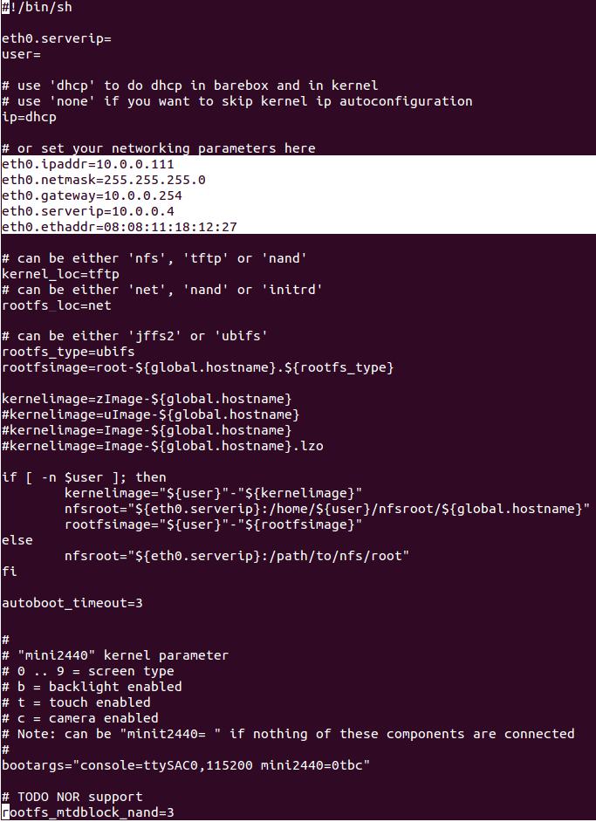

- After changes to script files, give following command to save that files perminantly into the nand.

**Mini2440:/ saveenv**

- To load those modifications give following command.

**Mini2440:/ . /env/bin/init**

**Setting bootargs environment variable for different types of porting:**

**initramfs:**

**Mini2440:/ bootargs=”console=ttySAC0,115200”**

**initrd:**

**Mini2440:/ bootargs=”console=ttySAC0,115200 root=/dev/ram0 initrd=0x32000000,4M"**

**nfs-portting:**

**Mini2440:/ bootargs="console=ttySAC0,115200 ip=10.0.0.111:10.0.0.4::255.255.255.0 root=/dev/nfs nfsroot=10.0.0.4:/path/to/rootfs"**

**nand-flash porting:**

**jffs2:**

**Mini2440:/ bootargs=”console=ttySAC0,115200 root=/dev/mtdblock3 rootfstype=jffs2”**

**yaffs2:**

**Mini2440:/ bootargs=”console=ttySAC0,115200 root=/dev/mtdblock3 rootfstype=yaffs2”**

**ubifs:**

**Mini2440:/ bootargs=”console=ttySAC0,115200 root=ubi0:rootfs1 ubi.mtd=3 rootfstype=ubifs”**

- **For getting kernel from host to target execute following command**

**- Downloading kernel from host to ram kernel memory:**

**Mini2440:/ tftp uImage /dev/mem.kernel**

**- Downloading rootfs.img from host to ram memory:**

**Mini2440:/ tftp rootfs.img /dev/mem.rootfs**

**- Downloading kernel from host to nand kernel partition:**

**Mini2440:/ tftp uImage /dev/nand0.kernel**

- After getting the kernel to specified device we instruct to bootload to **strart booting**.

- For starting boot process we give bootm followed kernel copied device.

**For ram kernel partition:**

**Mini2440:/ bootm /dev/mem.kernel**

**For nand device kernel partition:**

**Mini2440:/ bootm /dev/nand0.kernel**