Nov 9, 2026

Meeting Nov 9, 2026 at 17:33 UTC
Meeting records Transcript

Summary
Project IMAR simulations and hardware evaluations progressed via component analysis and presentation planning.
Antenna Simulation and Tool
Patch antenna simulations successfully reached 2.4 GHz through length adjustments. Python patch calculator tools computed necessary microstrip parameters.
Hardware and Component Sourcing
Hardware evaluations identified switches and connectors with synchronization challenges. Budget allocations required revisions to align with funding targets.
Presentation and Submission Review
Project submissions required 5-page PDF documentation by December 31st. Presentation feedback praised logical structural flows.

Decisions
Aligned
- Simulating the antenna concept The team will focus on simulating the antenna concept for the upcoming week.

Next steps
- [Rooney Ndereba] Design Hardware: Simulate the ESP32, Butler matrix, and phase shifter array components to ensure the system meets functional requirements.
- [Michael Kimani] Update Calculator: Incorporate substrate properties and fabrication tolerances into the calculation tool. This will improve accuracy compared to current simulations.
- [Michael Kimani] Build Interface: Develop the software display for the system monitoring. Create an effective interface for managing the antenna array and data.
- [Winnie Wanjiku, Charles Njuguna] Collect Hardware Data: Source the substrate, printed circuit board stackup, and fabrication tolerances from online suppliers. Gather this information to finalize the design specifications.
- [Winnie Wanjiku] Research Amplifiers: Investigate specific models of low noise amplifiers to ensure signal quality. Identify the most suitable options for the receiver architecture.
- [Winnie Wanjiku] Verify Timing: Analyze the timing accuracy requirements needed for simultaneous measurements. Determine if the current receiver clock synchronization is sufficient for sensing tasks.
- [The group] Ensure Receiver Compliance: Verify that the hardware design prevents any unintended transmission capabilities. Perform a comprehensive check of all components and connection configurations.
- [The group] Format Project Report: Edit the final portable document format document to remove formatting artifacts from artificial intelligence generation. Normalize numerical styles to ensure a professional presentation.
- [Winnie Wanjiku] Refine Project Budget: Refine the project budget to align closer to the 1,500 dollar target and justify component choices.
- [Rooney Ndereba] Send Meeting Minutes: Distribute meeting minutes and outline the specific next steps for the team.
- [Rooney Ndereba] Upload Files to GitHub: Upload the project files discussed during the meeting to the GitHub repository.
- [Rooney Ndereba] Assign Weekly Duties: Formally distribute simulation and research responsibilities among team members for the upcoming week.
- [Charles Njuguna] Assist with Simulation: Support the team with the simulation of the phase shifter array, butler matrix, or polarized array.
- [Michael Kimani] Update Dashboard: Update calculator inputs and compare the resulting figures against current simulation data.

Details
Project IMAR and Antenna Simulation Progress: Rooney Ndereba introduced Project IMAR as an integrated sensing and communication system architecture utilizing commercial Wi-Fi routers, a reconfigurable polarized array with four dual-polarized patch antennas, a Butler matrix for spatial sector division, and an ESP32 microcontroller (00:00:47). Rooney Ndereba reported using Python code and parameters provided by Michael Kimani to simulate a single patch antenna (00:11:34). Initial simulations yielded an operating frequency of 2.316 gigahertz instead of the required 2.4 gigahertz, but after adjusting the patch length from 29.4 to 27.5 millimeters, Rooney Ndereba successfully achieved the target frequency of 2.4 gigahertz and S-parameters of 7.9. Next steps involve simulating the ESP32, Butler matrix, and phase shifter array (00:14:39).
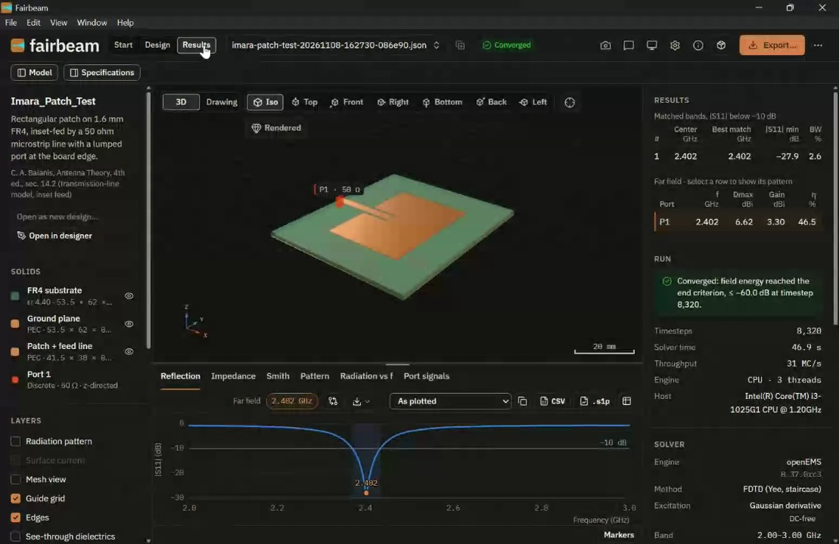

Development of the Python Patch Calculator Tool: Michael Kimani detailed the creation of a reusable Python tool designed to replace manual calculations by computing rectangular microstrip patch parameters and transmission line values based on user-inputted operating frequency and substrate properties (00:16:08). Michael Kimani explained that the tool incorporates formulas for patch width, effective permittivity (accounting for air and fringing effects on an FR4 substrate), fringing extensions, physical and electrical lengths, and insert notch width (00:20:25). The tool includes input validation and geometry checks to flag invalid parameters (00:18:59) (00:27:06). For future work, Michael Kimani requested that Rooney Ndereba provide simulated patch edge resistance and antenna geometry, and asked Winnie Wanjiku and Charles Njuguna to supply the substrate and printed circuit board stackup along with supplier fabrication tolerances (00:28:47).
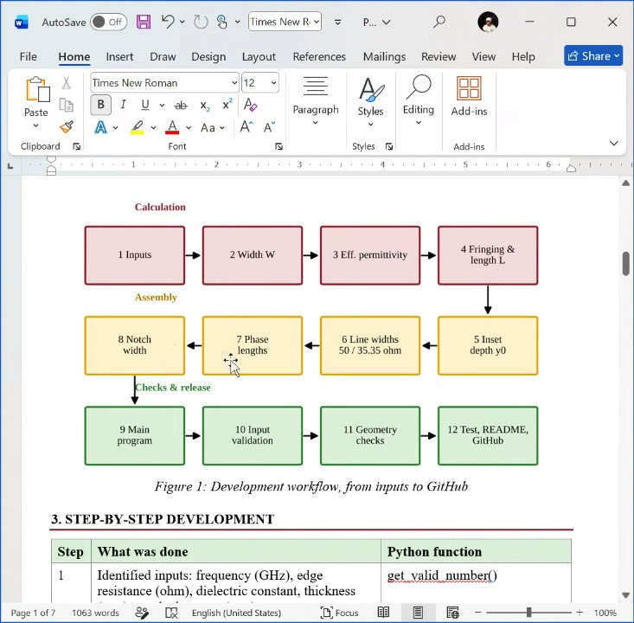

Hardware Component Selection and Cost Analysis: Winnie Wanjiku presented an evaluation of hardware components for Project IMAR, recommending P-semi RF switches over Skyworks, an affordable and widely accessible ESP32 microcontroller, 50-ohm SMA connectors, a passive Butler matrix over a complex phase shifter array, and low noise amplifiers (00:31:00) (00:43:22). Winnie Wanjiku identified potential synchronization challenges when connecting multiple receivers to a single USB hub due to internal clock drift, emphasizing the need to verify timing accuracy (00:41:27). Sourcing options were identified in Nairobi and Ghana, with approximate costs calculated at 608 shillings for four array switches, 1,500 to 3,000 shillings for four ESP32 units, and around 45,000 shillings for low noise amplifiers (00:43:22). Winnie Wanjiku also highlighted a critical project constraint requiring strict receiver-only operation, noting that firmware and hardware connections must be thoroughly inspected to prevent accidental signal transmission (00:45:26).
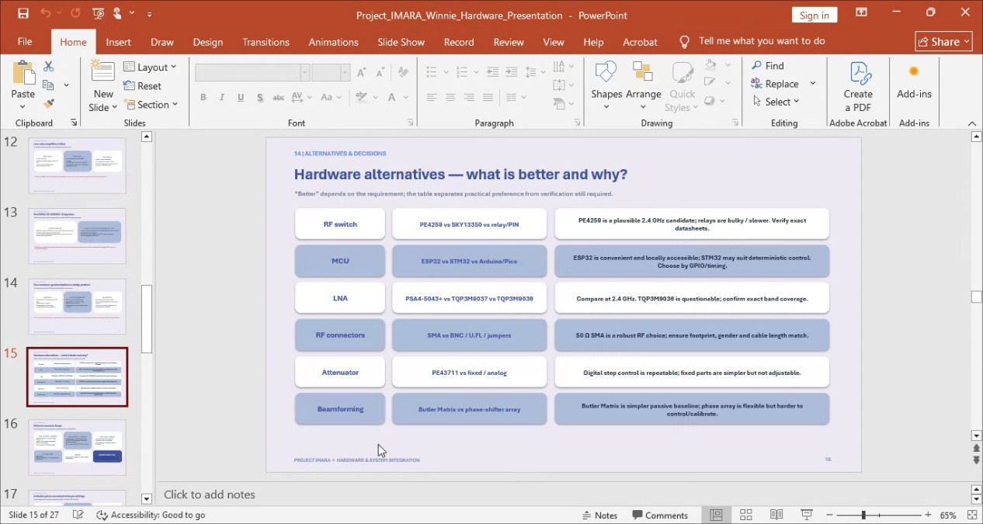

Team Integration and Responsibilities: Charles Njuguna reported on their integration into the team after joining the previous week, stating that their primary tasks involved catching up on project goals and assisting Winnie Wanjiku with hardware presentations. Charles Njuguna committed to presenting independent work in the subsequent meeting upon receiving specific assignments (00:49:53).

Project Submission Guidelines and Presentation Feedback: Dr. Elyas Smaida outlined the project submission requirements, explaining that a five-page PDF documenting the integrated sensing and communication system must be submitted by December 31st. Dr. Elyas Smaida noted that if selected among the top six teams, the project will be presented live in Tokyo (00:51:42). Evaluating the team's presentation structure, Dr. Elyas Smaida commended the logical flow from Rooney Ndereba's high-level simulation overview to Michael Kimani's technical parameter breakdown and Winnie Wanjiku's financial and hardware analysis (00:53:09). Additionally, Dr. Elyas Smaida advised the team to remove obvious artificial intelligence formatting artifacts, such as specific comma groupings in large numbers, from their written documentation to prevent reviewers from assuming the entire project was artificially generated (00:55:25).

Presentation Feedback and Project Scope: Elyas Smaida provided feedback on the team's presentation, commending Michael Kimani, Rooney Ndereba, and Winnie Wanjiku for their work. Elyas advised the team to present the full project simulation first, followed by the origins of specific parameters, and finally the costs. They also encouraged the team to prepare for future work in Japan by working efficiently (00:59:38).

Budget Discrepancies and Alignment: Rooney Ndereba inquired about the total project budget, to which Winnie Wanjiku initially stated around 5,000 (01:01:53). Rooney and Elyas Smaida noted this estimate was far below the expected $1,500 project funding target, with Rooney referencing an AI research estimate of $1,100. Elyas requested that Winnie revise the budget to align closer to the $1,500 allocation by factoring in components, taxes, and variations with the assistance of Charles Njuguna, while prioritizing logical choices over merely matching the budget (01:09:10) (01:12:05).

Project Schedule and Timeline Review: Rooney Ndereba reviewed the project plan for the week of November 9th, noting that the team is currently ahead of schedule because simulation work has already begun (01:03:54). Rooney outlined that the next two weeks will focus heavily on simulating antenna concepts, which involves designing and simulating four dualized antennas, a butler matrix, a phase shifter array, and a 32-element array (01:05:11).

Simulation Responsibilities and Team Integration: Rooney Ndereba detailed simulation tasks, including selecting antenna geometry, confirming butler matrix topology, and verifying PCB stack-up and fabrication tolerances with the supplier (01:06:29). Rooney proposed that newly joined Charles Njuguna could assist with simulating the phase shifter array, butler matrix, or polarized array. Rooney also welcomed Charles to the team and praised Michael Kimani and Winnie Wanjiku for their ongoing work (01:07:48).

Presentation Slide Assignment Attributions: Elyas Smaida suggested that Michael Kimani avoid using specific individual names like Rooney or Winnie for task assignments on presentation slides, recommending role- or task-based descriptions instead. Michael Kimani clarified that the listed assignments reflected the specific data values they personally needed from each participant to build the dashboard rather than formal task delegations (01:10:31).

Document Sharing and GitHub Repository: Michael Kimani requested that Rooney Ndereba upload project files to the GitHub repository instead of sharing them solely via WhatsApp. Rooney acknowledged the request and agreed to attempt uploading the files to GitHub (01:13:48).

Simulation Walkthrough and Demonstration: Michael Kimani expressed a lack of understanding regarding how the simulations were executed and requested a live walkthrough. In response, Rooney Ndereba shared their screen and provided a detailed demonstration of the tool used for simulations, explaining how to install the software, generate basic designs, and input parameters such as patch length, patch width, insert distance, gap, feed width, substrate permittivity, and frequency bounds (01:15:08). Rooney reviewed the iterative test results, noting metrics such as a frequency of 2.4 GHz, an S-loss of -27.9, bandwidth, and efficiency (01:19:50). Following the demonstration, Michael confirmed they fully understood the process (01:21:19).
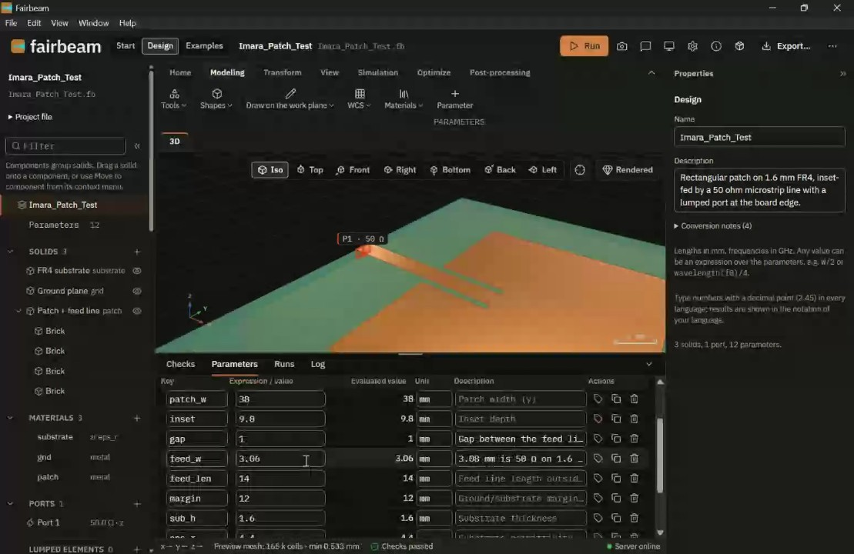

Custom Design versus Generic Simulation Approaches: Charles Njuguna, Michael Kimani, and Rooney Ndereba discussed simulation methodologies, debating whether to rely on generic tutorials from sources like YouTube or to develop custom methods to minimize signal losses for their specific design (01:22:38).

You should review Gemini's notes to make sure they're accurate. Get tips and learn how Gemini takes notes
How is the quality of these specific notes? Take a short survey to let us know your feedback, including how helpful the notes were for your needs.

