Installation instructions:
- Application platform for Windows 7 64 - bit systems.
- You need to install MCRIstaller first for running environment if the PC does not installe Matlab.
- Runing application need some times which depend on the configuration of the PC.
4. You can find MCRIstaller.exe in this path: MATLAB\R2013a\toolbox\compiler\deploy\win32
5. Installation Steps :

- double click MCRIstaller.exe .Following shown :
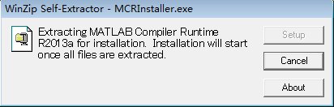

- Wait a moment ,Following shown :
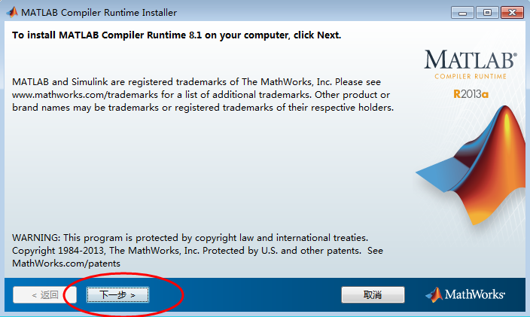

- Click “next step”,Following shown :
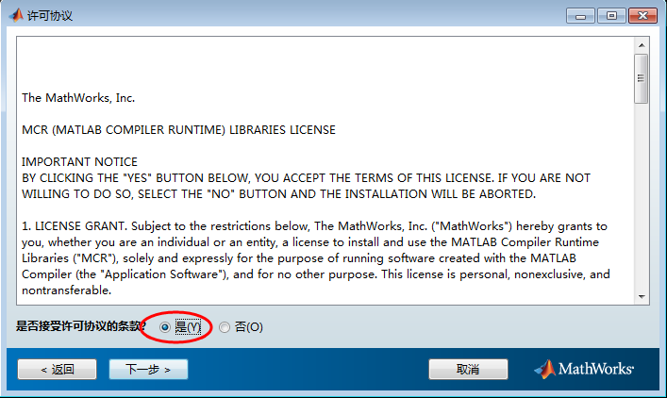

- Click “next step”,Following shown :
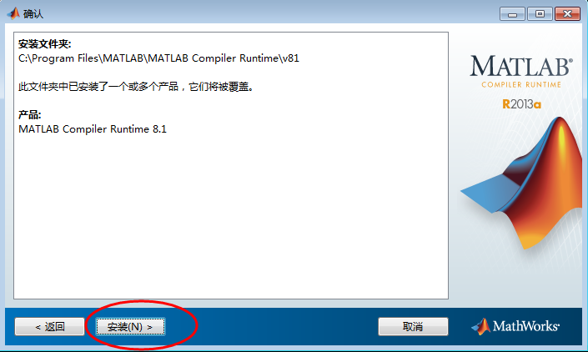

- Click “install”,Following shown :
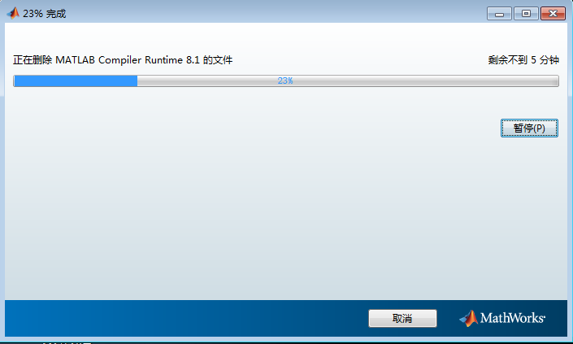

- This step need a couple minutes.
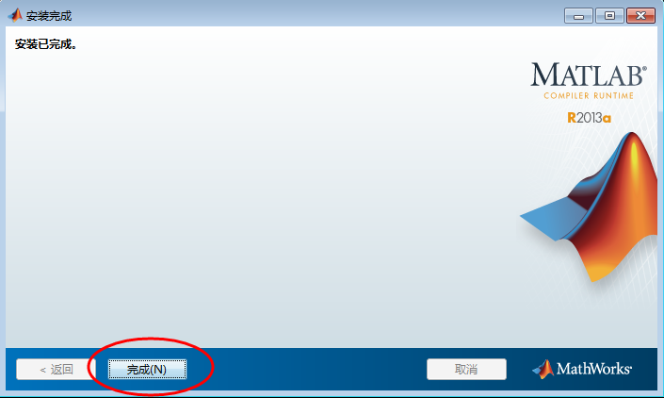

Installation Complete

