Use Case Diagram
These figures follow the same UML-style illustration pattern as the inventory reference: actors on the left, a large system boundary oval, teal primary use case ovals, and dashed <<include>> / <<extend>> dependencies to supporting use cases on the right. Labels are expanded to mirror the paper’s use case list and events table (group A–G), split across multiple diagrams so the layout stays readable.

Figure 1 — Customer: Access & Session
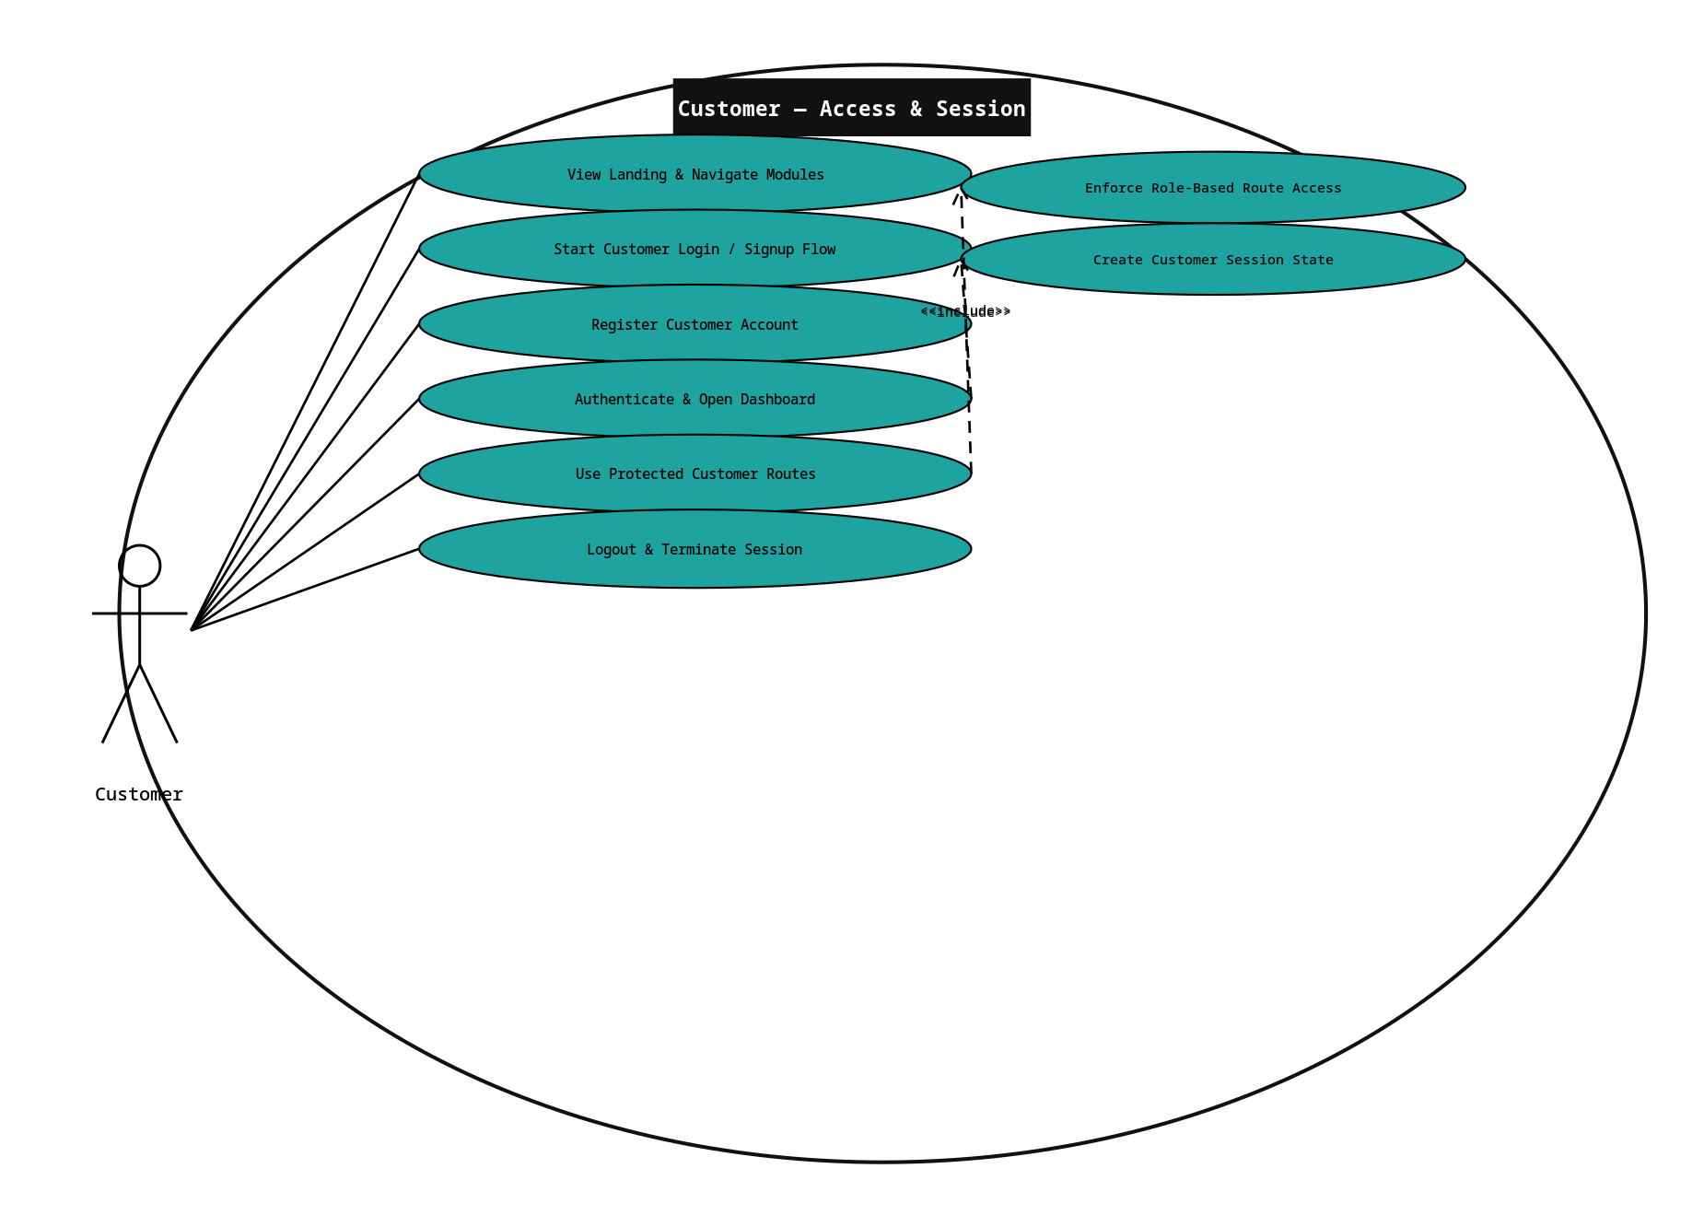

Figure 2 — Customer: Dashboard & Order Visibility
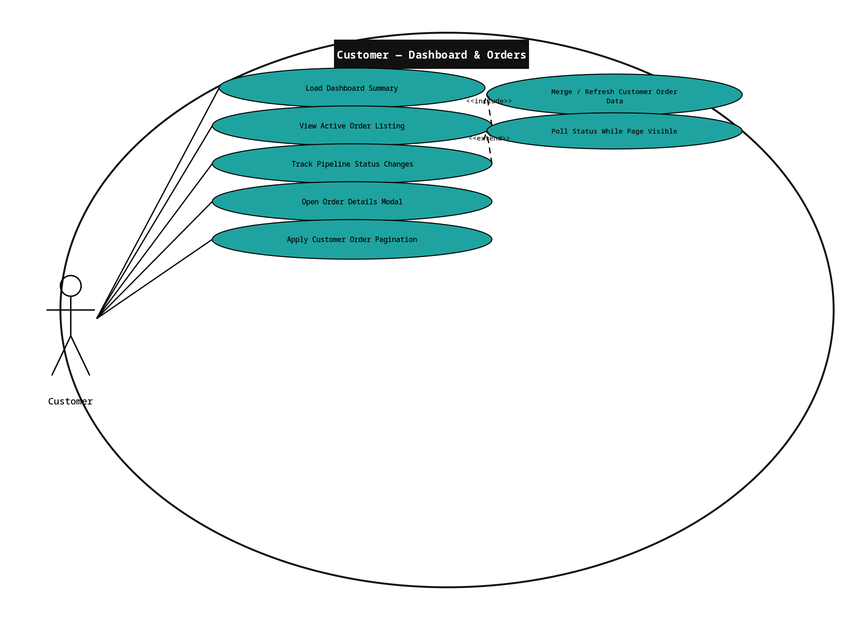

Figure 3 — Customer: POS Configuration (Pricing & Fulfillment)
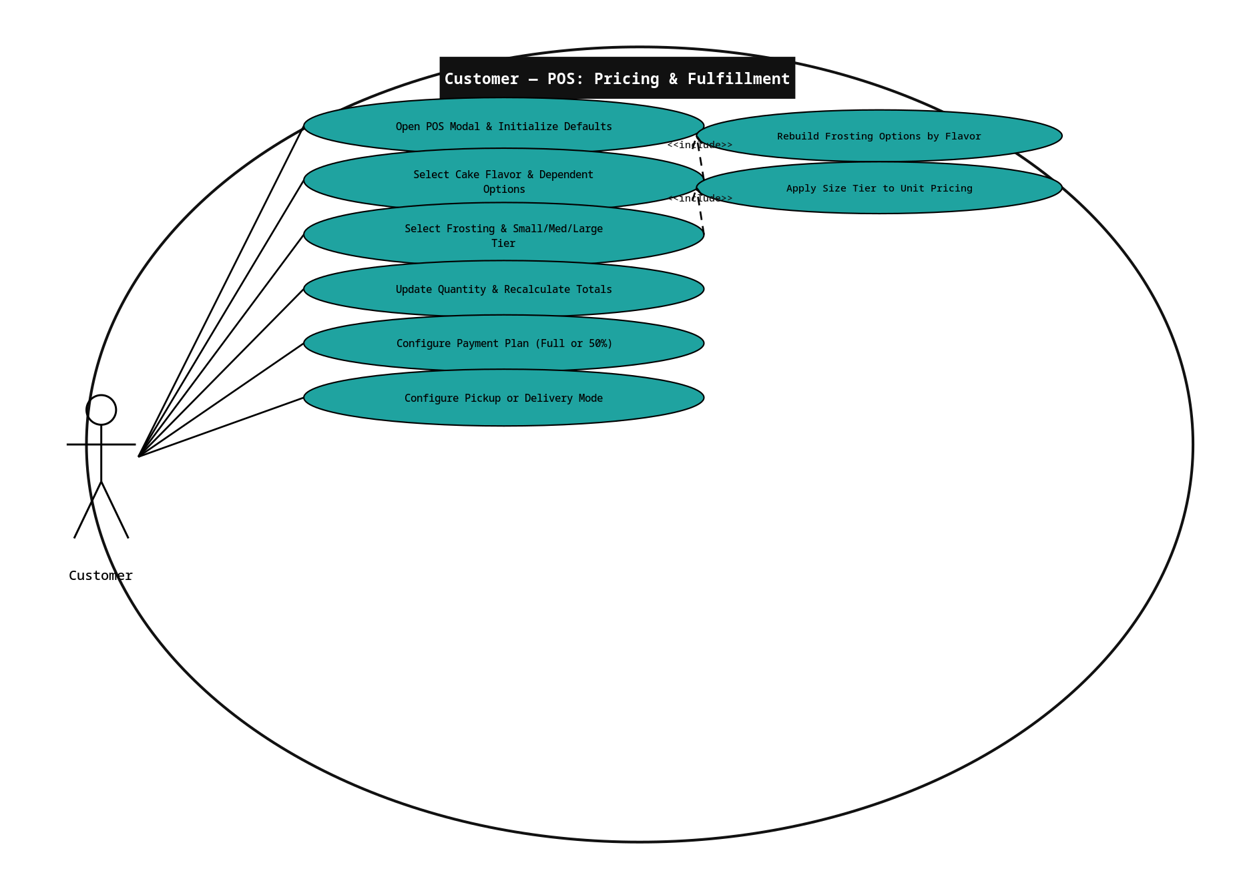

Figure 4 — Customer: POS Design, Date & References
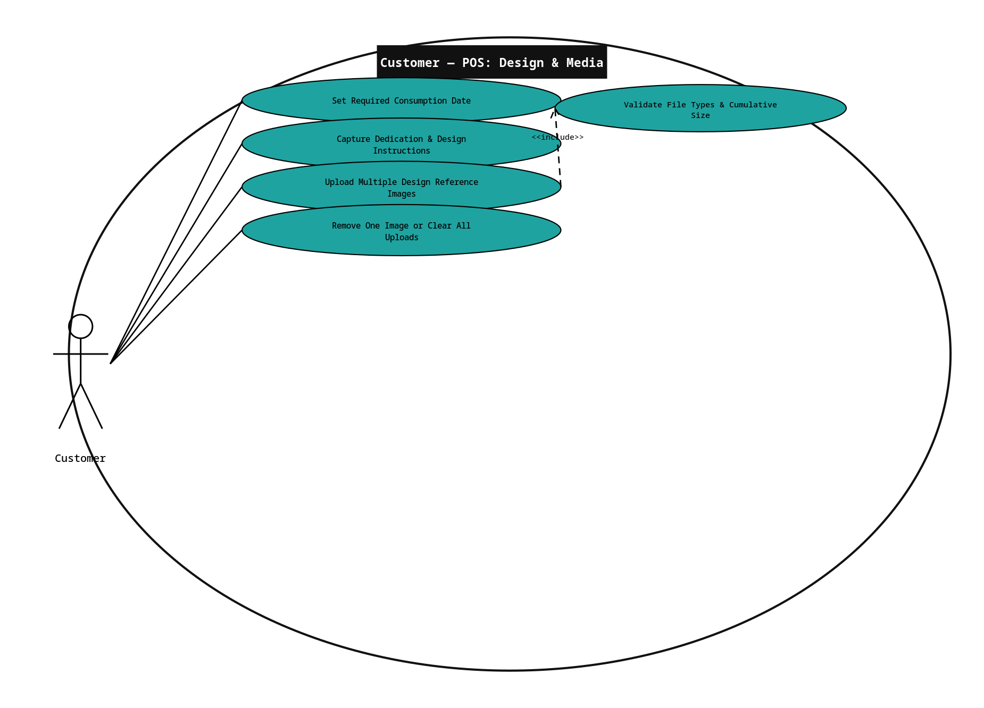

Figure 5 — Customer: Cart, Checkout & Confirmation
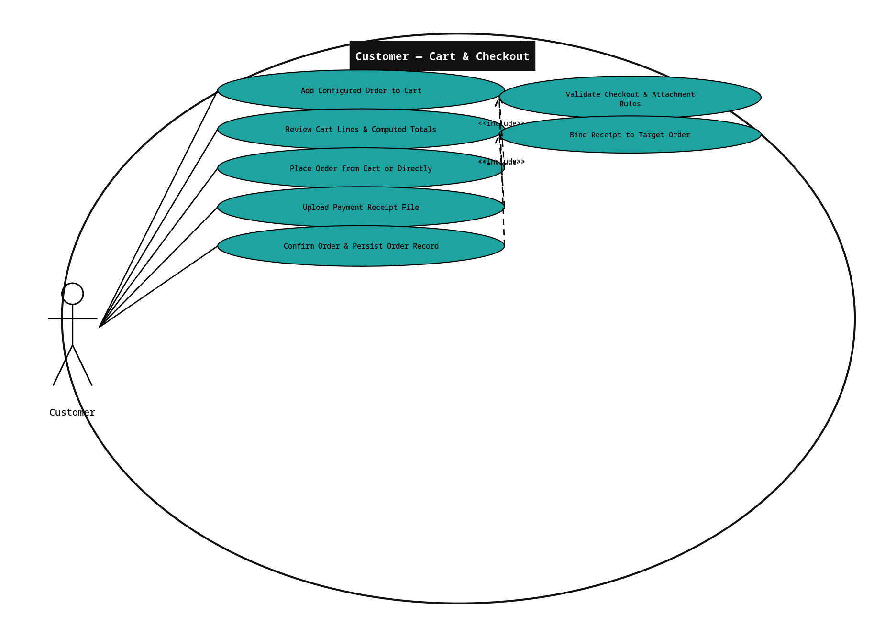

Figure 6 — Customer: Receipts & PDF Export
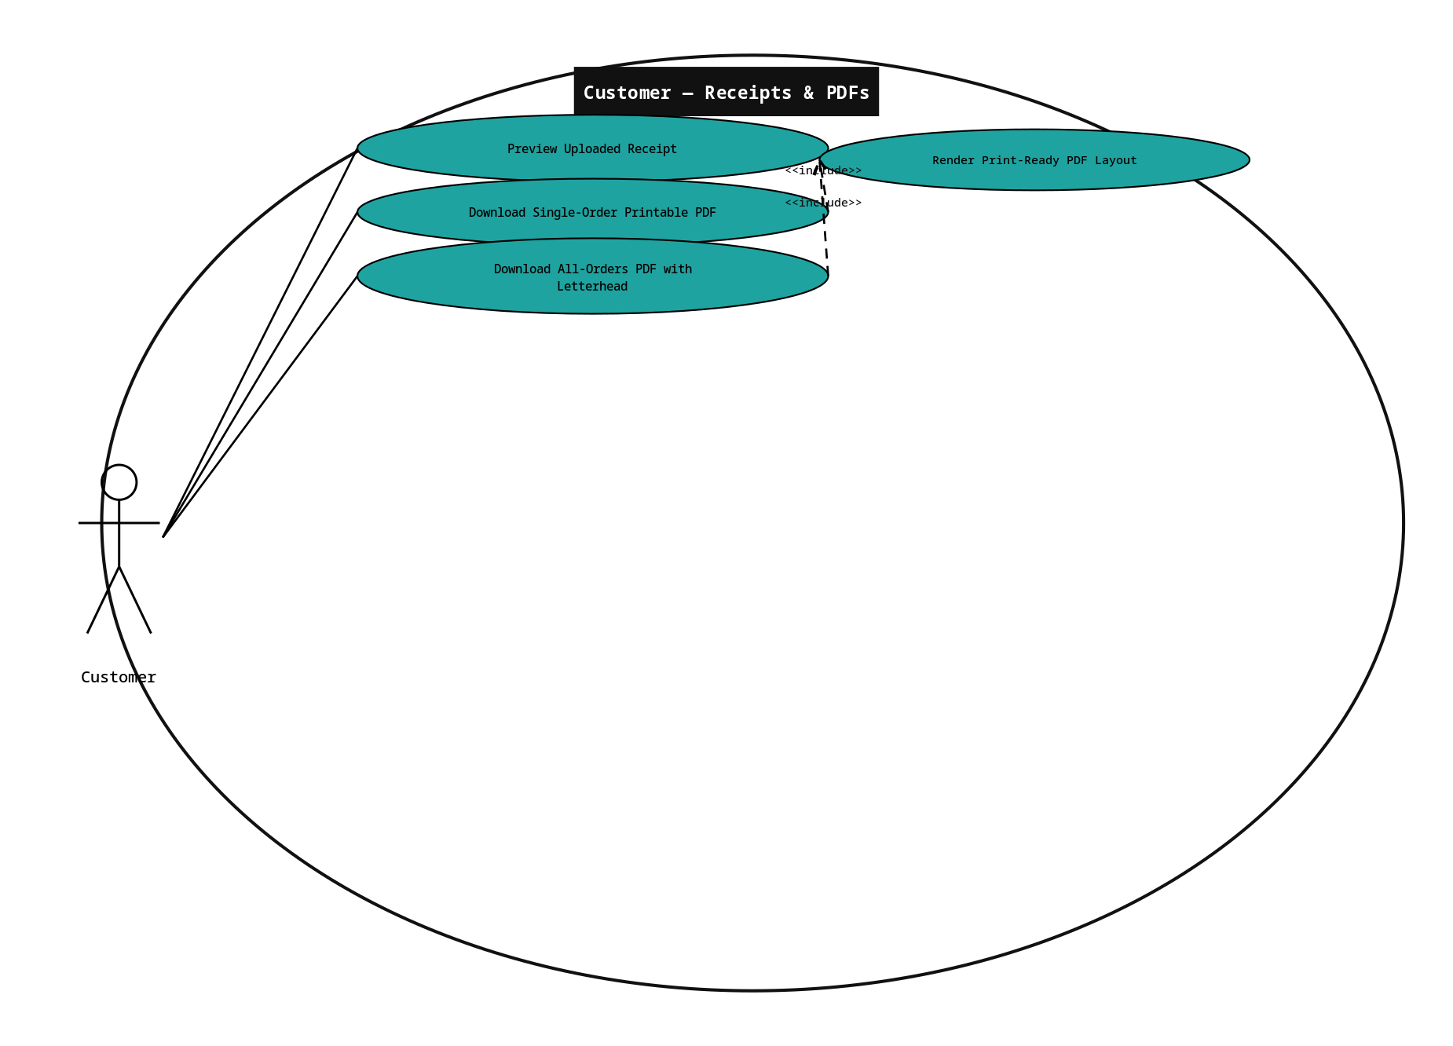

Figure 7 — Admin/Staff: Access, Session & Dashboard
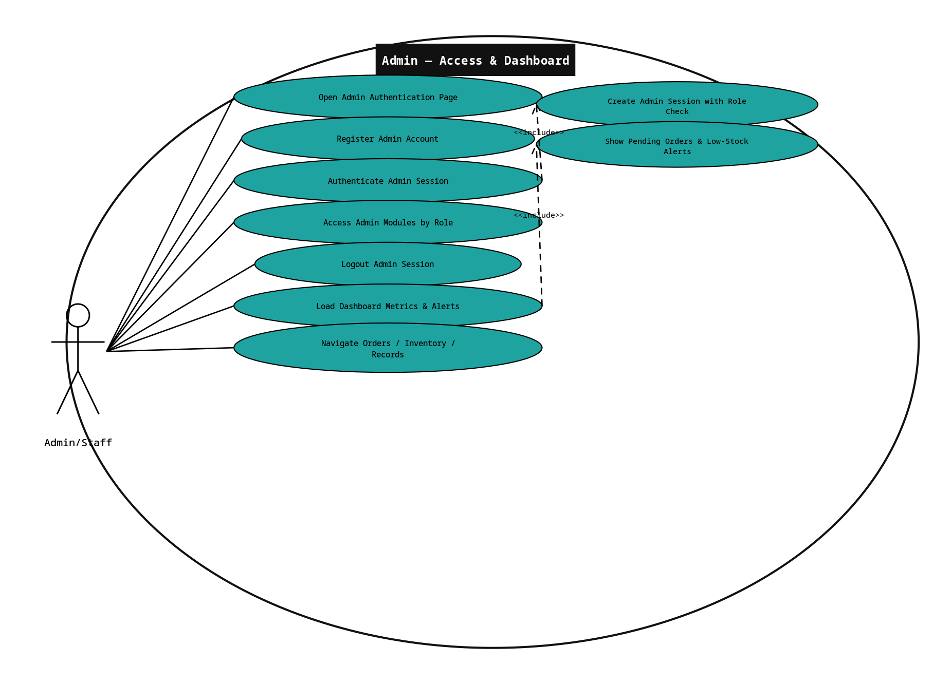

Figure 8 — Admin/Staff: Orders Management
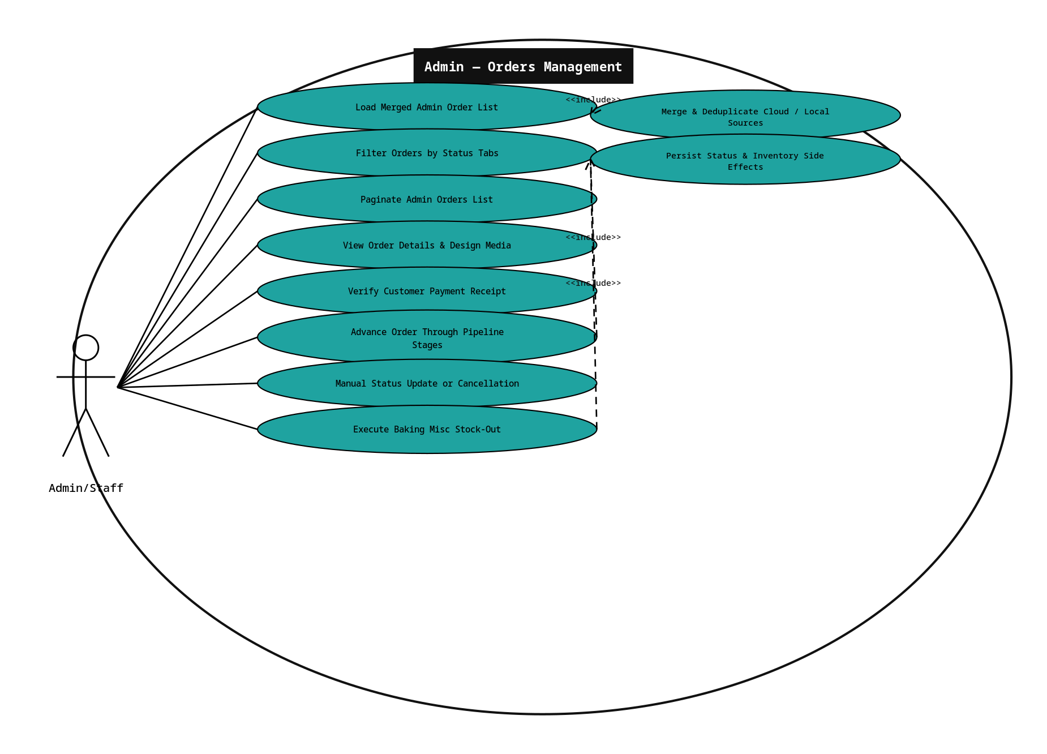

Figure 9 — Admin/Staff: Inventory Management
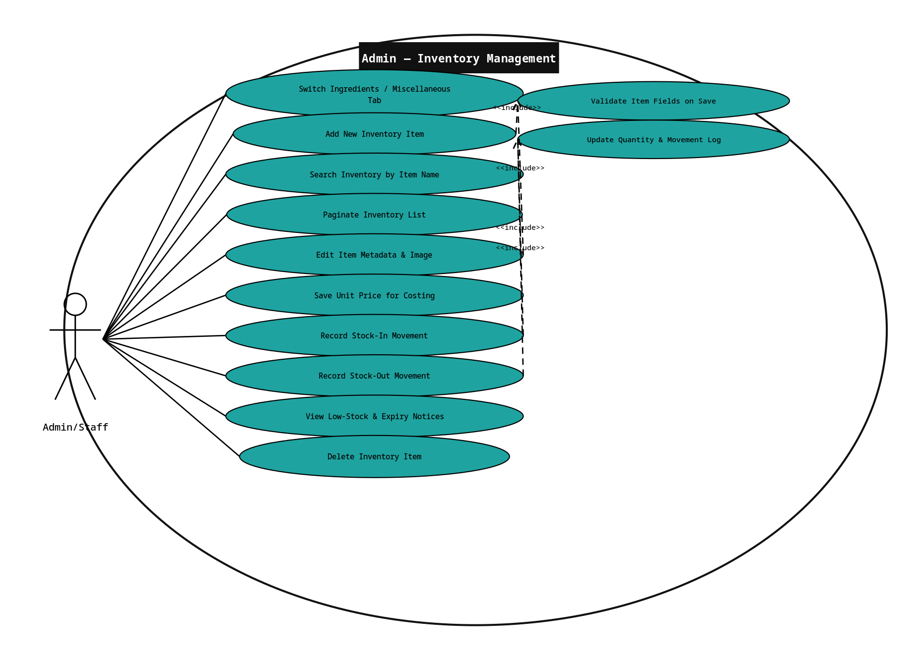

Figure 10 — Admin/Staff: Records Management
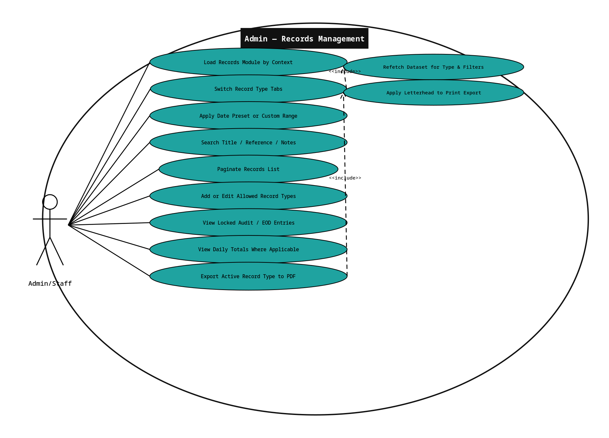
Actor naming (Admin/Staff): The back office is drawn as a single actor labeled Admin/Staff to reflect that operational employees share one administrative application surface, while the events table still refers to an Admin user as the authenticated party. If your instructor prefers strict UML, you may rename the actor to Admin only; the underlying behavior is unchanged.

