SAP-MON availability check for SCOM 2022

Test the sap_mon check on OS Level

create a “unit monitor” in SCOM 2022

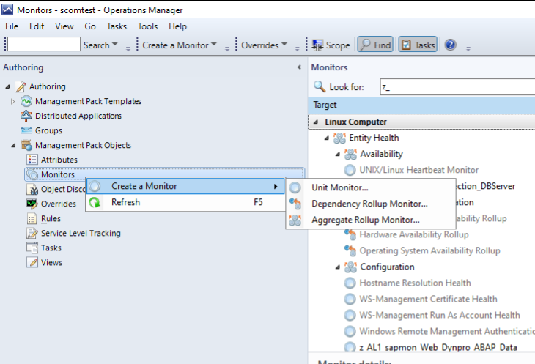

create a “UNIX/Linux Script Two State Monitor” and use the “z_sapmon” Management pack

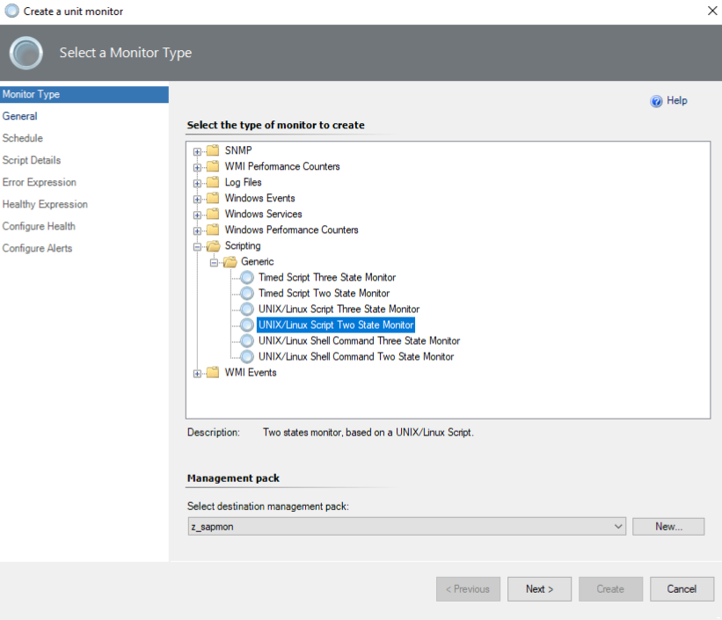

give a meaningful name for the check.
In this case e.g “z_AL3_sapmon_J2EEGetProcessList” .
Select the “Monitor target: Linux Computers” and “Parent monitor: Availability”

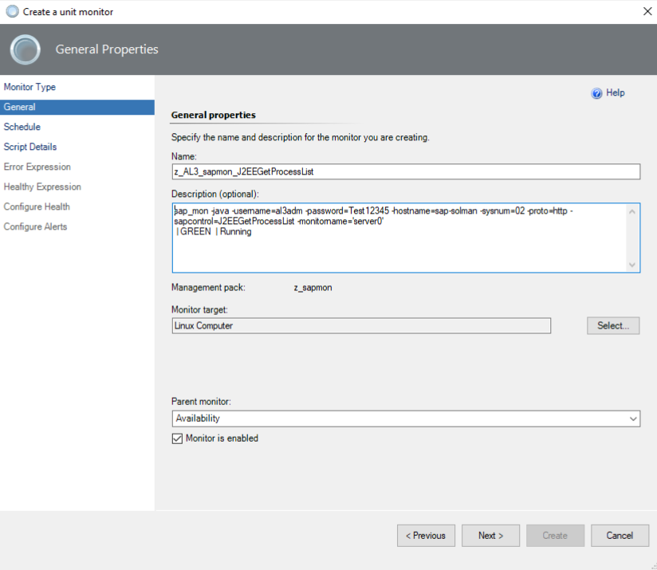

Let SCOM execute the script every 5 minutes

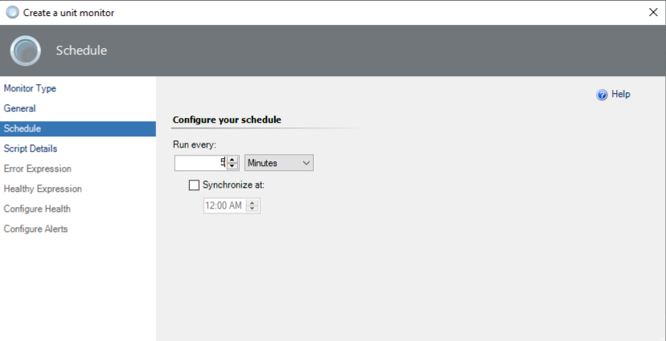

I'm not relay a Microsoft specialist or like products from Microsoft, but the check works best as “echo” output command.

here the script output, with the sap rfc library path:

#!/bin/bash
export PATH=$PATH:'/root/temp/sap_mon/lokal_git_repo/nwrfcsdk/lib'
export LD_LIBRARY_PATH=$LD_LIBRARY_PATH:'/root/temp/sap_mon/lokal_git_repo/nwrfcsdk/lib'
echo $(/root/temp/sap_mon/lokal_git_repo/sap_mon -java -username=al3adm -password=Test12345 -hostname=sap-solman -sysnum=02 -proto=http -sapcontrol=J2EEGetProcessList -monitorname='server0')

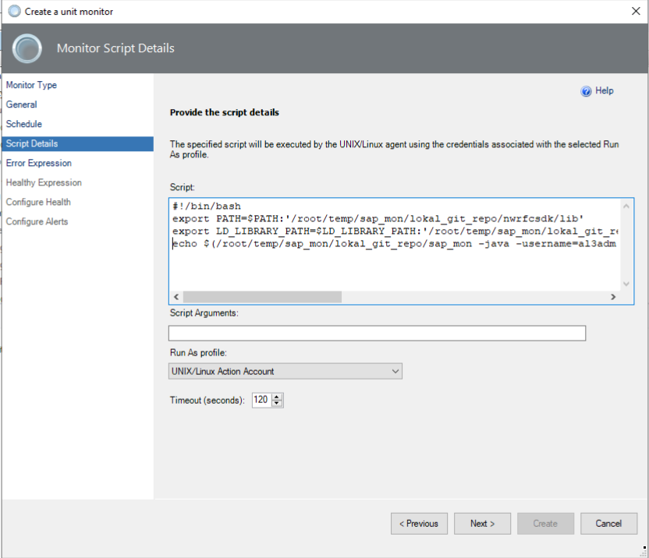

For the error expression user the sap_mon stdout output from linux OS and and negate it.
In this case “Does not contain“ “|GREEN | Running” and delete the “Return Code” line in this mask.

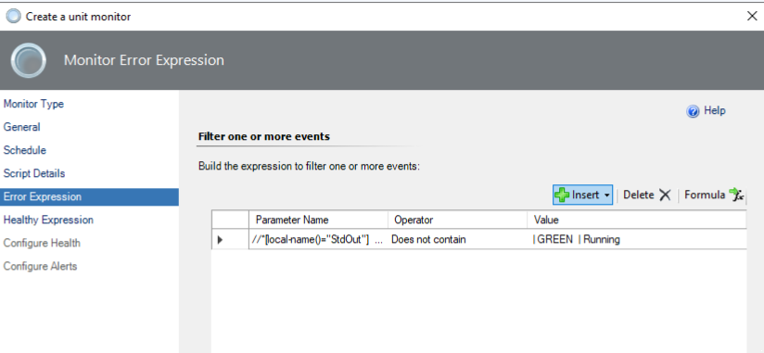

For the health state use the “Contains” operator

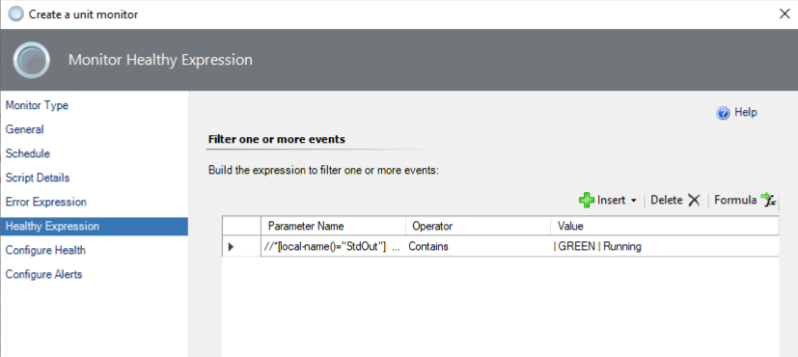

Let the next mask default

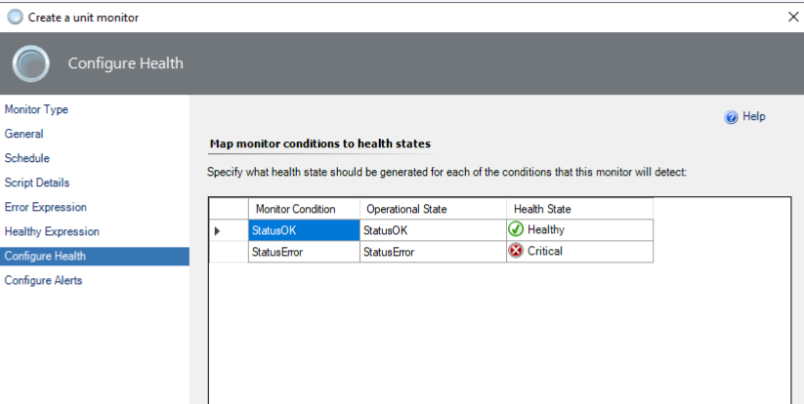

Set the alerting properties and finish (create) the dialog.

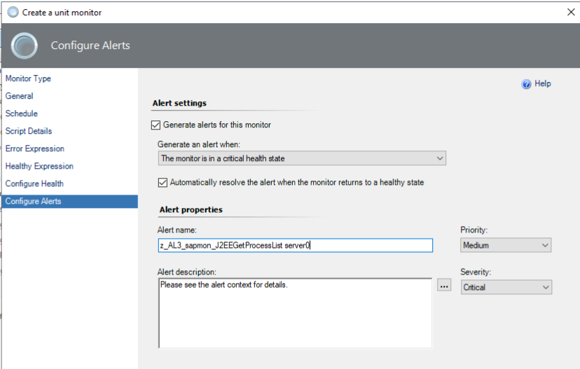

We can find the new check (monitor)

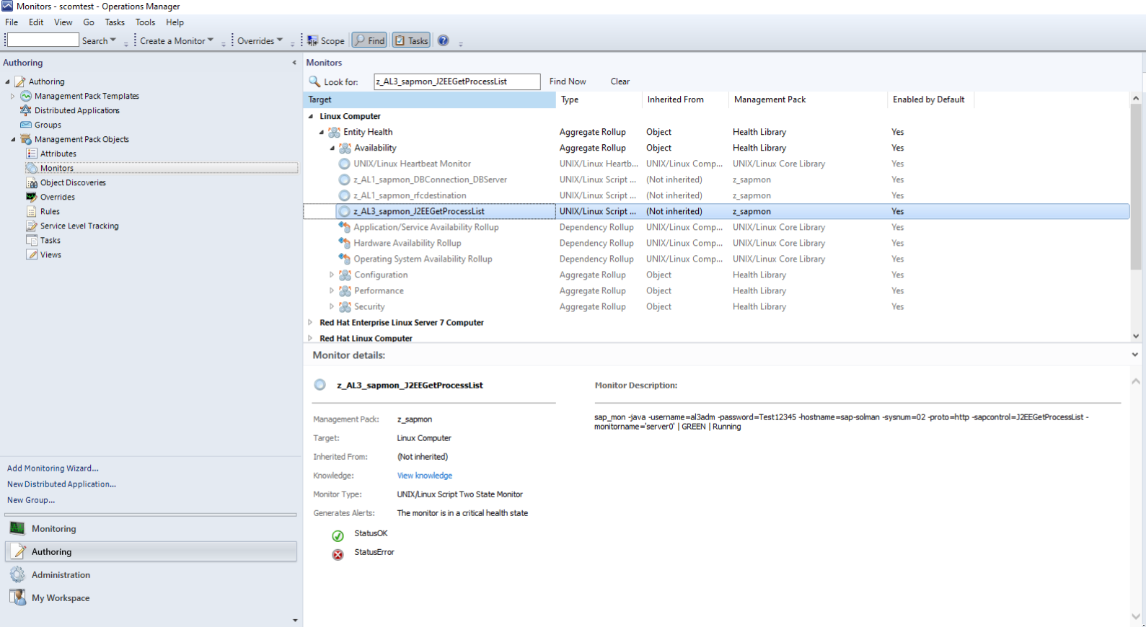

and let us check on the specific SAP Server in the “UNIX/Linux Computers” category, if the server0 process is running or not.
In this case it is running.

