SAP-MON perfomance monitoring for SCOM 2022

First check the sap_mon check on linux OS level. In this case we use the ResponseTime check form sap_mon.

Than create a “new rule” the the monitor

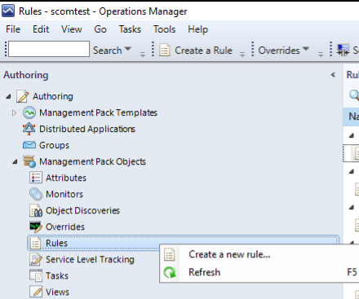

Use the “UNIX/Linux Script (Performance)” type in “Collection Rules” → “Probe Based” and use the
“z_sapmon” Management pack

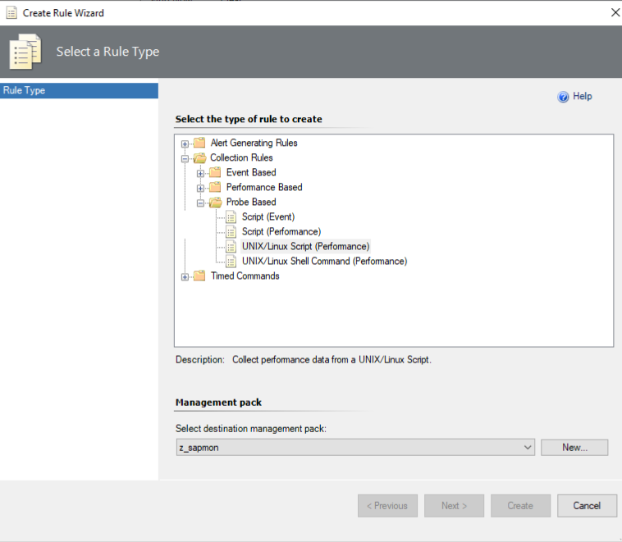

give a meaningful name for the check.
In this case e.g “z_AL1_sapmon_Dialog_ResponseTime” and Rule Category: Performance Collection and Rule target: Linux Computers

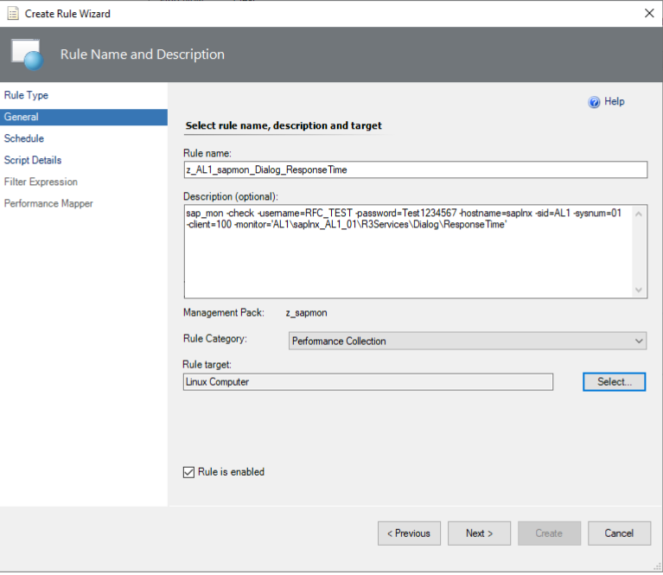

execute the rule every 2 minutes

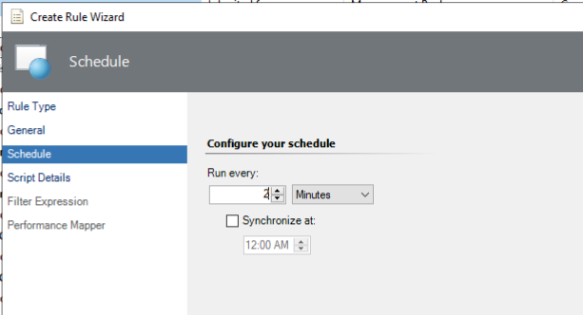

I'm not relay a Microsoft specialist or like products from Microsoft, but the check works best as “echo” output command.

here the script output, with the sap rfc library path:

#!/bin/bash
export PATH=$PATH:'/root/temp/sap_mon/lokal_git_repo/nwrfcsdk/lib'
export LD_LIBRARY_PATH=$LD_LIBRARY_PATH:'/root/temp/sap_mon/lokal_git_repo/nwrfcsdk/lib'
echo $(/root/temp/sap_mon/lokal_git_repo/sap_mon -check -username=RFC_TEST -password=Test1234567 -hostname=saplnx -sid=AL1 -sysnum=01 -client=100 -monitor='AL1\saplnx_AL1_01\R3Services\Dialog\ResponseTime')

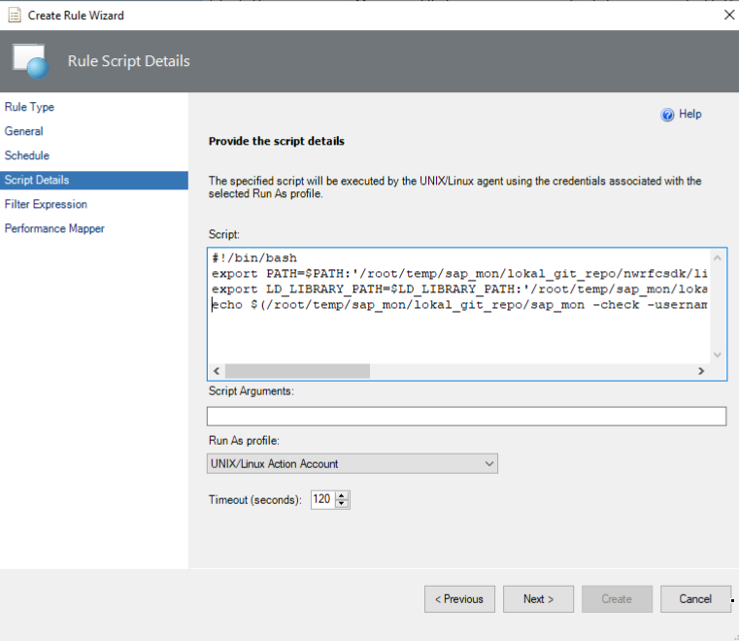

In this mask only delte the Return Code line and let the rest default.

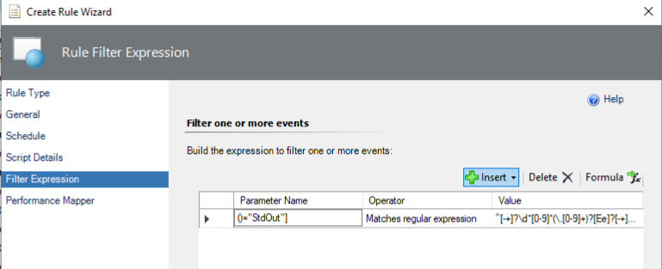

Finlay set the values as you can see from the screenshot.
And than create the monitor rule

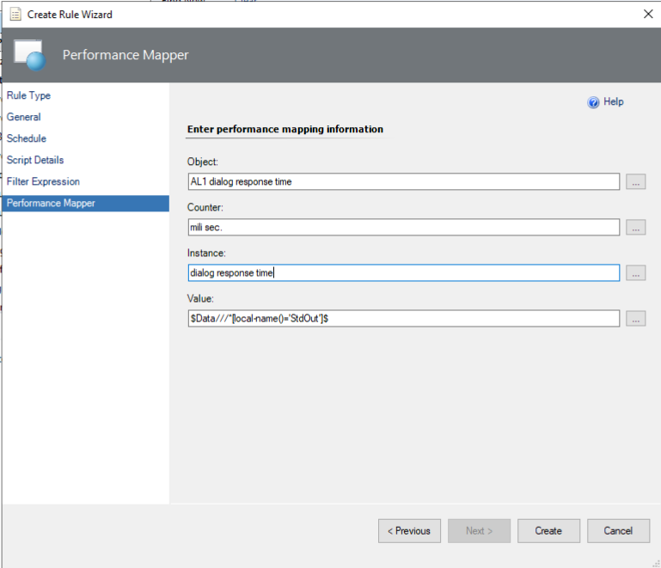

The works now.

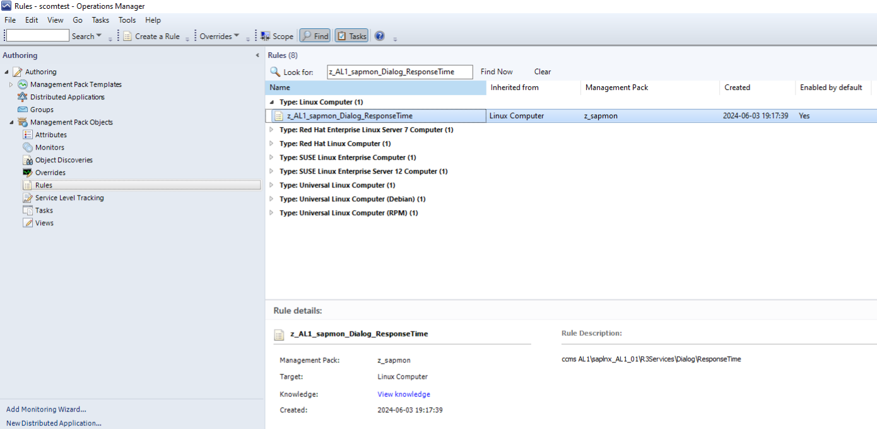

You can see the SAP Dialog Response Time with graph, now

