Pet Adoption Platform
Final Report of Team 13

Group Members:
Chen Letian 2330026013
Chen Tingxuan 2330026020
Yun Haoyi 2230026199
Xu Shuhan 2330026181
Xu Yilang 2330026184

- Purpose and goal
This project aims to help pets that are at risk of abandonment or homelessness. As living costs rise and life pressures increase, many pets may be abandoned by their owners or fail to receive the care they deserve for various reasons. Meanwhile, there is currently no effective or convenient adoption channel for pets, which often lacks proper regulation as well. The goal of this platform is to offer these pets a new home, while assisting pet owners in finding suitable adopters. At its core, the project seeks to provide an easy adoption channel, facilitating the replacing of pets and encouraging more people to engage in pet protection activities. Through this platform, we hope to ensure the well-being of these pets, raise awareness of pet responsibility, and reduce the number of pets potentially left without a home.

2. Front-end functions
User Registration and Login:
Users can easily create an account or log in.

Homepage:
The homepage introduces the platform’s main functions, showcasing hot activities and pet recommendations.

Pet List:
Users can browse available pets for adoption, filter them by category (such as “Cats” or “Dogs”), and view essential details like photos, names, adoption fees, and more. By clicking on a pet, users are directed to a detailed page where they can learn more and adopt the pet, adding it to their adoption order.

Activity List:
This page lists all activities hosted by the platform or other users that help the platform. Users can view activity names and details, with the ability to search for specific events by name or type.

Donation List:
The donation page shows a list of items donated to the platform. Each donation entry includes the name of the donor and the donated items, providing transparency about the donation process (can be written by the admin).

Personal Center:
The personal center allows users to manage their account information, update personal details, post donations, create fostering requests, and view adoption orders and donation history.

3. Assumptions for database
Pet Types (animals_type table)
In real life, most people's pets are either small dogs or small cats. Therefore, we assume that the platform's pet categories are limited to dogs and cats for now, which also helps prevent data redundancy. However, based on actual needs, we can add more pet types at any time.

Adoption Order Processing (animals_order table)
Each adoption order (animals_order) can only involve one pet (animals_id). However, if a user wants to adopt multiple pets, the system can handle this by creating multiple records in the animals_order table. This approach prevents confusion between different pets.

User and Admin Role Distinction (admin and user tables)
The administrator account (admin table) and regular user account (users table) are separate, and platform administrators can manage sensitive data such as activities and pet information through a dedicated data management system. Regular users can only view and submit their adoption orders, donations, or fostering requests on the main website. This distinction helps separate identities and functionalities, while also ensuring the security of the website's data.

Donation Item Information (donation table)
Donation items (donation table) include photos, the donor's information, and donation time, which helps the platform manage donated items. It also increases the transparency and regulatory effectiveness of the donation process.

Data Consistency and Integrity
Each table has a primary key (id field) to uniquely identify each record, and foreign key constraints are used to ensure data consistency.

- Final ER diagram & Description of entity and relationship set
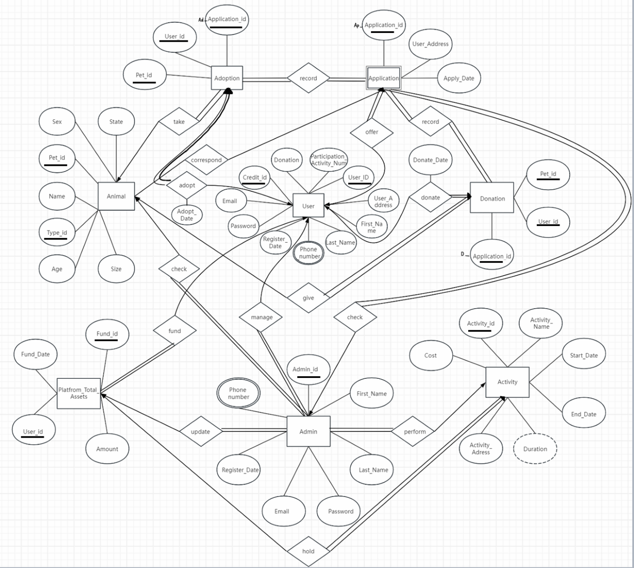

Entity Descriptions
- Animal and Application
Relationship: Application represents a user's application to adopt a specific animal.
Type: One-to-Many (One animal can have multiple applications, but one application corresponds to one animal).
Description:
Each application links a specific user to a specific animal.
The relationship is connected via the Pet_id foreign key in Application.

- Application and Adoption
Relationship: Adoption represents approved and completed applications.
Type: One-to-One (Each application results in at most one adoption).
Description:
Applications that are approved are converted to adoption records.
Connected via the primary key Application_id in Adoption.

- User and Application
Relationship: User submits applications to adopt animals.
Type: One-to-Many (One user can submit multiple applications).
Description:
Each user can apply for the adoption of multiple animals.
Connected via the foreign key User_id in Application.

4.User and Donation
Relationship: User makes donations to the platform, optionally linked to a specific application.
Type: One-to-Many (One user can make multiple donations).
Description:
Users donate either generally to the platform or specifically linked to an application.
Connected via the foreign key User_id in Donation and an optional Application_id.

- User and Activity
Relationship: Users can participate in activities organized by the platform.
Type: Many-to-Many (A user can participate in many activities, and one activity can have many participants).
Description:
The participation is represented via a linking table Participation, which stores user and activity associations.
Connected via User_id and Activity_id in Participation.

- Admin and Donation
Relationship: Admins monitor and manage donations made by users.
Type: One-to-Many (One admin can manage multiple donations).
Description:
Admins are responsible for reviewing and validating user donations.
Connected via the foreign key Admin_id in Donation.

- Admin and Activity
Relationship: Admins organize and manage activities.
Type: One-to-Many (One admin can organize multiple activities).
Description:
Each activity is managed by one or more admins.
Connected via Admin_id in Activity.

- Platform_Total_Assets and Donation
Relationship: Platform assets are accumulated through donations.
Type: One-to-Many (Platform funds are made up of multiple donations).
Description:
Total funds of the platform are updated based on user donations.
Connected via the foreign key Fund_id in Platform_Total_Assets.

Relationship Descriptions
- Animal → Application
Type: One-to-Many
Description: One animal can receive multiple applications (Pet_id → Application_id).

- Application → Adoption
Type: One-to-One
Description: Each application can result in one adoption record (Application_id → Ad_Application_id).

- User → Application
Type: One-to-Many
Description: A user can submit multiple applications (User_id → Application_id).

- User → Donation
Type: One-to-Many
Description: Users can make multiple donations (User_id → Donation_id).

- User → Activity
Type: Many-to-Many
Description: Users can participate in multiple activities, and each activity can have multiple participants, connected via Participation.

- Admin → Donation
Type: One-to-Many
Description: An admin can oversee multiple donations (Admin_id → Donation_id).

- Admin → Activity
Type: One-to-Many
Description: Admins can manage multiple activities (Admin_id → Activity_id).

- Platform_Total_Assets → Donation
Type: One-to-Many
Description: Platform funds are accumulated through user donations (Fund_id → Donation_id).

5 & 6. Functional dependencies(F), schemas and decomposition of schemas
- User = { User_id, User_address, First_name, Last_name, Phone_num, Register_date, Password, Email, Credit_id, Donation, Participation_Activity_num }

$$F=\{User_id→User_address, First_name, Last_name,Phone_num,Register_date,$$
$$password,email,Credit_id,Donation,Participation,Activity_num\}$$

Violates 3NF, decompose:
(1)
$$User_id=\{ User_id, User_address, First_name, Last_name, Phone_num, Register_date,$$
$$Password,Email, Credit_id\}$$
$$F_{1}=\{User_id→User_address, First_name, Last_name,Phone_num,Register_date,$$
$$password,email,Credit_id\}$$

(2)
$$Participation_Activity=\{User_id,Participation_Activity_num\}$$
$$F_{2}=\{User_id→Participation_Activity_num\}$$

- Donation = { Pet_id, User_id, Application_id }

$$F=\{Pet_id→User_id,Application_id\}$$

Satisfy 3NF, no need to decompose

- Application = { Application_id, User_address, Apply_data }

$$F=\{Application_id→User_address,Apply_date\}$$

Satisfy 3NF, no need to decompose

- Adoption = { Pet_id, User_id, Application_id }

$F_{1}=\{Pet_id,User_id→Applicaton_id\}$ (A specific pet adopted by a user through a specific application.)
$F_{2}=\{Application_id→Pet_id,User_id\}$ (The application corresponds to a specific pet and user.)

Satisfy 3NF, no need to decompose

- Animal = { Pet_id, Type_id, Name, Age, Sex, State, Size }

$$F=\{Pet_id→Type_id,Name,Age,Sex,State,Size\}$$

Satisfy 3NF, no need to decompose

- Platfrom TotalAssets = { User_id, Found_Date, Fund_id }

$$F=\{User_id→Found_date,Found_id\}$$

Satisfy 3NF, no need to decompose

- Admin = { Admin_id, First_name, Last_name, Password, Email, Register_date, Phone_num }

$$F=\{Admin_id→First_name,Last_name,Password,Email,$$
$$Register_date,Phone_num\}$$

Satisfy 3NF, no need to decompose

- Activity = { Activity_id, Activity_name, Start_date, End_date, Duration, Activity_address, cost }

$$F=\{Activity_id→Activity_name,Start_date,End_date,Duration,$$
$$Activity_address,Cost\}$$

Satisfy 3NF, no need to decompose

7. Primary keys description
- User Table: Composite Key (User_id, Credit_id)
Both User_id and Credit_id together ensure uniqueness of the user's record and associated credit information.
- Donation Table: Composite Key (Pet_id, User_id, Application_id)
This composite key ensures each donation is uniquely identified by the combination of the pet, user, and application.
- Application Table: Primary Key: Application_id
Application_id uniquely identifies each application submitted by a user for adopting or donating a pet
- Adoption Table: Composite Key (Pet_id, User_id, Application_id)
This composite key ensures each adoption is uniquely identified by the pet, user, and application.
- Animal Table: Composite Key (Pet_id, Type_id)
This composite key ensures each pet’s record is unique, based on its ID and type.
- Platform TotalAssets Table: Composite Key (User_id, Fund_id)
This composite key ensures that each asset record is unique per user and fund.
- Admin Table: Primary Key (Admin_id)
Admin_id uniquely identifies each administrator.
- Activity Table: Primary Key (Activity_id)
Activity_id uniquely identifies each activity.

8.Workload
Chen Letian 2330026013
Writing the Problem Description, creating and optimizing the ER diagram, coding and modifications (primarily responsible for SQL database and full code revisions), creating the PPT, delivering the presentation (Database), and writing the report.

Chen Tingxuan 2330026020
Writing the Problem Description, creating the ER diagram, coding and modifications (primarily responsible for the front end and full code revisions), creating and optimizing the PPT, delivering the presentation (live demo), and writing the report.

Yun Haoyi 2230026199
Writing the Problem Description, coding (primarily responsible for the back end), creating the PPT, delivering the presentation (front_end and back_end), and writing the report.

Xu Shuhan 2330026181
Writing the Problem Description, optimizing the initial ER diagram, creating initial Conclusion part for PPT and delivering the presentation (Conclusion).

Xu Yilang 2330026184
Writing the Problem Description, creating initial Introduction part for PPT and delivering the presentation (Introduction).

