|  |
| --- |
|  |

|  |
| --- |
| Collaboration Industry Apps Installation Guide |
|  |

**Table of Contents**

Contents

Purpose 2

Pre-requisites 2

• Creation of Provider Id for Actionable Messages 2

Solution Import 4

• Imports Steps 5

Post Deployment Steps 6

• Configuration of Power Automate flows 6

• Enablement of Collaboration features 6

✓ Teams Chat Integration 6

✓ Teams Call Integration 7

✓ Swarming Enablement 9

• Configuration settings for Adaptive Card Notification 9

✓ Configure Administration Area 10

✓ Configure Business Rule 15

Appendix 17

• Configuration of Application Names 17

• Configuration of SharePoint Site 18

• Find Entity OData Values and Fields Schema value 19

• Sample Outlook and Teams Adaptive cards 21

# Purpose

The intent of this document is to outline the steps that need to be carried out for setting up your own Industry Collaborative apps demos.

# Pre-requisites

Below you can find a list of installation prerequisites:

1. Dynamics 365 CE environment with Sales hub and Customer Service Hub apps
2. Valid Microsoft 365 Subscription (Outlook and Teams)
3. Access to Power Automate
4. Access to PVA (If applicable)
5. Enabled SharePoint Online instance Refer: Configuration of SharePoint Site
6. Creation of Provider Id for Actionable Messages

## Creation of Provider Id for Actionable Messages

Open this url <https://outlook.office.com/connectors/oam/publish>

Click New Provider

1. Create New Provider
2. Enter a friendly name for your provider
3. Enter sender email address
4. Enter Target URL - HTTPS URLs which will be invoked by the actions from the message card. A regular expression (REGEX) can be used to group multiple URLs (e.g. www.microsoft.com)

1. Scope of submission
2. Select Test Users option – as option is auto approved
3. Enter test user email addresses; can add multiple email addresses as shown below – These would be receiver of the actionable messages for testing

For demo purposes, we recommend to select “Test users” + enter all email addresses of users receiving emails with adaptive cards. Note: you won’t be able to change this after creation (only create a new provider).

# Solution Import

Please import following solutions in the below order:

|  |  |  |
| --- | --- | --- |
| Solution Name | Order | Purpose |
| Administration Solution (Adminstrationsoln_1_0_0_16) | 1 | This solution contains the administration and system configuration section and forms. It’s a common solution across all industry collaborative applications |
| Actionable Flows Solution (ActionableMessagesFlows_1_0_0_13) | 2 | Solution contains Power Automate flows responsible for sending notifications to Teams & Outlook. |
| PVA solution (ChatBotSoln_1_0_0_15) * | 3 | Solution contains Power Virtual Agent related components. Needs to be imported only if its applicable for specific scenario |
| PCF solution (sol_1_1_managed) ** | 4 | Solution contains custom PCF component(s) and custom control(s).  Needs to be imported only if its applicable for specific scenario |
| Collaborative Application Solution *** | 5 | Solution contains core collaborative industry application related components. |

* Only for Loan Eligibility, Construction Permit, Insurance B2B, Telco B2B and Unified B2B

**Only for Plant Maintenance & Inspections, River Pollution and Manufacturing – Health & Safety Collaboration and Manufacturing - Production Line Outage Crisis Management Collaboration

*** Refer Application specific solution name in *Configuration of Application Names*

## Imports Steps

1. Login to https://make.powerapps.com/
2. Go to Solutions
3. Click on Import

Installation of a solution file can take multiple minutes – please wait for a solution import to be completed prior to importing the next solution.

# Post Deployment Steps

## Configuration of Power Automate flows

Navigate to *Actionable Flows Solution* and execute the following actions for all the Power Automates listed below.

* + Enable connection
  + Turn On

*Table 1: List of Power Automates*

|  |  |
| --- | --- |
| **Power Automate Flow Name** | **Purpose** |
| Generic Flow - On Create - Case - Adaptive cards – Teams | On Creation of case sending Teams Adaptive Card Notifications to user |
| Generic Flow - On Create - Case - Actionable Messages | On Creation of case sending Outlook Actionable Message Card Notifications to user |
| Generic - On Modify - Case - Send Notification | In Approval Process: Sending Approval Adaptive Card to User who will approve it.  In Resolution Process: Sending Information Adaptive Card to User when case is resolved |
| Child - Get AddressTo - Sys Configuration | Child Flow called by above flows to get ‘Addressing to’ field value from System Configuration Records. This is the person to receive the notification/email with card |
| Child - Get Related lookup data - Sys Configuration | Child Flow called by above flows to get ‘Related Lookup Data’ field value from System Configuration Records |
| UpdateNotificationImageField * | Calculate priority in Prioritization Canvas App |

*Applicable for Banking Fraud, Manufacturing Product Line, Plant maintenance, River Pollution, Security – Cyber attack

## Enablement of Collaboration features

### Teams Chat Integration

1. Navigate to Sales Hub -> App Settings
2. Select Chat and Collaboration
   * 1. Enable Feature & Save
     2. Add Case, Account & Contact then click on Edit

* + 1. Add Collaboration settings (as per the below screenshot)

### Teams Call Integration

* 1. Select Teams calls
     1. Enable Feature & Save
     2. Add the specific Collaborative industry app name that you want to enable this calling feature on. Once enabled, Phone icon and chat icon should appear on the top right-hand side when inside one of the applications.

### Swarming Enablement

* 1. Navigate to Customer Service Hub
     1. Click Service Management
     2. Click on Swarming using Teams
     3. Enable Swarming Feature

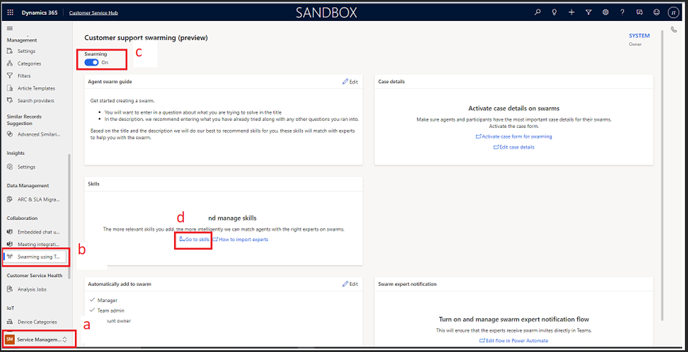

* + 1. Click on Go to Skills
    2. To Add Skills click on New. Specific scenario’s using swarming will require you to add skills and assign them to users for the flow to work.

## Configuration settings for Adaptive Card Notification

In the bottom left corner select the Administration area

### Configure Administration Area

1. Application Name

Application names are being maintained in a Dataverse table. On the creation of case/request, the application name gets stored at the record level, leveraging JavaScript, that helps the system to determine and to trigger the appropriate Power Automate flow for a specific collaborative industry application.

1. Navigate to your specific Collaborative industry app
   * + - Click Area (bottom left) -> Select Administration -> Application Names -> Click on +New

1. Create Application Record with
   * + - <App Name> Refer Configuration of Application Names Select Application Name in Administration Table
       - <App Id> (App Id is part of URL. e.g., https://org012101.crm11.dynamics.com/main.aspx?appid***=2e7daf28-f404-ec11-b6e6-000d3a86dfb0***)

Sample Application Names and App ID shown below

1. System Configuration

This system configuration table is being maintained to trigger adaptive card notifications to the user. System sends an adaptive card for specific action such as “View Details” determined basis on whether record is present in system configuration table for specific application and for specific channel such as Teams.

If the record is not present in the table for specific application, then the system wouldn’t send adaptive card. Moreover, the content of the adaptive card is being maintained at system configuration level. Content is dynamic in nature, and it can be configured as per the requirement.

1. Configure System Configuration (Click System Configurations in the left side navigation

* Click on +New
* Create New System Configuration record with below value

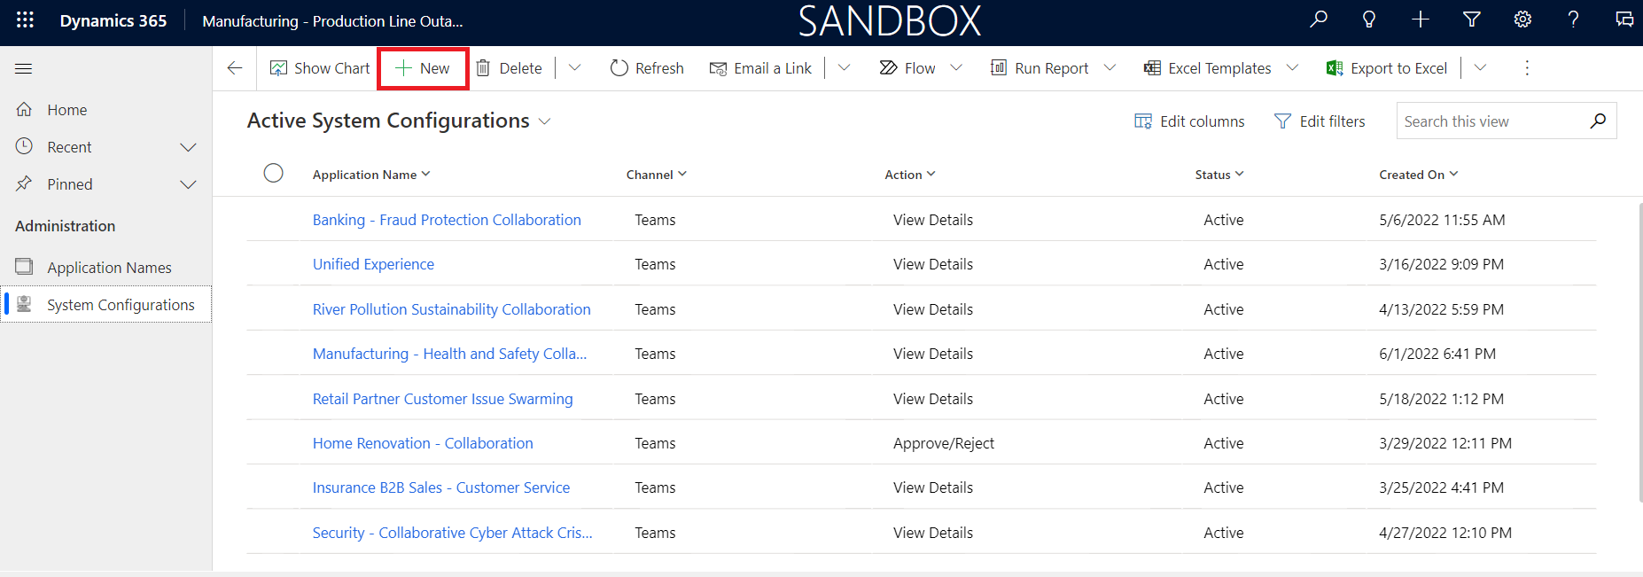

*Table 2. Fields present in System configuration table*

|  |  |  |  |
| --- | --- | --- | --- |
| **Field Name** | **Format** | **Example** | **Description** |
| Name | Text | Construction Permit Collaboration | Selected Application Name. Refer Application Name here *Configuration of Application Names* |
| Application Name | Look Up | Construction Permit Collaboration | Select Application Name Record from Lookup |
| Action | Option Set   * Approve/ Reject * View Details * Add Comments | View Details | **Approve/ Reject**: In case record needs Approval |
| **View Details:** In case to show the details |
| **Add Comments:** In case, wants to add any comments in description |
| Channel | Option Set   * Teams * Outlook | Teams | Select to which channel notifications should be sent |
| Data | **Single Line Data Type Fields Format**  {Label Name1: Field Schema Name1,  Label Name2: Schema Name 2,  Label Name3: Schema Name 3,  Label Name4: Schema Name 4} | {Case Id:  ticketnumber, Description:  description} | The fields data wants to show in Pre-defined Adaptive card. Can add up to 4 fields  Schema name needs to be lower case. For custom tables, add the Prefix – i.e. prefix scheme  Refer steps to get Schema Names here:  *Find Entity OData Values and Fields Schema value* |
| **Look Up Data Type Fields Format**  {Label Name1: EntityLogicalName1.FieldSchemaName1, Up to Four Fields} | {Contact:  contacts.fullname,  Account Name:  accounts.name} | The lookup fields data wants to show in Adaptive card. Can add up to 4 fields  Refer: *Find Entity OData Values and Fields Schema value* |
| Related Lookup Data | {EntityLogicalname:  EntityOdataValue} | {contacts: _customerid_value} | To get *Lookup record* field values (Above getting Full Name from Contacts look up).  To get ODATA value  Refere : *Find Entity OData Values and Fields Schema value* |
| Address To | {Label Name: EntityLogicalname.FieldSchemaName, EntityLogicalname:EntityOdataValue } | {Name: systemusers.fullname,  systemusers:_ownerid_value} | Mention name to whom Adaptive card should be send to in notification.  Refere : *Find Entity OData Values and Fields Schema value* |
| Header / Resolve Text | Text | A Record has been created/  A Record has been resolved | Heading in notification adaptive card |
| Provider ID |  | f647e65f-1e52-4a31-a3cf-6c378ed0cccf | Provider ID for actionable messages.  Refer Pre-requisites *#7 above* |

*Note*: Status of System configuration record should be Active

Sample System Configuration record shown below

To get Lookup record field values Ex: contact fullname pass Data values with format entity plural name(contacts):Field Schema Name(fullname) and Related lookup data values with entity plural name (contacts):Odata value(_Customerid_Value)

Refere to Find Entity OData Values and Fields Schema value

**By clicking on View Details, User will be navigated to a particular record**

*Table 3: Applicability of Various Actions across apps*

|  |  |
| --- | --- |
| **Action** | **Applicable For** |
| Approve Or Reject | 1. Construction Permit – Collaboration (Home Renovation) 2. Security - Collaborative Cyber Attack Crisis Management 3. Banking - Fraud Protection Collaboration   Required Fields:   1. Is Approval Required (mcs_isapprovalrequired) 2. Approver (mcs_approver)   Graphical user interface, text, application, email  Description automatically generated  Instruction:   1. Select Is Approval Required to “Yes” 2. Select User in Approver Lookup 3. Save |
| Add Comments | All |
| View Details | All |

### Configure Business Rule

1. Configure Business Rule in Case (Or in Idea entity in case of Horizontal Fusion app)
2. Open Make.Powerapps.com
3. Open solution and expand Case entity
4. Navigate Business Rules
5. Edit “Set Application Name to ‘App Name’” Business Rule and Deactivate it

1. Select “Set Value” Step
2. Add Application Name Record
3. Save and Activate

# Appendix

## Configuration of Application Names

|  |  |  |
| --- | --- | --- |
| **Industry Application Name** | **Application Name in** | **Solution Name** |
|  | **Administration Table** |  |
| B2B Sales-Customer Service Collaboration | Unified Experience | UnifiedUserExperience_1_0_0_20 |
| Banking - Fraud Protection Collaboration | Banking - Fraud Protection Collaboration | BankingFraudProtectionCollobration_1_0_0_4 |
| Construction Permit Collaboration | Home Renovation - Collaboration | HomeRenovationCollaboration_1_0_0_12 |
| Fusion Development Collaboration | Horizontal - Fusion development collaboration | HorizontalFusiondevelopmentcollaboration_1_0_0_6 |
| Insurance B2B Sales - Customer Service | Insurance B2B Sales - Customer Service | InsuranceB2B_1_0_0_28 |
| Loan Eligibility Collaboration | Loan | LoanTrackerSoln_1_0_0_16 |
| Manufacturing - Health and Safety Collaboration | Manufacturing - Health and Safety Collaboration | ManufacturingHealthandSafetyCollaboration_1_0_0_4 |
| Manufacturing - Production Line Outage Crisis Management Collaboration | Manufacturing - Production Line Outage Crisis Management Collaboration | ManufacturingProductionlineoutagecrisismanagement_1_0_0_12 |
| Plant Maintenance & Inspection | Inspection | OilDependencies_1_0_0_16 |
| Retail Partner Customer Issue Swarming | Retail Partner Customer Issue Swarming | RetailPartnerCustomerIssueSwarming_1_0_0_7 |
| River Pollution Sustainability Collaboration | River Pollution Sustainability Collaboration | RiverPollutionCollaboration_1_0_0_9 |
| Security - Collaborative Cyber Attack Crisis Management | Security - Collaborative Cyber Attack Crisis Management | Securitycollaborativecyberattackcrisismanagement_1_0_0_13 |
| Telco B2B Sales - Customer Service | Telco B2B Sales - Customer Service | TelcoB2BSalesCustomerService_1_0_0_16 |
| Treasury Collaboration | Treasury Collaboration | Treasuryapp_1_0_0_9 |

## Configuration of SharePoint Site

Step 1:

Go to Settings -> Administration -> Document Management

1. Click Enable server-Based SP Integration -> Next -> Next
2. Add site URL ->
3. Finish

Step 2:

1. Click Doc Settings ->
2. select required entity (Enable SharePoint for Case) ->
3. Add site URL ->
4. Finish

## Find Entity OData Values and Fields Schema value

* 1. Entity ODATA Value
     + - 1. Settings -> Customizations
         2. Click Developer Resources

* + - * 1. Copy Root URL

* + - * 1. Paste in new browser window
        2. Type incidents (entity plural name) and Enter
        3. Search Lookup field name

Ex: Customer : _customerid_value

Sample OData field value shown below

* 1. To Find Field Schema Name

1. Settings -> Customizations
2. Customize the system
3. Expand Entity (Case)
4. Click on Fields
5. Copy Field name

Sample Field Schema value shown below

## Sample Outlook and Teams Adaptive cards

|  |  |  |
| --- | --- | --- |
| Action | Channel | Sample Card |
| View Details | Teams |  |
| Approve Or Reject | Teams |  |
| Add Comments | Teams |  |
| View Details | Outlook |  |
| Approve Or Reject | Outlook |  |
| Add Comments | Outlook |  |