**____________________________________**

CI/CD Walkthrough For DTAC

Author: Gulam Moideen.

Creation Date: Feb 22, 2023

Last Updated: Feb 22, 2023

Version: Initial Document.

# CI

## Prerequisites: -

* Allthe latest changes should be commited on ALM by Dev Team
* Makefile and Dockerfile should be updated with latest image tag name by TA Team for **Telenor Asia Billing Common** project in ALM :
  + tab-common-brm
  + tab-common-rest

# LOGIN Credential

|  |  |  |  |
| --- | --- | --- | --- |
| **Application** | **URL** | **Username** | **Password** |
| Jenkins | http://100.76.194.253:8080/ | **devops** |  |
| ALM | https://alm.oraclecorp.com/cgbu | **Oracle e-mail** |  |

Steps for CI:

Step1: Login to ALM and select the **Telenor Asia Billing Common** Project.

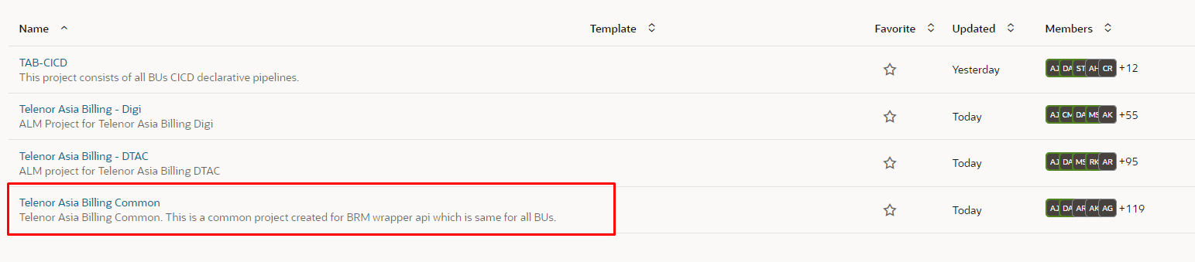

Step2: Select the tab-common-brm from the listed Option.

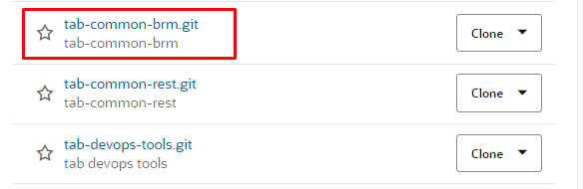

Step3: Select the latest IRT’s Branch as given by Release Manager.

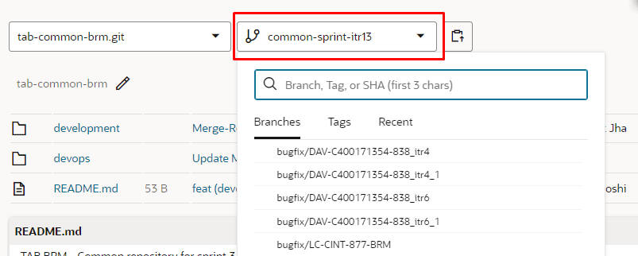

Step4: update the both Dockerfile and Makefile for CM under the following location (devop/container/cm)

Example:

Dockerfile:

ARG BASE_IMAGE=cm

ARG BASE_TAG=12.0.0.7.0-34916707

Makefile:

IMAGE_NAME=common-brm-cm

IMAGE_TAG=common-cm- 13.38.4-b002

Step5: update the both Dockerfile and Makefile for Config-jobs under the following location (devop/container/config-jobs)

Example:

Dockerfile:

ARG BASE_IMAGE=config_jobs

ARG BASE_TAG= 12.0.0.7.0-34763817

Makefile:

IMAGE_NAME= common-brm-config_jobs

IMAGE_TAG= common-config-jobs- 13.38.4-b002

Note: After making the changes for tab-common-brm section. We’ll continue with tab-common-rest.

Step6: Select the tab-common-rest and latest ITRs option from the drop-down

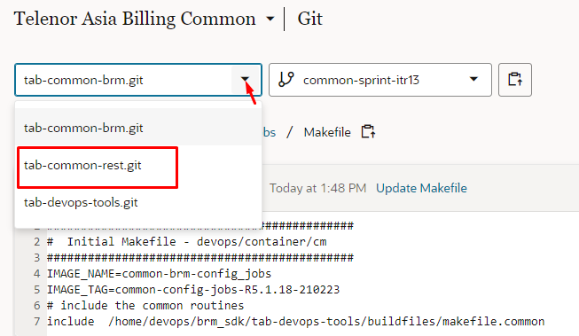

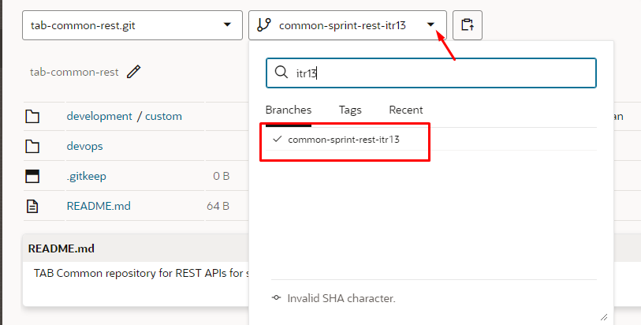

Step7: update the both Dockerfile and Makefile for Config-jobs under the following location (devop/container/billingcare_sdk)

Example:

Dockerfile:

ARG BASE_IMAGE= oracle/billingcare

ARG BASE_TAG= 12.0.0.7.0-34627512

Makefile:

IMAGE_NAME= common-billingcare_sdk

IMAGE_TAG= common-rest-13.38.4-b002

Note: Now we’ve successfully changed the latest images tags for tab-common-brm and tab-commom-rest.

But for tab-dtac-cn-brm which is Bu-Specific we’ll update the image tags directly from Jenkins CI Pipeline.

Step8: login to the Jenkins with the above mentioned URL. Click on DTAC on the Dashboard view and Select the DTAC_CI_FINAL_PIPELINE

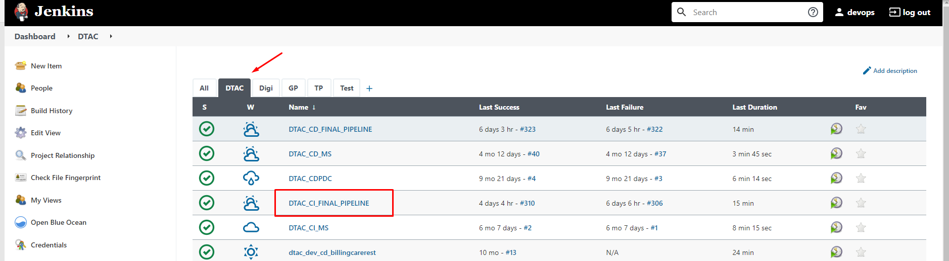

Step9: Select the Build with Parameters option to update the parameter required for CI pipeline.

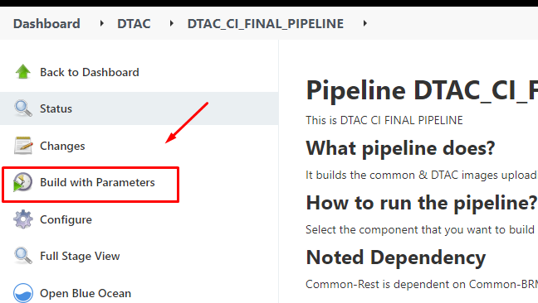

Step10: Update the Base Tag and Image Tag for tab-dtac-cn-brm section directly from Jenkins CI Pipeline

BRM-APP:

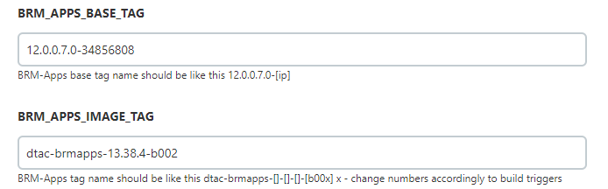

BU-CM:

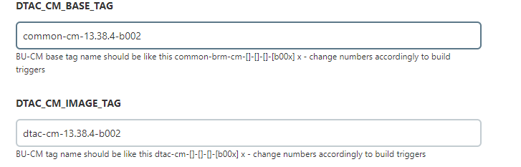

BU-Configjobs:

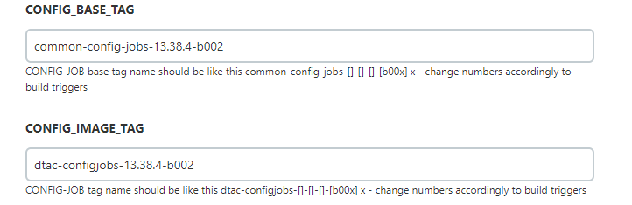

DM-kafka:

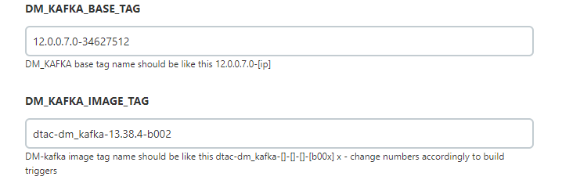

Eai-js:

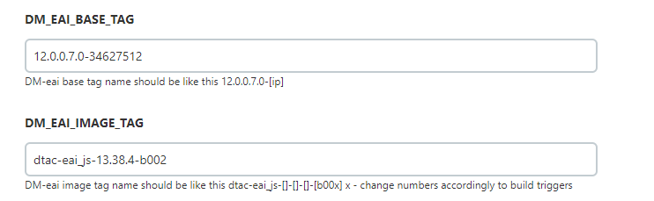

RealtimePipe:

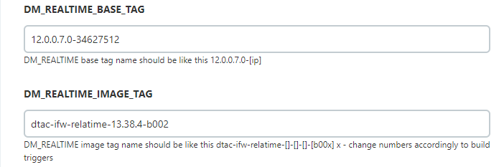

Step11: Select the latest ITR’s Bracnch and Check-in the box for which you would like to create Image.

* Common_BRM_Images
  + Common-cm
  + Common-configjobs

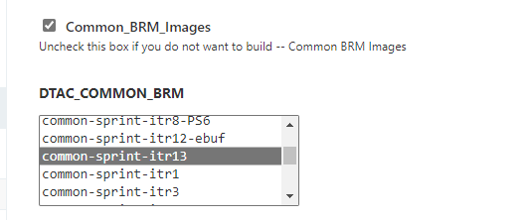

* Common_BRM_Images
  + Custom BCWS

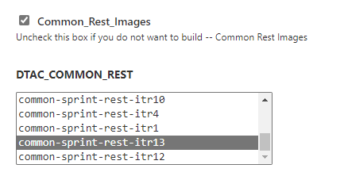

* DTAC_BRM_Images
  + Brm-apps
  + BU – CM
  + BU – Config-jobs
  + Dm_kafka
  + Eai_js
  + Realtime_Pipe

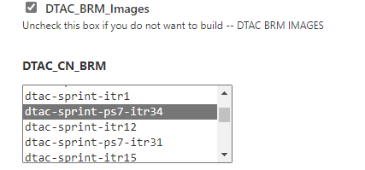

* ECE_Without_Images

Note: If you would like to create the custom image for ECE, then click on ECE_Images. Or For just Jars deployment. Select ECE_Without_images

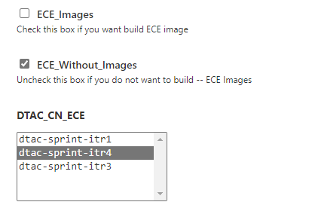

Step12: We’ve integrated other options as well with Jenkins CI Pipeline like

* + Parfait_scan 🡪 for Code scanning
  + Trivy_scan 🡪 for Images scanning

To run the Parfait, Select the Parfait_Scan option:



To run the Trivy, Select the Trivy_Scan option:

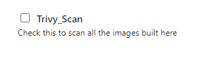

Note : Make sure that you’ve selected the right Environment before triggering the Build.

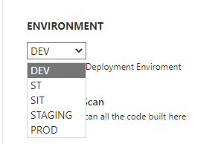

And If you are going deploy the Build in DEV Environment. Select the CD_Dry_Run option. It will initiate the Dry run for the DTAC_CD_FINAL_PIPELINE and Will be in a Ready-To-Deploy State.

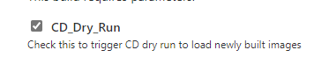

Now we’re good to trigger the DTAC_CI_FINAL_PIPELINE by clicking the Build.



CD walkthrough: DEV

Step1: Open the DTAC_CD_FINAL_PIPELINE from the DTAC Dashborad view.

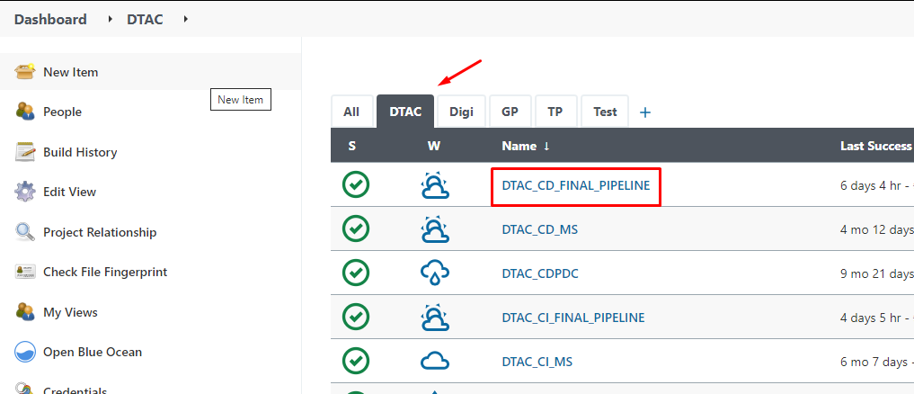

Step2: Click on Deploy option on Jenkins window.

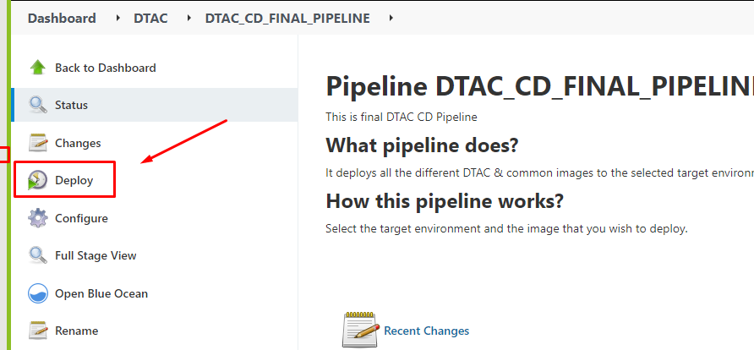

Step3: Select the latest ITR’s for the below sections:

tab-common-brm:

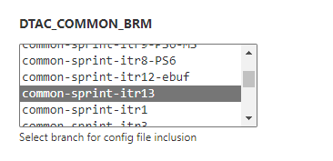

tab-common-rest:

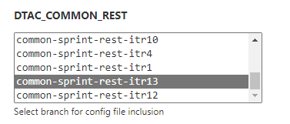

tab-dtac-cn-brm:

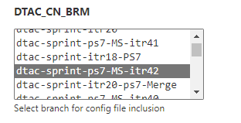

tab-dtac-cn-ece:

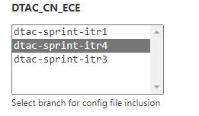

Step 4: Select the latest image tag for the below Applications.

BCWS:

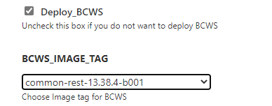

CM:

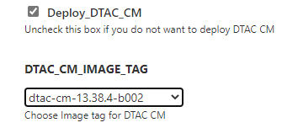

EAI JS:

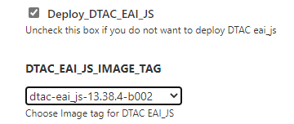

DM_Kafka:

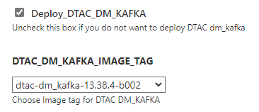

Realtimepipe:

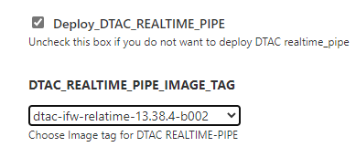

Brm_Apps:

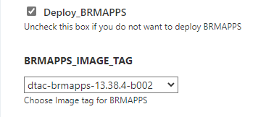

Dtac_Config:

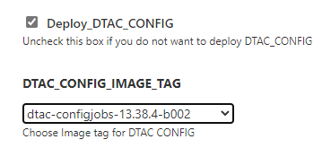

ECE:

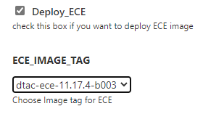

ECE_No_image:

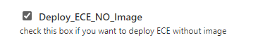

Common_config:

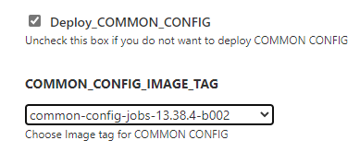

After Selecting the Image tag click on Build to trigger the CD Pipeline.

CD walkthrough: Client Environments.

## CD Prerequisites: -

|  |  |  |  |  |
| --- | --- | --- | --- | --- |
| **Application** | **Environment** | **URL** | **Username** | **Password** |
| Jenkins | **SIT & STG** | **https://brm-tb-cicd.dtacnetwork.dev:8080/** | **admin** |  |
| **Prod** | https://brm-cicd.dtacnetwork.co.th:8090/ | **admin** |  |

Step1: Follow the below steps to take the custom Release to the client environment.

* Create the directory in local
  + mkdir dtac_drelease38 (note: 38 denotes the release number)
* Copy the folders from local Jenkins workspace location to the newly created directory.
  + cd workspace_location
  + cp –r tab-common-brm tab-common-rest tab-dtac-cn-brm tab-dtac-cn-ece target_brm target_common target_ece path/dtac_drelease38
  + use the docker save command to save the image in a tar file.
    - docker save -o dtac_dtac-brm-cm.tar dtac-brm-cm:dtac-cm- 13.38.4-b002
    - docker save -o dtac_common-brm-config_jobs.tar common-brm-config_jobs:common-config-jobs- 13.38.4-b002
    - docker save -o dtac_common-billingcare_sdk_stg.tar common-billingcare_sdk:common-rest- 13.38.4-b002
    - docker save -o dtac_dtac-brm-config_jobs.tar dtac-brm-config_jobs:dtac-configjobs- 13.38.4-b002
    - docker save -o dtac_dtac-brmapps.tar dtac-brmapps:dtac-brmapps- 13.38.4-b002
    - docker save -o dtac_dtac-dm_kafka.tar dtac-dm_kafka:dtac-dm_kafka- 13.38.4-b002
    - docker save -o dtac_dtac-eai_js.tar dtac-eai_js:dtac-eai_js- 13.38.4-b002
    - docker save -o dtac_dtac-ifw-relatime.tar dtac-ifw-relatime:dtac-ifw-relatime- 13.38.4-b002

Your folder structure will look like:

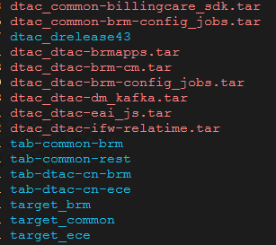

* make the tar of newly created folder which contains workspace’s folders and image tar file.
  + tar –cf dtac_drelease38.tar dtac_drelease38
* Use curl commad to push the tar file to OCI Storage.
  + curl -X PUT --data-binary '@dtac_drelease38.tar' https://objectstorage.uk-london-1.oraclecloud.com/p/hHdw5ayWjHnNTO7ctCsppUgzkh2piRtff8Sh_kgRH9pcNdshjnadQ1krgFMjb2iX/n/idvvfekwvhut/b/tab_dtac_lhrbkt/o/dtac_drelease38.tar
* After It got uploaded successfully. Take the URL from the above curl command and send it to DTAC via mail. DTAC will download the file in UTL server.
  + https://objectstorage.uk-london-1.oraclecloud.com/p/hHdw5ayWjHnNTO7ctCsppUgzkh2piRtff8Sh_kgRH9pcNdshjnadQ1krgFMjb2iX/n/idvvfekwvhut/b/tab_dtac_lhrbkt/o/dtac_drelease38.tar
* DTAC will confirm the location of downloaded file in UTL server over the mail.
  + Then we need to connect to UTL server, Then upload the file to CICD server with the help of winscp.
  + We need to place the tar file inside the $REPO_HOME location. Before that we need to make sure REPO_HOME is Empty.
  + Place only our tar file inside the REPO_HOME directory.

Example:



Step 2: Login to Jenkins using the below URL. And Open the Load_Tag_Push Pipeline.

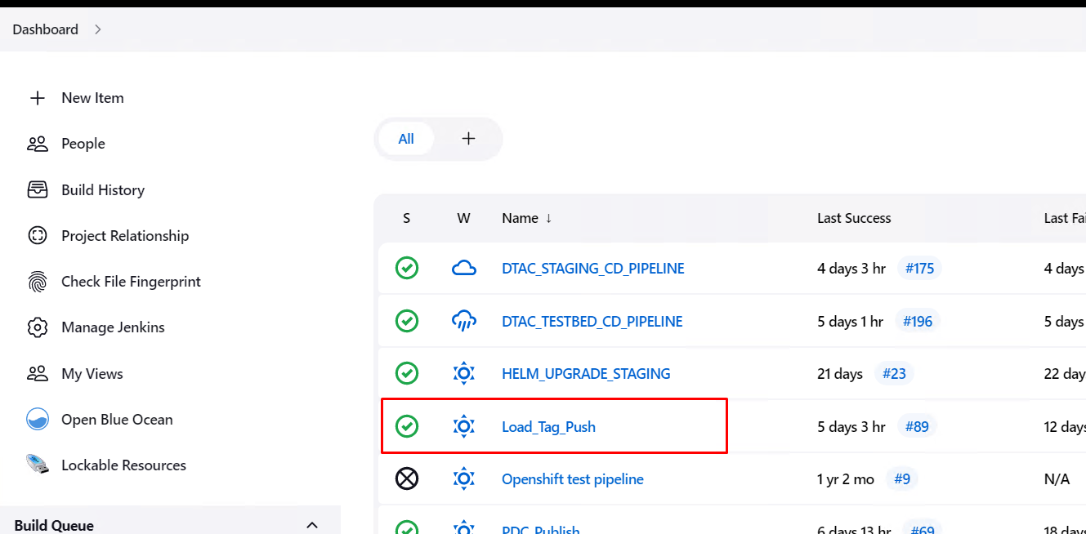

Step3: Uncheck all the boxes except {prerequisite & Load_Images}.

* + Prerequisite 🡪 It will untar the file (dtac_drelease38.tar)
  + Load_Images 🡪 It will load the images locally so that later we can tag the image and push to OCR.

Then trigger the Build.



Step4: After the completion of Pipeline. Open the pipeline job again and Uncheck all the boxes and then trigger the Build. (DRY_RUN).

Step5: After the completion of DRY_RUN. Open the pipeline job again and Uncheck the {prerequisite & Load_Images}. Then check and select the boxes and corresponding image tag.

BCWS:

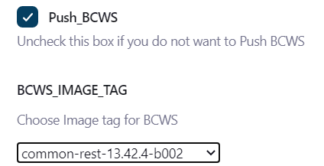

CM:

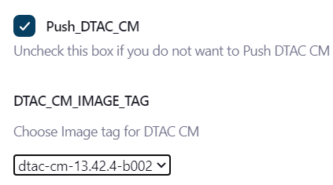

EAI:

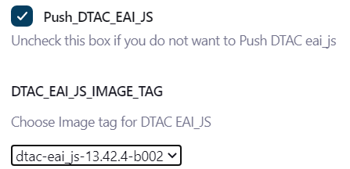

DM-Kafka:

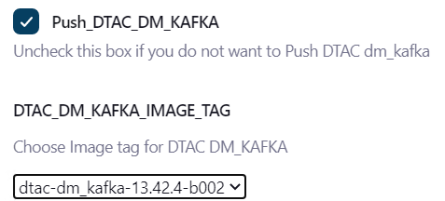

Realtime:

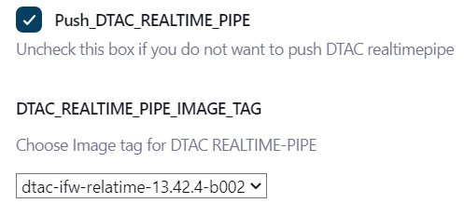

ECE:

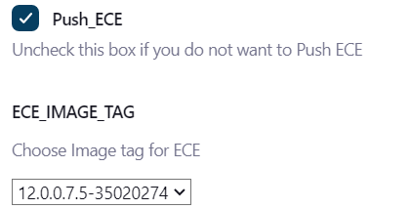

BRM_Apps:

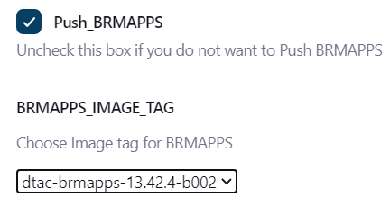

DTAC_Config:

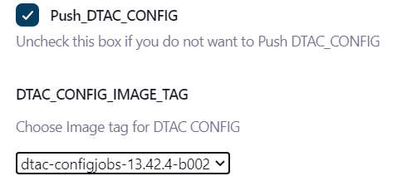

Common_config:

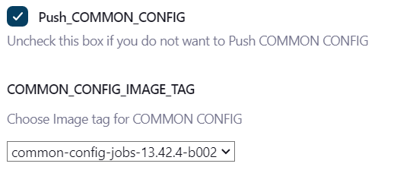

Make sure that you’ve selected the latest image tag from the drop down. And Click on Build to TAG and PUSH the latest image to OCR.

CD:

## Note: Perform the below steps after the completion of CD Prerequisites.

Step1: open the Pipeline job

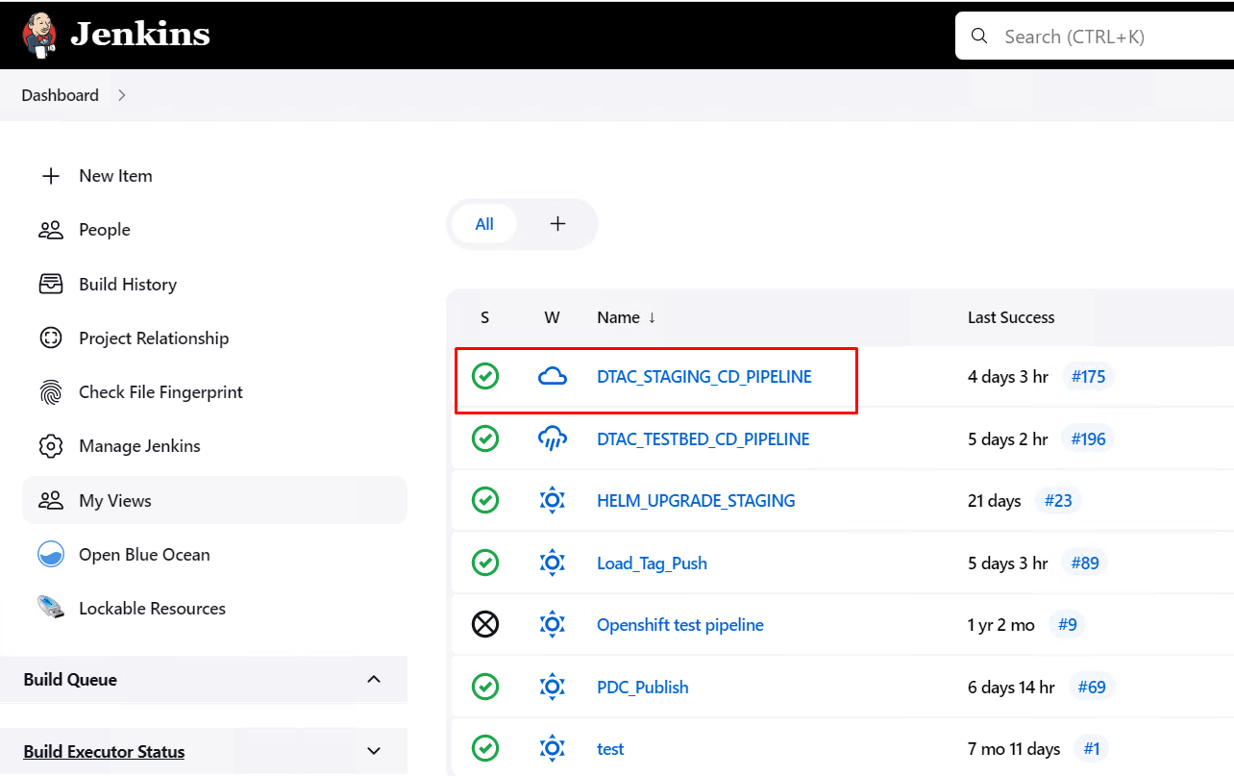

Step2: Click on the Build with Parameters option to update the parameter required for CD pipeline.

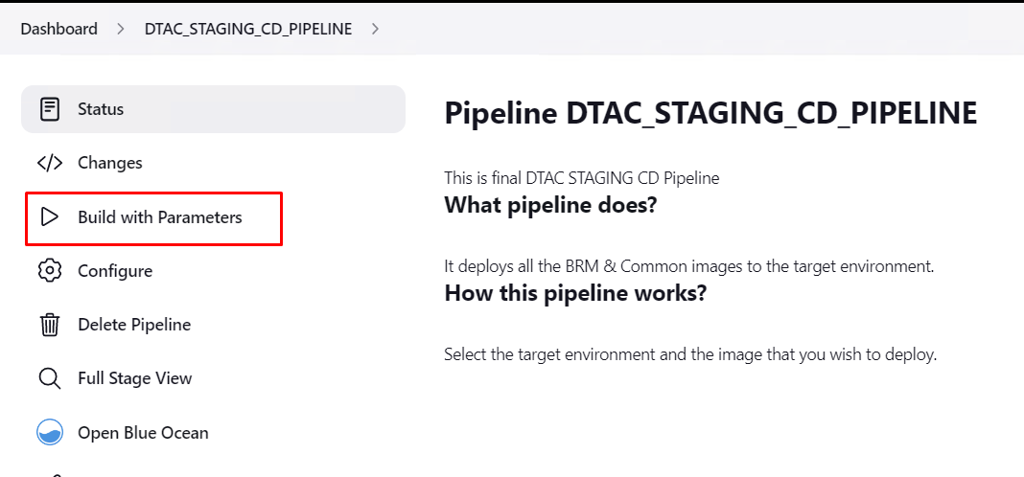

Step3: Check whether your Git has the latest helmchart or Local. If Local has the latest then check the Git_commit option alone. And Trigger the CD pipeline.

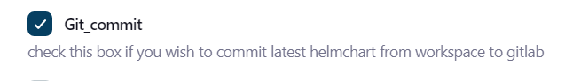

Note: Maintaining the latest helm chart in GitLab is a Good practice.

Step4: check the Checkout_helmchart ,Environment_Setup and Disable_Cronjob options then Trigger the Build.

Checkout_helmchart: To clone your helmchart from GitLab to Local

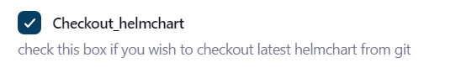

Enviroment_Setup: Creates the folder structure for the deployment and other pre-deployment activities.

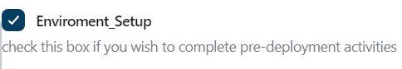

Disable_Cronjob: To disable the running cron-jobs from the server. Then Trigger the first round of build of CD Pipeline.

Note: After the completion of first round of build. Reopen the CD pipeline job and follow the below procedures by clicking on Build with Parameters.

Step5: Check the Trivy_Scan if you want to scan the image before its get deployed.

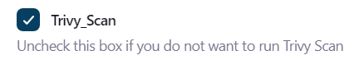

Step6: Check and select the images that needs to be deployed.

BCWS:

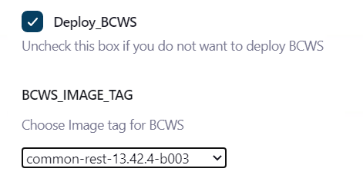

CM:

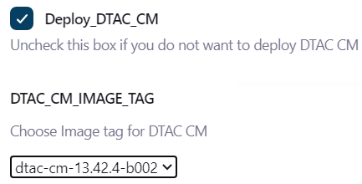

EAI:

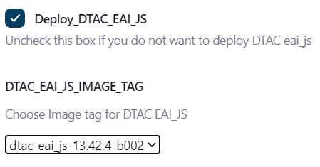

DM-Kafka:

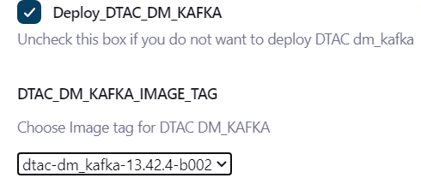

RealtimePipe:

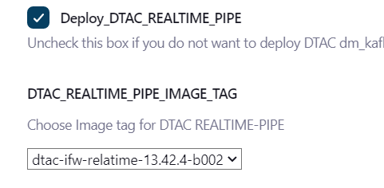

ECE:

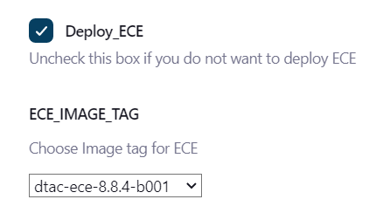

Note: If there is no custom image deployment and need to load the latest jars to ECE then select the below option.

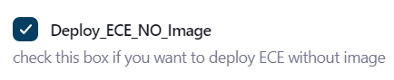

PDC:

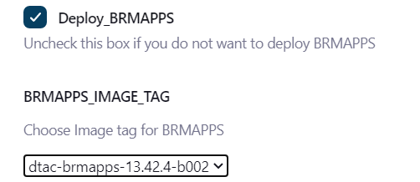

DTAC_Config:

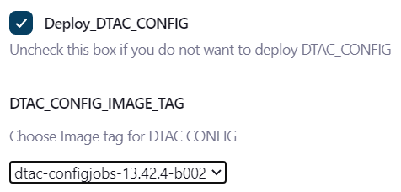

Common_Config:

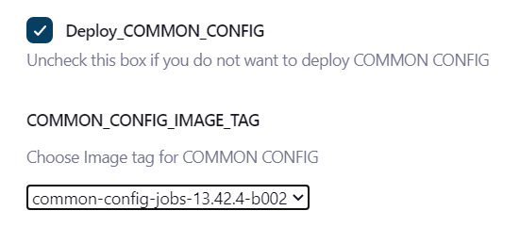



Step 7: Make sure that we’ve selected all the image tag properly and Trigger the Build.

Step 8: After the successful completion of second build. Open the Jenkins Job and Run the following Stages:

Enable cronjob: It will start the cronjob for the available cron entries.



Git_commit: It is used to commit the latest modified helmchart from workspace to GitLab.

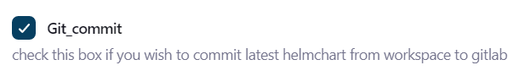

Note: we’ve one more option integrated with Jenkins i.e Gitlab_backup Select the option to take the backup of entire GitLab if required.