Forces on Inclined Planes
November 17, 2025
Table of Contents
1
Introduction to Forces on Inclined Planes 2
Which Forces Are Present? 2
Examples and Applications 3

Introduction to Forces on Inclined Planes
Objects slide down hills because there is a parallel force that acts on the object directing it downward. However, the object must overcome a force of friction in order to start moving. The force of friction depends on the angle of elevation of the plane as well as the weight of the object.

Which Forces Are Present?
On an inclined surface, the normal force of an object does not point directly upward from the center of Earth, but rather perpendicular to the surface. However, the weight, or the force of gravity (), still points toward the center of Earth. Similar to forces in an elevator, on an inclined plane.
The weight of an object on an inclined plane consists of two components: a perpendicular force and a parallel force. The magnitude of the perpendicular force equals that of the normal force. The magnitude of the parallel force is essentially the magnitude of the force of friction acting on the object on the slope.
To calculate the forces acting on an object on an inclined plane, you would need at least the angle of elevation of the slope along with the weight or one of the components. You would then use trigonometric functions to compute the magnitudes of the other forces.

Examples and Applications
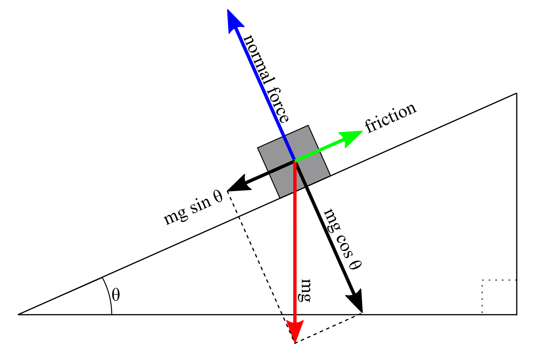Figure 1: The box on the slope is at rest. The red vector represents the weight of the object, and its magnitude is the length of the hypotenuse of the triangle formed by the components. The parallel force is the black vector labeled and is directed down the slope. Additionally, the perpendicular force is the black vector labeled and is directed downward perpendicular to the surface of the plane. The normal force, represented by the blue vector, is equal in magnitude but opposite in direction to the perpendicular force. Finally, the force of friction, depicted by the green vector, is equal in magnitude but opposite in direction to the parallel force.
- A -kilogram object is at rest on an inclined plane with an angle of elevation of degrees.
  - Calculate the weight of the -kilogram object.

  - Determine the magnitude and direction of the force of friction acting on the object at rest.

The force of friction is , and it is directed upward along the inclined plane.
  - Calculate the magnitude of the perpendicular component of the weight vector of the object.

  - Assuming the ramp is frictionless, calculate the magnitude of the acceleration of the object when a force of directed down the slope is applied to the object.

The magnitude of the acceleration of the object when a force of directed down the slope is applied to the object is .

