Sound**
(This idea or topic is a major aspect of the new Physical Science: Physics course.)
April 21, 2026
Table of Contents
1
Sound Waves 2
Longitudinal Waves 2
Temperature and the Speed of Sound* 2
Echoes and Reverberation 2
Sonar* 3
Natural Frequency and Resonance 3
The Doppler Effect 3
Sonic Booms 4
Redshift and Blueshift 4

Sound Waves
Sound is a longitudinal wave that travels in a direction parallel to the medium (i.e., air, water, a solid, etc.). As sound travels through the material, the molecules move back and forth in the same direction as the wave.

Longitudinal Waves
The molecules in the path of a longitudinal wave experience compressions in high-pressure zones and rarefactions in low-pressure zones. The molecules act like individual coils in a spring. The faster the molecules move back and forth, the greater the frequency of the wave, and the greater the distance they move, the greater the wave’s amplitude.
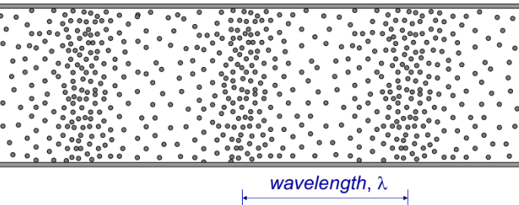Figure 1: The areas at which the molecules appear more "together" are zones of compression, whereas the regions with the molecules appear more spread out are rarefaction areas.

Temperature and the Speed of Sound*
(This idea or topic is excluded in the new Physical Science: Physics course.)
Because the speed of sound is inversely proportional to the medium’s density, faster sound correlates to a medium of lower density. The hotter a substance is, the faster its molecules and atoms vibrate and the more space they take up. This lowers the substance’s density (since less molecules are packed together) and increases the speed of sound through that medium. Therefore, temperature and the speed of sound are directly proportional; the higher the temperature, the faster the speed of sound. To visualize this more clearly, recall that molecules must bump into each other in order to transmit a longitudinal wave. When molecules move quickly, they need less time to bump into their neighbors.

Echoes and Reverberation
An echo is simply a reflected sound wave. When sound waves are reflected, they bounce off a point and travel back in the opposite direction.
Reverberation is the repeated reflection of sound at close quarters. If you were to yell inside a narrow tunnel, your reflected sound would bounce back to your ears so quickly that your brain would not be able to distinguish between the original yell and its reflection.

Sonar*
(This idea or topic is excluded in the new Physical Science: Physics course.)
Sonar stands for Sound Navigation and Ranging. The main principle of sonar is sending out sound waves and listening for echoes. The distance of an object can be determined based on the time it takes for an echo that reflects off that object to return.
Sonar is used in commercial fishing boats to find schools of fish. Scientists also use it to map the ocean floor. Special glasses that make use of sonar can help blind people by producing sounds of different pitches depending on how close an obstacle is.
Instruments that use radio (low-frequency light) waves utilize radar (Radio Detection and Ranging).

Natural Frequency and Resonance
Natural frequency is the frequency at which a specific body vibrates. Resonance, on the other hand, is the vibration of a body at its natural frequency due to the influence of another source vibrating at the same frequency.

The Doppler Effect
The Doppler effect (Doppler shift) is the variation in the observed frequency of a wave when there is relative motion between the source and the receive. Recall that wave fronts are all points on a wave that are in phase with each other.
Wavelength and frequency are inversely related, so increases in frequency must decrease wavelength.
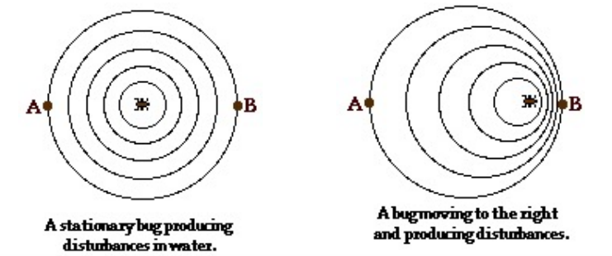Figure 2: A diagram representing the change in nature of water ripples (waves) due to the movement of a bug.

Sonic Booms
A sonic boom is a sound caused by shock waves, which are created when an object travels through the air faster than the speed of sound.

Redshift and Blueshift
A redshift is an increase in wavelength (decrease in frequency) of electromagnetic radiation. Conversely, a blueshift is a decrease in wavelength (increase in frequency) of electromagnetic radiation.
They essentially act as Doppler shift in light or other electromagnetic waves. They also allow scientists to verify that the universe is, indeed, expanding by revealing the relative movement of celestial objects.

