Refraction**
(This idea or topic is a major aspect of the new Physical Science: Physics course.)
May 6, 2026
Table of Contents
1
Refraction of a Wave 2
Absolute Index of Refraction 2
Snell’s Law 2
Critical Angle 3
Total Internal Reflection 4
Examples and Applications 5

Refraction of a Wave
Refraction refers to the change in direction of a wave due to a change in speed at the boundary between two media of different density.

Absolute Index of Refraction
Absolute index of refraction is a number that shows how optically dense a material is. The index of refraction () or “optical density” of a material is the ratio of the speed of light in a vacuum to the speed of light in the optical medium. The formula for index of refraction is defined as:
,
where is the index of refraction, is the speed of light in a vacuum (), and is the speed of light in a different medium. is a unitless number greater than or equal to .24.

Snell’s Law
Snell’s Law states that:
- Light bends according to how dense materials are.
- Light traveling from low to high density bends toward the normal.
- Light traveling from high to low density bends away from the normal.
A pneumonic to memorize this goes as follows:
- Let’s: Less dense
- Make: More dense
- Tea: Toward the normal
How can it be predicted if a light ray will bend closer or away from the normal? When light bends, speed, direction, and wavelength can change.`
If light passes into:
- A denser medium (), the light bends toward the normal, the speed decreases, the wavelength decreases, and the frequency remains the same.
- A less dense medium (), the light bends away from the normal, the speed increases, the wavelength increases, and the frequency remains the same.
- An equally dense medium, the light does not refract; it passes straight into the new medium.
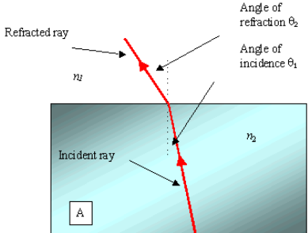Figure 1: A depiction of a refracted ray.

Critical Angle
A critical angle only exists when the light ray is going from a medium of higher optical density to a medium of lower optical density. In other words, it only exists if the ray bends away from the normal.
The critical angle of a ray, denoted by , is the angle of incidence that produces an angle of refraction of exactly .
If the angle of incidence exceeds the critical angle, the ray is completely reflected and does not enter the medium of lower density.

Total Internal Reflection
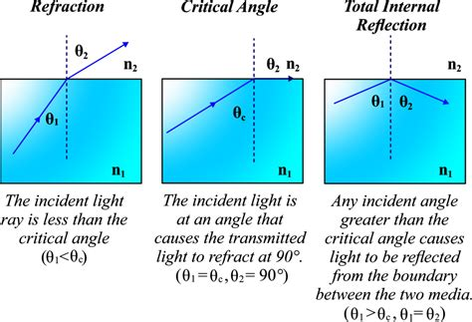Figure 2: A diagram distinguishing refraction, critical angle, and total internal reflection.
When the incident angle is greater than the critical angle, light does not enter the new medium at all. This is called total internal reflection, as the ray is literally reflected internally.
When a ray is reflected or refracted, the ray can appear in the quadrant diagonally across from the incident ray or horizontally adjacent to the incident ray, but it can never appear in the quadrant vertically adjacent to the incident ray.
Consider the following example, which highlights the possible locations of a refracted ray given an incident ray:
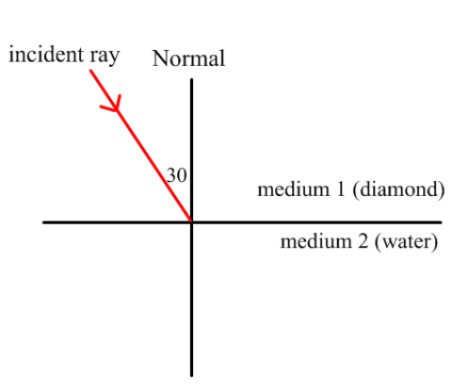Figure 3: In this example, the refracted or reflected ray can appear in Quadrant IV or Quadrant I, but not Quadrant III.

Examples and Applications
- What is the speed of light in a diamond? The index of refraction of diamond is .

- A microwave has a frequency of in air. What is the frequency, speed, and wavelength of the microwave in a material with an optical density of ?

- Calculate the critical angle for the diamond-air boundary when a light ray passes from a diamond into the air. The index of refraction of diamond is , while the index of refraction for air is .

