Geometric Optics
May 13, 2026
Table of Contents
1
Plane Mirrors 2
Concave and Convex Mirrors 2
Radius of Curvature and Focal Length 3
Reflections on Concave Mirrors 4
Reflections on Convex Mirrors 5
Calculating Focal Length 5
Calculating Magnification 5
Examples and Applications 6

Plane Mirrors
Plane mirrors have a flat surface and reflect rays with equal angles of incidence and reflection. If all rays were extended backward behind the mirror, they would intersect at one point representing the image of the original point. To an observer, the rays appear to come from the image at that point, but no source is there and no rays actually converge there. Thus, the image at that point is a virtual image.
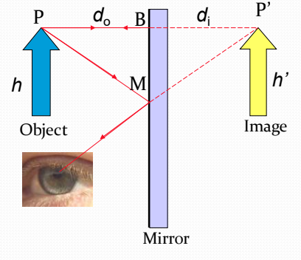Figure 1: The reflection of an object at point P can be seen by the observer due to the existence of an imaginary virtual image.

Concave and Convex Mirrors
Concave and convex mirrors are curved mirrors similar to portions of a sphere.
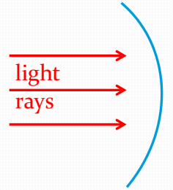Figure 2: Concave mirrors reflect light from their inner surface, like the inside of a spoon.
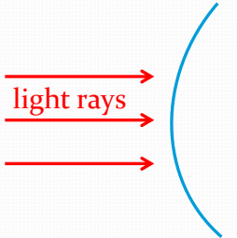Figure 3: Convex mirrors reflect light from their outer surface, similar to the outside of a spoon.
Most lenses and mirrors have at least some curvature. Convex lenses and mirorrs are shaped like an oval and bulge out in the middle. On the other hand, concave lenses and mirrors get sucked into the middle and look like an hourglass.

Radius of Curvature and Focal Length
The radius of curvature in a curved mirror is the distance from the lens to the center of the circle if the curve of the lens were extended to form a full circle.
The focal length of a curved mirror is exactly half the radius of curvature (, where is the focal length and is the radius of curvature).
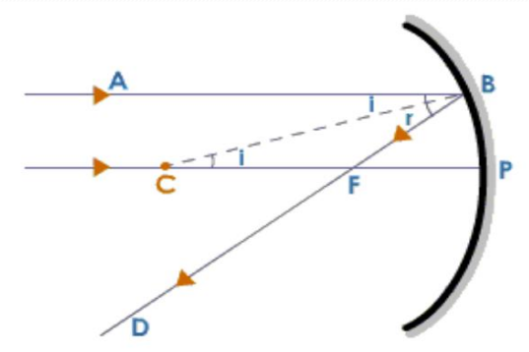Figure 4: Point C is the center of the circle, point F is the focal point, and segment CP is the radius of curvature.

Reflections on Concave Mirrors
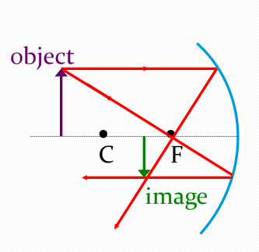Figure 5: The image formed when an object is placed beyond point C (the center of curvature) is located between C and F. It is a real, inverted image that is smaller in size than the object.
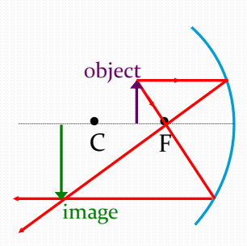Figure 6: The image formed when an object is placed between points C and F is located beyond C. It is a real, inverted image that is larger in size than the object.
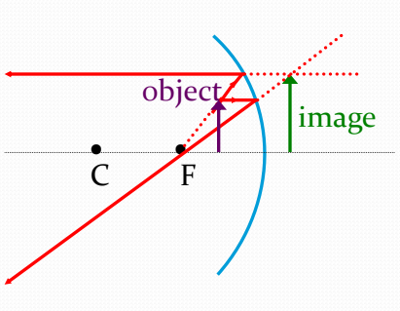Figure 7: The image formed when an object is placed in front of point F is located behind the mirror. It is a virtual, upright image that is larger in size than the object. It is virtual because it is formed only where light rights seem to be diverging from.

Reflections on Convex Mirrors
When an object is placed in front of a convex mirror, a virtual iamge will always be formed behind the mirror. The image will always be smaller and upright.
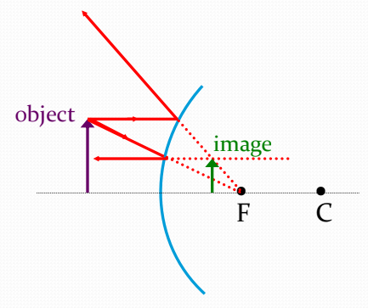Figure 8: The image formed by a convex mirror (no matter where the object is placed) will be virtual, upright, and smaller than the object. As the object is moved closer to the mirror, the size of the image will approach the size of the object.

Calculating Focal Length
To calculate the focal length given the distance to an object and the distance to that object’s image, use the formula:
,
where is the focal length, is the distance to the object, and is the distance to the image.

Calculating Magnification
To calculate the magnification of an object in a curved mirror, use:
,
where is the height of the image, is the height of the object, is the distance to the image, and is the distance to the object.
Magnification is defined as the ratio of the height of the image to the height of the object.

Examples and Applications
- A high object is placed from a concave mirror whose radius of curvature is meters. Calculate the distance to the image and its height.

