Universal Gravitation
November 18, 2025
Table of Contents
1
Newton’s Law of Universal Gravitation 2
Gravitational Fields 2
Force of Gravity in Orbit 2
Examples and Applications 3

Newton’s Law of Universal Gravitation
Newton’s law of universal gravitation states that the gravitation force of every particle attracts every other particle in the universe with a force that is proportional to the product of their masses and inversely proportional to the square of the distance between their centers.
It is defined using the formula:
,
where is the gravitational force, is the universal gravitational constant, and are the masses of the two objects, and is the distance between the centers of the two objects.
Even if their masses are different, the forces the two objects exert on each other are equal. In our universe, the gravitational constant, , is approximately .

Gravitational Fields
The farther an object is from an object exerting a gravitational force, the smaller the effect the gravity has on that object. Gravitational force always points toward the center of an object.

Force of Gravity in Orbit
When an object is orbiting a celestial body in a circular motion, the force of gravity points toward the center of the celestial body.
The straight line tangent to the trajectory of orbit at the point of the object is the expected path of the object, but the force of gravity alters this path and causes it to constantly change as the object revolves around the body. Thus, the object is technically accelerating because the direction of its velocity is constantly changing.
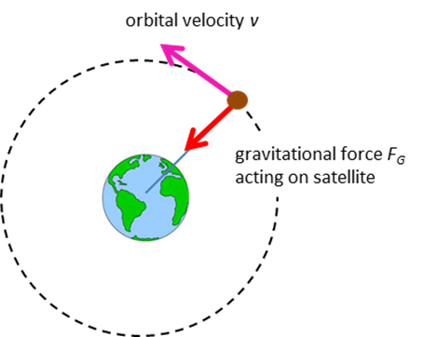Figure 1: The orbital velocity and the gravitational force acting on a satellite above Earth.

Examples and Applications
- Calculate the gravitational force between two students, each of mass , separated by a distance of .

- An electron () and a proton () in a hydrogen atom exert a force of approximately on each other. Compute the distance by which their centers are separated.

